*****************************************************************************************

CSCI 381-26 Project 3: Morphology Language: C++

Name: Akshar Patel

Due date: Soft copy: 2/26/2020

Hard copy: 2/27/2020

Submission date: Soft copy: 2/26/2020

Hard copy: 2/27/2020

*****************************************************************************************

**Part 1: Algorithm**

*******************************

IV. Main(...)

*******************************

step 0: imgFile, structFile, dilateOutFile, erodeOutFile, openingOutFile, closingOutFile,

prettyPrintFile 🡨 open

step 1: numImgRows, numImgCols, imgMin, imgMax 🡨 read from imgFile

numStructRows, numStructCols, structMin, structMax 🡨 read from structFile

rowOrigin, colOrigin 🡨 read from strucFile

step 2: zeroFramedAry, structAry, morphAry 🡨 dynamically allocate // see description in

the above

step 3: zero2DAry(zeroFramedAry) // see description in the above

step 4: loadImg (imgFile, zeroFramedAry) // see description in the above

prettyPrint (zeroFramedAry, prettyPrintFile) // see description in the above

step 5: zero2DAry(structAry)

loadstruct (structFile, structAry) // see description in the above

prettyPrint (structAry, prettyPrintFile) // see description in the above

step 6: zero2DAry(morphAry)

ComputeDilation (…) // see algorithm below

AryToFile (morphAry, dilateOutFile) // see description in the above

prettyPrint (morphAry, prettyPrintFile)

step 7: zero2DAry(morphAry)

ComputeErosion (…) // see algorithm below

AryToFile (morphAry, erodeOutFile)

prettyPrint (morphAry, prettyPrintFile)

step 8: zero2DAry(morphAry)

ComputeOpening (…) // see algorithm below

AryToFile (morphAry, openingOutFile)

prettyPrint (morphAry, prettyPrintFile)

step 9: zero2DAry(morphAry)

ComputeClosing (…) // see algorithm below

AryToFile (morphAry, closingOutFile)

prettyPrint (morphAry, prettyPrintFile)

step 10: close all files

#include <iostream>

#include <fstream>

#include <string>

#include <cmath>

using namespace std;

class Morphology{

public:

int numImgRows, numImgCols, imgMin, imgMax, numStructRows, numStructCols, structMin, structMax, rowOrigin, colOrigin;

int rowFrameSize, colFrameSize ,extraRows , extraCols;

int** zeroFramedAry;

int** morphAry;

int** structAry;

void set2DZero(int** Ary){

for(int i = 0 ; i < numImgRows + extraRows ; i++){

for(int j = 0 ; j < numImgCols + extraCols ; j++){

Ary[i][j] = 0;

}

}

}

void set2DStructZero(int** Ary){

for(int i = 0 ; i < numStructRows ; i++){

for(int j = 0 ; j < numStructCols ; j++){

Ary[i][j] = 0;

}

}

}

void loadImg(ifstream& file, int** Ary){

for(int i = rowOrigin ; i < numImgRows + rowOrigin ; i++){

for(int j = colOrigin ; j < numImgCols + colOrigin ; j++){

file>>Ary[i][j];

}

}

}

void prettyPrint(int** Ary, ofstream& file){

for(int i = rowOrigin ; i < numImgRows + rowOrigin ; i++){

for(int j = colOrigin ; j < numImgCols + colOrigin ; j++){

if(Ary[i][j]==0){

file<<". ";

}

else{file<<Ary[i][j]<<" ";}

}

file<<endl;

}

file<<"---------------------------------------------------------------------"<<endl;

}

void pretty1Print(int** Ary, ofstream& file){

file<<"structure element is:"<<endl;

for(int i=0; i<numStructRows ; i++){

for(int j=0; j<numStructCols ; j++){

file<<Ary[i][j]<<" ";

}

file<<endl;

}

file<<"---------------------------------------------------------------------"<<endl;

}

void loadstruct(ifstream& file, int** Ary){

for(int i = 0; i < numStructRows ; i++){

for(int j = 0; j < numStructCols ; j++){

file>>Ary[i][j];

}

}

}

void ComputeDilation(int** Ary){

for(int i = rowOrigin; i < numImgRows + rowOrigin ; i++){

for(int j = colOrigin; j < numImgCols + colOrigin ; j++){

if(Ary[i][j] > 0){

dilation(i,j);

}

}

}

}

void dilation(int i, int j){

int roffset = i-rowOrigin, coffset= j-colOrigin;

for(int r = 0 ; r < numStructRows ; r++){

for(int c = 0 ; c < numStructCols ; c++){

if(structAry[r][c]==1){

morphAry[r+roffset][c+coffset] = 1;

}

}

}

}

void ComputeErosion(int** Ary){

for(int i = rowOrigin; i < numImgRows + rowOrigin ; i++){

for(int j = colOrigin; j < numImgCols + colOrigin ; j++){

if(Ary[i][j] > 0){

erosion(i,j, Ary);

}

}

}

}

void erosion(int i, int j, int** Ary){

int roffset = i-rowOrigin, coffset= j-colOrigin;

bool match = true;

for(int r = 0 ; r < numStructRows ; r++){

for(int c = 0 ; c < numStructCols ; c++){

if(structAry[r][c]>0 && Ary[r+roffset][c+coffset]==0){

match = false;

}

}

}

if(match==true){

morphAry[i][j]=1;

}

}

void ComputeOpening(int** Ary){

int** tempAry = new int* [numImgRows + extraRows];

for(int i=0; i<numImgRows + extraRows; i++){

tempAry[i] = new int[numImgCols + extraCols];

}

ComputeErosion(Ary);

for(int i = rowOrigin; i < numImgRows + rowOrigin ; i++){

for(int j = colOrigin; j < numImgCols + colOrigin ; j++){

tempAry[i][j] = morphAry[i][j];

}

}

set2DZero(morphAry);

ComputeDilation(tempAry);

}

void ComputeClosing(int** Ary){

int** tempAry = new int* [numImgRows + extraRows];

for(int i=0; i<numImgRows + extraRows; i++){

tempAry[i] = new int[numImgCols + extraCols];

}

ComputeDilation(Ary);

for(int i = rowOrigin; i < numImgRows + rowOrigin ; i++){

for(int j = colOrigin; j < numImgCols + colOrigin ; j++){

tempAry[i][j] = morphAry[i][j];

}

}

set2DZero(morphAry);

ComputeErosion(tempAry);

}

void AryToFile(int** Ary, ofstream& file){

file<<numImgRows<<" "<<numImgCols<<" "<<imgMin<<" "<<imgMax<<endl;

for(int i = rowOrigin ; i < numImgRows + rowOrigin ; i++){

for(int j = colOrigin ; j < numImgCols + colOrigin ; j++){

file<<Ary[i][j]<<" ";

}

file<<endl;

}

}

};

int main(int argc, const char * argv[]){

Morphology mp;

string inputName1 = argv[1];

ifstream imgFile;

imgFile.open( inputName1 );

string inputName2 = argv[2];

ifstream structFile;

structFile.open( inputName2 );

string outputName1 = argv[3];

ofstream dilateOutFile;

dilateOutFile.open( outputName1 );

string outputName2 = argv[4];

ofstream erodeOutFile;

erodeOutFile.open( outputName2 );

string outputName3 = argv[5];

ofstream closingOutFile;

closingOutFile.open( outputName3 );

string outputName4 = argv[6];

ofstream openingOutFile;

openingOutFile.open( outputName4 );

string outputName5 = argv[7];

ofstream prettyPrintFile;

prettyPrintFile.open( outputName5 );

if( imgFile.is_open() && structFile.is_open() ){

if(dilateOutFile.is_open() && erodeOutFile.is_open() &&

openingOutFile.is_open() && closingOutFile.is_open() &&

prettyPrintFile.is_open() ){

imgFile>>mp.numImgRows>>mp.numImgCols>>mp.imgMin>>mp.imgMax;

structFile>>mp.numStructRows>>mp.numStructCols>>mp.structMin>>mp.structMax;

structFile>>mp.rowOrigin>>mp.colOrigin;

mp.rowFrameSize = (mp.numStructRows / 2);

mp.colFrameSize = (mp.numStructCols / 2);

mp.extraRows = (mp.rowFrameSize * 2);

mp.extraCols = (mp.colFrameSize * 2);

mp.zeroFramedAry = new int* [mp.numImgRows + mp.extraRows];

mp.morphAry = new int* [mp.numImgRows + mp.extraRows];

for(int i=0; i<mp.numImgRows + mp.extraRows; i++){

mp.zeroFramedAry[i] = new int[mp.numImgCols + mp.extraCols];

mp.morphAry[i] = new int[mp.numImgCols + mp.extraCols];

}

mp.structAry = new int * [mp.numStructRows];

for(int i = 0 ; i < mp.numStructRows ; i++){

mp.structAry[i] = new int[mp.numStructCols];

}

mp.set2DZero(mp.zeroFramedAry);

mp.loadImg(imgFile, mp.zeroFramedAry);

mp.prettyPrint(mp.zeroFramedAry, prettyPrintFile);

mp.set2DStructZero(mp.structAry);

mp.loadstruct(structFile, mp.structAry);

mp.pretty1Print(mp.structAry, prettyPrintFile);

mp.set2DZero(mp.morphAry);

mp.ComputeDilation(mp.zeroFramedAry);

mp.AryToFile(mp.morphAry, dilateOutFile);

mp.prettyPrint(mp.morphAry, prettyPrintFile);

mp.set2DZero(mp.morphAry);

mp.ComputeErosion(mp.zeroFramedAry);

mp.AryToFile(mp.morphAry, erodeOutFile);

mp.prettyPrint(mp.morphAry, prettyPrintFile);

mp.set2DZero(mp.morphAry);

mp.ComputeOpening(mp.zeroFramedAry);

mp.AryToFile(mp.morphAry, openingOutFile);

mp.prettyPrint(mp.morphAry, prettyPrintFile);

mp.set2DZero(mp.morphAry);

mp.ComputeClosing(mp.zeroFramedAry);

mp.AryToFile(mp.morphAry, closingOutFile);

mp.prettyPrint(mp.morphAry, prettyPrintFile);

imgFile.close();

structFile.close();

dilateOutFile.close();

erodeOutFile.close();

openingOutFile.close();

closingOutFile.close();

prettyPrintFile.close();

}else{cout<<"Error!! Could NOT create output file"<<endl ;}

}else{cout<<"Error!! Could NOT open input file"<<endl;}

}

**Test-1: Morphology_Img1.txt and Morphology_StrucElem3.txt**

|  |  |
| --- | --- |
| dilateOutFile | erodeOutFile |
| 40 30 0 1  0 0 0 0 0 0 0 0 0 0 1 1 1 1 1 0 0 0 0 0 0 0 0 0 0 0 0 0 0 0  1 1 1 1 1 0 0 0 0 1 1 1 1 1 1 1 1 1 1 0 0 0 0 1 1 1 1 1 1 1  1 1 1 1 1 1 1 1 1 1 1 1 1 1 1 1 1 1 1 1 0 0 1 1 1 1 1 1 1 1  0 1 1 1 1 1 1 1 1 1 1 1 1 1 1 1 1 1 1 1 0 0 0 1 1 1 1 1 1 1  0 0 1 1 1 1 1 1 1 1 1 0 0 1 1 1 1 1 1 1 1 1 1 1 1 1 1 1 1 1  0 1 1 1 1 1 1 1 1 1 1 1 1 1 1 1 1 1 1 1 1 1 1 1 1 1 1 1 1 0  0 0 0 0 0 0 0 0 0 1 1 1 1 1 1 1 1 1 1 1 1 1 1 1 1 1 0 0 0 0  1 1 1 1 1 1 1 0 0 1 1 1 1 1 1 1 1 1 1 1 1 1 1 1 1 1 1 1 1 1  0 1 1 1 1 1 0 0 0 0 1 1 1 1 1 1 1 1 1 1 1 1 1 1 1 1 1 1 1 1  0 0 0 1 1 1 1 1 1 1 1 1 1 1 0 0 1 1 1 1 1 1 1 1 1 0 0 0 0 0  0 0 0 0 0 0 0 1 1 1 1 1 1 1 1 0 0 1 1 1 1 1 1 1 0 0 0 0 0 0  0 1 1 1 1 1 1 1 1 1 1 1 1 1 1 1 1 1 1 1 1 1 1 1 1 1 1 1 1 1  1 1 1 1 1 1 1 1 1 1 1 1 1 1 0 0 0 0 0 0 0 0 0 0 0 0 1 1 1 1  1 1 1 1 1 1 1 1 0 0 0 0 0 0 0 0 0 1 1 1 1 1 1 1 1 0 1 1 1 1  0 1 1 1 1 1 1 0 0 1 1 1 1 1 1 1 1 1 1 1 1 1 1 1 1 1 1 1 0 0  0 0 0 0 1 1 1 1 1 1 1 1 1 1 1 1 1 1 1 1 1 1 1 1 1 1 1 0 0 0  1 1 1 1 1 0 0 1 1 1 1 1 1 1 1 1 1 1 1 1 1 0 0 1 1 1 1 1 0 0  0 1 1 1 1 1 1 1 1 1 1 1 1 1 1 1 1 1 1 1 1 1 1 1 1 1 1 1 1 1  0 0 0 0 0 1 1 1 1 1 0 1 1 1 1 1 1 1 1 1 1 1 1 1 1 1 1 1 1 1  0 0 0 0 1 1 1 1 1 0 1 1 1 1 1 1 1 1 1 1 1 1 1 1 1 1 1 1 1 1  0 0 1 1 1 1 1 1 1 1 1 1 1 1 1 1 1 1 1 1 1 1 1 1 1 1 1 1 1 0  0 1 1 1 1 1 1 1 1 1 1 1 1 0 1 1 1 1 1 1 1 1 1 1 1 1 1 1 0 0  1 1 1 1 1 1 1 1 1 1 1 0 0 1 1 1 1 1 1 1 0 0 1 1 1 1 1 1 1 1  1 1 1 1 1 1 1 1 1 1 1 0 1 1 1 1 1 1 1 1 1 0 0 1 1 1 1 1 1 1  1 1 1 1 1 1 1 1 1 1 1 1 1 1 1 1 1 1 1 1 1 1 1 1 1 1 1 0 0 0  0 1 1 1 1 1 1 1 1 1 0 1 1 1 1 1 1 1 1 1 1 1 1 1 1 1 0 0 0 0  0 0 1 1 1 1 1 1 1 1 1 1 1 1 1 1 1 1 1 1 1 1 1 1 1 1 1 1 1 1  0 0 0 1 1 1 1 1 1 1 1 1 1 1 1 1 1 1 1 1 1 1 1 1 0 0 0 0 0 0  0 1 1 1 1 1 1 0 1 1 1 1 1 1 1 1 1 1 1 1 1 1 1 1 1 1 1 1 1 1  0 0 0 0 0 0 0 0 1 1 1 1 1 1 1 0 0 0 1 1 1 1 1 1 1 1 1 1 1 1  0 0 0 0 0 0 0 0 1 1 1 1 1 1 1 1 1 1 1 1 1 1 1 1 1 1 0 0 0 0  0 0 0 0 0 1 1 1 1 1 1 0 0 0 0 0 0 0 0 1 1 1 1 1 1 0 1 1 1 1  0 1 1 1 1 1 1 0 0 0 0 0 1 1 1 1 1 1 1 1 1 1 1 1 1 1 1 1 1 1  0 1 1 1 1 1 1 1 1 1 1 1 1 1 1 1 1 1 1 1 1 1 1 1 1 1 0 0 0 0  0 0 0 0 0 0 0 0 0 0 1 1 1 1 1 1 1 1 1 1 1 1 1 1 1 1 1 1 0 0  0 0 1 1 1 1 1 1 1 1 1 1 1 1 1 1 1 1 1 1 1 1 1 1 1 1 1 1 1 0  0 0 0 1 1 1 1 1 1 1 1 1 1 1 1 1 1 1 1 1 1 1 0 0 0 1 1 1 1 1  0 0 0 0 0 1 1 1 1 1 0 0 1 1 1 1 1 1 1 0 0 0 0 0 0 1 1 1 1 1  0 1 1 1 1 1 1 1 1 0 0 0 1 1 1 1 1 1 0 0 0 1 1 1 1 1 1 0 0 0  0 0 0 1 1 1 1 1 0 0 0 0 0 1 1 1 1 1 1 1 0 0 1 1 1 1 1 1 0 0 | 40 30 0 1  0 0 0 0 0 0 0 0 0 0 0 0 0 0 0 0 0 0 0 0 0 0 0 0 0 0 0 0 0 0  0 0 0 0 0 0 0 0 0 0 0 0 0 0 0 0 0 0 0 0 0 0 0 0 0 0 0 0 0 0  0 0 0 0 0 0 0 0 0 0 0 0 0 0 0 0 0 0 0 0 0 0 0 0 0 0 0 0 0 0  0 0 0 0 0 1 0 0 0 0 0 0 0 0 0 0 0 0 0 0 0 0 0 0 0 0 0 0 0 0  0 0 0 0 1 0 0 0 0 0 0 0 0 0 0 0 0 0 0 0 0 0 0 0 0 0 0 0 0 0  0 0 0 0 0 0 0 0 0 0 0 0 0 0 0 0 0 0 1 0 0 0 0 0 0 0 0 0 0 0  0 0 0 0 0 0 0 0 0 0 0 0 0 0 0 0 0 1 1 1 0 0 0 0 0 0 0 0 0 0  0 0 0 0 0 0 0 0 0 0 0 0 0 0 0 0 0 1 1 1 0 0 0 0 0 0 0 0 0 0  0 0 0 0 0 0 0 0 0 0 0 0 0 0 0 0 0 1 1 1 0 0 0 0 0 0 0 0 0 0  0 0 0 0 0 0 0 0 0 0 0 0 0 0 0 0 0 0 1 0 0 0 0 0 0 0 0 0 0 0  0 0 0 0 0 0 0 0 0 0 0 0 0 0 0 0 0 0 0 0 0 0 0 0 0 0 0 0 0 0  0 0 0 0 0 0 0 1 1 0 0 0 0 0 0 0 0 0 0 0 0 0 0 1 1 0 0 0 0 0  0 0 0 0 0 0 0 0 0 0 0 0 0 0 0 0 0 0 0 0 0 0 0 0 0 0 0 0 0 0  0 0 0 0 0 0 0 0 0 0 0 0 0 0 0 0 0 0 0 0 0 0 0 0 0 0 0 0 0 0  0 0 0 0 0 0 0 0 0 0 0 0 0 0 0 0 1 1 1 1 1 1 0 0 0 0 0 0 0 0  0 0 0 0 0 0 0 0 0 0 0 0 0 0 0 0 1 1 0 0 0 0 0 0 0 0 0 0 0 0  0 0 0 0 0 0 0 0 0 1 1 1 1 1 1 0 0 0 0 0 0 0 0 0 0 0 0 0 0 0  0 0 0 0 0 0 0 0 0 0 0 0 0 0 0 0 0 0 0 0 0 0 0 0 0 0 0 0 0 0  0 0 0 0 0 0 0 0 0 0 0 0 0 0 0 0 0 0 0 0 0 0 0 0 0 0 0 0 0 0  0 0 0 0 0 0 0 0 0 0 0 0 0 0 0 0 0 0 0 0 0 0 0 0 0 0 0 0 0 0  0 0 0 0 0 0 0 0 0 0 0 0 0 0 0 0 0 0 0 0 0 0 0 0 0 0 0 0 0 0  0 0 0 1 0 0 0 0 0 0 0 0 0 0 0 0 0 0 0 0 0 0 0 0 0 0 0 0 0 0  0 0 1 1 1 0 0 0 0 0 0 0 0 0 0 0 0 0 0 0 0 0 0 0 0 0 0 0 0 0  0 0 1 1 1 0 0 0 0 0 0 0 0 0 1 0 0 0 0 0 0 0 0 0 0 0 0 0 0 0  0 0 1 1 1 0 0 0 0 0 0 0 0 1 1 1 0 0 0 0 0 0 0 0 0 0 0 0 0 0  0 0 0 1 0 0 0 0 0 0 0 0 0 1 1 1 0 0 0 0 0 0 0 0 0 0 0 0 0 0  0 0 0 0 0 0 0 0 0 0 0 0 0 1 1 1 0 0 0 0 0 0 0 0 0 0 0 0 0 0  0 0 0 0 0 0 0 0 0 0 0 0 0 0 1 0 0 0 0 0 0 0 0 0 0 0 0 0 0 0  0 0 0 0 0 0 0 0 0 0 0 0 0 0 0 0 0 0 0 0 0 0 0 0 0 0 0 0 0 0  0 0 0 0 0 0 0 0 0 0 0 0 0 0 0 0 0 0 0 0 0 0 0 0 0 0 0 0 0 0  0 0 0 0 0 0 0 0 0 0 0 0 0 0 0 0 0 1 1 1 0 0 0 0 0 0 0 0 0 0  0 0 0 0 0 0 0 0 0 0 0 0 0 0 0 0 0 0 0 0 0 0 0 0 0 0 0 0 0 0  0 0 0 0 0 0 0 0 0 0 0 0 0 0 0 0 0 0 0 0 0 0 0 0 0 0 0 0 0 0  0 0 0 0 0 0 0 0 0 0 0 0 1 1 0 0 0 0 0 0 0 0 0 0 0 0 0 0 0 0  0 0 0 0 0 0 0 0 0 0 0 0 1 1 0 0 0 0 0 0 0 0 0 0 0 0 0 0 0 0  0 0 0 0 0 0 0 0 0 0 0 0 1 1 0 0 0 0 0 0 0 0 0 0 0 0 0 0 0 0  0 0 0 0 0 0 0 0 0 0 0 0 0 0 0 0 0 0 0 0 0 0 0 0 0 0 0 0 0 0  0 0 0 0 0 0 0 0 0 0 0 0 0 0 0 0 0 0 0 0 0 0 0 0 0 0 0 0 0 0  0 0 0 0 0 0 0 0 0 0 0 0 0 0 0 0 0 0 0 0 0 0 0 0 0 0 0 0 0 0  0 0 0 0 0 0 0 0 0 0 0 0 0 0 0 0 0 0 0 0 0 0 0 0 0 0 0 0 0 0 |

|  |  |
| --- | --- |
| closingOutFile | openingOutFile |
| 40 30 0 1  0 0 0 0 0 0 0 0 0 0 0 1 0 0 0 0 0 0 0 0 0 0 0 0 0 0 0 0 0 0  0 1 0 0 0 0 0 0 0 0 1 1 1 1 1 1 0 0 0 0 0 0 0 0 1 1 1 0 0 0  0 1 1 1 1 1 1 1 1 1 1 1 1 1 1 1 1 0 0 0 0 0 0 1 1 1 1 0 0 0  0 0 1 1 1 1 1 1 1 1 1 1 1 1 1 1 1 0 0 0 0 0 0 0 1 1 1 0 0 0  0 0 0 1 1 1 1 1 0 0 0 0 0 0 1 1 1 1 1 1 1 1 1 1 1 1 1 0 0 0  0 0 1 1 1 1 1 1 1 1 1 1 1 1 1 1 1 1 1 1 1 1 1 1 1 1 0 0 0 0  0 0 0 0 0 0 0 0 0 0 1 1 1 1 1 1 1 1 1 1 1 1 1 0 0 0 0 0 0 0  0 1 1 1 0 0 0 0 0 0 1 1 1 1 1 1 1 1 1 1 1 1 1 1 1 1 1 0 0 0  0 0 1 0 0 0 0 0 0 0 0 1 1 1 1 1 1 1 1 1 1 1 1 1 1 1 1 0 0 0  0 0 0 0 1 1 1 1 1 1 1 0 0 0 0 0 0 1 1 1 1 1 0 0 0 0 0 0 0 0  0 0 0 0 0 0 0 0 1 1 1 1 0 0 0 0 0 0 1 1 1 0 0 0 0 0 0 0 0 0  0 0 1 1 1 1 1 1 1 1 1 1 1 1 1 1 1 1 1 1 1 1 1 1 1 1 1 0 0 0  0 1 1 1 1 1 1 1 1 1 1 0 0 0 0 0 0 0 0 0 0 0 0 0 0 0 0 0 0 0  0 1 1 1 1 0 0 0 0 0 0 0 0 0 0 0 0 0 1 1 1 1 0 0 0 0 0 0 0 0  0 0 1 1 0 0 0 0 0 0 1 1 1 1 1 1 1 1 1 1 1 1 1 1 1 0 0 0 0 0  0 0 0 0 0 1 1 1 1 1 1 1 1 1 1 1 1 1 1 1 1 1 1 1 0 0 0 0 0 0  0 1 0 0 0 0 0 0 1 1 1 1 1 1 1 1 1 1 0 0 0 0 0 0 1 0 0 0 0 0  0 0 1 1 1 1 1 1 1 1 1 1 1 1 1 1 1 1 1 1 1 1 1 1 1 1 1 0 0 0  0 0 0 0 0 0 1 0 0 0 0 0 1 1 1 1 1 1 1 1 1 1 1 1 1 1 1 0 0 0  0 0 0 0 0 1 0 0 0 0 0 1 1 1 1 1 1 1 1 1 1 1 1 1 1 1 1 0 0 0  0 0 0 1 1 1 1 1 1 1 1 1 1 1 1 1 1 1 1 1 1 1 1 1 1 1 0 0 0 0  0 0 1 1 1 1 1 1 1 1 0 0 0 0 0 1 1 1 1 1 1 1 1 1 1 0 0 0 0 0  0 1 1 1 1 1 1 1 0 0 0 0 0 0 1 1 1 0 0 0 0 0 0 1 1 1 1 0 0 0  0 1 1 1 1 1 1 1 0 0 0 0 0 1 1 1 1 1 0 0 0 0 0 0 1 1 1 0 0 0  0 1 1 1 1 1 1 1 1 1 1 1 1 1 1 1 1 1 1 1 1 1 1 1 0 0 0 0 0 0  0 0 1 1 1 1 1 0 0 0 0 0 1 1 1 1 1 1 1 1 1 1 1 0 0 0 0 0 0 0  0 0 0 1 1 1 1 1 1 1 1 1 1 1 1 1 1 1 1 1 1 1 1 1 1 1 1 0 0 0  0 0 0 0 1 1 1 1 1 1 1 1 1 1 1 1 1 1 1 1 1 0 0 0 0 0 0 0 0 0  0 0 1 1 0 0 0 0 0 1 1 1 1 1 1 1 1 1 1 1 1 1 1 1 1 1 1 0 0 0  0 0 0 0 0 0 0 0 0 1 1 1 0 0 0 0 0 0 0 1 1 1 1 1 1 1 1 0 0 0  0 0 0 0 0 0 0 0 0 1 1 1 1 1 1 1 1 1 1 1 1 1 1 0 0 0 0 0 0 0  0 0 0 0 0 0 1 1 0 0 0 0 0 0 0 0 0 0 0 0 1 1 0 0 0 0 0 0 0 0  0 0 1 1 0 0 0 0 0 0 0 0 0 1 1 1 1 1 1 1 1 1 1 1 1 1 1 0 0 0  0 0 1 1 1 1 1 1 1 1 1 1 1 1 1 1 1 1 1 1 1 1 1 0 0 0 0 0 0 0  0 0 0 0 0 0 0 0 0 0 0 1 1 1 1 1 1 1 1 1 1 1 1 1 1 0 0 0 0 0  0 0 0 1 1 1 1 1 1 1 1 1 1 1 1 1 1 1 1 1 1 1 1 1 1 1 0 0 0 0  0 0 0 0 1 1 1 1 1 1 1 1 1 1 1 1 1 1 1 0 0 0 0 0 0 0 1 0 0 0  0 0 0 0 0 0 1 0 0 0 0 0 0 1 1 1 0 0 0 0 0 0 0 0 0 0 1 0 0 0  0 0 1 1 1 1 0 0 0 0 0 0 0 1 1 0 0 0 0 0 0 0 1 1 0 0 0 0 0 0  0 0 0 0 1 0 0 0 0 0 0 0 0 0 1 1 1 0 0 0 0 0 0 1 1 0 0 0 0 0 | 40 30 0 1  0 0 0 0 0 0 0 0 0 0 0 0 0 0 0 0 0 0 0 0 0 0 0 0 0 0 0 0 0 0  0 0 0 0 0 0 0 0 0 0 0 0 0 0 0 0 0 0 0 0 0 0 0 0 0 0 0 0 0 0  0 0 0 0 0 0 0 0 0 0 0 0 0 0 0 0 0 0 0 0 0 0 0 0 0 0 0 0 0 0  0 0 0 0 1 1 1 1 1 0 0 0 0 0 0 0 0 0 0 0 0 0 0 0 0 0 0 0 0 0  0 0 0 1 1 1 1 1 0 0 0 0 0 0 0 0 0 0 0 0 0 0 0 0 0 0 0 0 0 0  0 0 0 0 0 0 0 0 0 0 0 0 0 0 0 0 0 1 1 1 1 1 0 0 0 0 0 0 0 0  0 0 0 0 0 0 0 0 0 0 0 0 0 0 0 0 1 1 1 1 1 1 1 0 0 0 0 0 0 0  0 0 0 0 0 0 0 0 0 0 0 0 0 0 0 0 1 1 1 1 1 1 1 0 0 0 0 0 0 0  0 0 0 0 0 0 0 0 0 0 0 0 0 0 0 0 1 1 1 1 1 1 1 0 0 0 0 0 0 0  0 0 0 0 0 0 0 0 0 0 0 0 0 0 0 0 0 1 1 1 1 1 0 0 0 0 0 0 0 0  0 0 0 0 0 0 0 0 0 0 0 0 0 0 0 0 0 0 0 0 0 0 0 0 0 0 0 0 0 0  0 0 0 0 0 0 1 1 1 1 1 1 0 0 0 0 0 0 0 0 0 0 1 1 1 1 1 1 0 0  0 0 0 0 0 0 0 0 0 0 0 0 0 0 0 0 0 0 0 0 0 0 0 0 0 0 0 0 0 0  0 0 0 0 0 0 0 0 0 0 0 0 0 0 0 0 0 0 0 0 0 0 0 0 0 0 0 0 0 0  0 0 0 0 0 0 0 0 0 0 0 0 0 0 0 1 1 1 1 1 1 1 1 1 1 0 0 0 0 0  0 0 0 0 0 0 0 0 0 0 0 0 0 0 0 1 1 1 1 1 1 0 0 0 0 0 0 0 0 0  0 0 0 0 0 0 0 0 1 1 1 1 1 1 1 1 1 1 0 0 0 0 0 0 0 0 0 0 0 0  0 0 0 0 0 0 0 0 0 0 0 0 0 0 0 0 0 0 0 0 0 0 0 0 0 0 0 0 0 0  0 0 0 0 0 0 0 0 0 0 0 0 0 0 0 0 0 0 0 0 0 0 0 0 0 0 0 0 0 0  0 0 0 0 0 0 0 0 0 0 0 0 0 0 0 0 0 0 0 0 0 0 0 0 0 0 0 0 0 0  0 0 0 0 0 0 0 0 0 0 0 0 0 0 0 0 0 0 0 0 0 0 0 0 0 0 0 0 0 0  0 0 1 1 1 1 1 0 0 0 0 0 0 0 0 0 0 0 0 0 0 0 0 0 0 0 0 0 0 0  0 1 1 1 1 1 1 1 0 0 0 0 0 0 0 0 0 0 0 0 0 0 0 0 0 0 0 0 0 0  0 1 1 1 1 1 1 1 0 0 0 0 0 1 1 1 1 1 0 0 0 0 0 0 0 0 0 0 0 0  0 1 1 1 1 1 1 1 0 0 0 0 1 1 1 1 1 1 1 0 0 0 0 0 0 0 0 0 0 0  0 0 1 1 1 1 1 0 0 0 0 0 1 1 1 1 1 1 1 0 0 0 0 0 0 0 0 0 0 0  0 0 0 0 0 0 0 0 0 0 0 0 1 1 1 1 1 1 1 0 0 0 0 0 0 0 0 0 0 0  0 0 0 0 0 0 0 0 0 0 0 0 0 1 1 1 1 1 0 0 0 0 0 0 0 0 0 0 0 0  0 0 0 0 0 0 0 0 0 0 0 0 0 0 0 0 0 0 0 0 0 0 0 0 0 0 0 0 0 0  0 0 0 0 0 0 0 0 0 0 0 0 0 0 0 0 0 0 0 0 0 0 0 0 0 0 0 0 0 0  0 0 0 0 0 0 0 0 0 0 0 0 0 0 0 0 1 1 1 1 1 1 1 0 0 0 0 0 0 0  0 0 0 0 0 0 0 0 0 0 0 0 0 0 0 0 0 0 0 0 0 0 0 0 0 0 0 0 0 0  0 0 0 0 0 0 0 0 0 0 0 0 0 0 0 0 0 0 0 0 0 0 0 0 0 0 0 0 0 0  0 0 0 0 0 0 0 0 0 0 0 1 1 1 1 1 1 0 0 0 0 0 0 0 0 0 0 0 0 0  0 0 0 0 0 0 0 0 0 0 0 1 1 1 1 1 1 0 0 0 0 0 0 0 0 0 0 0 0 0  0 0 0 0 0 0 0 0 0 0 0 1 1 1 1 1 1 0 0 0 0 0 0 0 0 0 0 0 0 0  0 0 0 0 0 0 0 0 0 0 0 0 0 0 0 0 0 0 0 0 0 0 0 0 0 0 0 0 0 0  0 0 0 0 0 0 0 0 0 0 0 0 0 0 0 0 0 0 0 0 0 0 0 0 0 0 0 0 0 0  0 0 0 0 0 0 0 0 0 0 0 0 0 0 0 0 0 0 0 0 0 0 0 0 0 0 0 0 0 0  0 0 0 0 0 0 0 0 0 0 0 0 0 0 0 0 0 0 0 0 0 0 0 0 0 0 0 0 0 0 |

**Test-1: Morphology_Img1.txt and Morphology_StrucElem3.txt**

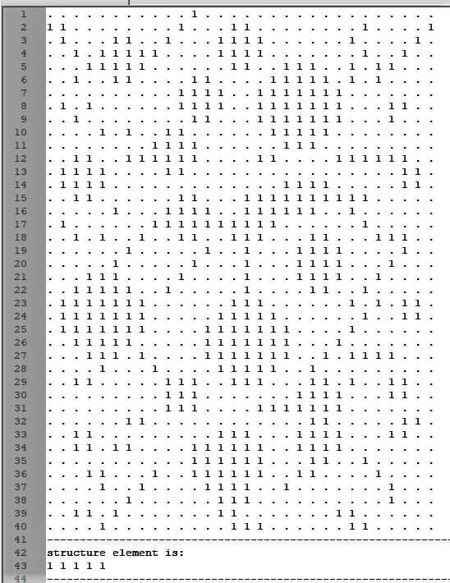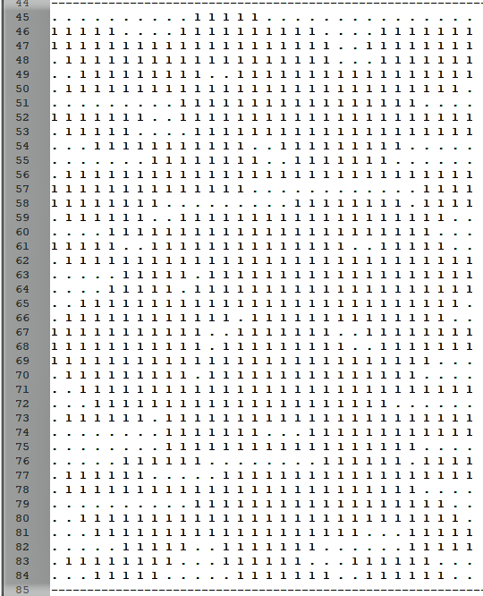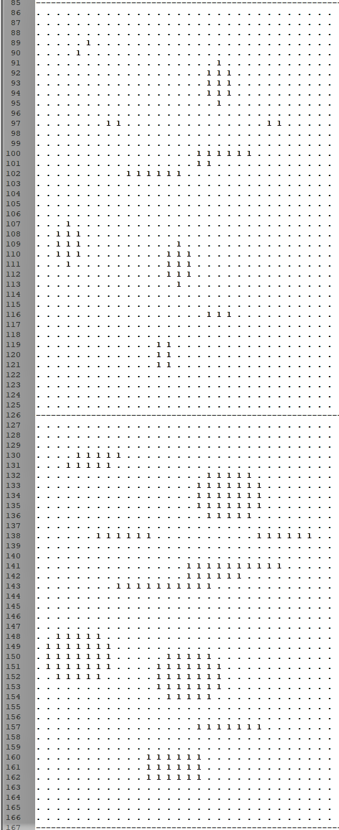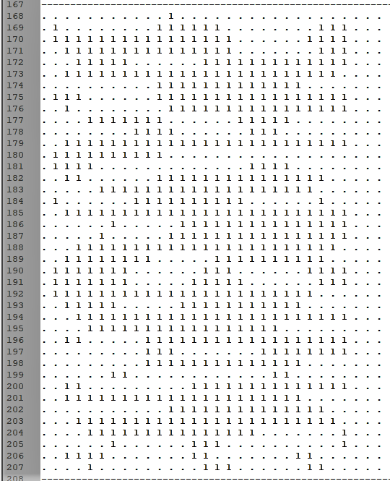

**Test-2: Morphology_Img1.txt and Morphology_StrucElem4.txt**

|  |  |
| --- | --- |
| dilateOutFile | erodeOutFile |
| 40 30 0 1  0 1 1 1 0 0 0 0 0 0 0 1 1 1 1 1 1 1 0 0 0 0 0 0 0 1 1 0 0 0  1 1 1 1 1 0 1 1 1 0 1 1 1 1 1 1 1 1 1 0 0 0 0 0 1 1 1 1 0 1  1 1 1 1 1 1 1 1 1 1 1 1 1 1 1 1 1 1 1 1 0 0 0 1 1 1 1 1 1 1  0 1 1 1 1 1 1 1 1 1 1 1 1 1 1 1 1 1 1 1 1 1 1 1 1 1 1 1 1 1  0 0 1 1 1 1 1 1 1 1 1 1 1 1 1 1 1 1 1 1 1 1 1 1 1 1 1 1 1 1  0 0 1 1 1 1 1 1 1 1 1 1 1 1 1 1 1 1 1 1 1 1 1 1 1 1 1 1 1 1  0 0 1 1 1 1 1 1 1 1 1 1 1 1 1 1 1 1 1 1 1 1 1 1 1 1 1 1 1 1  0 1 1 1 1 1 1 1 1 0 1 1 1 1 1 1 1 1 1 1 1 1 1 1 1 1 1 1 1 1  0 1 1 1 1 1 1 1 1 0 1 1 1 1 1 1 1 1 1 1 1 1 1 1 1 1 1 1 1 1  0 0 1 1 1 1 1 1 1 1 1 1 1 1 1 1 1 1 1 1 1 1 1 1 1 1 1 1 1 1  0 0 0 1 1 1 1 1 1 1 1 1 1 1 1 0 0 1 1 1 1 1 1 1 1 1 1 1 1 1  0 0 1 1 1 1 1 1 1 1 1 1 1 1 1 0 1 1 1 1 1 1 1 1 1 1 1 1 1 1  0 1 1 1 1 1 1 1 1 1 1 1 1 1 1 0 1 1 1 1 1 1 1 1 1 1 1 1 1 1  0 1 1 1 1 1 1 1 1 1 1 1 1 1 0 0 1 1 1 1 1 1 1 1 1 1 1 1 1 1  0 1 1 1 1 1 1 1 0 0 1 1 1 1 1 1 1 1 1 1 1 1 1 1 1 1 1 1 1 1  0 0 1 1 1 1 1 1 1 1 1 1 1 1 1 1 1 1 1 1 1 1 1 1 1 1 1 1 1 1  0 1 1 1 1 1 1 1 1 1 1 1 1 1 1 1 1 1 1 1 1 1 1 1 1 1 1 1 1 1  0 1 1 1 1 1 1 1 1 1 1 1 1 1 1 1 1 1 1 1 1 1 1 1 1 1 1 1 1 1  0 0 1 1 1 1 1 1 1 1 1 1 1 1 1 1 1 1 1 1 1 1 1 1 1 1 1 1 1 1  0 0 0 1 1 1 1 1 1 1 0 1 1 1 1 1 1 1 1 1 1 1 1 1 1 1 1 1 1 1  0 0 0 1 1 1 1 1 1 0 1 1 1 1 1 1 1 1 1 1 1 1 1 1 1 1 1 1 1 1  0 0 1 1 1 1 1 1 1 1 1 1 1 1 0 1 1 1 1 1 1 1 1 1 1 1 1 1 1 1  0 1 1 1 1 1 1 1 1 1 1 1 1 0 1 1 1 1 1 1 1 1 1 1 1 1 1 1 1 1  0 1 1 1 1 1 1 1 1 1 1 1 0 1 1 1 1 1 1 1 1 1 1 1 1 1 1 1 1 1  0 1 1 1 1 1 1 1 1 1 1 0 1 1 1 1 1 1 1 1 1 1 0 1 1 1 1 1 1 1  0 1 1 1 1 1 1 1 1 1 1 0 1 1 1 1 1 1 1 1 1 1 1 1 1 1 1 1 1 1  0 0 1 1 1 1 1 1 1 1 1 0 1 1 1 1 1 1 1 1 1 1 1 1 1 1 1 1 1 1  0 0 0 1 1 1 1 1 1 1 1 1 1 1 1 1 1 1 1 1 1 1 1 1 1 1 1 1 1 1  0 0 1 1 1 1 1 1 1 1 1 1 1 1 1 1 1 1 1 1 1 1 1 1 1 1 1 1 1 1  0 0 1 1 1 1 1 0 0 1 1 1 1 1 1 1 1 1 1 1 1 1 1 1 1 1 1 1 1 1  0 0 0 1 1 1 0 1 1 1 1 1 1 1 1 1 1 1 1 1 1 1 1 1 1 1 1 1 1 1  0 0 0 1 1 1 1 1 1 1 1 1 1 1 1 1 1 1 1 1 1 1 1 1 1 1 0 1 1 1  0 0 1 1 1 1 1 1 1 1 1 1 1 1 1 1 1 1 1 1 1 1 1 1 1 1 1 1 1 1  0 0 1 1 1 1 1 1 1 1 0 1 1 1 1 1 1 1 1 1 1 1 1 1 1 1 1 1 1 1  0 0 1 1 1 1 1 1 1 1 1 1 1 1 1 1 1 1 1 1 1 1 1 1 1 1 1 1 1 1  0 0 0 1 1 1 1 1 1 1 1 1 1 1 1 1 1 1 1 1 1 1 1 1 1 1 1 1 1 0  0 0 0 1 1 1 1 1 1 1 1 1 1 1 1 1 1 1 1 1 1 1 1 1 0 1 1 1 1 1  0 0 0 1 1 1 1 1 1 1 1 0 1 1 1 1 1 1 1 1 1 1 1 1 1 1 1 1 1 1  0 0 1 1 1 1 1 1 1 1 0 0 0 1 1 1 1 1 1 1 1 0 1 1 1 1 1 1 1 1  0 0 1 1 1 1 1 1 1 0 0 0 0 1 1 1 1 1 1 1 0 0 1 1 1 1 1 1 1 0 | 40 30 0 1  0 0 0 0 0 0 0 0 0 0 0 0 0 0 0 0 0 0 0 0 0 0 0 0 0 0 0 0 0 0  0 0 0 0 0 0 0 0 0 0 0 0 0 0 0 0 0 0 0 0 0 0 0 0 0 0 0 0 0 0  0 0 0 0 0 0 0 0 0 0 0 0 0 1 0 0 0 0 0 0 0 0 0 0 0 0 0 0 0 0  0 0 0 0 1 0 0 0 0 0 0 0 0 0 0 0 0 0 0 0 0 0 0 0 0 0 0 0 0 0  0 0 0 0 0 0 0 0 0 0 0 0 0 0 0 0 0 0 0 0 0 0 0 0 0 0 0 0 0 0  0 0 0 0 0 0 0 0 0 0 0 0 0 0 0 0 0 1 1 0 0 0 0 0 0 0 0 0 0 0  0 0 0 0 0 0 0 0 0 0 1 0 0 0 0 0 1 1 1 1 0 0 0 0 0 0 0 0 0 0  0 0 0 0 0 0 0 0 0 0 0 0 0 0 0 0 1 1 1 1 0 0 0 0 0 0 0 0 0 0  0 0 0 0 0 0 0 0 0 0 0 0 0 0 0 0 0 1 1 0 0 0 0 0 0 0 0 0 0 0  0 0 0 0 0 0 0 0 0 0 0 0 0 0 0 0 0 0 0 0 0 0 0 0 0 0 0 0 0 0  0 0 0 0 0 0 0 0 1 0 0 0 0 0 0 0 0 0 0 0 0 0 0 0 0 0 0 0 0 0  0 0 0 0 0 0 0 0 0 0 0 0 0 0 0 0 0 0 0 0 0 0 0 0 0 0 0 0 0 0  0 1 0 0 0 0 0 0 0 0 0 0 0 0 0 0 0 0 0 0 0 0 0 0 0 0 0 0 0 0  0 0 0 0 0 0 0 0 0 0 0 0 0 0 0 0 0 0 0 0 0 0 0 0 0 0 0 0 0 0  0 0 0 0 0 0 0 0 0 0 0 0 0 0 0 0 0 0 0 0 0 0 0 0 0 0 0 0 0 0  0 0 0 0 0 0 0 0 0 1 0 0 0 0 0 0 0 0 0 0 0 0 0 0 0 0 0 0 0 0  0 0 0 0 0 0 0 0 0 0 0 0 0 0 0 0 0 0 0 0 0 0 0 0 0 0 0 0 0 0  0 0 0 0 0 0 0 0 0 0 0 0 0 0 0 0 0 0 0 0 0 0 0 0 0 0 0 0 0 0  0 0 0 0 0 0 0 0 0 0 0 0 0 0 0 0 0 0 0 1 0 0 0 0 0 0 0 0 0 0  0 0 0 0 0 0 0 0 0 0 0 0 0 0 0 0 0 0 0 1 0 0 0 0 0 0 0 0 0 0  0 0 0 0 0 0 0 0 0 0 0 0 0 0 0 0 0 0 0 0 0 0 0 0 0 0 0 0 0 0  0 0 1 1 0 0 0 0 0 0 0 0 0 0 0 0 0 0 0 0 0 0 0 0 0 0 0 0 0 0  0 1 1 1 1 0 0 0 0 0 0 0 0 0 0 0 0 0 0 0 0 0 0 0 0 0 0 0 0 0  0 1 1 1 1 0 0 0 0 0 0 0 0 1 1 0 0 0 0 0 0 0 0 0 0 0 0 0 0 0  0 0 1 1 0 0 0 0 0 0 0 0 1 1 1 1 0 0 0 0 0 0 0 0 0 0 0 0 0 0  0 0 0 0 0 0 0 0 0 0 0 0 1 1 1 1 0 0 0 0 0 0 0 0 0 0 0 0 0 0  0 0 0 0 0 0 0 0 0 0 0 0 0 1 1 0 0 0 0 0 0 0 0 0 0 0 0 0 0 0  0 0 0 0 0 0 0 0 0 0 0 0 0 0 0 0 0 0 0 0 0 0 0 0 0 0 0 0 0 0  0 0 0 0 0 0 0 0 0 0 0 0 0 0 0 0 0 0 0 0 0 0 0 0 0 0 0 0 0 0  0 0 0 0 0 0 0 0 0 0 0 0 0 0 0 0 0 0 0 1 0 0 0 0 0 0 0 0 0 0  0 0 0 0 0 0 0 0 0 0 0 0 0 0 0 0 0 0 0 0 0 0 0 0 0 0 0 0 0 0  0 0 0 0 0 0 0 0 0 0 0 0 0 0 0 0 0 0 0 0 0 0 0 0 0 0 0 0 0 0  0 0 0 0 0 0 0 0 0 0 0 0 0 0 0 0 0 0 0 1 0 0 0 0 0 0 0 0 0 0  0 0 0 0 0 0 0 0 0 0 0 0 1 1 0 0 0 0 0 0 0 0 0 0 0 0 0 0 0 0  0 0 0 0 0 0 0 0 0 0 0 1 1 1 0 0 0 0 0 0 0 0 0 0 0 0 0 0 0 0  0 0 0 0 0 0 0 0 0 0 0 0 1 0 0 0 0 0 0 0 0 0 0 0 0 0 0 0 0 0  0 0 0 0 0 0 0 0 0 0 0 0 0 0 0 0 0 0 0 0 0 0 0 0 0 0 0 0 0 0  0 0 0 0 0 0 0 0 0 0 0 0 0 0 0 0 0 0 0 0 0 0 0 0 0 0 0 0 0 0  0 0 0 0 0 0 0 0 0 0 0 0 0 0 0 0 0 0 0 0 0 0 0 0 0 0 0 0 0 0  0 0 0 0 0 0 0 0 0 0 0 0 0 0 0 0 0 0 0 0 0 0 0 0 0 0 0 0 0 0 |

|  |  |
| --- | --- |
| closingOutFile | openingOutFile |
| 40 30 0 1  0 0 0 0 0 0 0 0 0 0 0 0 0 0 0 0 0 0 0 0 0 0 0 0 0 0 0 0 0 0  1 1 0 0 0 0 0 0 0 0 1 1 1 1 1 1 0 0 0 0 0 0 0 0 1 0 0 0 0 0  0 1 1 0 0 1 1 0 0 1 1 1 1 1 1 1 1 0 0 0 0 0 0 1 1 1 0 0 0 0  0 0 1 1 1 1 1 1 1 1 1 1 1 1 1 1 1 1 0 0 0 0 1 1 1 1 1 0 0 0  0 0 1 1 1 1 1 1 1 1 1 1 1 1 1 1 1 1 1 1 1 1 1 1 1 1 1 0 0 0  0 0 1 1 1 1 1 0 0 1 1 1 1 1 1 1 1 1 1 1 1 1 1 1 1 1 1 0 0 0  0 0 1 1 1 1 0 0 0 0 1 1 1 1 1 1 1 1 1 1 1 1 1 1 1 1 1 0 0 0  0 1 1 1 1 1 0 0 0 0 1 1 1 1 1 1 1 1 1 1 1 1 1 1 1 1 1 0 0 0  0 0 1 1 1 1 0 0 0 0 1 1 1 0 0 0 1 1 1 1 1 1 1 1 1 1 1 0 0 0  0 0 0 1 1 1 1 0 0 1 1 1 0 0 0 0 0 1 1 1 1 1 1 1 1 1 1 0 0 0  0 0 0 1 1 1 1 1 1 1 1 1 0 0 0 0 0 1 1 1 1 1 1 1 1 1 1 0 0 0  0 0 1 1 1 1 1 1 1 1 1 1 0 0 0 0 1 1 1 1 1 1 1 1 1 1 1 0 0 0  0 1 1 1 1 1 0 0 0 1 1 0 0 0 0 0 1 1 1 1 1 1 1 1 1 1 1 0 0 0  0 1 1 1 1 0 0 0 0 0 1 0 0 0 0 0 1 1 1 1 1 1 1 1 1 1 1 0 0 0  0 0 1 1 1 0 0 0 0 0 1 1 0 0 0 1 1 1 1 1 1 1 1 1 1 1 1 0 0 0  0 0 1 1 1 1 0 0 0 1 1 1 1 1 1 1 1 1 1 1 1 1 1 1 1 1 1 0 0 0  0 1 1 1 1 1 1 1 1 1 1 1 1 1 1 1 1 1 1 1 1 1 1 1 1 1 1 0 0 0  0 0 1 1 1 1 1 1 0 0 1 1 1 1 1 1 1 1 1 1 1 1 1 1 1 1 1 0 0 0  0 0 0 1 1 1 1 0 0 0 0 1 1 1 1 1 1 1 1 1 1 1 1 1 1 1 1 0 0 0  0 0 0 1 1 1 0 0 0 0 0 1 0 0 1 1 1 1 1 1 1 1 1 1 1 1 1 0 0 0  0 0 0 1 1 1 0 0 0 0 1 0 0 0 0 1 1 1 1 1 1 1 1 1 1 1 1 0 0 0  0 0 1 1 1 1 1 0 0 1 0 0 0 0 0 1 1 1 1 1 1 1 1 1 1 1 1 0 0 0  0 1 1 1 1 1 1 1 1 0 0 0 0 0 1 1 1 1 1 1 0 0 1 1 1 1 1 0 0 0  0 1 1 1 1 1 1 1 0 0 0 0 0 1 1 1 1 1 1 0 0 0 0 1 1 1 1 0 0 0  0 1 1 1 1 1 1 1 0 0 0 0 1 1 1 1 1 1 1 0 0 0 0 1 1 1 1 0 0 0  0 0 1 1 1 1 1 1 0 0 0 0 1 1 1 1 1 1 1 1 0 0 1 1 1 1 1 0 0 0  0 0 0 1 1 1 1 1 0 0 0 0 1 1 1 1 1 1 1 1 1 1 1 1 1 1 1 0 0 0  0 0 0 1 1 0 0 0 1 0 0 1 1 1 1 1 1 1 1 1 1 1 1 1 1 1 1 0 0 0  0 0 1 1 0 0 0 0 0 1 1 1 1 1 1 1 1 1 1 1 1 1 1 1 1 1 1 0 0 0  0 0 0 0 0 0 0 0 0 1 1 1 1 1 1 1 1 1 1 1 1 1 1 1 0 0 1 0 0 0  0 0 0 0 0 0 0 0 1 1 1 1 1 1 1 1 1 1 1 1 1 1 1 0 0 0 0 0 0 0  0 0 0 1 0 0 1 1 0 0 1 1 1 1 1 1 1 1 1 1 1 1 1 0 0 0 0 0 0 0  0 0 1 1 1 1 1 0 0 0 0 1 1 1 1 1 1 1 1 1 1 1 1 1 0 0 1 0 0 0  0 0 1 1 1 1 1 0 0 0 0 1 1 1 1 1 1 1 1 1 1 1 1 1 1 1 1 0 0 0  0 0 0 1 1 1 1 1 0 0 1 1 1 1 1 1 1 1 1 1 1 1 0 0 1 1 0 0 0 0  0 0 0 1 1 1 1 1 1 0 0 1 1 1 1 1 1 1 1 1 1 0 0 0 0 1 0 0 0 0  0 0 0 1 1 1 1 1 0 0 0 0 1 1 1 1 1 1 1 0 0 0 0 0 0 1 1 0 0 0  0 0 0 1 1 1 1 0 0 0 0 0 0 1 1 1 1 1 0 0 0 0 0 0 1 1 1 0 0 0  0 0 0 0 0 0 0 0 0 0 0 0 0 0 0 0 0 0 0 0 0 0 0 0 0 0 0 0 0 0  0 0 0 0 0 0 0 0 0 0 0 0 0 0 0 0 0 0 0 0 0 0 0 0 0 0 0 0 0 0 | 40 30 0 1  0 0 0 0 0 0 0 0 0 0 0 0 0 0 0 0 0 0 0 0 0 0 0 0 0 0 0 0 0 0  0 0 0 0 0 0 0 0 0 0 0 0 0 0 1 1 0 0 0 0 0 0 0 0 0 0 0 0 0 0  0 0 0 0 0 1 1 0 0 0 0 0 0 1 1 1 1 0 0 0 0 0 0 0 0 0 0 0 0 0  0 0 0 0 1 1 1 1 0 0 0 0 0 1 1 1 1 0 0 0 0 0 0 0 0 0 0 0 0 0  0 0 0 0 1 1 1 1 0 0 0 0 0 0 1 1 0 0 1 1 1 0 0 0 0 0 0 0 0 0  0 0 0 0 0 1 1 0 0 0 0 1 1 0 0 0 0 1 1 1 1 1 0 0 0 0 0 0 0 0  0 0 0 0 0 0 0 0 0 0 1 1 1 1 0 0 1 1 1 1 1 1 1 0 0 0 0 0 0 0  0 0 0 0 0 0 0 0 0 0 1 1 1 1 0 0 1 1 1 1 1 1 1 0 0 0 0 0 0 0  0 0 0 0 0 0 0 0 0 0 0 1 1 0 0 0 1 1 1 1 1 1 1 0 0 0 0 0 0 0  0 0 0 0 0 0 0 0 0 1 1 0 0 0 0 0 0 1 1 1 1 1 0 0 0 0 0 0 0 0  0 0 0 0 0 0 0 0 1 1 1 1 0 0 0 0 0 0 1 1 1 0 0 0 0 0 0 0 0 0  0 0 1 1 0 0 0 0 1 1 1 1 0 0 0 0 0 0 0 0 0 0 0 0 0 0 0 0 0 0  0 1 1 1 1 0 0 0 0 1 1 0 0 0 0 0 0 0 0 0 0 0 0 0 0 0 0 0 0 0  0 1 1 1 1 0 0 0 0 0 0 0 0 0 0 0 0 0 0 0 0 0 0 0 0 0 0 0 0 0  0 0 1 1 0 0 0 0 0 0 1 1 0 0 0 0 0 0 0 0 0 0 0 0 0 0 0 0 0 0  0 0 0 0 0 0 0 0 0 1 1 1 1 0 0 0 0 0 0 0 0 0 0 0 0 0 0 0 0 0  0 0 0 0 0 0 0 0 0 1 1 1 1 0 0 0 0 0 0 0 0 0 0 0 0 0 0 0 0 0  0 0 0 0 0 0 0 0 0 0 1 1 0 0 0 0 0 0 0 0 1 1 0 0 0 0 0 0 0 0  0 0 0 0 0 0 0 0 0 0 0 0 0 0 0 0 0 0 0 1 1 1 1 0 0 0 0 0 0 0  0 0 0 0 0 0 0 0 0 0 0 0 0 0 0 0 0 0 0 1 1 1 1 0 0 0 0 0 0 0  0 0 0 1 1 1 0 0 0 0 0 0 0 0 0 0 0 0 0 1 1 1 1 0 0 0 0 0 0 0  0 0 1 1 1 1 1 0 0 0 0 0 0 0 0 0 0 0 0 0 1 1 0 0 0 0 0 0 0 0  0 1 1 1 1 1 1 1 0 0 0 0 0 0 1 1 1 0 0 0 0 0 0 0 0 0 0 0 0 0  0 1 1 1 1 1 1 1 0 0 0 0 0 1 1 1 1 1 0 0 0 0 0 0 0 0 0 0 0 0  0 1 1 1 1 1 1 1 0 0 0 0 1 1 1 1 1 1 1 0 0 0 0 0 0 0 0 0 0 0  0 0 1 1 1 1 1 0 0 0 0 0 1 1 1 1 1 1 1 0 0 0 0 0 0 0 0 0 0 0  0 0 0 1 1 1 0 0 0 0 0 0 1 1 1 1 1 1 1 0 0 0 0 0 0 0 0 0 0 0  0 0 0 0 0 0 0 0 0 0 0 0 0 1 1 1 1 1 0 0 0 0 0 0 0 0 0 0 0 0  0 0 0 0 0 0 0 0 0 0 0 0 0 0 1 1 1 0 0 0 1 1 0 0 0 0 0 0 0 0  0 0 0 0 0 0 0 0 0 0 0 0 0 0 0 0 0 0 0 1 1 1 1 0 0 0 0 0 0 0  0 0 0 0 0 0 0 0 0 0 0 0 0 0 0 0 0 0 0 1 1 1 1 0 0 0 0 0 0 0  0 0 0 0 0 0 0 0 0 0 0 0 0 0 0 0 0 0 0 0 1 1 0 0 0 0 0 0 0 0  0 0 0 0 0 0 0 0 0 0 0 0 0 1 1 1 0 0 0 1 1 1 1 0 0 0 0 0 0 0  0 0 0 0 0 0 0 0 0 0 0 0 1 1 1 1 1 0 0 1 1 1 1 0 0 0 0 0 0 0  0 0 0 0 0 0 0 0 0 0 0 1 1 1 1 1 1 0 0 0 1 1 0 0 0 0 0 0 0 0  0 0 0 0 0 0 0 0 0 0 0 1 1 1 1 1 1 0 0 0 0 0 0 0 0 0 0 0 0 0  0 0 0 0 0 0 0 0 0 0 0 0 1 1 1 1 0 0 0 0 0 0 0 0 0 0 0 0 0 0  0 0 0 0 0 0 0 0 0 0 0 0 0 1 1 0 0 0 0 0 0 0 0 0 0 0 0 0 0 0  0 0 0 0 0 0 0 0 0 0 0 0 0 0 0 0 0 0 0 0 0 0 0 0 0 0 0 0 0 0  0 0 0 0 0 0 0 0 0 0 0 0 0 0 0 0 0 0 0 0 0 0 0 0 0 0 0 0 0 0 |

**Test-2: Morphology_Img1.txt and Morphology_StrucElem4.txt**

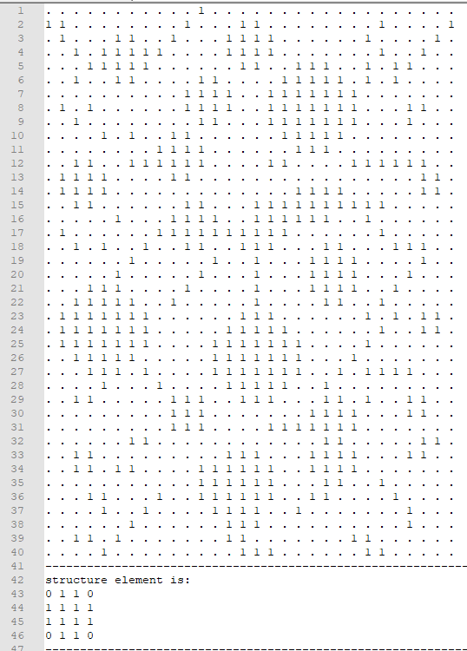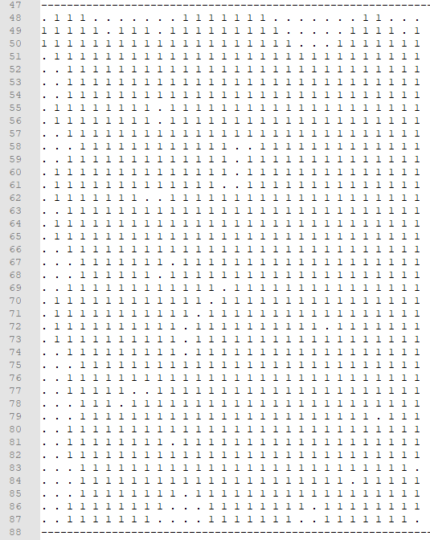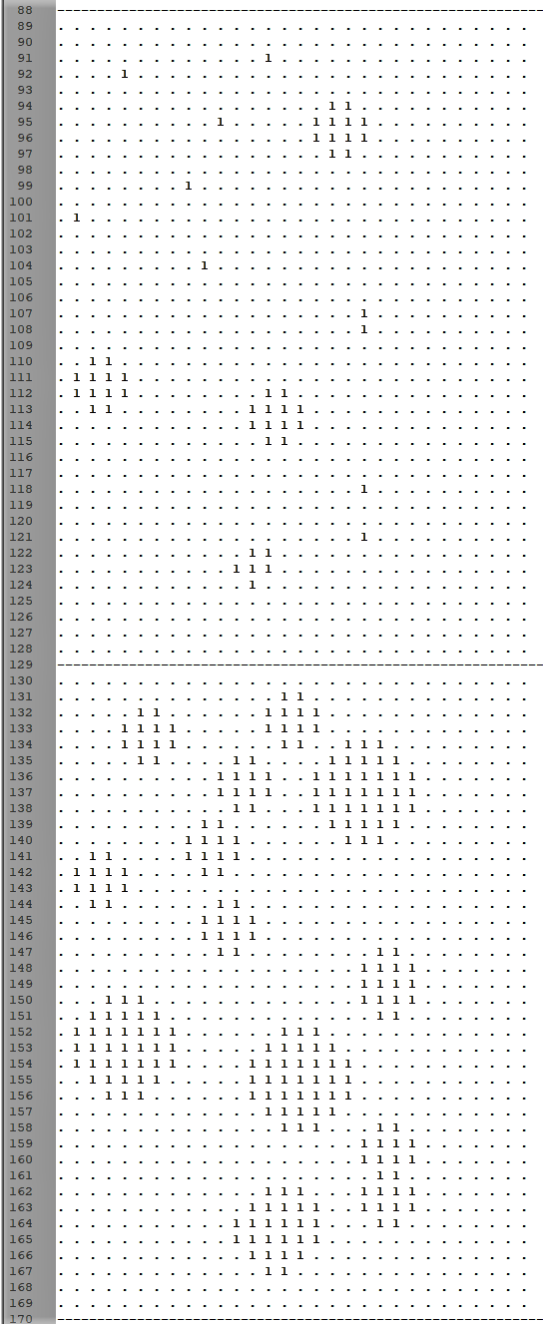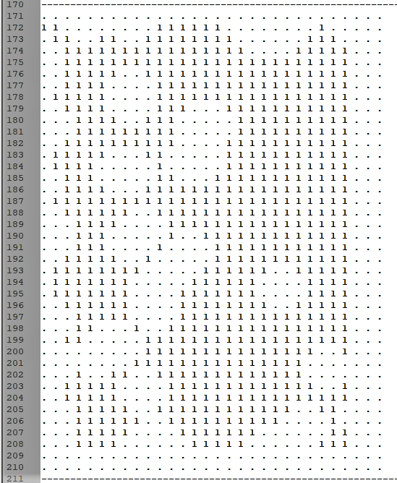

**Test-3: Morphology_Img2.txt and Morphology_StrucElem3.txt**

|  |  |
| --- | --- |
| dilateOutFile | erodeOutFile |
| 40 31 0 1  0 0 0 0 0 0 0 0 0 0 0 0 0 0 1 1 1 1 1 0 0 0 0 0 0 0 0 0 0 0 0  0 0 0 0 0 0 0 0 0 0 0 0 0 0 1 1 1 1 1 0 0 0 0 0 0 0 0 0 1 1 1  0 0 0 1 1 1 1 1 1 0 0 0 1 1 1 1 1 1 1 1 1 0 0 0 0 0 0 1 1 1 1  1 1 1 1 1 1 1 1 1 0 0 1 1 1 1 1 1 1 1 1 1 1 0 0 0 0 0 0 0 0 0  1 1 1 1 1 1 0 0 0 0 1 1 1 1 1 1 1 1 1 1 1 1 1 0 0 0 0 0 0 0 0  0 0 0 0 0 0 0 0 0 1 1 1 1 1 1 1 1 1 1 1 1 1 1 1 0 0 0 0 0 0 0  0 0 0 0 0 0 0 0 1 1 1 1 1 1 1 1 1 1 1 1 1 1 1 1 1 0 0 0 0 0 0  1 1 1 1 1 0 0 1 1 1 1 1 1 1 1 1 1 1 1 1 1 1 1 1 1 1 0 0 0 0 0  0 0 0 0 0 0 0 1 1 1 1 1 1 1 1 1 1 1 1 1 1 1 1 1 1 1 0 0 0 0 0  0 0 0 0 0 0 0 1 1 1 1 1 1 1 1 1 1 1 1 1 1 1 1 1 1 1 0 0 0 0 0  1 1 1 1 1 1 1 1 1 1 1 1 1 1 1 1 1 1 1 1 1 1 1 1 1 1 1 1 1 1 1  0 0 0 0 0 0 0 1 1 1 1 1 1 1 1 1 1 1 1 1 1 1 1 1 1 1 0 0 0 0 0  0 0 0 0 0 0 0 0 1 1 1 1 1 1 1 1 1 1 1 1 1 1 1 1 1 0 0 0 0 0 0  0 0 0 0 0 0 0 0 0 1 1 1 1 1 1 1 1 1 1 1 1 1 1 1 1 1 0 0 0 0 0  0 0 0 0 0 0 0 0 1 1 1 1 1 1 1 1 1 1 1 1 1 1 1 1 1 1 1 0 0 0 0  0 0 0 0 0 0 0 1 1 1 1 1 1 1 1 1 1 1 1 1 1 1 0 1 1 1 1 1 1 1 1  0 0 0 0 0 0 1 1 1 1 1 0 1 1 1 1 1 1 1 1 1 0 0 0 1 1 1 1 1 0 0  0 0 0 0 0 1 1 1 1 1 0 0 0 0 1 1 1 1 1 0 0 0 0 0 0 0 0 0 0 0 0  0 0 0 0 0 0 0 0 0 0 0 0 0 0 1 1 1 1 1 0 0 0 1 1 1 1 1 1 0 0 0  0 0 1 1 1 1 1 0 0 0 0 0 0 0 1 1 1 1 1 0 1 1 1 1 1 1 0 0 0 0 0  1 1 1 1 1 1 1 0 0 0 0 1 1 1 1 1 1 1 1 1 0 0 0 0 0 0 0 0 0 0 0  0 1 1 1 1 1 1 1 0 0 0 0 0 0 1 1 1 1 1 0 0 0 0 0 1 1 1 1 1 0 0  0 0 1 1 1 1 1 0 0 0 0 0 0 1 1 1 1 1 1 1 0 0 0 1 1 1 1 1 0 0 0  0 0 0 0 0 0 0 0 0 0 0 0 1 1 1 1 1 1 1 1 1 0 1 1 1 1 1 0 0 0 0  0 0 0 0 0 1 1 1 1 1 0 1 1 1 1 1 1 1 1 1 1 1 1 1 1 1 0 0 0 0 0  0 0 0 0 1 1 1 1 1 1 1 1 1 1 1 1 1 1 1 1 1 1 1 1 1 0 0 1 1 1 1  0 0 0 1 1 1 1 1 1 1 1 1 1 1 1 1 1 1 1 1 1 1 1 1 0 0 0 0 0 0 0  0 0 1 1 1 1 1 0 1 1 1 1 1 1 1 1 1 1 1 1 1 1 1 1 1 1 1 1 1 1 1  0 0 0 0 0 0 0 1 1 1 1 1 1 1 1 1 1 1 1 1 1 1 1 1 1 1 1 1 1 0 0  0 0 0 0 0 0 0 1 1 1 1 1 1 1 1 1 1 1 1 1 1 1 1 1 1 1 1 1 1 0 0  0 0 0 0 0 0 0 1 1 1 1 1 1 1 1 1 1 1 1 1 1 1 1 1 1 1 1 1 1 0 0  0 0 0 0 0 0 0 1 1 1 1 1 1 1 1 1 1 1 1 1 1 1 1 1 1 1 1 1 1 0 0  0 0 0 0 0 0 0 1 1 1 1 1 1 1 1 1 1 1 1 1 1 1 1 1 1 1 0 0 0 0 0  0 0 0 0 0 0 0 0 1 1 1 1 1 1 1 1 1 1 1 1 1 1 1 1 1 1 1 1 0 0 0  0 0 0 0 0 0 0 1 1 1 1 1 1 1 1 1 1 1 1 1 1 1 1 1 1 1 1 1 1 0 0  0 0 0 0 0 0 1 1 1 1 1 1 1 1 1 1 1 1 1 1 1 1 0 0 1 1 1 1 1 1 0  0 0 0 0 0 1 1 1 1 1 0 0 1 1 1 1 1 1 1 1 1 0 0 0 1 1 1 1 1 0 0  0 0 0 0 1 1 1 1 1 0 0 0 0 1 1 1 1 1 1 1 0 0 0 0 0 0 0 0 0 0 0  0 0 0 1 1 1 1 1 0 0 0 0 0 1 1 1 1 1 1 1 0 0 0 0 0 0 0 0 0 0 0  1 1 1 1 1 1 0 0 0 0 0 0 0 0 1 1 1 1 1 0 0 0 1 1 1 1 1 1 1 0 0 | 40 31 0 1  0 0 0 0 0 0 0 0 0 0 0 0 0 0 0 0 0 0 0 0 0 0 0 0 0 0 0 0 0 0 0  0 0 0 0 0 0 0 0 0 0 0 0 0 0 0 0 0 0 0 0 0 0 0 0 0 0 0 0 0 0 0  0 0 0 0 0 0 0 0 0 0 0 0 0 0 1 0 0 0 0 0 0 0 0 0 0 0 0 0 0 0 0  0 0 0 0 0 0 0 0 0 0 0 0 0 1 1 1 0 0 0 0 0 0 0 0 0 0 0 0 0 0 0  0 0 0 0 0 0 0 0 0 0 0 0 1 1 1 1 1 0 0 0 0 0 0 0 0 0 0 0 0 0 0  0 0 0 0 0 0 0 0 0 0 0 1 0 0 0 0 0 0 0 0 0 0 0 0 0 0 0 0 0 0 0  0 0 0 0 0 0 0 0 0 0 1 1 1 1 1 1 1 1 1 0 0 0 0 0 0 0 0 0 0 0 0  0 0 0 0 0 0 0 0 0 0 0 0 0 0 0 1 1 1 1 1 0 0 0 0 0 0 0 0 0 0 0  0 0 0 0 0 0 0 0 0 1 1 1 1 0 0 0 0 0 1 1 0 0 0 0 0 0 0 0 0 0 0  0 0 0 0 0 0 0 0 0 1 1 1 1 1 1 1 0 0 0 0 0 0 0 0 0 0 0 0 0 0 0  0 0 1 1 1 1 1 1 0 0 0 0 0 0 1 1 1 1 1 1 1 1 1 1 1 1 0 0 0 0 0  0 0 0 0 0 0 0 0 0 1 1 0 0 0 0 0 0 0 0 0 0 0 0 0 0 0 0 0 0 0 0  0 0 0 0 0 0 0 0 0 0 1 0 0 0 0 0 1 1 1 0 0 0 0 0 0 0 0 0 0 0 0  0 0 0 0 0 0 0 0 0 0 0 1 1 1 1 1 1 1 0 0 0 0 0 0 0 0 0 0 0 0 0  0 0 0 0 0 0 0 0 0 0 0 0 1 1 1 1 1 0 0 0 0 0 0 0 0 0 0 0 0 0 0  0 0 0 0 0 0 0 0 0 0 0 0 0 1 1 1 0 0 0 0 0 0 0 0 0 0 0 0 0 0 0  0 0 0 0 0 0 0 0 0 0 0 0 0 0 1 0 0 0 0 0 0 0 0 0 0 0 0 0 0 0 0  0 0 0 0 0 0 0 0 0 0 0 0 0 0 0 0 0 0 0 0 0 0 0 0 0 0 0 0 0 0 0  0 0 0 0 0 0 0 0 0 0 0 0 0 0 0 0 0 0 0 0 0 0 0 0 0 0 0 0 0 0 0  0 0 0 0 0 0 0 0 0 0 0 0 0 0 0 0 0 0 0 0 0 0 0 0 0 0 0 0 0 0 0  0 0 0 0 0 0 0 0 0 0 0 0 0 0 0 0 0 0 0 0 0 0 0 0 0 0 0 0 0 0 0  0 0 0 0 0 0 0 0 0 0 0 0 0 0 0 0 0 0 0 0 0 0 0 0 0 0 0 0 0 0 0  0 0 0 0 0 0 0 0 0 0 0 0 0 0 0 0 0 0 0 0 0 0 0 0 0 0 0 0 0 0 0  0 0 0 0 0 0 0 0 0 0 0 0 0 0 1 0 0 0 0 0 0 0 0 0 0 0 0 0 0 0 0  0 0 0 0 0 0 0 0 0 0 0 0 0 1 1 1 0 0 0 0 0 0 0 0 0 0 0 0 0 0 0  0 0 0 0 0 0 0 0 0 0 0 0 1 0 0 0 0 0 0 0 0 0 0 0 0 0 0 0 0 0 0  0 0 0 0 0 0 0 0 0 0 0 1 1 1 1 1 1 1 0 0 0 0 0 0 0 0 0 0 0 0 0  0 0 0 0 0 0 0 0 0 0 0 0 0 0 0 1 1 1 1 0 0 0 0 0 0 0 0 0 0 0 0  0 0 0 0 0 0 0 0 0 1 1 1 1 0 0 0 0 0 0 1 0 0 0 0 0 0 0 0 0 0 0  0 0 0 0 0 0 0 0 0 1 1 1 1 0 0 0 0 0 1 1 0 0 0 0 0 0 0 0 0 0 0  0 0 0 0 0 0 0 0 0 1 1 1 1 1 1 1 1 1 1 1 0 0 0 0 0 0 0 0 0 0 0  0 0 0 0 0 0 0 0 0 0 0 0 0 0 1 1 1 1 1 1 0 0 0 0 0 0 0 0 0 0 0  0 0 0 0 0 0 0 0 0 0 0 0 0 0 1 1 1 1 1 1 0 0 0 0 0 0 0 0 0 0 0  0 0 0 0 0 0 0 0 0 0 1 1 0 0 0 0 0 0 1 1 1 1 0 0 0 0 0 0 0 0 0  0 0 0 0 0 0 0 0 0 0 0 1 1 1 1 1 1 1 0 0 0 0 0 0 0 0 0 0 0 0 0  0 0 0 0 0 0 0 0 0 0 0 0 0 1 1 1 0 0 0 0 0 0 0 0 0 0 0 0 0 0 0  0 0 0 0 0 0 0 0 0 0 0 0 0 0 1 0 0 0 0 0 0 0 0 0 0 0 0 0 0 0 0  0 0 0 0 0 0 0 0 0 0 0 0 0 0 0 0 0 0 0 0 0 0 0 0 0 0 0 0 0 0 0  0 0 0 0 0 0 0 0 0 0 0 0 0 0 0 0 0 0 0 0 0 0 0 0 0 0 0 0 0 0 0  0 0 0 0 0 0 0 0 0 0 0 0 0 0 0 0 0 0 0 0 0 0 0 0 0 0 0 0 0 0 0 |

|  |  |
| --- | --- |
| closingOutFile | openingOutFile |
| 40 31 0 1  0 0 0 0 0 0 0 0 0 0 0 0 0 0 0 1 0 0 0 0 0 0 0 0 0 0 0 0 0 0 0  0 0 0 0 0 0 0 0 0 0 0 0 0 0 0 1 0 0 0 0 0 0 0 0 0 0 0 0 0 0 0  0 0 0 0 1 1 0 0 0 0 0 0 0 1 1 1 1 1 0 0 0 0 0 0 0 0 0 0 0 0 0  0 1 1 1 1 1 0 0 0 0 0 0 1 1 1 1 1 1 1 0 0 0 0 0 0 0 0 0 0 0 0  0 1 1 0 0 0 0 0 0 0 0 1 1 1 1 1 1 1 1 1 0 0 0 0 0 0 0 0 0 0 0  0 0 0 0 0 0 0 0 0 0 1 1 1 1 1 1 1 1 1 1 1 0 0 0 0 0 0 0 0 0 0  0 0 0 0 0 0 0 0 0 1 1 1 1 1 1 1 1 1 1 1 1 1 0 0 0 0 0 0 0 0 0  0 1 0 0 0 0 0 0 1 1 1 1 1 1 1 1 1 1 1 1 1 1 1 0 0 0 0 0 0 0 0  0 0 0 0 0 0 0 0 1 1 1 1 1 1 1 1 1 1 1 1 1 1 1 0 0 0 0 0 0 0 0  0 0 0 0 0 0 0 0 1 1 1 1 1 1 1 1 1 1 1 1 1 1 1 0 0 0 0 0 0 0 0  0 1 1 1 1 1 1 1 1 1 1 1 1 1 1 1 1 1 1 1 1 1 1 1 1 1 1 1 0 0 0  0 0 0 0 0 0 0 0 1 1 1 1 1 1 1 1 1 1 1 1 1 1 1 0 0 0 0 0 0 0 0  0 0 0 0 0 0 0 0 0 1 1 1 1 1 1 1 1 1 1 1 1 1 0 0 0 0 0 0 0 0 0  0 0 0 0 0 0 0 0 0 0 1 1 1 1 1 1 1 1 1 1 1 1 1 0 0 0 0 0 0 0 0  0 0 0 0 0 0 0 0 0 1 1 1 1 1 1 1 1 1 1 1 1 1 1 1 0 0 0 0 0 0 0  0 0 0 0 0 0 0 0 1 1 1 1 1 1 1 1 1 1 1 0 0 0 0 0 1 1 1 1 0 0 0  0 0 0 0 0 0 0 1 0 0 0 0 0 1 1 1 1 1 0 0 0 0 0 0 0 1 0 0 0 0 0  0 0 0 0 0 0 1 0 0 0 0 0 0 0 0 1 0 0 0 0 0 0 0 0 0 0 0 0 0 0 0  0 0 0 0 0 0 0 0 0 0 0 0 0 0 0 1 0 0 0 0 0 0 0 1 1 0 0 0 0 0 0  0 0 0 1 0 0 0 0 0 0 0 0 0 0 0 1 0 0 0 0 0 1 1 0 0 0 0 0 0 0 0  0 1 1 1 0 0 0 0 0 0 0 0 1 1 1 1 1 0 0 0 0 0 0 0 0 0 0 0 0 0 0  0 0 1 1 1 0 0 0 0 0 0 0 0 0 0 1 0 0 0 0 0 0 0 0 0 1 0 0 0 0 0  0 0 0 1 0 0 0 0 0 0 0 0 0 0 1 1 1 0 0 0 0 0 0 0 1 0 0 0 0 0 0  0 0 0 0 0 0 0 0 0 0 0 0 0 1 1 1 1 1 0 0 0 0 0 1 0 0 0 0 0 0 0  0 0 0 0 0 0 1 0 0 0 0 0 1 1 1 1 1 1 1 1 1 1 1 0 0 0 0 0 0 0 0  0 0 0 0 0 1 1 1 1 1 1 1 1 1 1 1 1 1 1 1 1 1 0 0 0 0 0 0 0 0 0  0 0 0 0 1 1 1 1 1 1 1 1 1 1 1 1 1 1 1 1 1 0 0 0 0 0 0 0 0 0 0  0 0 0 1 0 0 0 0 0 1 1 1 1 1 1 1 1 1 1 1 1 1 1 1 1 1 1 1 0 0 0  0 0 0 0 0 0 0 0 1 1 1 1 1 1 1 1 1 1 1 1 1 1 1 1 1 1 0 0 0 0 0  0 0 0 0 0 0 0 0 1 1 1 1 1 1 1 1 1 1 1 1 1 1 1 1 1 1 0 0 0 0 0  0 0 0 0 0 0 0 0 1 1 1 1 1 1 1 1 1 1 1 1 1 1 1 1 1 1 0 0 0 0 0  0 0 0 0 0 0 0 0 1 1 1 1 1 1 1 1 1 1 1 1 1 1 1 1 1 1 0 0 0 0 0  0 0 0 0 0 0 0 0 1 1 1 1 1 1 1 1 1 1 1 1 1 1 1 0 0 0 0 0 0 0 0  0 0 0 0 0 0 0 0 0 1 1 1 1 1 1 1 1 1 1 1 1 1 1 1 1 0 0 0 0 0 0  0 0 0 0 0 0 0 0 1 1 1 1 1 1 1 1 1 1 1 1 1 1 1 1 1 1 0 0 0 0 0  0 0 0 0 0 0 0 1 1 1 1 1 1 1 1 1 1 1 1 0 0 0 0 0 0 1 1 0 0 0 0  0 0 0 0 0 0 1 0 0 0 0 0 0 1 1 1 1 1 0 0 0 0 0 0 0 1 0 0 0 0 0  0 0 0 0 0 1 0 0 0 0 0 0 0 0 1 1 1 0 0 0 0 0 0 0 0 0 0 0 0 0 0  0 0 0 0 1 0 0 0 0 0 0 0 0 0 1 1 1 0 0 0 0 0 0 0 0 0 0 0 0 0 0  0 1 1 0 0 0 0 0 0 0 0 0 0 0 0 1 0 0 0 0 0 0 0 1 1 1 0 0 0 0 0 | 40 31 0 1  0 0 0 0 0 0 0 0 0 0 0 0 0 0 0 0 0 0 0 0 0 0 0 0 0 0 0 0 0 0 0  0 0 0 0 0 0 0 0 0 0 0 0 0 0 0 0 0 0 0 0 0 0 0 0 0 0 0 0 0 0 0  0 0 0 0 0 0 0 0 0 0 0 0 0 1 1 1 1 1 0 0 0 0 0 0 0 0 0 0 0 0 0  0 0 0 0 0 0 0 0 0 0 0 0 1 1 1 1 1 1 1 0 0 0 0 0 0 0 0 0 0 0 0  0 0 0 0 0 0 0 0 0 0 0 1 1 1 1 1 1 1 1 1 0 0 0 0 0 0 0 0 0 0 0  0 0 0 0 0 0 0 0 0 0 1 1 1 1 1 0 0 0 0 0 0 0 0 0 0 0 0 0 0 0 0  0 0 0 0 0 0 0 0 0 1 1 1 1 1 1 1 1 1 1 1 1 1 0 0 0 0 0 0 0 0 0  0 0 0 0 0 0 0 0 0 0 0 0 0 0 1 1 1 1 1 1 1 1 1 0 0 0 0 0 0 0 0  0 0 0 0 0 0 0 0 1 1 1 1 1 1 1 1 0 1 1 1 1 1 1 0 0 0 0 0 0 0 0  0 0 0 0 0 0 0 0 1 1 1 1 1 1 1 1 1 1 1 0 0 0 0 0 0 0 0 0 0 0 0  0 1 1 1 1 1 1 1 1 1 1 0 0 1 1 1 1 1 1 1 1 1 1 1 1 1 1 1 1 0 0  0 0 0 0 0 0 0 0 1 1 1 1 1 1 0 0 0 0 0 0 0 0 0 0 0 0 0 0 0 0 0  0 0 0 0 0 0 0 0 0 1 1 1 1 1 0 1 1 1 1 1 1 1 0 0 0 0 0 0 0 0 0  0 0 0 0 0 0 0 0 0 0 1 1 1 1 1 1 1 1 1 1 1 0 0 0 0 0 0 0 0 0 0  0 0 0 0 0 0 0 0 0 0 0 1 1 1 1 1 1 1 1 1 0 0 0 0 0 0 0 0 0 0 0  0 0 0 0 0 0 0 0 0 0 0 0 1 1 1 1 1 1 1 0 0 0 0 0 0 0 0 0 0 0 0  0 0 0 0 0 0 0 0 0 0 0 0 0 1 1 1 1 1 0 0 0 0 0 0 0 0 0 0 0 0 0  0 0 0 0 0 0 0 0 0 0 0 0 0 0 0 0 0 0 0 0 0 0 0 0 0 0 0 0 0 0 0  0 0 0 0 0 0 0 0 0 0 0 0 0 0 0 0 0 0 0 0 0 0 0 0 0 0 0 0 0 0 0  0 0 0 0 0 0 0 0 0 0 0 0 0 0 0 0 0 0 0 0 0 0 0 0 0 0 0 0 0 0 0  0 0 0 0 0 0 0 0 0 0 0 0 0 0 0 0 0 0 0 0 0 0 0 0 0 0 0 0 0 0 0  0 0 0 0 0 0 0 0 0 0 0 0 0 0 0 0 0 0 0 0 0 0 0 0 0 0 0 0 0 0 0  0 0 0 0 0 0 0 0 0 0 0 0 0 0 0 0 0 0 0 0 0 0 0 0 0 0 0 0 0 0 0  0 0 0 0 0 0 0 0 0 0 0 0 0 1 1 1 1 1 0 0 0 0 0 0 0 0 0 0 0 0 0  0 0 0 0 0 0 0 0 0 0 0 0 1 1 1 1 1 1 1 0 0 0 0 0 0 0 0 0 0 0 0  0 0 0 0 0 0 0 0 0 0 0 1 1 1 1 1 0 0 0 0 0 0 0 0 0 0 0 0 0 0 0  0 0 0 0 0 0 0 0 0 0 1 1 1 1 1 1 1 1 1 1 1 0 0 0 0 0 0 0 0 0 0  0 0 0 0 0 0 0 0 0 0 0 0 0 0 1 1 1 1 1 1 1 1 0 0 0 0 0 0 0 0 0  0 0 0 0 0 0 0 0 1 1 1 1 1 1 1 1 0 0 1 1 1 1 1 0 0 0 0 0 0 0 0  0 0 0 0 0 0 0 0 1 1 1 1 1 1 1 1 0 1 1 1 1 1 1 0 0 0 0 0 0 0 0  0 0 0 0 0 0 0 0 1 1 1 1 1 1 1 1 1 1 1 1 1 1 1 0 0 0 0 0 0 0 0  0 0 0 0 0 0 0 0 0 0 0 0 0 1 1 1 1 1 1 1 1 1 1 0 0 0 0 0 0 0 0  0 0 0 0 0 0 0 0 0 0 0 0 0 1 1 1 1 1 1 1 1 1 1 0 0 0 0 0 0 0 0  0 0 0 0 0 0 0 0 0 1 1 1 1 1 1 0 0 1 1 1 1 1 1 1 1 0 0 0 0 0 0  0 0 0 0 0 0 0 0 0 0 1 1 1 1 1 1 1 1 1 1 1 0 0 0 0 0 0 0 0 0 0  0 0 0 0 0 0 0 0 0 0 0 0 1 1 1 1 1 1 1 0 0 0 0 0 0 0 0 0 0 0 0  0 0 0 0 0 0 0 0 0 0 0 0 0 1 1 1 1 1 0 0 0 0 0 0 0 0 0 0 0 0 0  0 0 0 0 0 0 0 0 0 0 0 0 0 0 0 0 0 0 0 0 0 0 0 0 0 0 0 0 0 0 0  0 0 0 0 0 0 0 0 0 0 0 0 0 0 0 0 0 0 0 0 0 0 0 0 0 0 0 0 0 0 0  0 0 0 0 0 0 0 0 0 0 0 0 0 0 0 0 0 0 0 0 0 0 0 0 0 0 0 0 0 0 0 |

**Test-3: Morphology_Img2.txt and Morphology_StrucElem3.txt**

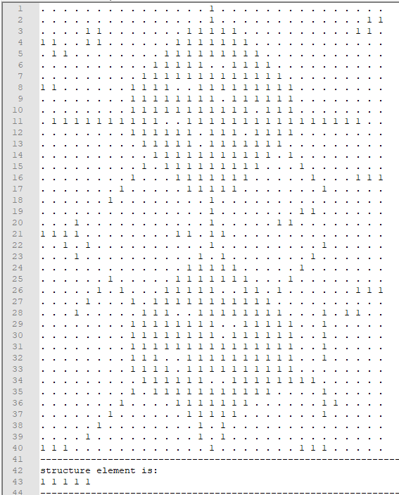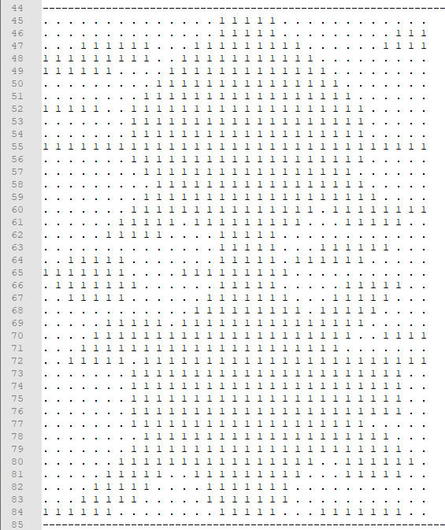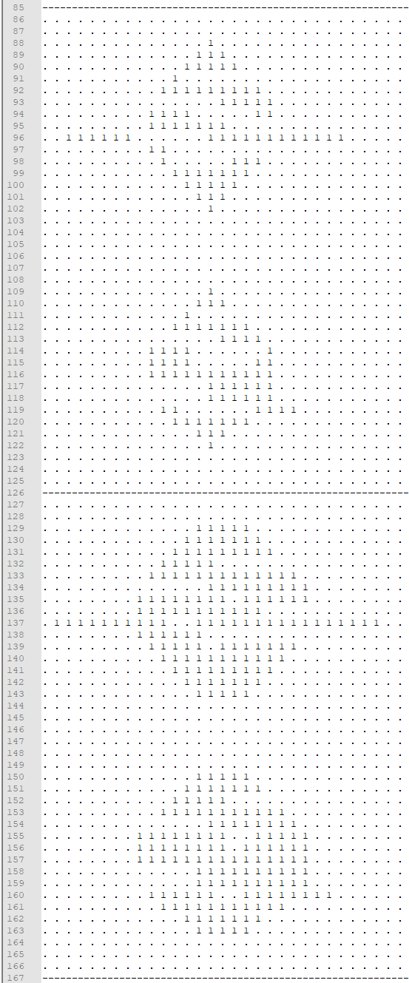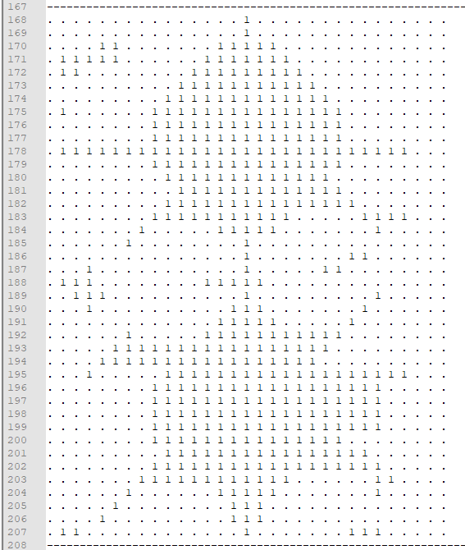

**Test-4: Morphology_Img2.txt and Morphology_StrucElem4.txt**

|  |  |
| --- | --- |
| dilateOutFile | erodeOutFile |
| 40 31 0 1  0 0 0 0 0 0 0 0 0 0 0 0 0 0 0 1 1 1 1 0 0 0 0 0 0 0 0 0 0 0 1  0 0 0 0 0 1 1 1 0 0 0 0 0 0 1 1 1 1 1 1 0 0 0 0 0 0 0 0 0 1 1  0 1 1 1 1 1 1 1 1 0 0 0 0 1 1 1 1 1 1 1 1 0 0 0 0 0 0 0 1 1 1  1 1 1 1 1 1 1 1 1 0 0 0 1 1 1 1 1 1 1 1 1 1 0 0 0 0 0 0 1 1 1  1 1 1 1 1 1 1 1 1 0 0 1 1 1 1 1 1 1 1 1 1 1 1 0 0 0 0 0 0 1 1  0 1 1 1 1 1 1 1 0 0 1 1 1 1 1 1 1 1 1 1 1 1 1 1 0 0 0 0 0 0 0  0 1 1 1 1 0 0 0 0 1 1 1 1 1 1 1 1 1 1 1 1 1 1 1 1 0 0 0 0 0 0  1 1 1 1 1 0 0 0 1 1 1 1 1 1 1 1 1 1 1 1 1 1 1 1 1 1 0 0 0 0 0  1 1 1 1 1 0 0 0 1 1 1 1 1 1 1 1 1 1 1 1 1 1 1 1 1 1 0 0 0 0 0  0 1 1 1 1 1 1 1 1 1 1 1 1 1 1 1 1 1 1 1 1 1 1 1 1 1 1 1 1 1 1  0 1 1 1 1 1 1 1 1 1 1 1 1 1 1 1 1 1 1 1 1 1 1 1 1 1 1 1 1 1 1  0 1 1 1 1 1 1 1 1 1 1 1 1 1 1 1 1 1 1 1 1 1 1 1 1 1 1 1 1 1 1  0 0 1 1 1 1 1 1 1 1 1 1 1 1 1 1 1 1 1 1 1 1 1 1 1 1 1 1 1 1 1  0 0 0 0 0 0 0 0 0 1 1 1 1 1 1 1 1 1 1 1 1 1 1 1 1 1 0 0 0 0 0  0 0 0 0 0 0 0 0 0 1 1 1 1 1 1 1 1 1 1 1 1 1 1 1 1 1 1 0 0 1 1  0 0 0 0 0 0 0 0 1 1 1 1 1 1 1 1 1 1 1 1 1 1 1 1 1 1 1 1 1 1 1  0 0 0 0 0 0 0 1 1 1 1 1 1 1 1 1 1 1 1 1 1 1 0 0 1 1 1 1 1 1 1  0 0 0 0 0 0 1 1 1 1 1 0 0 1 1 1 1 1 1 1 1 0 0 0 1 1 1 1 1 1 1  0 0 0 0 1 1 1 1 1 1 0 0 0 0 1 1 1 1 1 1 0 0 1 1 1 1 1 1 0 0 0  0 1 1 1 1 1 1 1 1 0 0 0 0 1 1 1 1 1 1 0 0 1 1 1 1 1 1 1 0 0 0  1 1 1 1 1 1 1 0 0 0 0 0 1 1 1 1 1 1 1 1 0 1 1 1 1 1 1 1 0 0 0  1 1 1 1 1 1 1 1 0 0 0 0 1 1 1 1 1 1 1 1 0 0 1 1 1 1 1 1 1 0 0  0 1 1 1 1 1 1 1 0 0 0 0 0 1 1 1 1 1 1 1 0 0 0 0 1 1 1 1 1 0 0  0 0 0 1 1 1 1 1 1 0 0 0 0 1 1 1 1 1 1 1 1 0 0 1 1 1 1 1 0 0 0  0 0 0 0 1 1 1 1 1 1 0 0 1 1 1 1 1 1 1 1 1 1 1 1 1 1 1 0 0 1 1  0 0 0 0 0 1 1 1 1 1 1 1 1 1 1 1 1 1 1 1 1 1 1 1 1 1 0 0 1 1 1  0 0 0 0 1 1 1 1 1 1 1 1 1 1 1 1 1 1 1 1 1 1 1 1 1 0 1 1 1 1 1  0 0 0 1 1 1 1 1 1 1 1 1 1 1 1 1 1 1 1 1 1 1 1 1 1 1 1 1 1 1 1  0 0 0 1 1 1 1 0 1 1 1 1 1 1 1 1 1 1 1 1 1 1 1 1 1 1 1 1 1 1 1  0 0 0 0 1 1 0 0 1 1 1 1 1 1 1 1 1 1 1 1 1 1 1 1 1 1 1 1 1 1 1  0 0 0 0 0 0 0 0 1 1 1 1 1 1 1 1 1 1 1 1 1 1 1 1 1 1 1 1 1 0 0  0 0 0 0 0 0 0 0 1 1 1 1 1 1 1 1 1 1 1 1 1 1 1 1 1 1 1 1 1 0 0  0 0 0 0 0 0 0 0 1 1 1 1 1 1 1 1 1 1 1 1 1 1 1 1 1 1 1 1 1 0 0  0 0 0 0 0 0 0 0 1 1 1 1 1 1 1 1 1 1 1 1 1 1 1 1 1 1 1 1 0 0 0  0 0 0 0 0 0 0 0 1 1 1 1 1 1 1 1 1 1 1 1 1 1 1 1 1 1 1 1 1 0 0  0 0 0 0 0 0 0 1 1 1 1 1 1 1 1 1 1 1 1 1 1 1 1 1 1 1 1 1 1 1 0  0 0 0 0 0 0 1 1 1 1 1 1 1 1 1 1 1 1 1 1 1 1 1 0 0 1 1 1 1 1 0  0 0 0 0 0 1 1 1 1 1 0 0 0 1 1 1 1 1 1 1 1 0 0 0 0 1 1 1 1 0 0  0 1 1 1 1 1 1 1 1 0 0 0 0 0 1 1 1 1 1 1 0 0 0 0 1 1 1 1 0 0 0  1 1 1 1 1 1 1 1 0 0 0 0 0 0 1 1 1 1 1 1 0 0 0 1 1 1 1 1 1 0 0 | 40 31 0 1  0 0 0 0 0 0 0 0 0 0 0 0 0 0 0 0 0 0 0 0 0 0 0 0 0 0 0 0 0 0 0  0 0 0 0 0 0 0 0 0 0 0 0 0 0 0 0 0 0 0 0 0 0 0 0 0 0 0 0 0 0 0  0 0 0 0 0 0 0 0 0 0 0 0 0 0 0 0 0 0 0 0 0 0 0 0 0 0 0 0 0 0 0  0 0 0 0 0 0 0 0 0 0 0 0 1 0 0 0 0 0 0 0 0 0 0 0 0 0 0 0 0 0 0  0 0 0 0 0 0 0 0 0 0 0 1 0 0 0 0 0 0 0 0 0 0 0 0 0 0 0 0 0 0 0  0 0 0 0 0 0 0 0 0 0 0 0 0 0 0 0 0 1 0 0 0 0 0 0 0 0 0 0 0 0 0  0 0 0 0 0 0 0 0 0 0 0 0 0 0 0 0 1 1 1 0 0 0 0 0 0 0 0 0 0 0 0  0 0 0 0 0 0 0 0 1 0 0 0 0 0 0 0 0 0 0 1 0 0 0 0 0 0 0 0 0 0 0  0 0 0 0 0 0 0 0 1 0 0 0 0 0 0 0 0 0 0 0 0 0 0 0 0 0 0 0 0 0 0  0 0 0 0 0 0 0 0 0 0 0 0 0 0 0 0 0 0 0 0 0 0 0 0 0 0 0 0 0 0 0  0 0 0 0 0 0 0 0 0 0 0 0 0 0 0 0 0 0 0 1 0 0 0 0 0 0 0 0 0 0 0  0 0 0 0 0 0 0 0 0 0 0 0 0 0 0 0 0 0 0 0 0 0 0 0 0 0 0 0 0 0 0  0 0 0 0 0 0 0 0 0 0 1 0 0 0 0 1 0 0 0 0 0 0 0 0 0 0 0 0 0 0 0  0 0 0 0 0 0 0 0 0 0 0 1 0 0 1 1 1 0 0 0 0 0 0 0 0 0 0 0 0 0 0  0 0 0 0 0 0 0 0 0 0 0 0 1 1 1 1 0 0 0 0 0 0 0 0 0 0 0 0 0 0 0  0 0 0 0 0 0 0 0 0 0 0 0 0 0 0 0 0 0 0 0 0 0 0 0 0 0 0 0 0 0 0  0 0 0 0 0 0 0 0 0 0 0 0 0 0 0 0 0 0 0 0 0 0 0 0 0 0 0 0 0 0 0  0 0 0 0 0 0 0 0 0 0 0 0 0 0 0 0 0 0 0 0 0 0 0 0 0 0 0 0 0 0 0  0 0 0 0 0 0 0 0 0 0 0 0 0 0 0 0 0 0 0 0 0 0 0 0 0 0 0 0 0 0 0  0 0 0 0 0 0 0 0 0 0 0 0 0 0 0 0 0 0 0 0 0 0 0 0 0 0 0 0 0 0 0  0 0 0 0 0 0 0 0 0 0 0 0 0 0 0 0 0 0 0 0 0 0 0 0 0 0 0 0 0 0 0  0 0 0 0 0 0 0 0 0 0 0 0 0 0 0 0 0 0 0 0 0 0 0 0 0 0 0 0 0 0 0  0 0 0 0 0 0 0 0 0 0 0 0 0 0 0 0 0 0 0 0 0 0 0 0 0 0 0 0 0 0 0  0 0 0 0 0 0 0 0 0 0 0 0 0 0 0 0 0 0 0 0 0 0 0 0 0 0 0 0 0 0 0  0 0 0 0 0 0 0 0 0 0 0 0 1 0 0 0 0 0 0 0 0 0 0 0 0 0 0 0 0 0 0  0 0 0 0 0 0 0 0 0 0 0 0 0 0 0 0 0 0 0 0 0 0 0 0 0 0 0 0 0 0 0  0 0 0 0 0 0 0 0 0 0 0 0 0 0 0 0 0 1 0 0 0 0 0 0 0 0 0 0 0 0 0  0 0 0 0 0 0 0 0 0 0 0 0 0 0 0 0 0 0 1 0 0 0 0 0 0 0 0 0 0 0 0  0 0 0 0 0 0 0 0 1 1 0 0 0 0 0 0 0 0 1 1 0 0 0 0 0 0 0 0 0 0 0  0 0 0 0 0 0 0 0 1 0 0 0 1 0 0 0 0 1 1 1 0 0 0 0 0 0 0 0 0 0 0  0 0 0 0 0 0 0 0 0 0 0 0 0 1 0 0 1 1 1 1 0 0 0 0 0 0 0 0 0 0 0  0 0 0 0 0 0 0 0 0 0 0 0 0 0 0 0 1 1 1 1 0 0 0 0 0 0 0 0 0 0 0  0 0 0 0 0 0 0 0 0 0 0 0 0 0 0 0 0 1 1 0 0 0 0 0 0 0 0 0 0 0 0  0 0 0 0 0 0 0 0 0 0 0 0 0 0 0 0 0 0 0 0 0 0 0 0 0 0 0 0 0 0 0  0 0 0 0 0 0 0 0 0 0 0 0 1 0 0 0 0 0 0 0 0 0 0 0 0 0 0 0 0 0 0  0 0 0 0 0 0 0 0 0 0 0 0 0 0 0 0 0 0 0 0 0 0 0 0 0 0 0 0 0 0 0  0 0 0 0 0 0 0 0 0 0 0 0 0 0 0 0 0 0 0 0 0 0 0 0 0 0 0 0 0 0 0  0 0 0 0 0 0 0 0 0 0 0 0 0 0 0 0 0 0 0 0 0 0 0 0 0 0 0 0 0 0 0  0 0 0 0 0 0 0 0 0 0 0 0 0 0 0 0 0 0 0 0 0 0 0 0 0 0 0 0 0 0 0  0 0 0 0 0 0 0 0 0 0 0 0 0 0 0 0 0 0 0 0 0 0 0 0 0 0 0 0 0 0 0 |

|  |  |
| --- | --- |
| closingOutFile | openingOutFile |
| 40 31 0 1  0 0 0 0 0 0 0 0 0 0 0 0 0 0 0 0 0 0 0 0 0 0 0 0 0 0 0 0 0 0 0  0 0 0 0 0 0 0 0 0 0 0 0 0 0 1 1 1 0 0 0 0 0 0 0 0 0 0 0 0 0 0  0 0 0 0 1 1 0 0 0 0 0 0 0 1 1 1 1 1 0 0 0 0 0 0 0 0 0 0 0 0 0  1 1 1 1 1 1 0 0 0 0 0 0 1 1 1 1 1 1 1 0 0 0 0 0 0 0 0 0 0 0 0  0 1 1 0 0 0 0 0 0 0 0 1 1 1 1 1 1 1 1 1 0 0 0 0 0 0 0 0 0 0 0  0 1 0 0 0 0 0 0 0 0 1 1 1 1 1 1 1 1 1 1 1 0 0 0 0 0 0 0 0 0 0  0 1 0 0 0 0 0 0 0 1 1 1 1 1 1 1 1 1 1 1 1 1 0 0 0 0 0 0 0 0 0  1 1 0 0 0 0 0 0 1 1 1 1 1 1 1 1 1 1 1 1 1 1 1 0 0 0 0 0 0 0 0  0 1 0 0 0 0 0 0 1 1 1 1 1 1 1 1 1 1 1 1 1 1 1 0 0 0 0 0 0 0 0  0 1 1 0 0 0 0 1 1 1 1 1 1 1 1 1 1 1 1 1 1 1 1 1 0 0 0 0 0 0 0  0 1 1 1 1 1 1 1 1 1 1 1 1 1 1 1 1 1 1 1 1 1 1 1 1 1 1 1 0 0 0  0 0 0 0 0 0 0 0 1 1 1 1 1 1 1 1 1 1 1 1 1 1 1 1 0 0 0 0 0 0 0  0 0 0 0 0 0 0 0 0 1 1 1 1 1 1 1 1 1 1 1 1 1 1 0 0 0 0 0 0 0 0  0 0 0 0 0 0 0 0 0 1 1 1 1 1 1 1 1 1 1 1 1 1 1 0 0 0 0 0 0 0 0  0 0 0 0 0 0 0 0 0 1 1 1 1 1 1 1 1 1 1 1 0 0 0 1 0 0 0 0 0 0 0  0 0 0 0 0 0 0 0 1 0 0 0 1 1 1 1 1 1 1 0 0 0 0 0 1 0 0 0 0 0 0  0 0 0 0 0 0 0 1 0 0 0 0 0 1 1 1 1 1 0 0 0 0 0 0 1 1 0 0 0 0 0  0 0 0 0 0 0 1 0 0 0 0 0 0 0 1 1 1 0 0 0 0 0 0 0 1 0 0 0 0 0 0  0 0 0 0 0 0 0 0 0 0 0 0 0 0 1 1 0 0 0 0 0 0 0 1 1 0 0 0 0 0 0  0 0 0 1 0 0 0 0 0 0 0 0 0 1 1 1 0 0 0 0 0 1 1 1 1 0 0 0 0 0 0  1 1 1 1 0 0 0 0 0 0 0 0 1 1 1 1 1 0 0 0 0 0 0 1 1 0 0 0 0 0 0  0 0 1 1 1 0 0 0 0 0 0 0 0 1 1 1 1 0 0 0 0 0 0 0 1 1 0 0 0 0 0  0 0 0 1 1 0 0 0 0 0 0 0 0 1 1 1 1 0 0 0 0 0 0 0 1 0 0 0 0 0 0  0 0 0 0 1 1 0 0 0 0 0 0 0 1 1 1 1 1 0 0 0 0 0 1 0 0 0 0 0 0 0  0 0 0 0 0 1 1 0 0 0 0 0 1 1 1 1 1 1 1 0 0 0 1 0 0 0 0 0 0 0 0  0 0 0 0 0 1 1 1 0 0 0 1 1 1 1 1 1 1 1 1 1 1 0 0 0 0 0 0 0 0 0  0 0 0 0 1 0 0 1 1 1 1 1 1 1 1 1 1 1 1 1 1 1 0 0 0 0 0 1 0 0 0  0 0 0 1 0 0 0 0 1 1 1 1 1 1 1 1 1 1 1 1 1 1 1 0 0 1 1 1 0 0 0  0 0 0 0 0 0 0 0 1 1 1 1 1 1 1 1 1 1 1 1 1 1 1 1 1 1 1 0 0 0 0  0 0 0 0 0 0 0 0 1 1 1 1 1 1 1 1 1 1 1 1 1 1 1 1 1 1 0 0 0 0 0  0 0 0 0 0 0 0 0 1 1 1 1 1 1 1 1 1 1 1 1 1 1 1 1 1 1 0 0 0 0 0  0 0 0 0 0 0 0 0 1 1 1 1 1 1 1 1 1 1 1 1 1 1 1 1 1 1 0 0 0 0 0  0 0 0 0 0 0 0 0 1 1 1 1 1 1 1 1 1 1 1 1 1 1 1 1 1 0 0 0 0 0 0  0 0 0 0 0 0 0 0 1 1 1 1 1 1 1 1 1 1 1 1 1 1 1 1 1 0 0 0 0 0 0  0 0 0 0 0 0 0 0 1 1 1 1 1 1 1 1 1 1 1 1 1 0 0 0 1 1 0 0 0 0 0  0 0 0 0 0 0 0 1 0 0 0 0 1 1 1 1 1 1 1 0 0 0 0 0 0 1 1 0 0 0 0  0 0 0 0 0 0 1 0 0 0 0 0 0 1 1 1 1 1 0 0 0 0 0 0 0 1 0 0 0 0 0  0 0 0 0 0 1 0 0 0 0 0 0 0 0 1 1 1 0 0 0 0 0 0 0 0 0 0 0 0 0 0  0 0 0 0 0 0 0 0 0 0 0 0 0 0 0 0 0 0 0 0 0 0 0 0 0 0 0 0 0 0 0  0 0 0 0 0 0 0 0 0 0 0 0 0 0 0 0 0 0 0 0 0 0 0 0 0 0 0 0 0 0 0 | 40 31 0 1  0 0 0 0 0 0 0 0 0 0 0 0 0 0 0 0 0 0 0 0 0 0 0 0 0 0 0 0 0 0 0  0 0 0 0 0 0 0 0 0 0 0 0 0 0 0 0 0 0 0 0 0 0 0 0 0 0 0 0 0 0 0  0 0 0 0 0 0 0 0 0 0 0 0 0 1 1 0 0 0 0 0 0 0 0 0 0 0 0 0 0 0 0  0 0 0 0 0 0 0 0 0 0 0 0 1 1 1 1 0 0 0 0 0 0 0 0 0 0 0 0 0 0 0  0 0 0 0 0 0 0 0 0 0 0 1 1 1 1 1 0 0 1 1 0 0 0 0 0 0 0 0 0 0 0  0 0 0 0 0 0 0 0 0 0 0 1 1 1 1 0 0 1 1 1 1 0 0 0 0 0 0 0 0 0 0  0 0 0 0 0 0 0 0 0 1 1 0 1 1 0 0 1 1 1 1 1 1 0 0 0 0 0 0 0 0 0  0 0 0 0 0 0 0 0 1 1 1 1 0 0 0 0 1 1 1 1 1 1 1 0 0 0 0 0 0 0 0  0 0 0 0 0 0 0 0 1 1 1 1 0 0 0 0 0 1 1 1 1 1 1 0 0 0 0 0 0 0 0  0 0 0 0 0 0 0 0 1 1 1 1 0 0 0 0 0 0 0 0 1 1 0 0 0 0 0 0 0 0 0  0 0 0 0 0 0 0 0 0 1 1 0 0 0 0 0 0 0 0 1 1 1 1 0 0 0 0 0 0 0 0  0 0 0 0 0 0 0 0 0 0 0 1 1 0 0 0 1 1 0 1 1 1 1 0 0 0 0 0 0 0 0  0 0 0 0 0 0 0 0 0 0 1 1 1 1 0 1 1 1 1 0 1 1 0 0 0 0 0 0 0 0 0  0 0 0 0 0 0 0 0 0 0 1 1 1 1 1 1 1 1 1 1 0 0 0 0 0 0 0 0 0 0 0  0 0 0 0 0 0 0 0 0 0 0 1 1 1 1 1 1 1 1 1 0 0 0 0 0 0 0 0 0 0 0  0 0 0 0 0 0 0 0 0 0 0 0 1 1 1 1 1 1 1 0 0 0 0 0 0 0 0 0 0 0 0  0 0 0 0 0 0 0 0 0 0 0 0 0 1 1 1 1 1 0 0 0 0 0 0 0 0 0 0 0 0 0  0 0 0 0 0 0 0 0 0 0 0 0 0 0 0 0 0 0 0 0 0 0 0 0 0 0 0 0 0 0 0  0 0 0 0 0 0 0 0 0 0 0 0 0 0 0 0 0 0 0 0 0 0 0 0 0 0 0 0 0 0 0  0 0 0 0 0 0 0 0 0 0 0 0 0 0 0 0 0 0 0 0 0 0 0 0 0 0 0 0 0 0 0  0 0 0 0 0 0 0 0 0 0 0 0 0 0 0 0 0 0 0 0 0 0 0 0 0 0 0 0 0 0 0  0 0 0 0 0 0 0 0 0 0 0 0 0 0 0 0 0 0 0 0 0 0 0 0 0 0 0 0 0 0 0  0 0 0 0 0 0 0 0 0 0 0 0 0 0 0 0 0 0 0 0 0 0 0 0 0 0 0 0 0 0 0  0 0 0 0 0 0 0 0 0 0 0 0 0 1 1 0 0 0 0 0 0 0 0 0 0 0 0 0 0 0 0  0 0 0 0 0 0 0 0 0 0 0 0 1 1 1 1 0 0 0 0 0 0 0 0 0 0 0 0 0 0 0  0 0 0 0 0 0 0 0 0 0 0 0 1 1 1 1 0 0 1 1 0 0 0 0 0 0 0 0 0 0 0  0 0 0 0 0 0 0 0 0 0 0 0 0 1 1 0 0 1 1 1 1 0 0 0 0 0 0 0 0 0 0  0 0 0 0 0 0 0 0 0 1 1 1 0 0 0 0 0 1 1 1 1 1 0 0 0 0 0 0 0 0 0  0 0 0 0 0 0 0 0 1 1 1 1 1 1 1 0 0 0 1 1 1 1 1 0 0 0 0 0 0 0 0  0 0 0 0 0 0 0 0 1 1 1 1 1 1 1 1 0 1 1 1 1 1 1 0 0 0 0 0 0 0 0  0 0 0 0 0 0 0 0 1 1 1 1 1 1 1 1 1 1 1 1 1 1 1 0 0 0 0 0 0 0 0  0 0 0 0 0 0 0 0 0 1 1 0 0 1 1 1 1 1 1 1 1 1 1 0 0 0 0 0 0 0 0  0 0 0 0 0 0 0 0 0 0 0 0 0 0 1 1 1 1 1 1 1 1 1 0 0 0 0 0 0 0 0  0 0 0 0 0 0 0 0 0 0 0 0 0 1 1 0 0 1 1 1 1 1 0 0 0 0 0 0 0 0 0  0 0 0 0 0 0 0 0 0 0 0 0 1 1 1 1 0 0 1 1 1 0 0 0 0 0 0 0 0 0 0  0 0 0 0 0 0 0 0 0 0 0 0 1 1 1 1 0 0 0 0 0 0 0 0 0 0 0 0 0 0 0  0 0 0 0 0 0 0 0 0 0 0 0 0 1 1 0 0 0 0 0 0 0 0 0 0 0 0 0 0 0 0  0 0 0 0 0 0 0 0 0 0 0 0 0 0 0 0 0 0 0 0 0 0 0 0 0 0 0 0 0 0 0  0 0 0 0 0 0 0 0 0 0 0 0 0 0 0 0 0 0 0 0 0 0 0 0 0 0 0 0 0 0 0  0 0 0 0 0 0 0 0 0 0 0 0 0 0 0 0 0 0 0 0 0 0 0 0 0 0 0 0 0 0 0 |

**Test-4: Morphology_Img2.txt and Morphology_StrucElem4.txt**

