ADVANCED OPERATING SYSTEMS

TERM PROJECT WEEKLY REPORT

Under,

An-I Andy Wang

Shuanglong Zhang

By,

Akshara Dendi ([ad13r@my.fsu.edu](mailto:ad13r@my.fsu.edu))

Lehari Saggam ([ls13d@my.fsu.edu](mailto:ls13d@my.fsu.edu))

Sinduri Shyamala ([ss13w@my.fsu.edu](mailto:ss13w@my.fsu.edu))

**OPTION CHOSEN:** SURVEY PROJECT

**PROJECT TITLE:** A STUDY ON LINUX LOCK SYSTEMS.

**GOAL:** To do a detailed analysis on the Linux lock systems.

**TEAM MEMBERS:** Akshara Dendi ([ad13r@my.fsu.edu](mailto:ad13r@my.fsu.edu))

Lehari Saggam ([ls13d@my.fsu.edu](mailto:ls13d@my.fsu.edu))

Sinduri Shyamala ([ss13w@my.fsu.edu](mailto:ss13w@my.fsu.edu))

**DATE:** 3/31/2014

**PATCH COMPARISON:**

In order to compare the patches, we will be using tools that will help us in finding the differences. One such comparison tool that we came across is the Patch Viewer and Kdiff3. This week we have gone through various tutorials that helped us in understanding how the tools work. Also, these tools are very efficient in showing the differences between two patch codes. The kdiff3 opens two patch files and shows the changes that were made in the latest version of Linux. Differences are clearly shown in the code and also explanation about the changes is displayed. This tool is very helpful in finding the differences in the locks and helps us to understand why the locks were changed for every version. An image of the kdiff3 is shown below

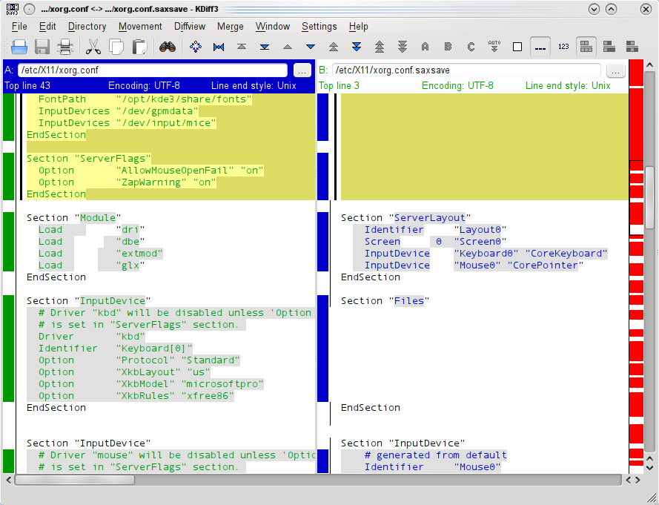

Hence using kdiff3 for patch comparison will help us a lot to see the changes in the code and also by the end of the project, we will be able to show our results about the different locks used in different versions.

We have started working on comparing the first version of Linux with the second version. We have encountered a few problems in identifying the exact code for the locks and we are trying to overcome the challenges this week. We will compare most of the patches by the end of this week and will publish our results.

As we will be working on MacOS, We are using the Patch Viewer which we downloaded from the App Store. We were successful in viewing many patch files in this viewer. By using the kdiff3 along with the patch viewer, files can be compared and merged. Merge conflicts can also be solved using the kdiff3. This tool will also help in line-by-line comparison of the code and differences are thus identified.

**REFERENCES:**

Data Source: <http://kdiff3.sourceforge.net/doc/>

<https://drupal.org/node/85184>

Image Source: <http://www.kde.org/images/screenshots/kdiff3.png>