Title: Multi-Agent AI Research Assistant for Scientific Discovery

Abstract
Scientific research is growing rapidly, with thousands of research papers being published every day across various domains. Researchers, students, and professionals often spend significant time searching for relevant literature, reading lengthy papers, comparing different research works, identifying research gaps, and organizing citations. Traditional search engines and digital libraries provide access to research papers but offer limited assistance in understanding, comparing, and extracting meaningful insights from multiple publications. This project proposes a Multi-Agent AI Research Assistant for Scientific Discovery, an intelligent platform that leverages multiple specialized AI agents to automate the research process and provide comprehensive research assistance.
The proposed system employs a Coordinator Agent that manages several specialized AI agents, including a Search Agent, Summary Agent, Comparison Agent, Research Gap Detection Agent, Citation Generation Agent, Dataset Recommendation Agent, Knowledge Graph Agent, Trend Analysis Agent, and Report Generation Agent. The Search Agent retrieves relevant research papers from trusted scientific repositories, while the Summary Agent generates concise and easy-to-understand summaries. The Comparison Agent analyzes multiple papers based on methodology, datasets, performance metrics, advantages, and limitations. The Research Gap Detection Agent identifies unexplored research opportunities, while the Citation Agent automatically generates citations in multiple formats such as IEEE, APA, MLA, and BibTeX.
The proposed framework further provides interactive knowledge graphs to visualize relationships among research papers, authors, datasets, algorithms, and research domains. It also performs publication trend analysis to identify emerging research topics and recommends publicly available datasets relevant to the selected research area. The Report Generation Agent compiles all outputs into a structured report that users can download for future reference. The performance of the system is evaluated based on the relevance of retrieved papers, quality of generated summaries, accuracy of research gap identification, response time, and overall user satisfaction. The resulting system aims to reduce the time and effort required for literature review while improving research productivity and enabling faster scientific discover

Datasets

Dataset | URL link
arXiv API | https://arxiv.org/help/api
Semantic Scholar API | https://api.semanticscholar.org/
CrossRef REST API | https://api.crossref.org/
PubMed (NCBI E-utilities API) | https://www.ncbi.nlm.nih.gov/books/NBK25501/
Papers with Code Dataset | https://paperswithcode.com/datasets
CORD-19 Research Dataset | https://www.kaggle.com/datasets/allen-institute-for-ai/CORD-19-research-challenge

Approach

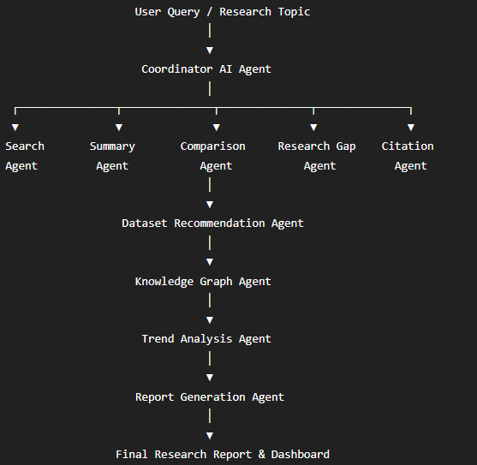
Project Group Members

S.No. | Roll.No. | Student Name
1 | 2420030205 | - Madhumitha
2 | 2420030206 | P.Lahari
3 | 2420030260 | - Akshara

