Green Enterprise Architecture (GEA)
Green Enterprise Architecture (GEA) aims to develop a comprehensive understanding of business, technology, and the environment in which an organization operates. It supports green transformation by modeling business processes, information usage, and technology infrastructure together.
GEA superimposes organizational and technical constraints on information and solution architectures. Enterprise Architecture (EA) frameworks such as Zachman Framework and TOGAF (The Open Group Architecture Framework) help in modeling enterprise views and supporting green transformation.

Architecture Diagram
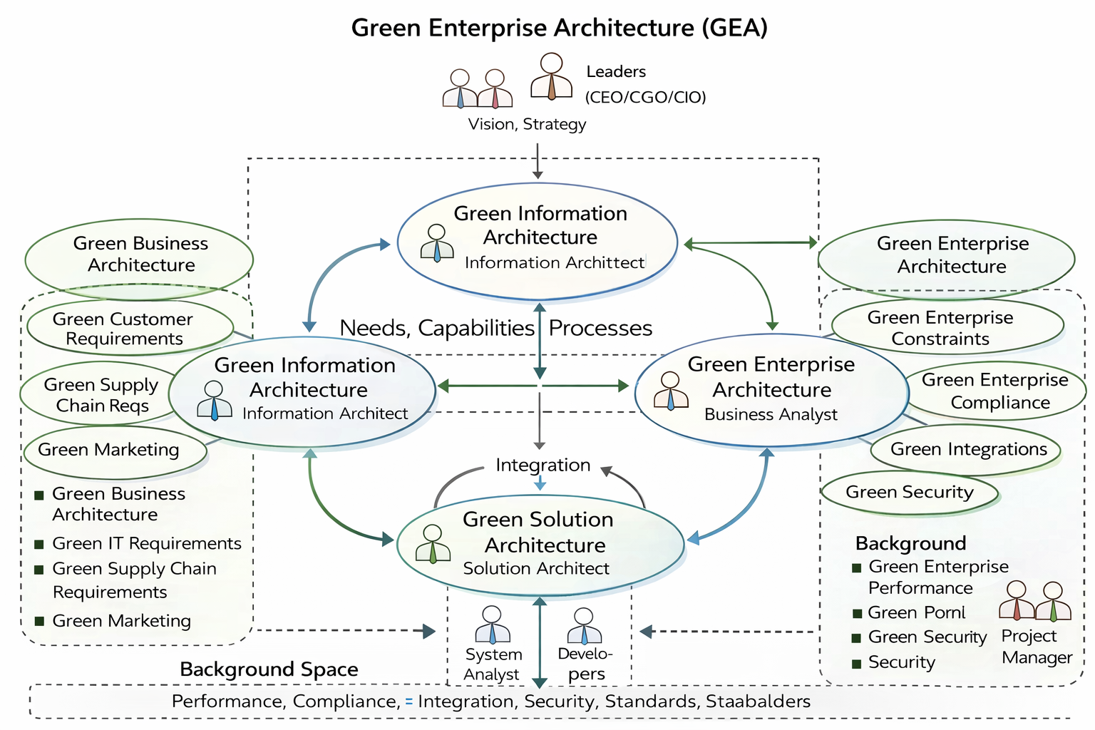
Explanation of the Diagram:
The diagram shows the interaction between Green Business Architecture, Green Information Architecture (GIA), and Green Solution Architecture (GSA). Leadership roles such as CEO (Chief Executive Officer), CGO (Chief Green Officer), and CIO (Chief Information Officer) provide vision and strategy. The background space enforces constraints such as compliance, integration, performance, and security across the enterprise.

Detailed Explanation (10-Mark Answer)
Green Information Architecture (GIA):
GIA focuses on information capture, management, and provisioning for both internal and external stakeholders. It identifies business requirements, functional requirements, and operational requirements. GIA supports Green IT strategies, applications, processes, and IT governance.
Green Solution Architecture (GSA):
GSA deals with technical implementation, including applications, networks, green portals, data warehouses, testing, and deployment. It is supported by solution architects, system analysts, and developers. GSA ensures scalability, reliability, security, and integration.
Role of GEA as Background Architecture:
GEA acts as a background architecture providing enterprise-wide constraints such as compliance, integration, performance, and security. It influences both GIA and GSA and ensures consistency across systems.

