**Role-based access control and Authentication to Users**

**1. User - admin**

**Admin is given Select, Insert, Update and Delete permission access to all the tables in the dental_clinic database**

CREATE USER 'admin'@'localhost' IDENTIFIED BY 'admin';

GRANT SELECT ON dental_clinic.* TO 'admin'@'localhost';

GRANT INSERT ON dental_clinic.* TO 'admin'@'localhost';

GRANT UPDATE ON dental_clinic.* TO 'admin'@'localhost';

GRANT DELETE ON dental_clinic.* TO 'admin'@'localhost';

**2. User – doctor**

**Doctor is given Select, Insert and Update permission access to Patients, Patients_contact_details, Diagnosis, Prescription and Visits tables in the dental_clinic database**

CREATE USER 'doctor'@'localhost' IDENTIFIED BY 'doctor';

GRANT SELECT ON patients TO 'doctor'@'localhost';

GRANT INSERT ON patients TO 'doctor'@'localhost';

GRANT UPDATE ON patients TO 'doctor'@'localhost';

GRANT SELECT ON patient_contact_details TO 'doctor'@'localhost';

GRANT INSERT ON patient_contact_details TO 'doctor'@'localhost';

GRANT UPDATE ON patient_contact_details TO 'doctor'@'localhost';

GRANT SELECT ON diagnosis TO 'doctor'@'localhost';

GRANT INSERT ON diagnosis TO 'doctor'@'localhost';

GRANT UPDATE ON diagnosis TO 'doctor'@'localhost';

GRANT SELECT ON prescription TO 'doctor'@'localhost';

GRANT INSERT ON prescription TO 'doctor'@'localhost';

GRANT UPDATE ON prescription TO 'doctor'@'localhost';

GRANT SELECT ON visits TO 'doctor'@'localhost';

GRANT INSERT ON visits TO 'doctor'@'localhost';

GRANT UPDATE ON visits TO 'doctor'@'localhost';

**2. User – receptionist**

**Receptionist is given Select, Insert and Update permission access to Patients, Patients_contact_details, Patient_Bills and Visits tables in the dental_clinic database**

CREATE USER 'receptionist'@'localhost' IDENTIFIED BY 'receptionist';

GRANT SELECT ON patients TO 'receptionist'@'localhost';

GRANT INSERT ON patients TO 'receptionist'@'localhost';

GRANT UPDATE ON patients TO 'receptionist'@'localhost';

GRANT DELETE ON patients TO 'receptionist'@'localhost';

GRANT SELECT ON patient_contact_details TO 'receptionist'@'localhost';

GRANT INSERT ON patient_contact_details TO 'receptionist'@'localhost';

GRANT UPDATE ON patient_contact_details TO 'receptionist'@'localhost';

GRANT DELETE ON patient_contact_details TO 'receptionist'@'localhost';

GRANT SELECT ON visits TO 'receptionist'@'localhost';

GRANT INSERT ON visits TO 'receptionist'@'localhost';

GRANT UPDATE ON visits TO 'receptionist'@'localhost';

GRANT DELETE ON visits TO 'receptionist'@'localhost';

GRANT SELECT ON patient_bills TO 'receptionist'@'localhost';

GRANT INSERT ON patient_bills TO 'receptionist'@'localhost';

GRANT UPDATE ON patient_bills TO 'receptionist'@'localhost';

GRANT DELETE ON patient_bills TO 'receptionist'@'localhost';

**The Three user roles – admin, doctor and receptionist that are created above can be seen in the dashboard below:**

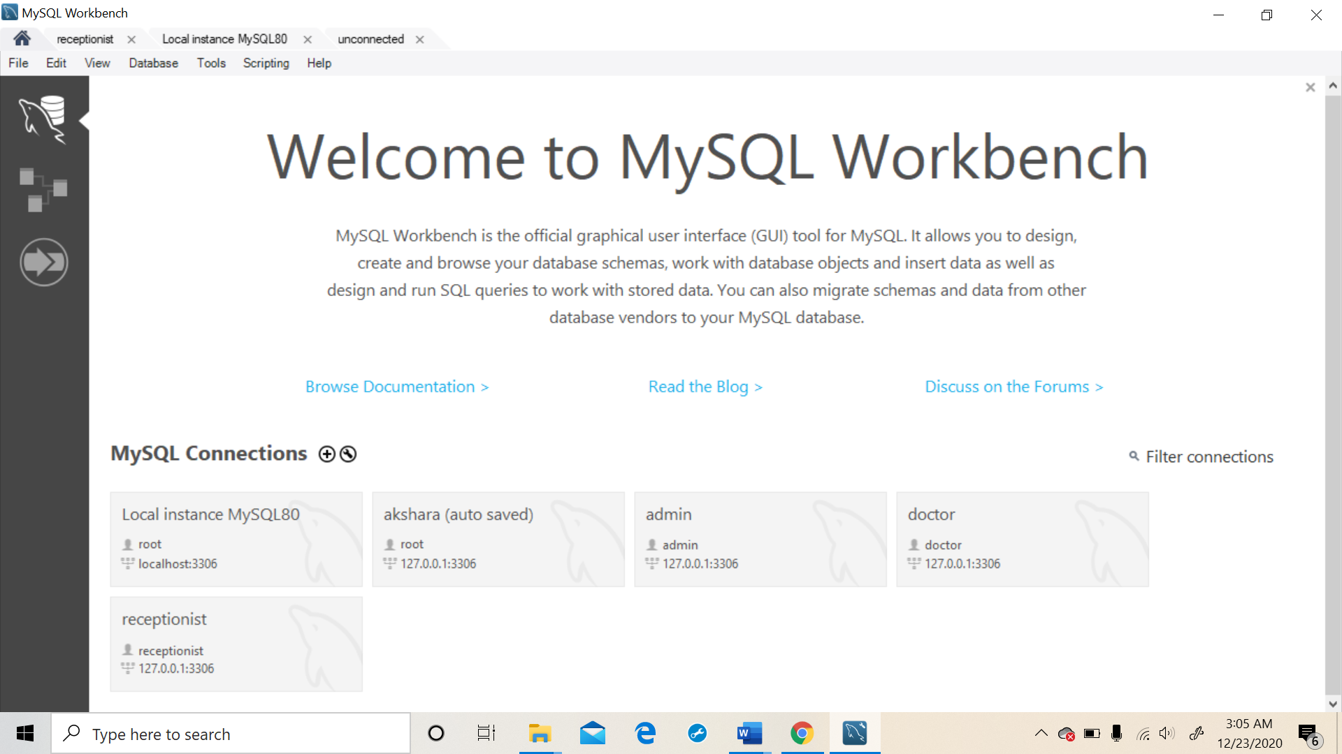

**Role 1: Admin**

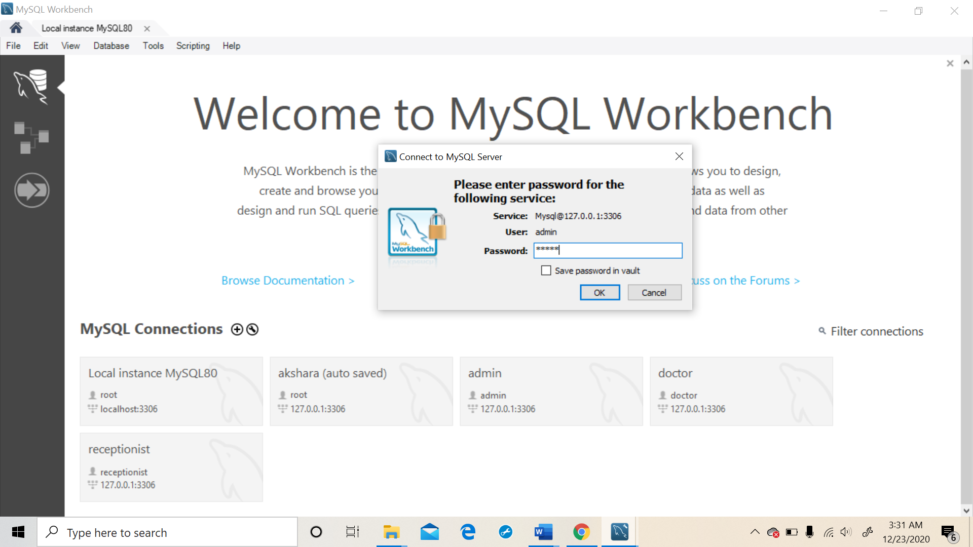



**Test Case 1: Admin is able to access doctors table, as he is not granted all access.**

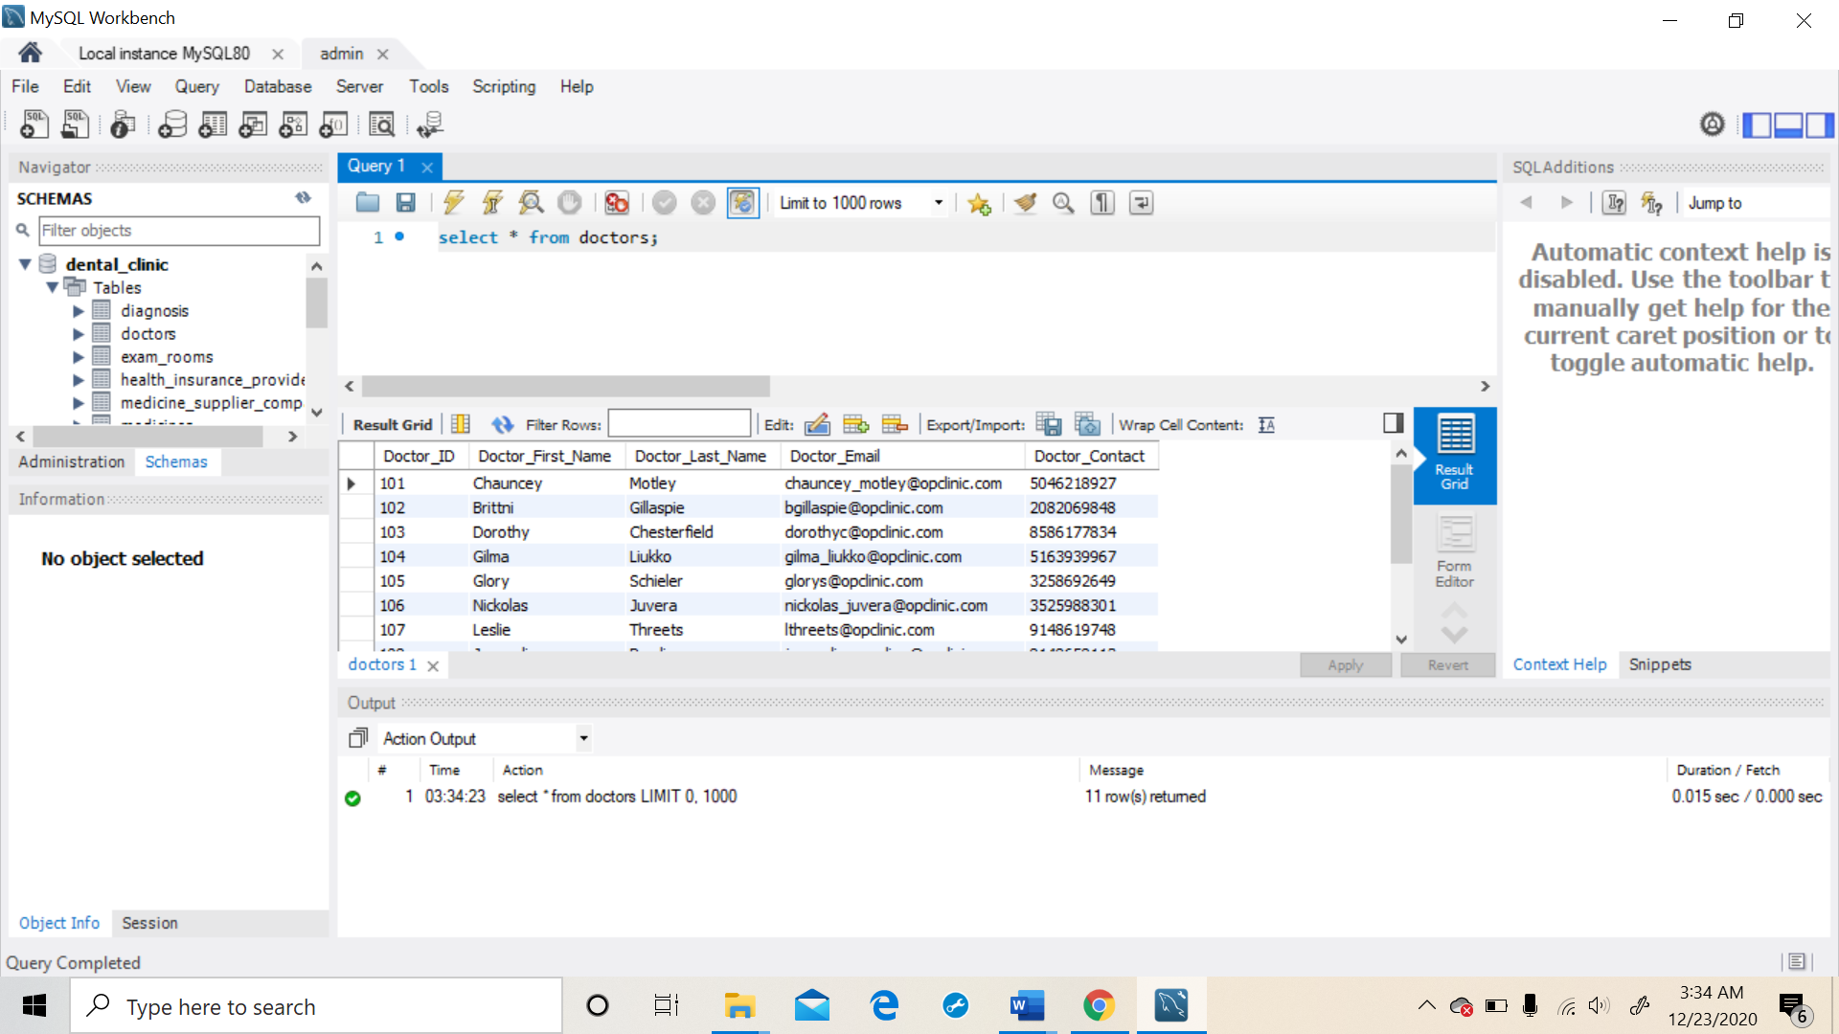



**Test Case 2: Admin is able to insert into medicine_supplier_company table, as he is granted all access.**

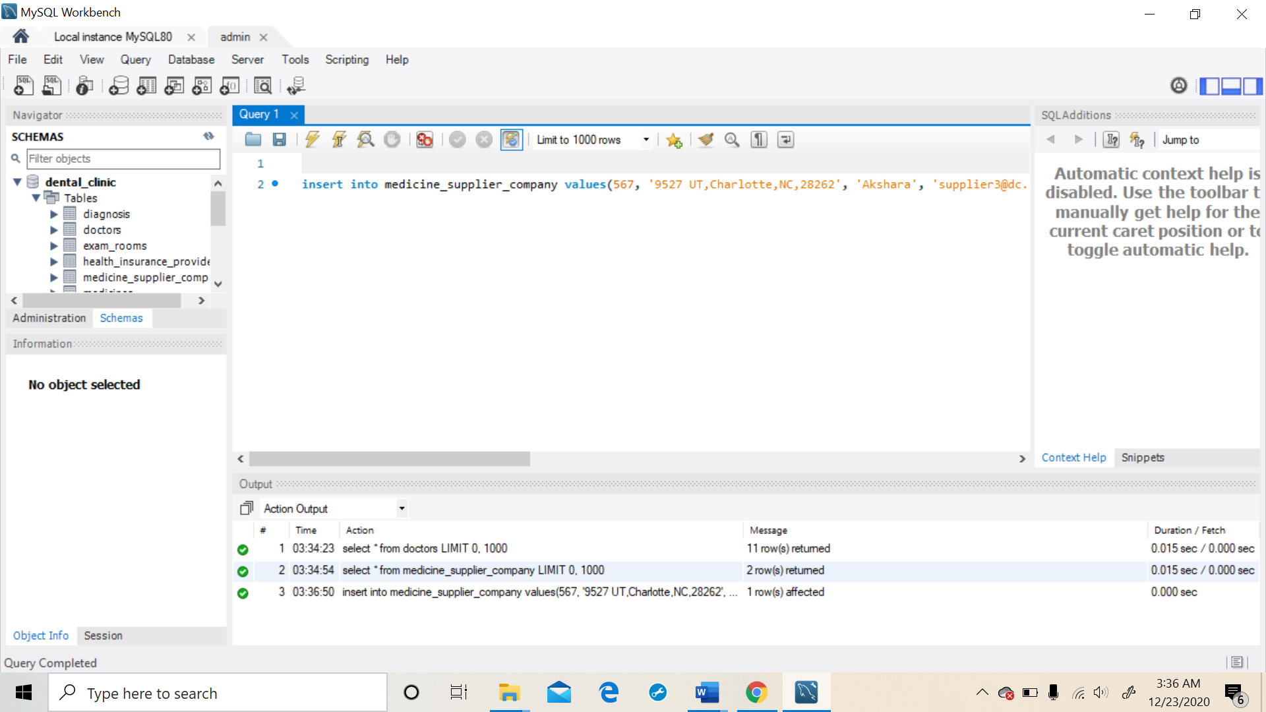

**Role 2: Doctor**

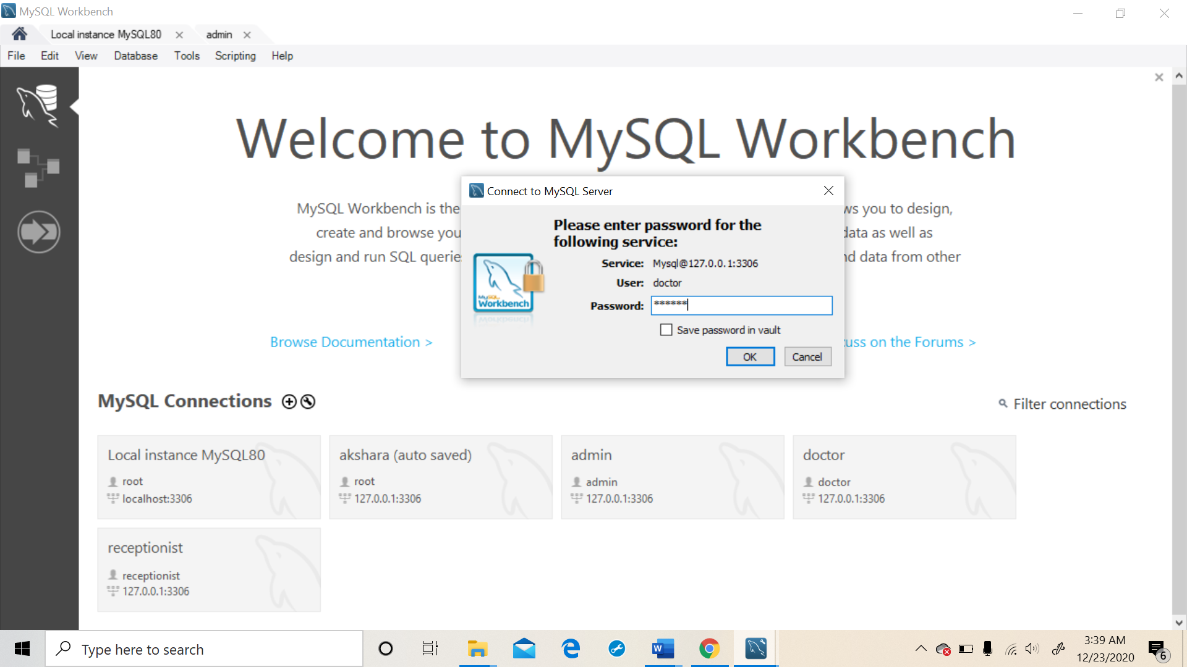



**Test Case 1: Doctor is unable to access health_insurance_provider table, as he is not granted the access.**

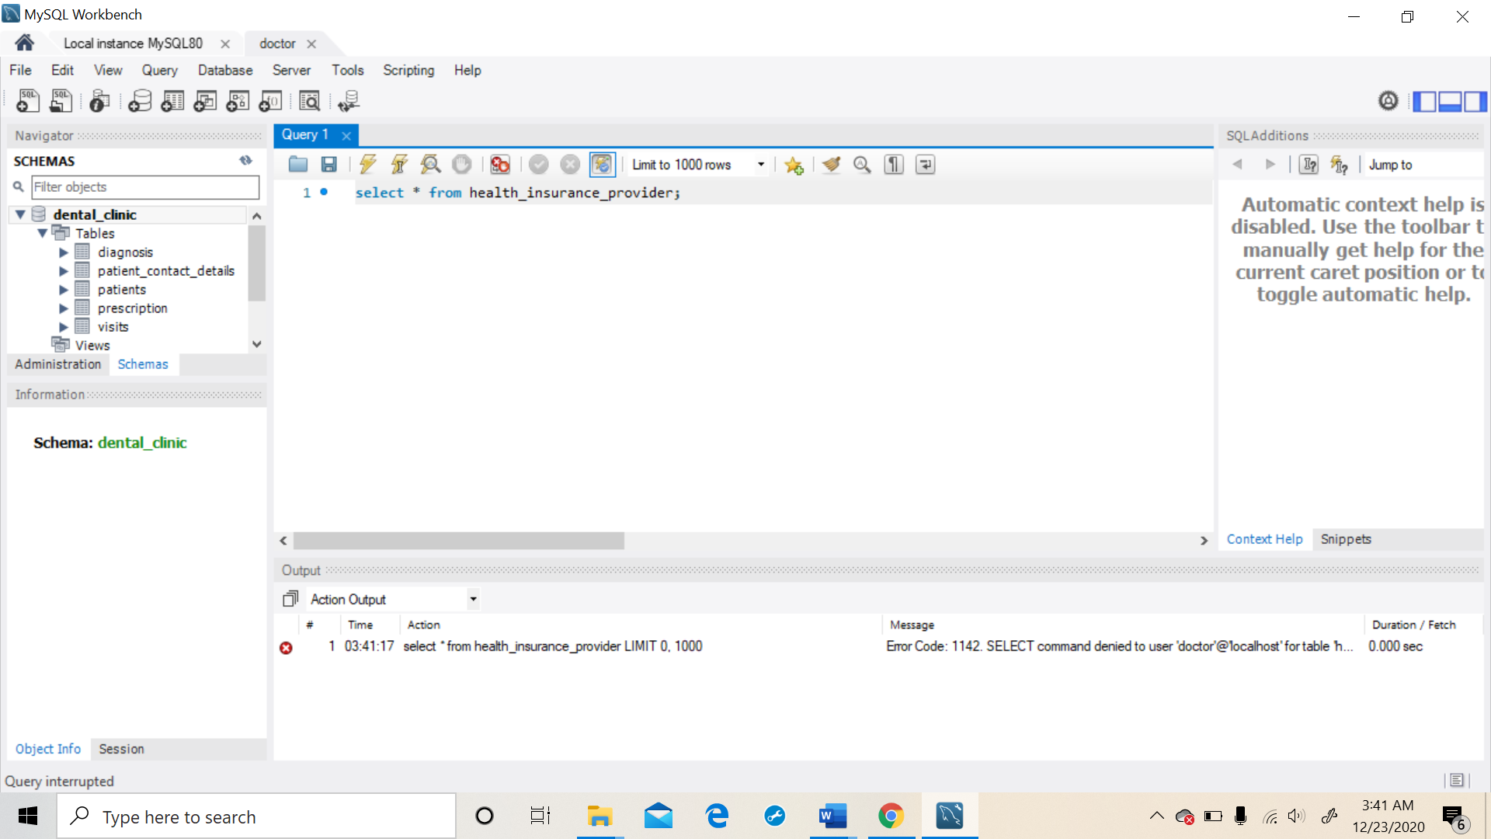



**Test Case 2: Doctor is able to access patients table, as he is granted the access.**

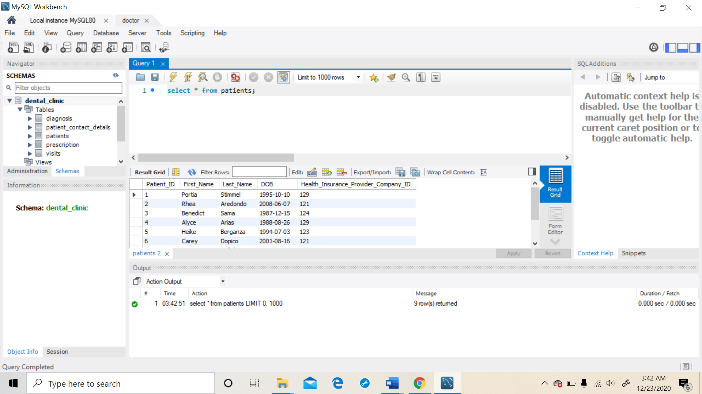

**Role 3: Receptionist**

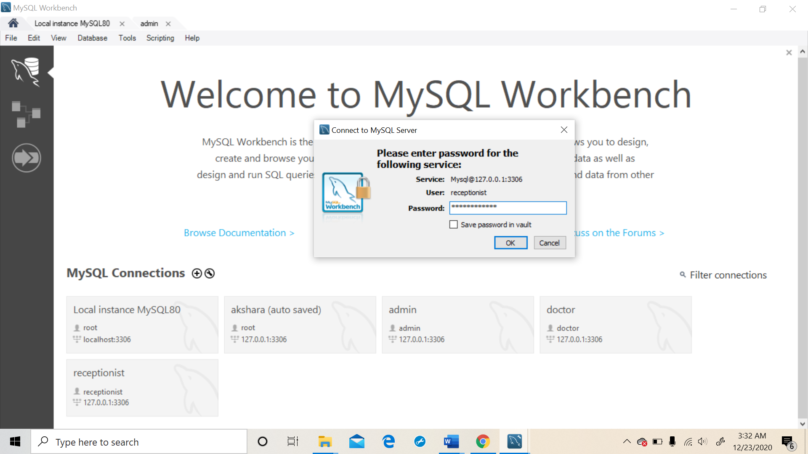



**Test Case 1: Receptionist is unable to access doctors table, as he is not granted the access.**

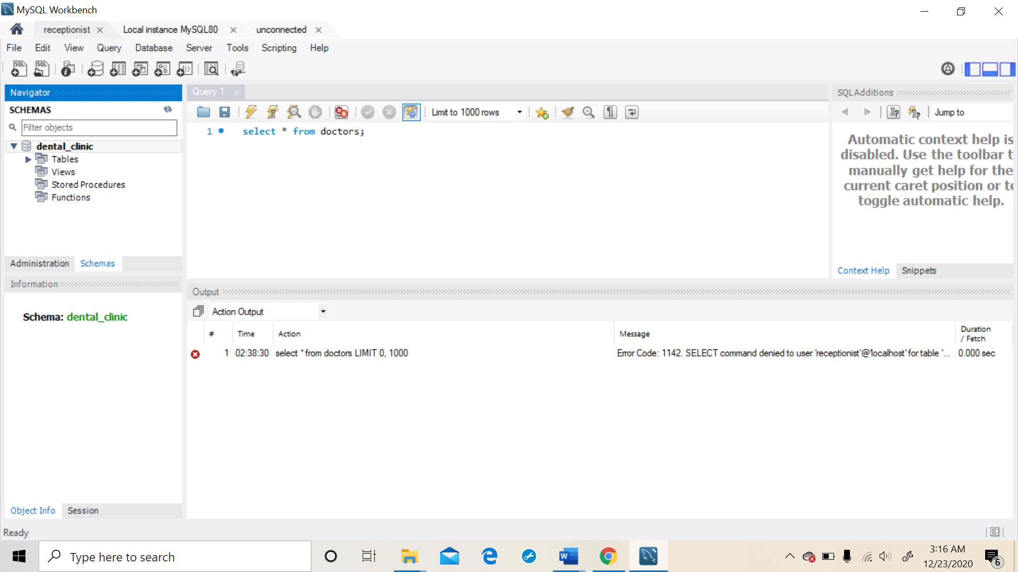



**Test Case 2: Receptionist is able to update patients table, as he is granted the access.**

