RESTAURANT
MANAGEMENT SYSTEM
PSPJ PROJECT

Introduction
A restaurant has many daily tasks such as showing the menu, booking tables, taking food orders, checking the kitchen order and preparing the bill. This project is a simple Java program that manages these basic restaurant activities through the console. The customer enters their details, books a table, orders food and completes the payment.
Abstract
The Restaurant Management System is a simple Java application for handling common restaurant activities. The program provides a food menu, table booking, food ordering, food searching, kitchen order display, bill calculation and payment selection. It is designed as a small console-based system that keeps restaurant operations organised and easy to use.
Advantages
- Easy to use with a simple numbered menu.
- Makes food ordering and bill calculation easier.
- Reduces manual calculation mistakes.
- Prevents a booked table from being booked again.
- Displays the customer's order for the kitchen.
- Allows quick searching of food items.
- Keeps the program simple and easy to understand.
Implementation
The program first takes the customer's name and displays a main menu until the customer chooses Exit. The food prices and the quantity ordered for each item are stored in simple variables, and a boolean array keeps track of six tables. The whole program is written inside the main method using a switch menu, if-else statements and loops. The bill applies a 5% discount for a subtotal of Rs.500 or more and a 10% discount for Rs.1000 or more. The customer can select Cash, Card or UPI for payment.

Java Code
import java.util.Scanner;
public class RestaurantManagementSystem {
public static void main(String[] args) {
Scanner sc = new Scanner(System.in);
// Food prices
int burger = 80, pizza = 200, pasta = 150, noodles = 110;
// Quantity ordered for each food item
int q1 = 0, q2 = 0, q3 = 0, q4 = 0;
boolean[] table = new boolean[6]; // false = available, true = booked
int myTable = 0, total = 0;
int choice = 0, t, item, q, subtotal, discount, pay;
String key, mode;
System.out.println("=== WELCOME TO OUR RESTAURANT ===");
System.out.print("Enter customer name: ");
String name = sc.nextLine();
while (choice != 8) {
System.out.println("\n------ MAIN MENU ------");
System.out.println("1. View Menu");
System.out.println("2. Book Table");
System.out.println("3. Order Food");
System.out.println("4. Search Food");
System.out.println("5. Kitchen Order");
System.out.println("6. Generate Bill");
System.out.println("7. Payment");
System.out.println("8. Exit");
System.out.print("Enter your choice: ");
choice = sc.nextInt();
switch (choice) {
case 1: // View Menu
System.out.println("\n------ FOOD MENU ------");
System.out.println("1. Burger - Rs." + burger);
System.out.println("2. Pizza - Rs." + pizza);
System.out.println("3. Pasta - Rs." + pasta);
System.out.println("4. Noodles - Rs." + noodles);
break;
case 2: // Book Table
for (int i = 0; i < 6; i++) {
if (table[i])
System.out.println("Table " + (i + 1) + " - Booked");
else
System.out.println("Table " + (i + 1) + " - Available");
}
System.out.print("Enter table number: ");
t = sc.nextInt();
if (myTable != 0)
System.out.println("You have already booked table " + myTable);
else if (t >= 1 && t <= 6 && !table[t - 1]) {
table[t - 1] = true;
myTable = t;
System.out.println("Table " + t + " booked successfully.");
} else
System.out.println("Invalid or already booked table.");
break;
case 3: // Order Food
if (myTable == 0) {
System.out.println("Please book a table first.");
break;
}
System.out.print("Enter item number (1-4): ");
item = sc.nextInt();
System.out.print("Enter quantity: ");
q = sc.nextInt();
if (item >= 1 && item <= 4 && q > 0) {
if (item == 1) q1 += q;
else if (item == 2) q2 += q;
else if (item == 3) q3 += q;
else q4 += q;
total = 0; // bill has to be generated again
System.out.println("Item added to your order.");
} else
System.out.println("Invalid item or quantity.");
break;
case 4: // Search Food
System.out.print("Enter food name: ");
key = sc.next().toLowerCase();
if (key.equals("burger")) System.out.println("Burger - Rs." + burger);
else if (key.equals("pizza")) System.out.println("Pizza - Rs." + pizza);
else if (key.equals("pasta")) System.out.println("Pasta - Rs." + pasta);
else if (key.equals("noodles")) System.out.println("Noodles - Rs." + noodles);
else System.out.println("Food item not found.");
break;
case 5: // Kitchen Order
System.out.println("\n------ KITCHEN ORDER ------");
if (q1 + q2 + q3 + q4 == 0) {
System.out.println("No food ordered.");
break;
}
System.out.println("Table No : " + myTable);
if (q1 > 0) System.out.println("Burger x " + q1);
if (q2 > 0) System.out.println("Pizza x " + q2);
if (q3 > 0) System.out.println("Pasta x " + q3);
if (q4 > 0) System.out.println("Noodles x " + q4);
break;
case 6: // Generate Bill
subtotal = q1 * burger + q2 * pizza + q3 * pasta + q4 * noodles;
if (subtotal == 0) {
System.out.println("No items ordered.");
break;
}
discount = 0;
if (subtotal >= 1000) discount = subtotal * 10 / 100;
else if (subtotal >= 500) discount = subtotal * 5 / 100;
total = subtotal - discount;
System.out.println("\n========== BILL ==========");
System.out.println("Customer : " + name);
System.out.println("Table No : " + myTable);
if (q1 > 0) System.out.println("Burger x " + q1 + " = Rs." + (q1 * burger));
if (q2 > 0) System.out.println("Pizza x " + q2 + " = Rs." + (q2 * pizza));
if (q3 > 0) System.out.println("Pasta x " + q3 + " = Rs." + (q3 * pasta));
if (q4 > 0) System.out.println("Noodles x " + q4 + " = Rs." + (q4 * noodles));
System.out.println("--------------------------");
System.out.println("Subtotal : Rs." + subtotal);
System.out.println("Discount : Rs." + discount);
System.out.println("Total : Rs." + total);
break;
case 7: // Payment
if (total == 0) {
System.out.println("Please generate the bill first.");
break;
}
System.out.println("1. Cash 2. Card 3. UPI");
System.out.print("Select payment: ");
pay = sc.nextInt();
if (pay >= 1 && pay <= 3) {
if (pay == 1) mode = "Cash";
else if (pay == 2) mode = "Card";
else mode = "UPI";
System.out.println("Rs." + total + " paid by " + mode + ".");
System.out.println("Thank you for visiting!");
// Clear everything for the next customer
table[myTable - 1] = false;
myTable = 0;
total = 0;
q1 = 0; q2 = 0; q3 = 0; q4 = 0;
} else
System.out.println("Invalid payment choice.");
break;
case 8:
System.out.println("Goodbye!");
break;
default:
System.out.println("Invalid choice.");
}
}
sc.close();
}
}

OUTPUT

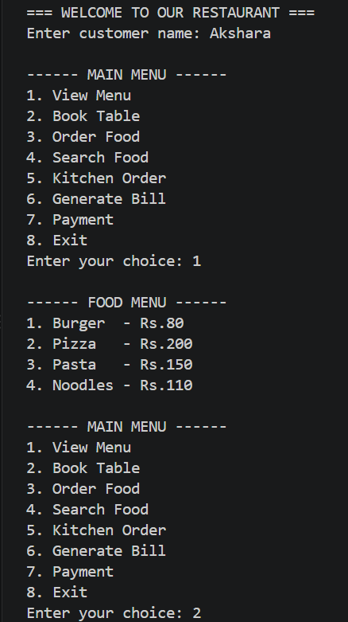
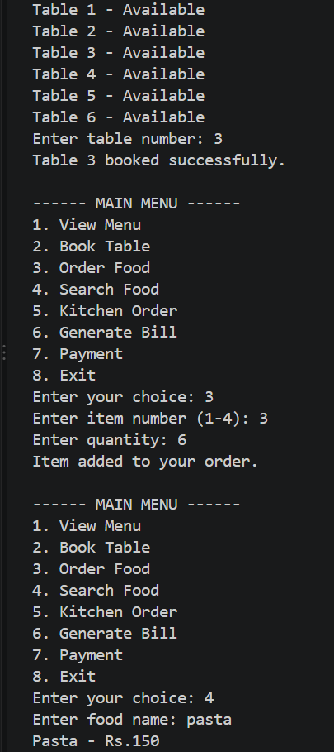
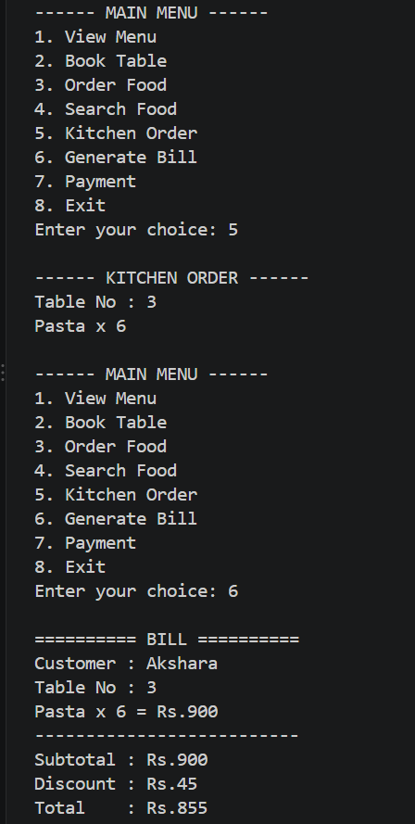

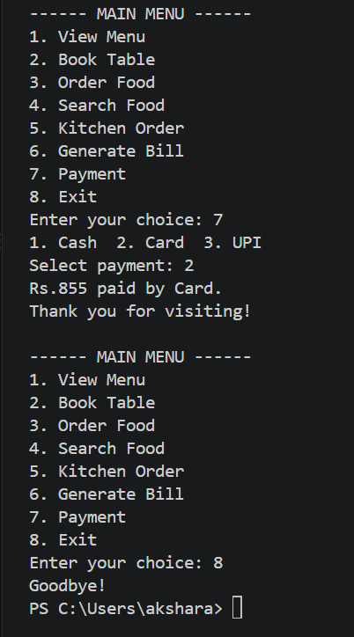

Conclusion
This project shows how basic restaurant activities can be handled using a simple Java program. It manages the menu, table booking, food orders, kitchen display, billing and payment in one system. The project provides a practical example of using Java to solve a real-life problem in a clear and organised way.

