**ASSIGNMENT – 1**

Ques 1:- Write a program to calculate the simple interest. Accept the value of principal, rate of interest and time from the user through the standard input device.

Code –

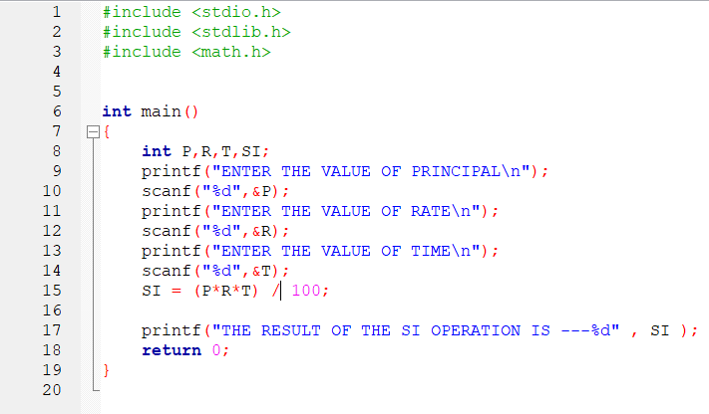

**Output -**

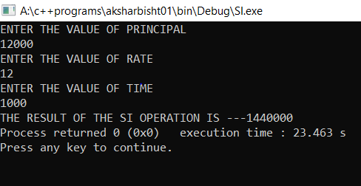

AKSHAR BISHT 1 BCA 1st YEAR 2ND SHIFT

Ques 2 :- Write a program to swap two numbers (using third variable).

Code –

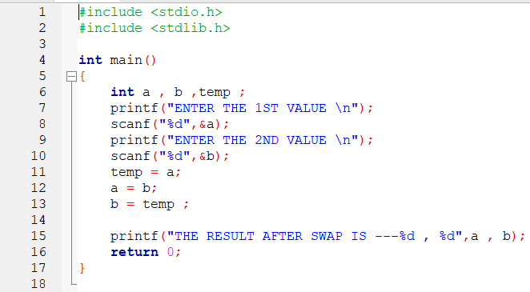

**Output -**

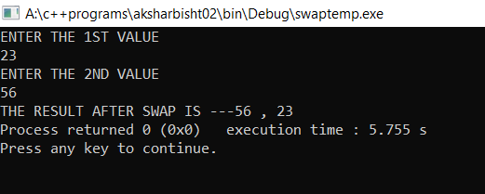

AKSHAR BISHT 2 BCA 1st YEAR 2ND SHIFT

Ques 3 :- Write a program to swap two numbers (without using third variable).

Code –

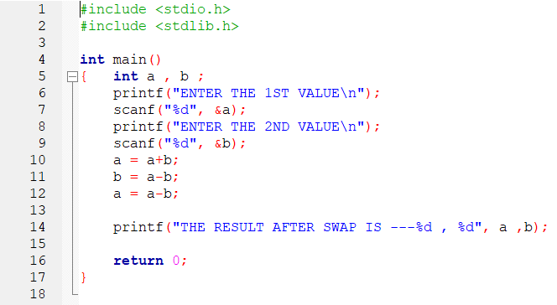

**Output -**

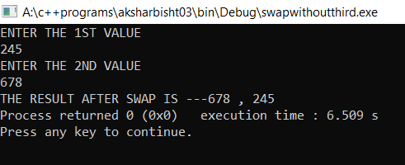

AKSHAR BISHT 3 BCA 1st YEAR 2ND SHIFT

Ques 4 :- Write a program to find the compound interest for the 5 year duration .

Code –

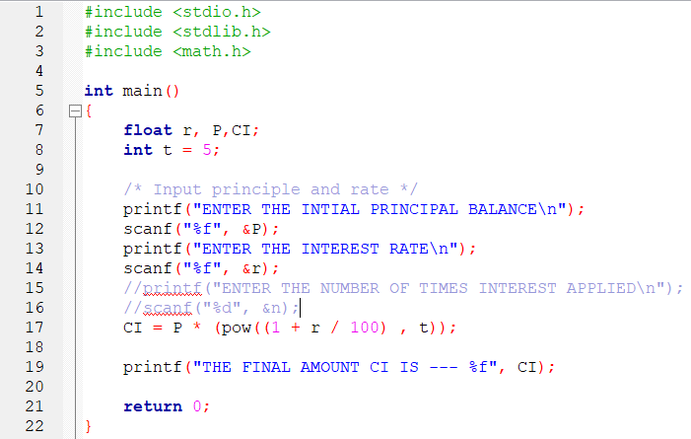

**Output -**

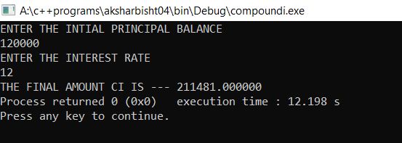

AKSHAR BISHT 4 BCA 1st YEAR 2ND SHIFT

Ques 5 :- Write a program to find the value of ‘y’ in the following equation : y=x2+3x+1.

Code –

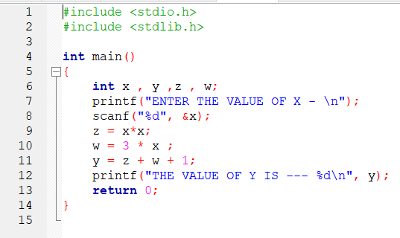

**Output -**

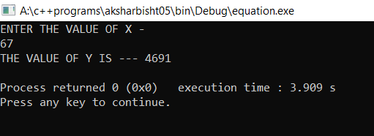

AKSHAR BISHT 5 BCA 1st YEAR 2ND SHIFT

[Ques 6 :- Write a program to calculate the area of triangle using Hero’s formula . area= $s*s-a*s-b*(s-c)$]

Code –

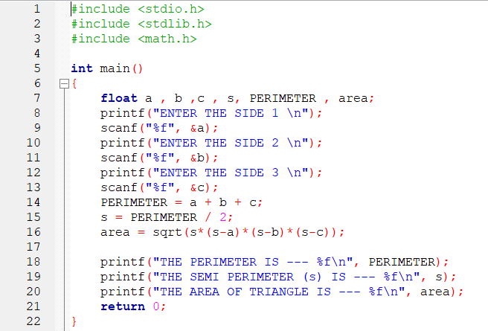

**Output -**

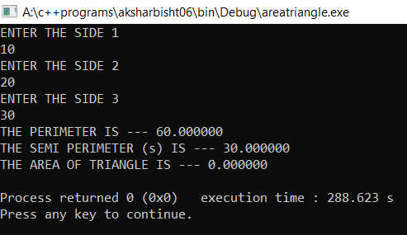

AKSHAR BISHT 6 BCA 1st YEAR 2ND SHIFT

Ques 7 :- Write a program to calculate the bill amount for an item given its quantity sold, value, discount and tax.

Code –

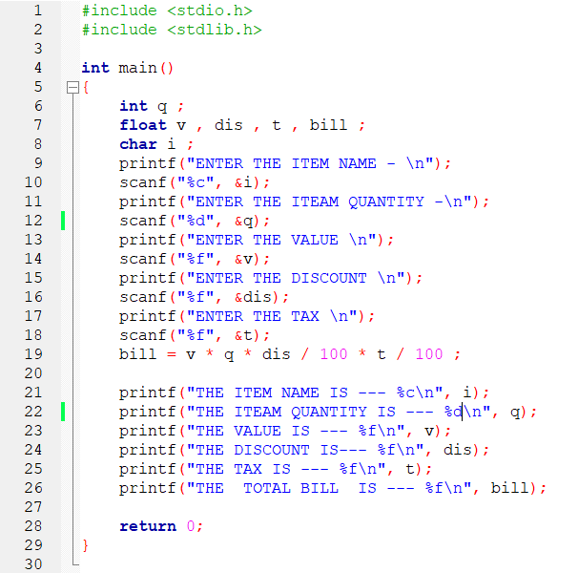

**Output –**

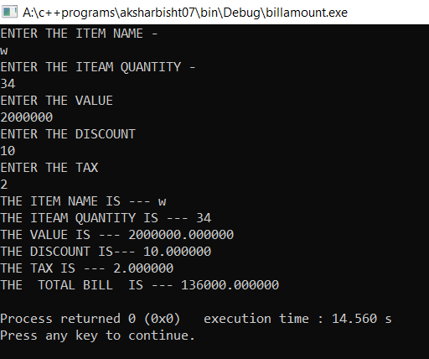

AKSHAR BISHT 7 BCA 1st YEAR 2ND SHIFT

Ques 8 :- Write a program to print the digit at ones place of a number.

Code –

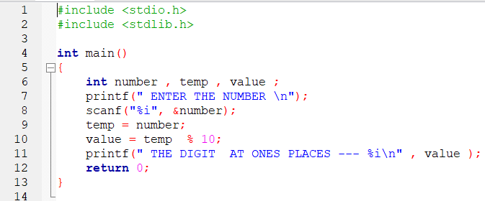

**Output –**

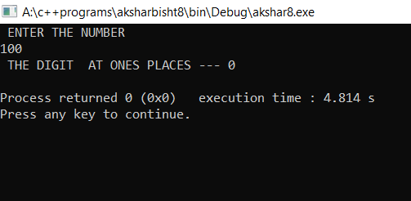

AKSHAR BISHT 8 BCA 1st YEAR 2ND SHIFT

Ques 9 :- Write a program to read a character in upper case and then print it in lower case.

Code –

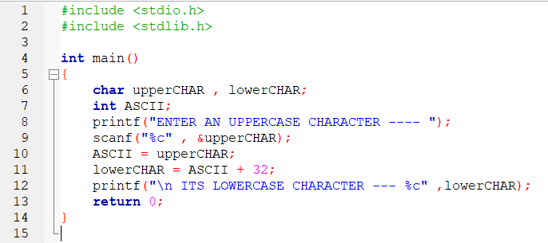

**Output –**

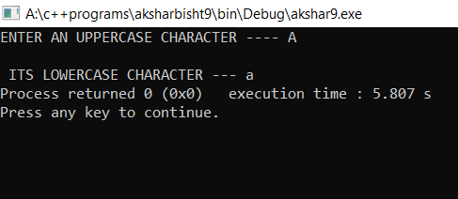

AKSHAR BISHT 9 BCA 1st YEAR 2ND SHIFT

Ques 10 :- Write a program to display the size of every data type.

Code –

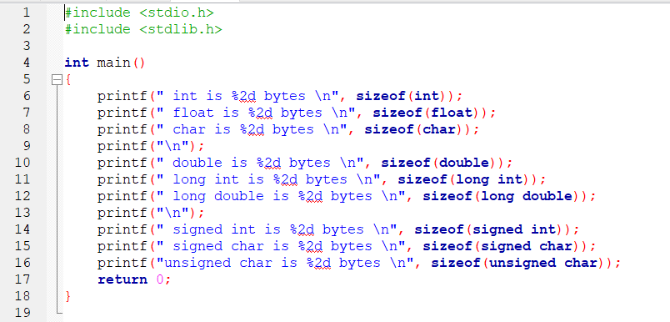

**Output –**

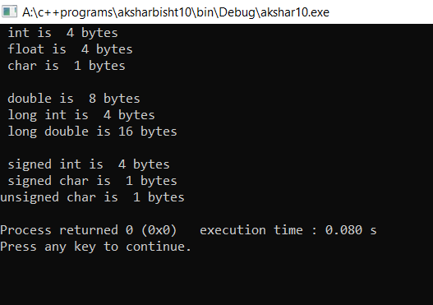

AKSHAR BISHT 10 BCA 1st YEAR 2ND SHIFT