

Search Engine for Updated Stock

## Challenges while Searching

Here we have tried to search the current stock in the warehouse by using and entering the different keywords in the search box. However, we often encounter uncertainty regarding what to input during client interactions, whether online or face-to-face communication. This document guide aims to assist in formulating appropriate keywords and familiarizing oneself with synonyms for efficient search keywords. Within this document, technical terms for items are paired with their corresponding common market terminology, facilitating smoother communication and accurate inventory retrieval.

## Item Groups

Below we try to understand the Item Group wise searching keywords and their synonyms

First, we need a short form for each Item Group

|  |  |
| --- | --- |
| AL FLAT SERVICE WIRES | ASW |
| AL MYL SCREENED CABLES | AL.MY |
| AL SCREENED CABLES | AL-SCR |
| APPLIANCE WIRING MATERIAL- UL758 | AWM UL |
| ATC FLAT BRAIDED WIRE (KGS) | ATC BRD RW |
| ATC FLAT BRAIDED WIRE (MTRS) | [ATC FBWM FBW](javascript:void(0)) |
| ATC ROUND BRAIDED WIRE (MTRS) | [ATC RBWM RBW](javascript:void(0)) |
| ATC SCREENED CABLES | [ATC-SCR](javascript:void(0)) |
| AUTO BATTERY CABLES | [BTC](javascript:void(0)) |
| AUTO CABLES FOR AFTER MARKET | [ACAM OR AC](javascript:void(0)) |
| AUTO INS CABLES - IS 2465 | [AIC](javascript:void(0)) |
| AUTO INS CABLES ISO T2 | [AIC-T2](javascript:void(0)) |
| AUTO INS CABLES ISO T3 | [AIC-T3](javascript:void(0)) |
| AUTO INS CABLES JASO- AVSS | [AIC-AVSS JASO AVSS](javascript:void(0)) |
| AUTO INS CABLES JASO-AVS | [AIC-AVS JASO AVS](javascript:void(0)) |
| AUTO INS CABLES JIS-AV | [AIC-AV JASO AV](javascript:void(0)) |
| AUTO INSULATED CABLES | AC |
| AUTO MULTICORE CABLES | [AUTO MUL](javascript:void(0)) |
| AWM MULTICORE CABLES-758 | [AWM MUL](javascript:void(0)) |
| BATTERY LEAD | [BL](javascript:void(0)) |
| BRADING | Null |
| CCTV CABLES | [CCTV](javascript:void(0)) |
| CU SCREENED CABLES | [CU.SCR](javascript:void(0)) |
| DA FLAT TWIN WIRES | [DA FLAT TWIN](javascript:void(0)) |
| DURITE BATTERY CABLES | [DA BAT](javascript:void(0)) |
| DURITE FLEXIBLE MULTICORE | [DA FMC](javascript:void(0)) |
| DURITE INSULATED CABLES | DA |
| EQUIVALENT STANDARD CABLES | [EQS STD](javascript:void(0)) |
| EXTRUSION | Null |
| FIRE SERVIVALCABLES | [FSC](javascript:void(0)) |
| FLEXIBLE CONTROL CABLES | [FCC](javascript:void(0)) |
| FLEXIBLE MULTICORE CABLES | [FMC](javascript:void(0)) |
| HOUSE WIRES | [HW](javascript:void(0)) |
| INSULTED CABLES | [IC](javascript:void(0)) |
| LAN CABLES | [LAN](javascript:void(0)) |
| PANEL WIRES | [PW](javascript:void(0)) |
| PVC CU AR CABLES | [PVC CUAR](javascript:void(0)) |
| PVC SLV (NON-SLT) KG | [SLV](javascript:void(0)) |
| PVC SLV (NON-SLT) MTR | [SLV](javascript:void(0)) |
| PVC THREAD_DUMMY | [PVC TH](javascript:void(0)) |
| PW HF FR | PW,HF,FR |
| PW HR CE | PW,HR,CE |
| SINGLE CORE CABLES | [SCC](javascript:void(0)) |
| SOLAR CABLES | SOLAR CABLE |
| SPEAKER WIRES | [SPK](javascript:void(0)) |
| SUBMERSIBLE FLAT CABLES | [SUB](javascript:void(0)) |
| TELEPHONE WIRES | [TPW](javascript:void(0)) |
| TPU FLEXIBLE MULTICO | [TPU](javascript:void(0)) |
| TWISTED CABLES | [TWST](javascript:void(0)) |
| XLPE AL AR CABLES | ALARM / AL AR |
| XLPE AL UNAR CABLES | [AL.UN XLPE](javascript:void(0)) |
| XLPE CU AR CABLES | [CU.AR XLPE](javascript:void(0)) |
| XLPE CU UNAR CABLES | CUN.AR XLPE |

1. **House Wire**

Item Description is shown as like below

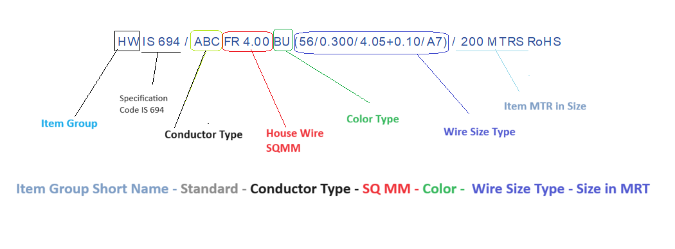

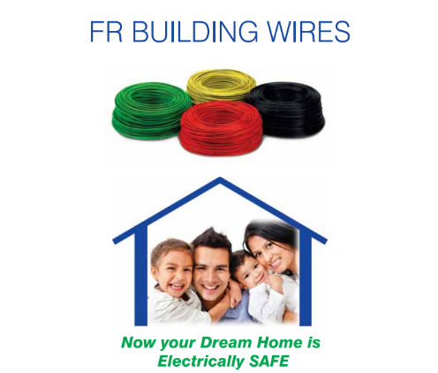

|  |  |
| --- | --- |
| **Technical Word** | **Common Word for search** |
| **Fire Retardant** | **FR** |
| SQ.MM 0.5 | FR 0.5 |
| SQ.MM 0.75 | FR 0.75 |
| SQ.MM 1.0 | FR 1.0 |
| SQ.MM 1.5 | FR 1.5 |
| SQ.MM 2.5 | FR 2.5 |
| SQ.MM 4.0 | FR 4.0 |
| SQ.MM 6 | FR 6 |
| SQ.MM 10 | FR 10 |
| SQ.MM 16 | FR 16 |
| **FR – LSH** | **FRLSH** |
| SQ.MM 0.5 | FRLSH 0.5 |
| SQ.MM 0.75 | FRLSH 0.75 |
| SQ.MM 1.0 | FRLSH 1.0 |
| SQ.MM 1.5 | FRLSH 1.5 |
| SQ.MM 2.5 | FRLSH 2.5 |
| SQ.MM 4.0 | FRLSH 4.0 |
| SQ.MM 6 | FRLSH 6 |
| SQ.MM 10 | FRLSH 10 |
| SQ.MM 16 | FRLSH 16 |
| **FR – HFFR** | **HFFR** |
| SQ.MM 0.5 | HFFR 0.5 |
| SQ.MM 0.75 | HFFR 0.75 |
| SQ.MM 1.0 | HFFR 1.0 |
| SQ.MM 1.5 | HFFR 1.5 |
| SQ.MM 2.5 | HFFR 2.5 |
| SQ.MM 4.0 | HFFR 4.0 |
| SQ.MM 6 | HFFR 6 |
| SQ.MM 10 | HFFR 10 |
| SQ.MM 16 | HFFR 16 |
|  |  |
| Search for FR PVC “IS 694” First select the product group and then search for the item code. | |
| Wires Specifications IS 694 | HW IS 694 |
| **Color Code for Search** |  |
| YELLOW | YE |
| RED | RD |
| BLUE | BU |
| BLACK | BK |
| WHITE | WH |
| GREEN | GN |
| Perrot Green | P.GN |
| GRAY | GY |
| Silver GRAY | S.GY |
| Light GRAY | LT.GY |
| **Packing as per meters** |  |
|  | 90 Mtr |
|  | 200 Mtr |
|  | 300 Mtr |
|  | 100 Mtr |

1. Panel Wire

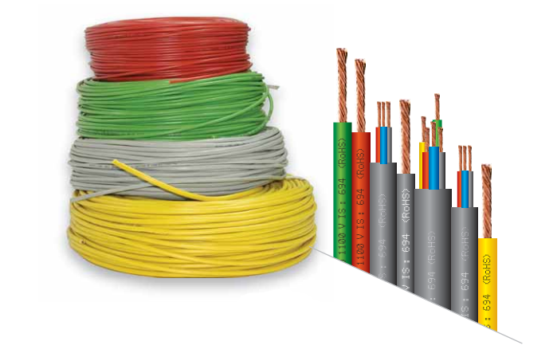

|  |  |
| --- | --- |
| **Technical Word** | **Common Word for search** |
| **Panel Wire** | PW |
| SQ.MM 0.5 | FR 0.5 |
| SQ.MM 1.5 | FR 1.5 |
| SQ.MM 2.5 | FR 2.5 |
| SQ.MM 4.0 | FR 4.0 |
| SQ.MM 10 | FR 10 |
| SQ.MM 16 | FR 16 |
| SQ.MM 50 | FR 50 |
| **PW – FRLSH** | **FRLSH** |
| SQ.MM 0.5 | FRLSH 0.5 |
| SQ.MM 1.0 | FRLSH 1.0 |
| SQ.MM 1.5 | FRLSH 1.5 |
| SQ.MM 2.5 | FRLSH 2.5 |
| SQ.MM 4.0 | FRLSH 4.0 |
| SQ.MM 6 | FRLSH 6.0 |
| SQ.MM 16 | FRLSH 16 |
| SQ.MM 35 | FRLSH 35 |
| **PW - LSHF** | **LSHF** |
| SQ.MM 2.5 | LSHF 2.5 |
| Search for FR PVC “IS 694” First select the product group and then search for the item code. | |
| Wires Specifications IS 694 | PW IS 694 |
| **Color Code for Search** |  |
| YELLOW | YE |
| RED | RD |
| BLUE | BU |
| BLACK | BK |
| WHITE | WH |
| GREEN | GN |
| Perrot Green | P.GN |
| GRAY | GY |
| Silver GRAY | S.GY |
| Light GRAY | LT.GY |
| **Packing as per meters** |  |
|  | 100 Mtr |
|  | 200 Mtr |

1. Solar Cable

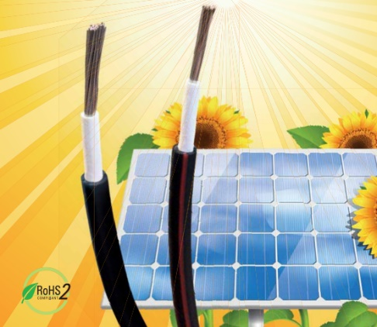

|  |  |
| --- | --- |
| **Technical Word** | **Common Word for search** |
| **Solar Cable** | Solar Cable |
| SQ.MM 1.5 | 1.5 |
| SQ.MM 2.5 | 2.5 |
| SQ.MM 4 | 4.0 |
| SQ.MM 6 | 6.0 |
| SQ.MM 10 | 140/0.30 |
| SQ.MM 16 | 126/0.40 |
| SQ.MM 25 | 196/0.40 |
| SQ.MM 35 | 276/0.40 |
| SQ.MM 50 | 396/0.40 |
| SQ.MM 70 | 354/0.50 |
| SQ.MM 95 | 480/0.50 |
| SQ.MM 120 | 607/0.50 |
| SQ.MM 150 | 760/0.50 |
| SQ.MM 185 | 941/0.50 |
| SQ.MM 240 | 1221/0.50 |
| Search for Solar Cables “IS 694” First select the product group and then search for the item code. | |
| Wires Specifications Standards | IS 694 , IEC-62930, IEC/EN/IS |
| **Color Code For Search** | RD, BK, BK/RD |
| Red | RD |
| Black | BK |
| Black/Red | BK/RD |
| Packing as per meters | 100, 200 |

1. Telephone Cable

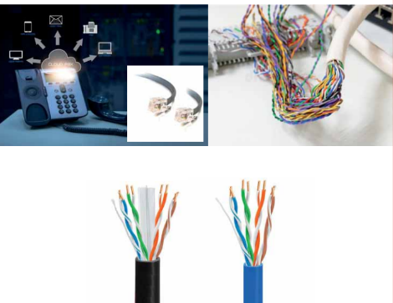

|  |  |
| --- | --- |
| **Technical Word** | **Common Word for search** |
| **Telephone Cable** | TPW |
| **Pair** |  |
| 2 | 2 pair |
| 4 | 4 Pair |
| **Wires Specifications Standards** | ABC |
| **Color Code For Search** |  |
| **Gray** | GY |
| **Packing as per meters** | 100 MTRS |

1. Screen Cable

5-1) AL SCREENED CABLES

|  |  |
| --- | --- |
| **Technical Word** | **Common Word for search** |
| **AL SCREENED CABLES** | [AL-SCR](javascript:void(0)) |
| **Pair** |  |
| 2 | 2 pair |
| 4 | 4 Pair |
| **Wires Specifications Standards** | ABC |
| Search for Screen Cable “ First select the product group and then search for the item code. | |
| **Color Code For Search** |  |
| **Red + Yellow + Blue + Green** | RD+YE+BU+GN |
| **White + Black** | WH+BK |
| **Red+Yellow+Blue+Green+White+Black+Gray** | RD+YE+BU+GN+WH+BK+GY |
| **Black+Red** | BK+RD |
| **Green+Yellow** | GR+YE |
| **Red+Yellow+Blue+Green+White+Black+Gray** | RD+YE+BU+GN+WH+BK+GY |
| **Red+Yellow+Blue+Black** | RD+YE+BU+BK |
| **Red+Yellow+Blue+Black+Green+Sliver.Gray+White** | RD+YE+BU+BK+GN+S.GY+WH |
| **Red+Yellow+Blue+Green** | RD+YE+BU+GN |
| Packing as per meters | 200 MTRS, 300 MTRs, 500 MTRS, 1000MTRs |

5-2) CU SCREENED CABLES

|  |  |
| --- | --- |
| **Technical Word** | **Common Word for search** |
| **CU SCREENED CABLES** | [CU.SCR](javascript:void(0)) |
| **SQ.MM** |  |
| SQ.MM 0.50 | 0.50 |
| SQ.MM 0.75 | 0.75 |
|  | 1C |
|  | 2C |
|  | 3C |
|  | 4C |
|  | 6C |
| **Wires Specifications Standards** | ABC |
| Search for CU Screen Cable “ First select the product group and then search for the item code. | |
| **Color Code For Search** |  |
| **Black** | BK |
| **Orange** | OG |
| **Blue** | BU |
| **Red** | RD |
| **White** | WH |
| **Green** | GN |
|  | Dummy |
| **Packing as per meters** | 200 MTRS, 300 MTRs |

5-3) ATC SCREENED CABLES

|  |  |
| --- | --- |
| **Technical Word** | **Common Word for search** |
| **ATC SCREENED CABLES** | [ATC-SCR](javascript:void(0)) |
| **SQ.MM** |  |
| SQ.MM 0.50 | 0.50 |
|  | 2C |
|  | 6C |
|  | 7C |
| **Wires Specifications Standards** | ATC, ABC |
| Search for ATC Screen Cable “ First select the product group and then search for the item code. | |
| **Color Code For Search** |  |
| **Light.Gray** | LT.GY |
| **Black** | BK |
| **Orange** | OG |
| **Blue** | BU |
| **Red** | RD |
| **White** | WH |
| **Green** | GN |
|  | Dummy |
| **Packing as per meters** | 300 MTRs |

5-4) AL MYL SCREENED CABLES

|  |  |
| --- | --- |
| **Technical Word** | **Common Word for search** |
| **AL MYL SCREENED CABLES** | [AL.MY](javascript:void(0)) |
| **SQ.MM** |  |
| SQ.MM 0.50 | 0.50 |
| SQ.MM 0.75 | 0.75 |
|  | 2C |
|  | 6C |
|  | 7C |
| **Wires Specifications Standards** | ATC, ABC |
| Search for AL MYL Screen Cable “ First select the product group and then search for the item code. | |
| **Color Code For Search** |  |
| **Light.Gray** | LT.GY |
| **Black** | BK |
| **Orange** | OG |
| **Blue** | BU |
| **Red** | RD |
| **White** | WH |
| **Green** | GN |
|  | Dummy |
| **Packing as per meters** | 200 MTRs, 300 MTRs, 400 MTRs |

1. Automobile and Battery cable

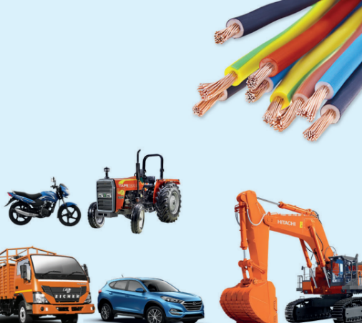

|  |  |
| --- | --- |
| **Technical Word** | **Common Word for search** |
| **AUTO BATTERY CABLES** | [BTC](javascript:void(0)) |
| **SQ.MM** |  |
| SQ.MM | 16.00 |
| SQ.MM | 25.00 |
|  | 35.00 |
|  | 40.00 |
|  | 50.00 |
|  | 60.00 |
|  | 70.00 |
| **Wires Specifications Standards** | ABC |
| Search for Automobile and Battery cable select the product group and then search for the item code. | |
| **Color Code For Search** |  |
| **Black** | BK |
| **Blue** | BU |
| **Red** | RD |
| **Packing as per meters** | 25 MTRs, 50 MTRs, 70 MTRs, 90 MTRs, 100 MTRs |

1. TPU Cable

|  |  |
| --- | --- |
| **Technical Word** | **Common Word for search** |
| **TPU FLEXIBLE MULTICO** | TPU FMC |
| **SQ.MM** |  |
|  | 0.50 |
|  | 0.75 |
|  | 16 |
|  | 50 |
|  | 300 |
| **Wires Specifications Standards** |  |
| Search for TPU Flexible Multico cable select the product group and then search for the item code. | |
| **Color Code For Search** |  |
| **Black** | BK |
| **Bworn** | BN |
| **Camel Bworn** | CAM.BN |
| **Packing as per meters** | 300MTRs, 500MTRs |

1. Submersible Cable

|  |  |
| --- | --- |
| **Technical Word** | **Common Word for search** |
| **SUBMERSIBLE FLAT CABLES** | SUB |
| **SQ.MM** |  |
|  | 1.50 |
|  | 2.50 |
|  | 4.00 |
|  | 6.00 |
|  | 10.00 |
|  | 16.00 |
| **Wires Specifications Standards** |  |
| Search for Submersible Cable select the product group and then search for the item code. | |
| **Color Code For Search** |  |
| **Black** | BK |
| **Packing as per meters** | 1. RS, 500MTRS |

1. Flexible Multicore Cable

|  |  |
| --- | --- |
| **Technical Word** | **Common Word for search** |
| **FLEXIBLE MULTICORE CABLES** | FMC |
| **SQ.MM** |  |
|  | 0.50 |
|  | 0.75 |
|  | 1.00 |
|  | 1.50 |
|  | 2.50 |
|  | 4.00 |
|  | 6.00 |
|  | 10.00 |
|  | 16.00 |
|  | 25.00 |
|  | 35.00 |
| **Wires Specifications Standards** |  |
| Search for Flexible Multicore Cable select the product group and then search for the item code. | |
| **Color Code For Search** |  |
| **Black** | BK |
| **White** | WH |
| **Red** | RD |
| **Yellow** | YE |
| **Blue** | BU |
| **Green** | GN |
| **Packing as per meters or cm** | 90 CM, 0.750 MTRS, 1.750 MTRS, 100 MTRS, 200MTRS, 500MTRS |