Executive Summary
Product Line Profitability & Margin Performance - Nassau Candy Distributor | Jan 2024 - Dec 2025

Bottom line
Nassau Candy is profitable (65.9% gross margin) but dependent on five chocolate products. Two products need immediate pricing or cost action, and a long tail of small products adds complexity without adding profit.

Key numbers
Sales | Gross profit | Gross margin | Units | Profit / unit
$141,784 | $93,443 | 65.9% | 38,654 | $2.42

What we found
- Five Wonka Bars carry the business. They provide 92.9% of revenue and 95.1% of profit, at margins of 65% to 71%.
- Concentration is high. Only 5 of 15 products are needed to reach 80% of revenue and of profit. The Chocolate division makes 95% of profit and two factories (Lot's O' Nuts and Wicked Choccy's) make 95%.
- Kazookles is nearly break-even. Margin is 7.7%: it costs $3.00 to make and sells for $3.25.
- Lickable Wallpaper under-earns. It has 5.5% of revenue but only a 50% margin, 15 to 21 points below the chocolate bars.
- The tail adds little. Wonka Gum and seven Sugar products together provide 0.7% of revenue.
- Margins are structural, not volatile. Prices and unit costs do not change over time, and margins are almost identical across regions (65.5% to 66.4%). Product mix drives profit.
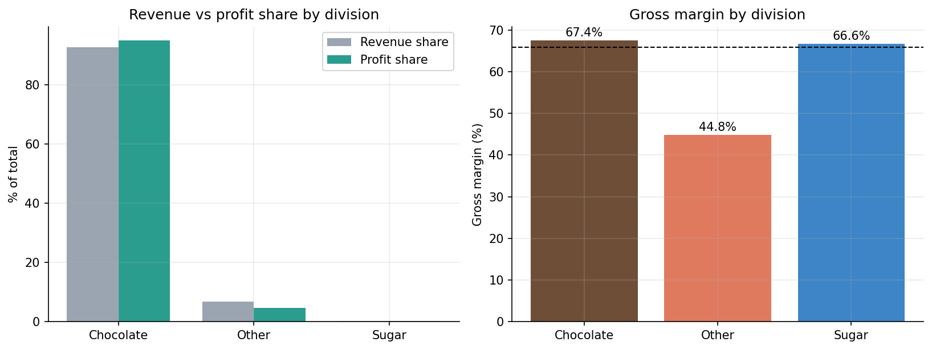

Recommended actions
- Reprice or recost Kazookles; discontinue if a 60% margin is not achievable. (about +$631 profit)
- Renegotiate Lickable Wallpaper cost (unit cost $10 to $8) or raise price to $25. (about +$786 profit)
- Review Wonka Gum, SweeTARTS, Nerds and Fun Dip for discontinuation or bundling.
- Reduce supply risk in the chocolate franchise: backup production capacity and safety stock.
- Adopt a 60% gross-margin floor for pricing decisions and monitor it with the dashboard.
Expected impact: Actions 1 and 2 add about $1,417 (+1.5% of gross profit over the 24 months) at constant volume; the larger benefit is lower dependency risk.

Caveats
Gross profit excludes freight and overheads. Sugar products have very few sales records. Ship-date data is unreliable and was not used. Full detail is in the research paper, and the Streamlit dashboard allows live exploration by date, division, margin threshold and product.

