Unified Mentor Project
Product Line Profitability & Margin Performance Analysis
Nassau Candy Distributor
Research Paper: Exploratory Data Analysis, Insights and Recommendations
Author: Akshar Prajapati
Data period: 2 January 2024 - 31 December 2025 | 10,194 order lines

Abstract
Sales volume alone is a misleading measure of product success. This paper analyses 10,194 order lines (January 2024 to December 2025) from Nassau Candy Distributor to determine which product lines actually generate profit, which divisions dilute margin, and where pricing, sourcing or portfolio decisions are needed. The business earned $141,784 in sales and $93,443 in gross profit, a portfolio gross margin of 65.9%.
The analysis shows an extremely concentrated business. Five Wonka Bar products account for 92.9% of revenue and 95.1% of gross profit, and only 5 of the 15 products (33%) are needed to reach 80% of both revenue and profit. Two products represent clear margin risk: Kazookles earns a gross margin of only 7.7% (cost is 92% of price), and Lickable Wallpaper, the only non-chocolate product with meaningful sales, earns 50.0%, well below the 66.5% to 71.4% of the chocolate bars. Seven Sugar-division products and Wonka Gum together contribute under 1% of revenue and are candidates for portfolio review.
A further structural finding is that unit price and unit cost are constant for every product across all 24 months, so margin volatility is effectively zero. Portfolio margin is therefore determined by product mix, not by discounting or cost drift. Fixing the two margin-risk products alone, at constant volume, would raise gross profit by roughly $1,417 (+1.5%); the larger strategic exposure is dependence on one division and one factory.

1. Introduction
For a confectionery distributor, high sales do not guarantee high profit. Some products sell in volume but earn thin margins; others consume a disproportionate share of manufacturing cost. Without product-level visibility, decisions on pricing, promotion and portfolio remain reactive and intuition-based.

1.1 Problem statement
The organisation lacks clear answers to four questions: which product lines deliver the highest gross margin; whether high-sales products are actually profitable; how profitability varies across divisions; and which products represent margin risk.

1.2 Objectives
- Calculate gross margin, profit per unit and profit/revenue contribution for every product.
- Rank products and divisions, and segment products by sales level and margin level.
- Measure profit concentration using Pareto analysis and dependency indicators.
- Diagnose cost structure and flag products for repricing, cost renegotiation or discontinuation review.
- Deliver the findings as this paper, an interactive Streamlit dashboard and an executive summary.

2. Data and Cleaning

2.1 Dataset
The dataset contains one row per order line with 18 fields: order and ship dates, ship mode, customer geography (country, state/province, city, postal code, region), division, product ID and name, sales, units, cost and gross profit. It covers 15 products in 3 divisions (Chocolate, Sugar, Other), 8,549 distinct orders, 4 regions and 59 states/provinces (9,994 U.S. rows and 200 Canadian rows). The brief also supplies a product-to-factory mapping for five factories, which was joined to every row.

2.2 Validation steps and results
Check | Result
Missing values (all fields) | None
Zero or negative sales / units / cost | 0 rows
Gross Profit = Sales - Cost (tolerance $0.02) | Holds on all 10,194 rows
Duplicate Row IDs | 0
Order dates parsed (dd-mm-yyyy) | 100% valid, 2 Jan 2024 - 31 Dec 2025
Product label standardisation | 'Wonka Bar -Scrumdiddlyumptious' corrected to 'Wonka Bar - Scrumdiddlyumptious'; labels trimmed
Product ID to product name | One-to-one for all 15 products
Ship Date anomaly | All ship dates fall 904-1,642 days (median 1,274) after order date, beyond Dec 2025

No rows needed to be removed. The ship-date anomaly (ship dates lying years after order dates) looks like a data-generation or date-shift artefact. Because this study concerns profitability, not delivery performance, Ship Date was excluded from all calculations, but the issue should be corrected at source before any logistics analysis.

3. Methodology

3.1 Metrics
KPI | Definition
Gross Margin (%) | Sum of Gross Profit / Sum of Sales x 100 (aggregated first, never an average of row margins)
Profit per Unit | Gross Profit / Units
Revenue Contribution (%) | Product sales / total sales
Profit Contribution (%) | Product gross profit / total gross profit
Margin Volatility | Standard deviation of monthly gross margin (percentage points); requires at least 3 months of sales
Cost Ratio (%) | Cost / Sales; the complement of gross margin
HHI | Herfindahl-Hirschman index of profit shares (0 to 10,000); above 2,500 indicates high concentration

3.2 Segmentation and risk-flag rules
Products were placed in four segments using two cut-offs: high-sales means at least 5% of total revenue, and high-margin means at least the margin threshold (default 60%, adjustable in the dashboard). Risk flags follow explicit rules:
- Critical: gross margin below 25%, so reprice and renegotiate cost.
- Below target: margin below threshold with at least 1% revenue share, so cost renegotiation.
- Discontinuation review: margin below threshold and revenue share below 0.5%.
- Low-volume watch: healthy margin but revenue share below 0.5%.
All calculations are implemented in a single Python module (src/metrics.py) shared by the analysis script and the dashboard, so figures in this paper and the dashboard reconcile exactly.

4. Exploratory Data Analysis and Results

4.1 Overall performance
The business generated $141,784 in sales, $48,341 in cost and $93,443 in gross profit from 38,654 units, a gross margin of 65.9% and profit of $2.42 per unit. Sales grew 44.6% from $57,956 in 2024 to $83,827 in 2025 while gross margin stayed flat (65.8% to 66.0%), so growth came from volume rather than from any change in unit economics.
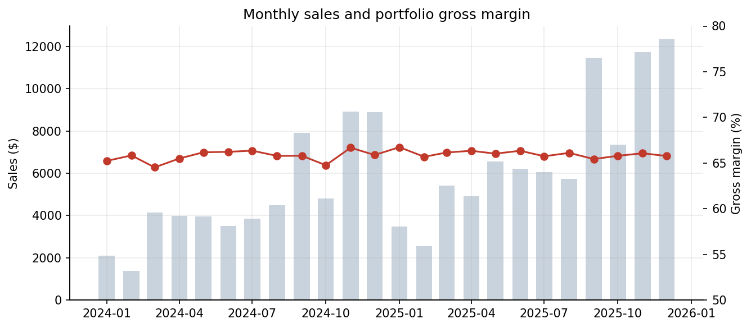
Figure 1. Monthly sales and portfolio gross margin

4.2 Product-level profitability
Table 1 ranks all 15 products by gross profit. The five Wonka Bars occupy ranks 1 to 5, each contributing 17.8% to 20.7% of profit. Nutty Crunch Surprise has the highest margin (71.4%) and Scrumdiddlyumptious the highest profit ($19,358). Milk Chocolate has the lowest bar margin (64.9%) but still sits close to the portfolio average.
# | Product | Division | Sales $ | Profit $ | GM % | Profit/Unit $ | Rev % | Profit %
1 | WB: Scrumdiddlyumptious | Chocolate | 27,875 | 19,358 | 69.4 | 2.50 | 19.66 | 20.72
2 | WB: Triple Dazzle Caramel | Chocolate | 28,485 | 18,610 | 65.3 | 2.45 | 20.09 | 19.92
3 | WB: Milk Chocolate | Chocolate | 26,868 | 17,443 | 64.9 | 2.11 | 18.95 | 18.67
4 | WB: Nutty Crunch Surprise | Chocolate | 23,575 | 16,820 | 71.3 | 2.49 | 16.63 | 18.00
5 | WB: Fudge Mallows | Chocolate | 24,890 | 16,594 | 66.7 | 2.40 | 17.56 | 17.76
6 | Lickable Wallpaper | Other | 7,860 | 3,930 | 50.0 | 10.00 | 5.54 | 4.21
7 | Wonka Gum | Other | 598 | 311 | 52.0 | 0.65 | 0.42 | 0.33
8 | Everlasting Gobstopper | Sugar | 130 | 104 | 80.0 | 8.00 | 0.09 | 0.11
9 | Kazookles | Other | 1,206 | 93 | 7.7 | 0.25 | 0.85 | 0.10
10 | Hair Toffee | Sugar | 76 | 60 | 77.8 | 3.50 | 0.05 | 0.06
11 | Fizzy Lifting Drinks | Sugar | 79 | 47 | 60.0 | 2.25 | 0.06 | 0.05
12 | Laffy Taffy | Sugar | 54 | 33 | 62.3 | 1.24 | 0.04 | 0.04
13 | SweeTARTS | Sugar | 62 | 29 | 46.7 | 0.70 | 0.04 | 0.03
14 | Nerds | Sugar | 15 | 7 | 46.7 | 0.70 | 0.01 | 0.01
15 | Fun Dip | Sugar | 12 | 5 | 40.0 | 0.60 | 0.01 | 0.01
Table 1. Product profitability leaderboard (ranked by gross profit)
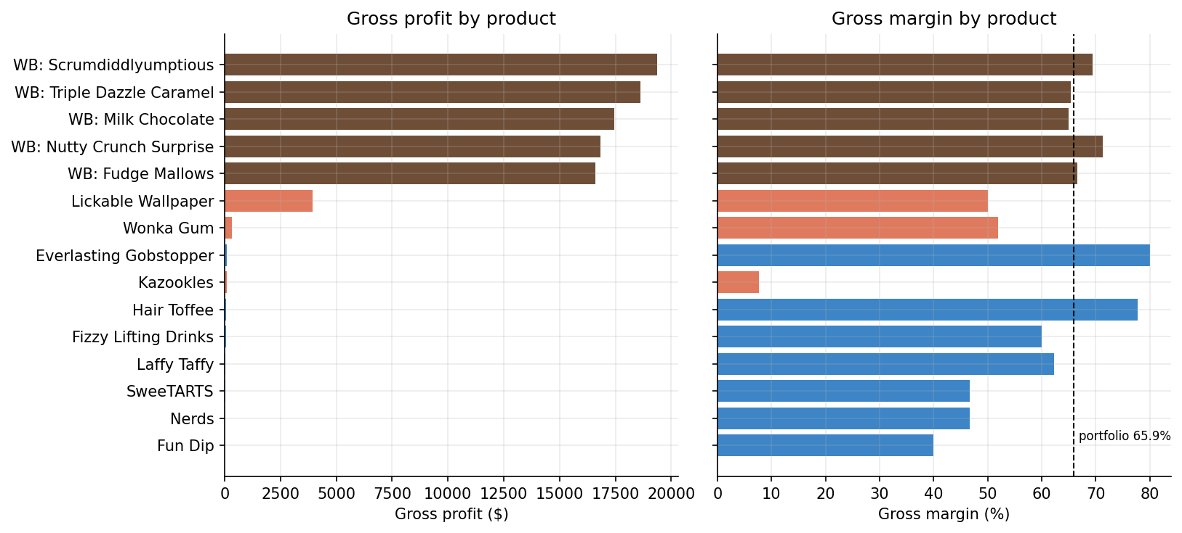
Figure 2. Gross profit and gross margin by product

4.3 Segmentation: high-sales, low-margin and low-sales, low-profit products
- High-profit / high-margin (5 products): all five Wonka Bars, 93% of revenue and 95% of profit.
- High-sales / low-margin (1 product): Lickable Wallpaper. It is the sixth-largest product with 5.5% of revenue, but a 50.0% margin means it delivers only 4.2% of profit. Its unit price is $20.00 against a unit cost of $10.00.
- Low-sales / low-profit (5 products): Kazookles, Wonka Gum, SweeTARTS, Nerds and Fun Dip. Each contributes at most 0.33% of profit.
- Low-sales / high-margin (4 products): Everlasting Gobstopper (80.0%), Hair Toffee (77.8%), Laffy Taffy (62.3%) and Fizzy Lifting Drinks (60.0%). Margins are healthy but volumes are tiny (3 to 10 order lines each).
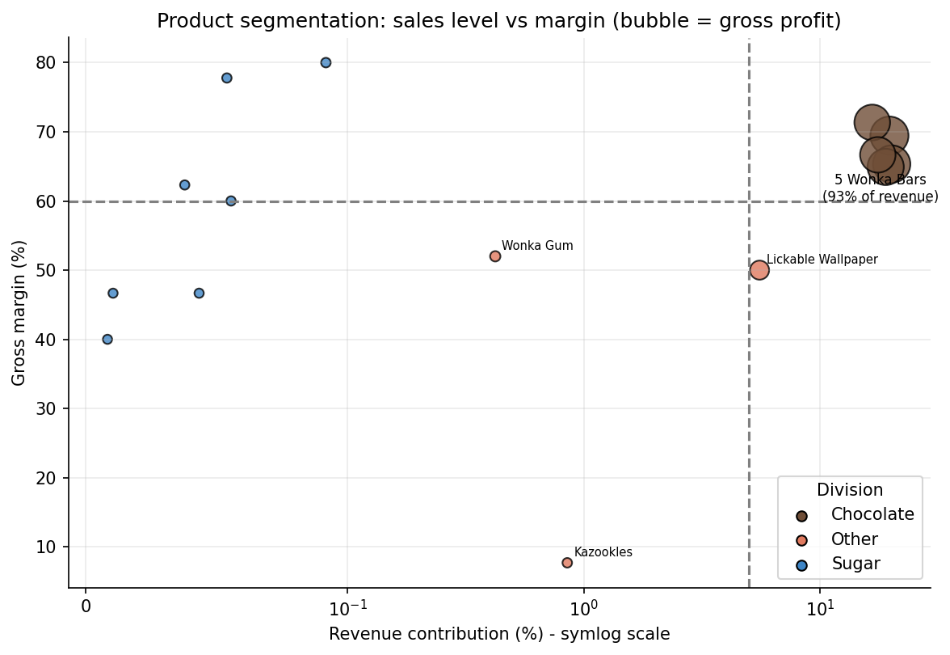
Figure 3. Product segmentation by revenue share and gross margin

4.4 Division-level performance
Division | Sales $ | Profit $ | GM % | Rev share % | Profit share % | Gap (pp) | Avg product GM %
Chocolate | 131,693 | 88,825 | 67.4 | 92.88 | 95.06 | +2.17 | 67.5
Other | 9,663 | 4,333 | 44.8 | 6.82 | 4.64 | -2.18 | 36.6
Sugar | 427 | 285 | 66.6 | 0.30 | 0.30 | +0.00 | 59.1
Table 2. Division performance
Chocolate has both the largest scale and a margin (67.4%) above the portfolio average, and its profit share exceeds its revenue share by 2.2 percentage points. The Other division is the structural weak point: its 44.8% margin is 21 points below Chocolate, it gives back 2.2 points of profit share relative to revenue share, and its unweighted average product margin is only 36.6% because Kazookles (7.7%) pulls it down alongside Lickable Wallpaper (50.0%) and Wonka Gum (52.0%). Sugar's 66.6% margin looks strong, but it rests on only 40 order lines and $427 of sales, so it should not be treated as reliable.
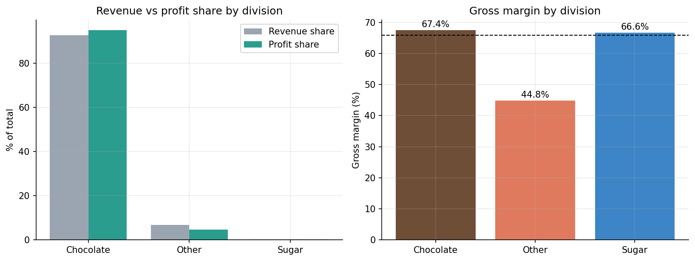
Figure 4. Revenue vs profit share and gross margin by division
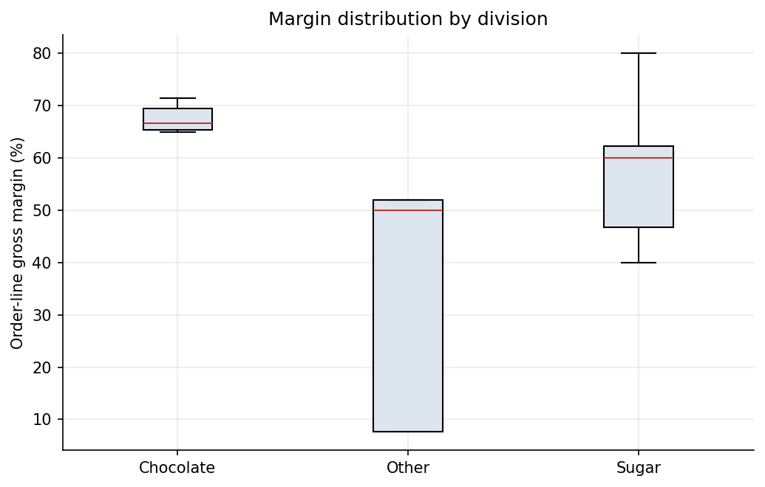
Figure 5. Distribution of order-line margins by division

4.5 Profit concentration (Pareto)
Only 5 of 15 products (33%) are needed to reach 80% of revenue, and the same 5 are needed for 80% of profit. The profit HHI is 1,831 at product level, but because all top products sit in one division and two factories, concentration is far higher at those levels (Table 3).
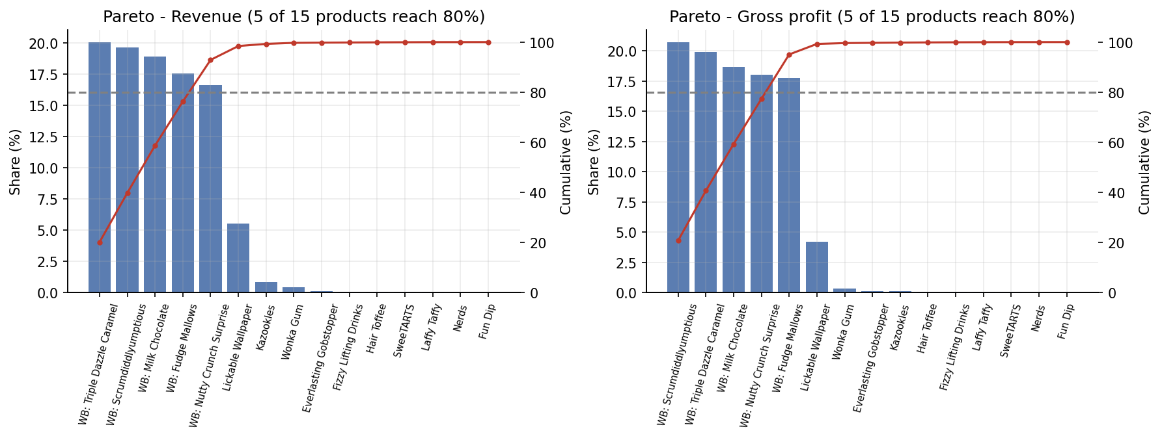
Figure 6. Pareto charts for revenue and gross profit
Dimension | Top item | Top share % | Top-3 share % | HHI | Risk
Product | Wonka Bar - Scrumdiddlyumptious | 20.7 | 59.3 | 1,831 | Low
Factory | Lot's O' Nuts | 56.5 | 99.7 | 4,700 | High
State/Province | California | 19.8 | 40.3 | 765 | Low
Region | Pacific | 32.6 | 84.3 | 2,664 | Moderate
Division | Chocolate | 95.1 | 100.0 | 9,058 | High
Table 3. Dependency indicators (shares of gross profit)
Two dependency risks stand out. First, the Chocolate division generates 95.1% of profit (HHI 9,058). Second, the factory Lot's O' Nuts produces 56.5% of profit and, together with Wicked Choccy's, 95.0%; a disruption at either site would put most of the business at risk. Geographic concentration is moderate: the Pacific region provides 32.6% of profit and California alone 19.8%; the top 5 states provide 50.7% and 16 of 59 states reach 80%. Regional margins are almost identical (65.5% to 66.4%), so geography influences volume but not margin.
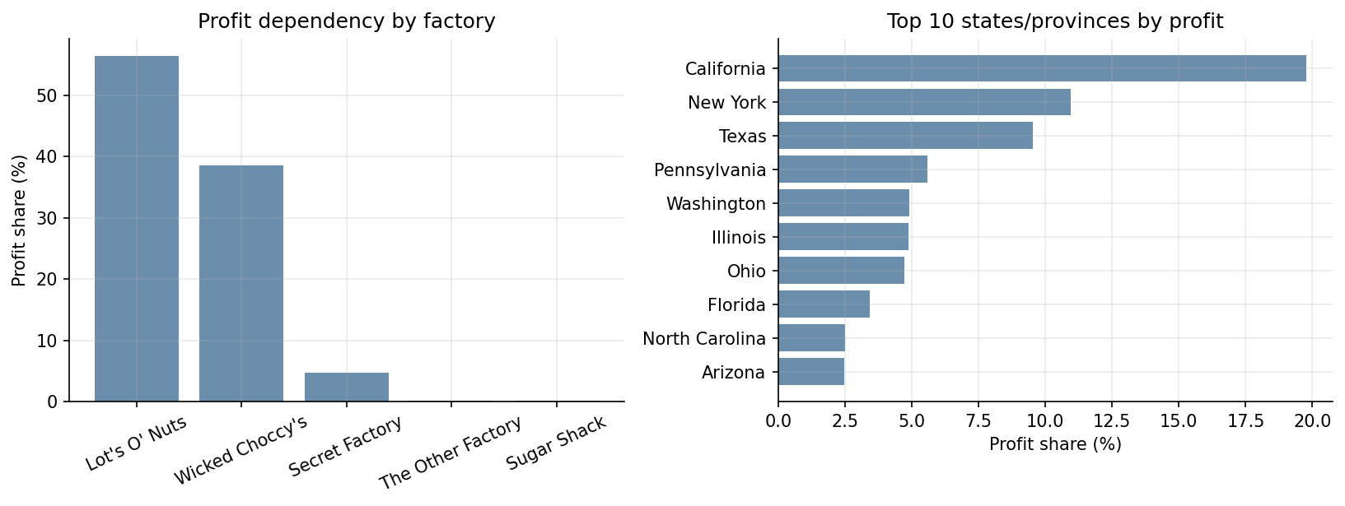
Figure 7. Profit dependency by factory and by state/province
Factory | Sales $ | Profit $ | GM % | Profit share %
Lot's O' Nuts | 76,340 | 52,771 | 69.1 | 56.47
Wicked Choccy's | 55,353 | 36,054 | 65.1 | 38.58
Secret Factory | 8,588 | 4,345 | 50.6 | 4.65
The Other Factory | 1,282 | 152 | 11.9 | 0.16
Sugar Shack | 221 | 121 | 54.9 | 0.13
Table 4. Factory profitability (via product-to-factory mapping)
The Other Factory (Hair Toffee and Kazookles) earns an 11.9% margin and 0.16% of profit, driven by Kazookles. Secret Factory (Gobstopper, Lickable Wallpaper, Wonka Gum) earns 50.6%, well below the two chocolate factories.

4.6 Cost structure diagnostics
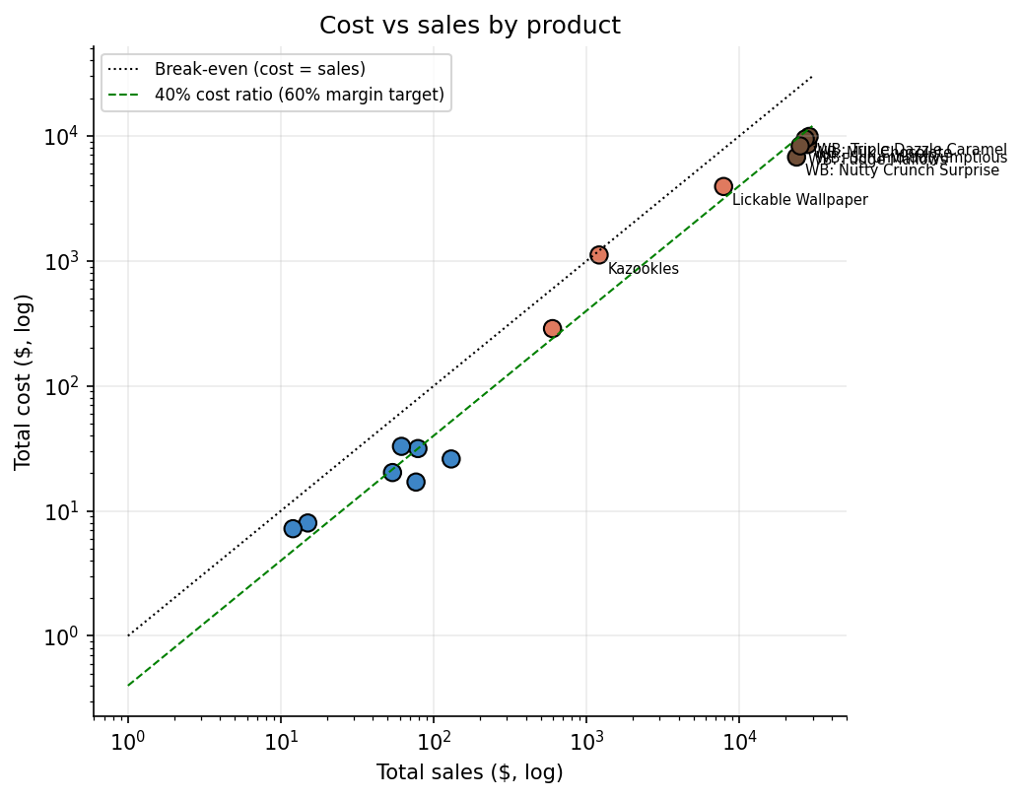
Figure 8. Cost vs sales; products above the dashed line miss the 60% margin target
On the cost-sales scatter, the five chocolate bars sit well below the 40% cost-ratio line, while Lickable Wallpaper (50% cost ratio) and Kazookles (92% cost ratio) sit above it. Unit economics explain why:
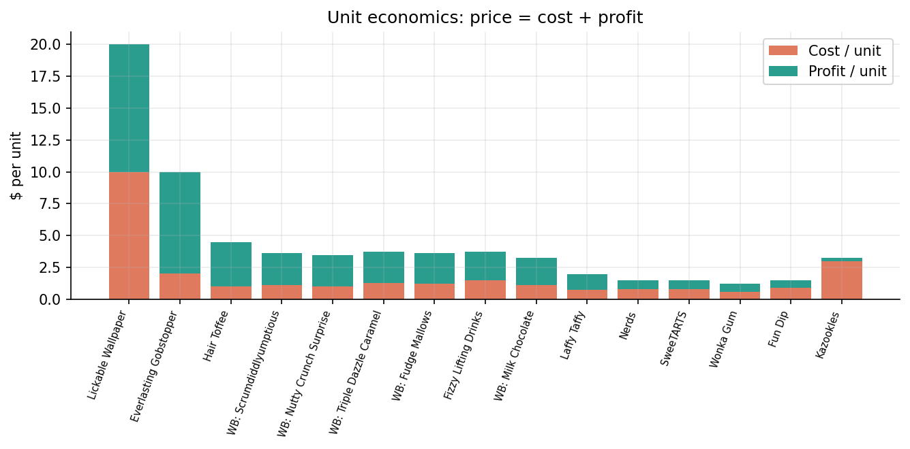
Figure 9. Unit economics: price split into cost and profit
Kazookles sells at $3.25 per unit and costs $3.00 to make, leaving $0.25 of profit per unit (compared with $2.11 to $2.50 for a Wonka Bar sold at a similar price). Lickable Wallpaper earns $10.00 profit per unit, the highest in the range, but its 50% margin is below target, so its cost base has the most room to improve in absolute terms.
Product | GM % | Cost ratio % | Rev share % | Flag
Lickable Wallpaper | 50.0 | 50.0 | 5.54 | Below target - cost renegotiation
Wonka Gum | 52.0 | 48.0 | 0.42 | Discontinuation review
Everlasting Gobstopper | 80.0 | 20.0 | 0.09 | Low-volume watch
Kazookles | 7.7 | 92.3 | 0.85 | Critical - reprice & renegotiate cost
Hair Toffee | 77.8 | 22.2 | 0.05 | Low-volume watch
Fizzy Lifting Drinks | 60.0 | 40.0 | 0.06 | Low-volume watch
Laffy Taffy | 62.3 | 37.7 | 0.04 | Low-volume watch
SweeTARTS | 46.7 | 53.3 | 0.04 | Discontinuation review
Nerds | 46.7 | 53.3 | 0.01 | Discontinuation review
Fun Dip | 40.0 | 60.0 | 0.01 | Discontinuation review
Table 5. Margin-risk flags at the 60% threshold

4.7 Margin volatility
For every product, unit price and unit cost are constant across all order lines and months. Consequently the monthly gross margin of each product has a standard deviation of zero (Fun Dip has fewer than three months of data). This means that (a) no discounting, promotion or cost fluctuation is visible in the data, (b) portfolio margin moves only through product mix, and (c) margin risk is structural, built into list prices and standard costs, rather than caused by operational leakage. If actual transaction prices vary in practice, the dataset is not capturing it.

5. Recommendations
- Reprice and renegotiate Kazookles (priority 1). At $3.25 price and $3.00 unit cost the product is close to break-even. Reaching a 60% margin needs either a price near $7.50 at current cost or a cost near $1.30 at current price; a realistic mix is a moderate price rise plus supplier or recipe renegotiation. If neither is feasible, discontinue. At constant volume, a 60% margin would add about $631 of profit.
- Renegotiate the cost of Lickable Wallpaper (priority 2). It is the largest non-chocolate line, with 5.5% of revenue. A unit cost of $8.00 (-20%) or a price of $25.00 reaches 60% margin and would add about $786 of profit at constant volume.
- Review Wonka Gum, SweeTARTS, Nerds and Fun Dip for discontinuation. All four have margins of 40% to 52% and under 0.5% of revenue each; the three Sugar items earn just $41 of profit combined. Decide whether to reprice, bundle or drop them to cut portfolio complexity.
- Test growth for high-margin niche products. Everlasting Gobstopper (80%), Hair Toffee (77.8%), Laffy Taffy and Fizzy Lifting Drinks have healthy margins but almost no volume. Small promotions or placement tests could show whether demand can be grown.
- Protect the chocolate franchise and diversify production. With 95% of profit in five bars made at two factories, supply continuity planning (backup co-manufacturing, safety stock) and incremental development of a second profit engine are the most valuable strategic actions.
- Use a margin threshold in pricing governance. Adopt a floor (e.g. 60% gross margin for new SKUs) and review any product below it quarterly, using the dashboard's margin-threshold slider and risk flags.
- Fix the data. Correct the ship-date anomaly, and capture actual transaction prices, discounts and period costs so margin volatility can be measured meaningfully.
Estimated impact: Items 1 and 2 together would add about $1,417 of gross profit over the 24-month period (+1.5% of the total) at constant volume; this ignores price elasticity and should be treated as an upper bound.

6. Limitations
- Gross profit uses manufacturing cost only; freight, marketing and overheads are excluded, so net profitability may differ.
- Constant unit price and cost per product suggest standardised or synthetic data; margin volatility and pricing-inefficiency conclusions are limited by this.
- Sugar-division products have very few observations (3 to 10 order lines each), so their margins are indicative only.
- Impact estimates assume unchanged volumes and no price elasticity.
- Ship dates are unreliable, so delivery and logistics analysis was out of scope.

7. Conclusion
Nassau Candy's profit comes from five Wonka Bars that deliver margins of 65% to 71%. Beyond them, the portfolio is thin: one meaningful product with a sub-target margin (Lickable Wallpaper), one product close to break-even (Kazookles), and a tail of items that barely register. The most actionable steps are repricing or recosting Kazookles and Lickable Wallpaper, rationalising the low-volume tail, and managing the concentration risk in the chocolate division and its two factories. The accompanying Streamlit dashboard lets management explore these results by date, division, margin threshold and product.

Appendix: Deliverables and reproducibility
- app.py: Streamlit dashboard (run with: streamlit run app.py).
- analysis.py: reproduces every table and figure in this paper into charts/ and outputs/.
- src/metrics.py: cleaning and KPI functions shared by both.
- outputs/: product, division, Pareto, dependency and factory tables as CSV; clean_data.csv.

