**Notes from 2022 Fall Garden Group meeting:**

**King Conservation District (KCD) sale** starts Nov 15th. You need to sign up ahead of time to get the email invitation to place your order. KCD.org Native plant sale. Those who order can sign up for 10am on the first pick up day (March 4th) so we can car pool and pick everything up together. They have a very useful website with lots of information on native NW plants.

**New Broadhurst Website** will include a Broadhurst Garden Group page where we can post information and ask questions, have dialogue. Sean Peng will be our IT person setting it up and maintaining it.

**Favorite Trees for Fall Color:**

Cornus Cusa Dogwood: Beautiful white flowers, Fall Color

Coral Bark Maple: Beautiful Fall Color (Yellow Orange)

Red Sunset Maple: Beautiful Fall Color (Red) Big Trees

Stewartia: Spring flowers (white), Fall Color

Katsura: Beautiful Tree

Best Dahlia Bulbs:

Swan Island Dahlias in Oregon <https://www.dahlias.com/shop>

Other favorite bulbs: King Alfred Daffodil

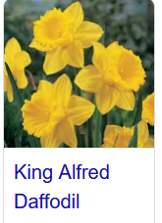 Tete A Tete Daffodil 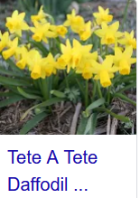

Rodent problems? Attic Crew was recommended for bigger problems. For regular pest control, electronic mousetraps were recommended. They’re available through Amazon and other sources.