**Team Name :** ______ KALAM_____________________

|  |  |  |  |  |
| --- | --- | --- | --- | --- |
|  | **Name** | **Branch and Semester** | **Contact Number** | **Email- ID** |
| **Team Leader** | AMITKUMAR SIDDARADDI | EEE & 6TH | 9113204358 | Amit4599hoy@gmail.com |
| **Member 1** | VINAY L | EEE & 6TH | 9972144742 | Vinay30s99@gmail.com |
| **Member 2** | NAVYASHREE B M | EEE & 6TH | 7019360607 | Shree.navya144@gmail.com |
| **Transaction ID**  **(anju.marina.lobo@oksbi)** | P2002231243307343456692 | | | |

**Note:**

1. One can participate either as a part of a team or an individual basis. Switching teams is not allowed.
2. The uploaded ideas will be screened to go to the second round.
3. Judging : competition entries shall be judged, or winners selected based on the following criteria

* Is the problem worth solving
* How innovative or novel is the idea
* Scientific accuracy
* Social impact
* Scalability

1. Decisionsof IIC JSSSTUin respect of all matters to do with the competition will be final and no correspondence will be entertained.
2. In second round, the selected teams will have to present their idea in front of the jury panel.
3. Payment of INR 50 should be made to the UPI ID [**anju.marina.lobo@oksbi**](mailto:anju.marina.lobo@oksbi)and submit the transaction ID above.
4. Idea should be submitted in **.pdf** format.

**Abstract:**

In modern days efficient usage and saving of energy is most required and the biggest challenge to human kind, as most of the conventional energy resources available today are depleting. Even now we make use of very old technique of establishing electrical contact between moving mechanical part and static electrical part, which is using graphite brushes. The usage of these brushes have huge internal disadvantages, major being friction. The frictional losses contributed by brushes are 20 to 30% of full load losses, which are comparatively very huge loss and should not be neglected.

So we have come up with an idea by which we can have a mechanism of establishing electrical contact between moving mechanical part and static electrical part with reduced frictional loss and thus increasing efficiency of motor and thus reducing wastage of energy.

**Introduction**

As said above even now some of electrical machines have still many unaddressed inherent problems. One of them being huge friction between brush and commutator or slip rings (in case of slip ring ac motor).

We have the idea which addresses mainly this problem, that is by blending property of existing ball bearing (which have efficiency of 90 to 95%, for power delivery) and the the concept of commutation. The inner case which is moving part of ball bearing being commutator segment and outer case which is static gives out facility for external connection, the whole ball bearing will be made from insulator (Torlon 4203L) except two opposite positioned balls and part of outer case in contact with these balls, this enables us to collect current. Torlon 4203L has mechanical properties similar to metal and electrical properties similar to insulator, so all the insulator parts of this will be made from torlon 4203L.

**Motivation**

The main motivation that lead us to think and find solution about this problem comes from the autobiographic book of Nikola Tesla, in which he mentioned drawbacks of DC machines where that machine is impossible without brush commutator arrangement such as,

1. Noise it makes

2. Frictional losses

3. Sparking between brush and commutator

4. Replacement of brush after certain usage

These above drawbacks motivated Tesla to invent induction machines, but drawbacks of dc machines are still remain untouched, but even other machines wherever this method of establishing contact has been employed have these problem.

**Methodology**

Labelled diagram depicting commutator with reduced friction

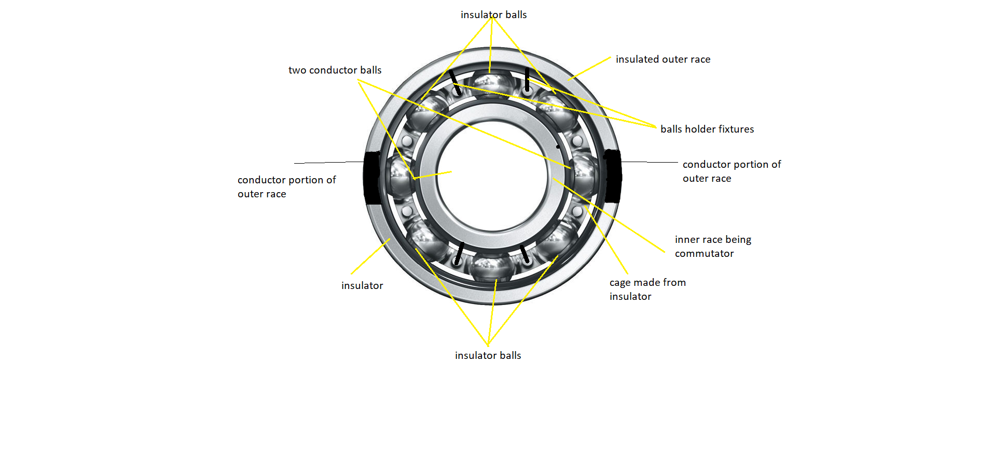

**Social Impact**

By decreasing frictional losses in a machine, one has used very less energy to do the same work and the energy which was getting wasted in form of heat can be supplied to some other remote villages which faces maximum load shedding.

As we are reducing frictional losses thus we have reduced heat dissipated to environment and thus temperature rise of globe is controlled and thus it reduces global warming and further consequences of global warming is avoided.

And energy which was getting wasted can be transmitted some other place.

**Market Survey**

As frictional losses in a machine are reduced, it reduces total power consumed by the machine and hence total energy consumed. As energy consumed is less then the owner of machine gets decreased electricity bill.

And one has to use less energy to do the same work. And the energy which was getting wasted in form of heat would be used by some other people, as they utilize certain energy they prosper.

Just with some initial investment for getting their machines updated can earn him a lot of profit in future. Hence this solution will very soon gets popularised to solve real time problems of machines for advancing human kind.