|  |  |  |  |  |
| --- | --- | --- | --- | --- |
|  | Name | Branch and semester | Contact Number | E-Mail ID |
| Team Leader | Raghunandan H | Mechanical- 3rd sem | 9738622242 | raghunandanh3507@gmail.com |
| Member 1 | Pruthu Manderwad | Mechanical- 3rd sem | 9731744669 | pruthumanderwad@gmail.com |

***Team Name- Anti-theft petrol device***

**Abstract-**

Our approach to solve this issue is by designing an electrically actuated plunger that is housed inside the fuel tank of the vehicle. When the vehicle is switched on, the circuit sends a message to the device that raises the plunger blocking the fuel outlet pipe, thus allowing free flow of the fuel to the engine. The advantage that this mechanism has over traditional lock and key mechanisms are,

i) As the mechanism is inside the fuel tank, it is not possible for anyone except technicians to gain access to the device.

ii) As most of the mechanical parts are made up of high-density polyethylene (HDPE), the same material that fuel tanks are made up of, the chance of corrosion and mechanical failure are kept minimum.

iii) It can be added to existing vehicles but by sacrificing a very minimal amount of fuel tank storage.

**Introduction-**

Anything of high value is susceptible to theft, and in nowadays scenario, this vulnerable, yet highly precious item is petrol. As the value is increasing day after day, the rise in the number of petrol robbery is also increasing proportionally. These unforeseen events are causing a huge mess in day to day activities by causing delays in people's lives and also causing them financial losses. A change has to be made to avoid this ruckus, and to overcome this situation, a simple yet effective method needs to be implemented to bring back ease in people’s lives. Many two wheelers have an exposed fuel outlet pipe that runs from the fuel tank to the engine, making it easy for thieves to steal the petrol. Thus, there may be two approaches that can stop petrol theft. One method is by hiding the petrol transfer pipe in a not so easily accessible location and the other way is by providing a locking mechanism that avoids the flow of petrol when the vehicle is switched off. Locking mechanisms are seen in some vehicles but can be surpassed easily as they use lock and key technology which is a primitive design and can be surpassed easily.

**Motivation-**

We got the idea of this device when we experienced this problem first hand. The chaos that people had to go through troubled us, thus leading us to this decision. Finally, we came up with this design which would soon develop to be our Anti-theft petrol locker. A device that would be easy on our pockets to manufacture and inexpensive for the consumers to purchase was our main goal, which led us to this point.

**Methodology-**

Our goal was to keep the design simple, lightweight, reliable and cost effective. Thus we chose HDPE to be one of the main material of our device. When the vehicle is powered on, an electrical signal is passed on to our device (which is placed between the fuel and the outlet pipe) that lifts the plunger blocking the outlet valve, releasing a path for the petrol to flow, and when the vehicle is switched off, the plunger falls back in place, thus blocking the outlet pipe.

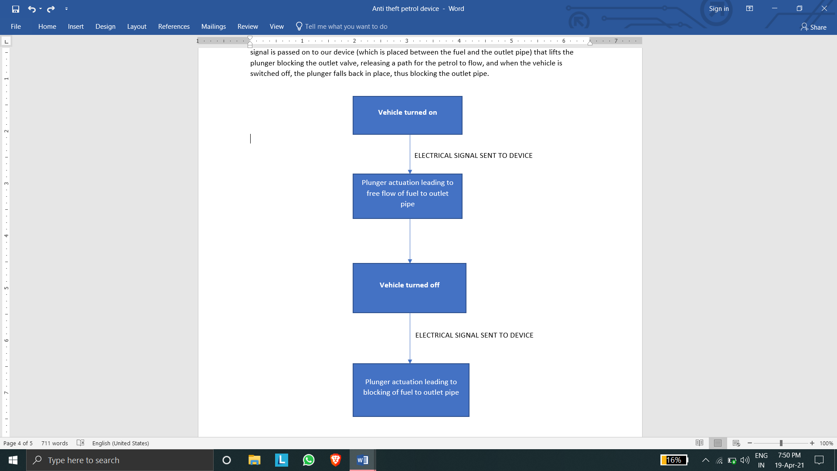

**Simple pictorial representation**

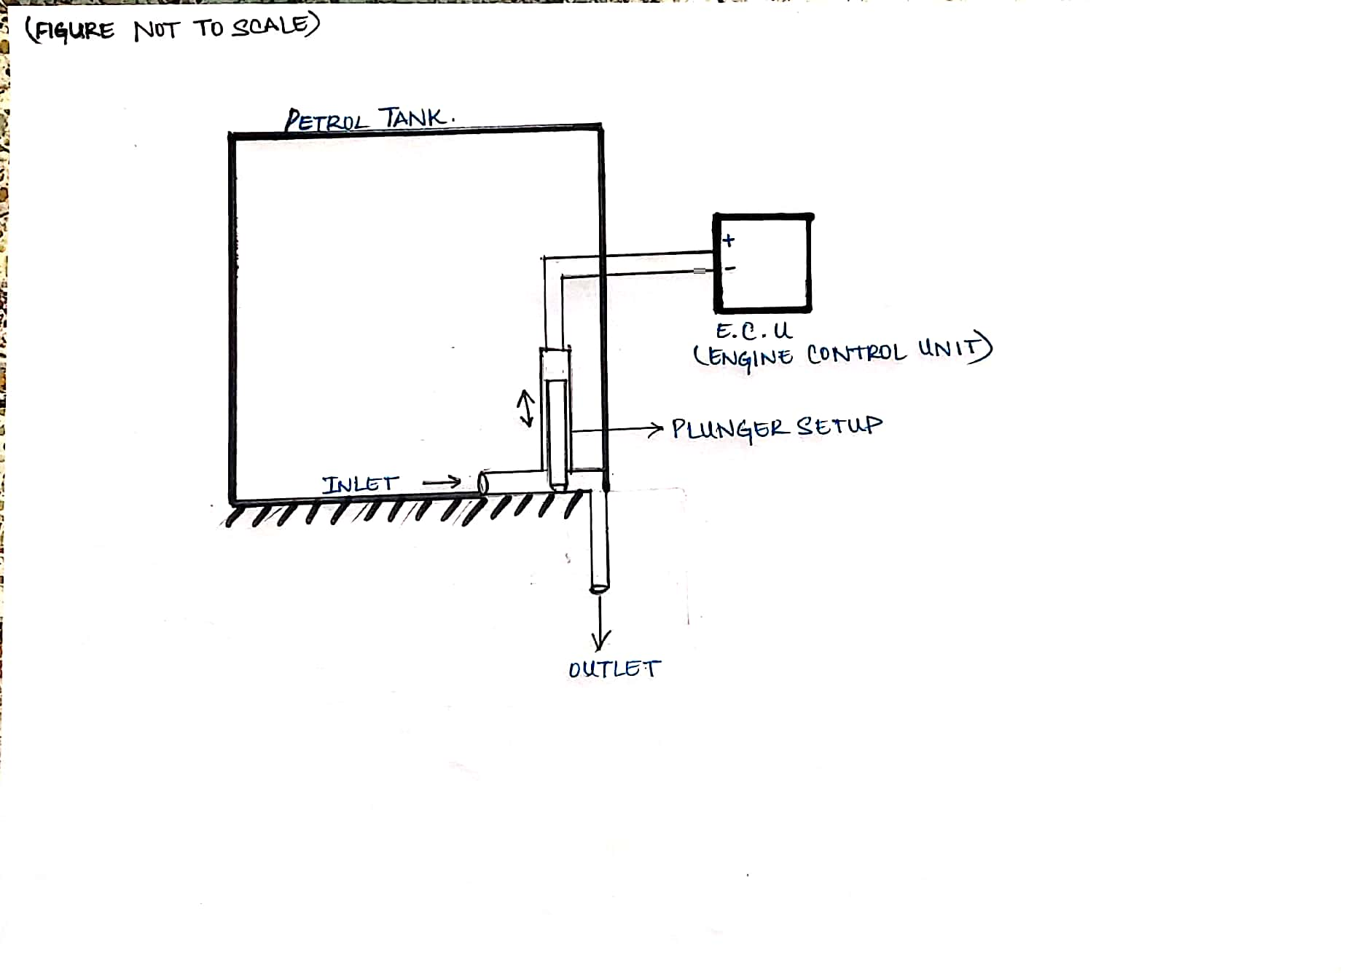

**Social Impact-**

We conducted a survey regarding if the people have also been victims of petrol theft and if they are aware about how easily the petrol of their vehicle can be stolen. Another question that we asked the people was if they would be interested to see such a device as ours be installed in their current vehicles or just for it to be seen as a feature provided by manufacturers in the upcoming models, for which people responded positively for both the ideas. People responded positively to our idea and felt that it would create a huge social impact for the mental and financial wellbeing of the people.

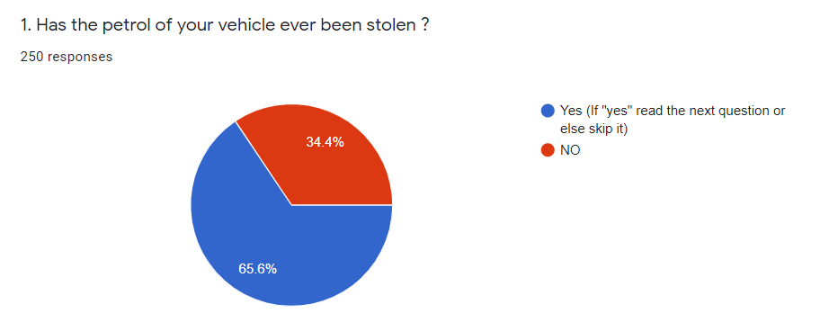



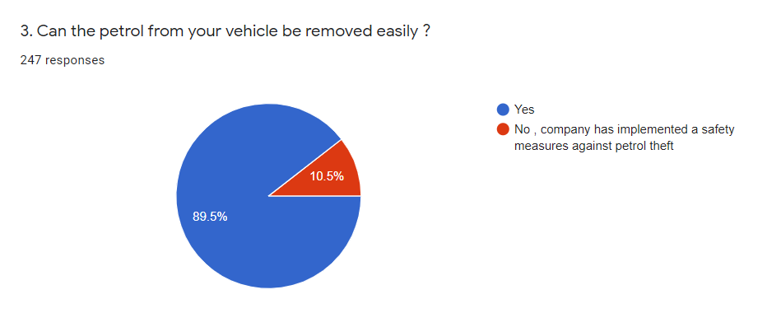

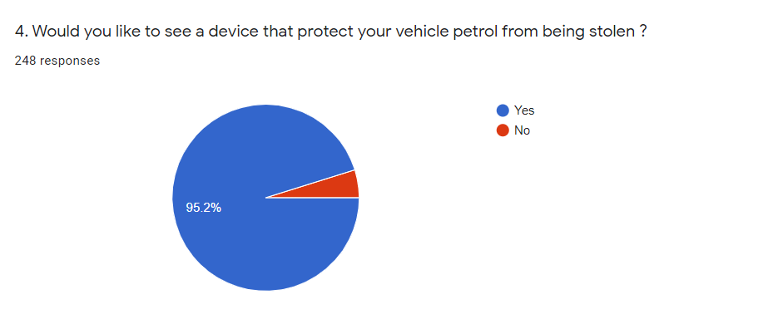

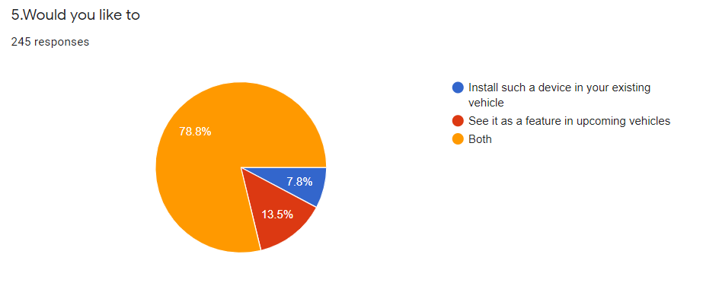

**Marketing survey-** The only other alternative solution to our product is primitive lock and key solutions which may be easily broken through just by acquiring the vehicle’s key or by using safety pins or by just breaking off the lock by striking it with force

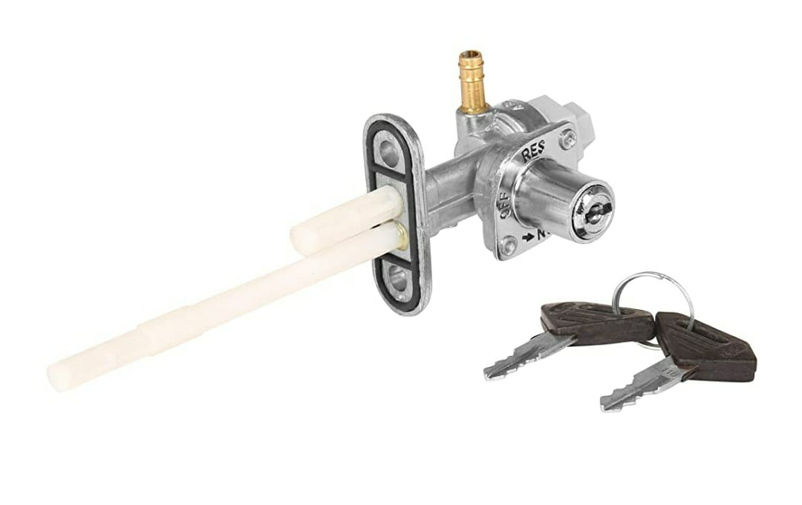

This is an example of the primitive technology.