* **JSS Mahavidhyapeetha**

**JSS SCIENCE AND TECHNOLOGY UNIVERSITY (Formerly SJCE)**

**MYSURU – 570006**



A Project Report on

**“Voltage Monitoring System”**

Submitted By

|  |  |  |
| --- | --- | --- |
| SL.NO | STUDENT NAME | SR.NO |
| 1 | Harsha Vishweshwara Bhat | 190045 |
| 2 | Hardik shettigar | 190093 |
| 3 | G Sai Nitish | 194011 |
| 4 | M V Sai Satwik | 194084 |

Under the Guidance of

**1.prof.K.M Vinay ji**

Professor

Dept. of Electrical and Electronics engineering

JSS Science and Technology University

Mysuru - 570006

**DEPARTMENT Of Electrical and Electronics engineering**

**November 2019**

**Table of contents**

|  |  |  |
| --- | --- | --- |
| **SL.NO** | **TITLE** | **PAGE NO.** |
| 1 | Introduction | 1 |
| 2 | Objective of the project | 1 |
| 3 | Hardware components | 1-2 |
| 4 | Circuit Diagram | 2 |
| 5 | Working and Operation | 2-4 |
| 6 | Result | 4 |
| 7 | Applications | 5 |
| 8 | Advantages | 5 |
| 9 | Conclusion | 6 |
| 10 | References | 6 |

### 

### 

### 

### 

### 

### 

### 

### 

### 

### 

### 

### 

### 

### **Battery Voltage Monitor**

**Introduction**:

All rechargeable battery has their specific level of charging and discharging, they are likely to get damaged if the battery voltage exceeds that level. This electronic project is used to monitor the charging and discharging of the battery such that the battery voltage doesn’t exceed the specified level of that battery. It basically acts as a controlled battery charger. It indicates the state of the battery. To test battery, there is one common method which is using voltmeter that is available in the Multimeters. But here, we have made a battery monitor circuit to test the battery charging status. In this circuit, we can easily test batteries by connecting it with the circuit. Here, some LEDs are used for showing battery status. This is used in various applications which are stated further below where this circuit, helps to monitor and indicate the voltage of the main circuit.

**The objective of the project:**

The aim of this project is to make a circuit that could be used to visually indicate the level of charge in the battery. In reality, a multimeter is used but this circuit along with the main circuit could be used to know the voltage across the circuit because the different LED’s are used to indicate the half point, low point and overcharge conditions as well.

**Hardware components:**

1. LM358 chip - 2
2. 4.7k Ohm Resistor - 4
3. 6.8k Ohm Resistor - 4
4. 10k Ohm Pot-1
5. Breadboard -2
6. 9 Volt Battery-2
7. Battery Connector -2
8. LED - 4

**Circuit Diagram:**

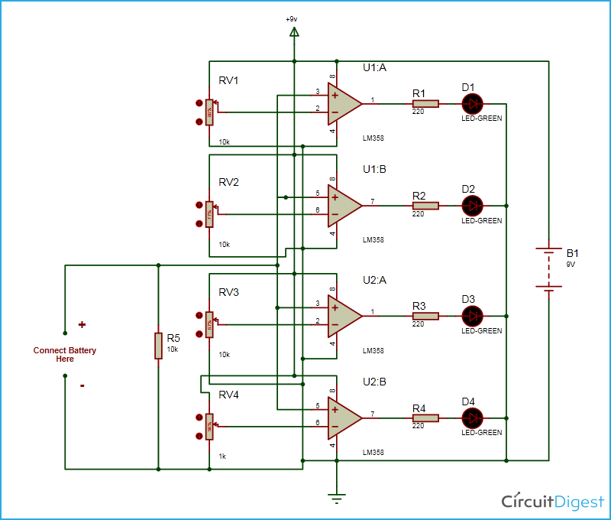

**Working and operation:**

LM358 is a Dual Low Noise Operational Amplifier which has two Op Amp in a single chip. This is a general purpose op-amp which can be configured in many modes like comparator, summer, integrator, amplifier, differentiator, inverting mode, non- inverting mode, etc.

In this battery monitor circuit, we have used two LM358 Dual Comparator ICs for comparing voltages. Comparator configured in non-inverting mode and 10 K potentiometer is connected at its inverting terminal and testing battery’s positive terminal wire is connected to non-inverting pins of the comparator. Non-inverting pins of all comparator are connected with each other. Four green LEDs connected at output pins of comparators through 220-ohm resistor for indicating battery power status. And a 9-volt battery or adaptor has used for powering the circuit.

Here we have set reference voltages for each comparator by using a potentiometer. For First Comparator we have set reference voltage of 8.0 Volt, for second comparator 7.0 Volt, for third one 6.0 Volt and for last 5.0 Volt.

**2.25V**

**>9V**

Battery to be tested

comparator

**>6.75V**

**>4.5VV**

Suppose if testing battery’s voltage is greater than 8.0 Volt then all four LEDs will Glow. It means battery standing in a good stage. If the battery’s voltage greater than 7.0 Volt and less than 8.0 Volt then Last three LED’s will Glow and first LED will be OFF. It means battery standing in moderate stage. If Voltage of battery is greater than 6.0 Volt and less than 7.0 Volt then First Two LEDs will go OFF and the last two LEDs will Glow. If Voltage of battery is greater than 5.0 Volt and less than 6.0 Volt then first three LEDs will go OFF and last LED will Glow. It means Battery is LOW. And if the Voltage of battery is less than 5 volts no LED will Glow and it means the battery’s voltage is below 5 volts. We can assume that battery as discharged.

For a demonstration of this project, we have added an extra potentiometer to change the testing battery’s voltage. And it's circuit diagram is shown above.

**Result:**

|  |  |  |  |
| --- | --- | --- | --- |
| **Comparator Number** | **LED status** | **Reference Voltage** | **Standing** |
| 1 | All ON | 9.0 Volt | Good |
| 2 | First OFF | 6.75 Volt | Moderate |
| 3 | First Two OFF | 4.50 Volt | LOW |
| 4 | Last ON | 2.25 Volt | About To Die |
|  | All OFF |  | dead |

**Applications:**

* Power Utilities
* Telecommunications
* CATV / Broadband
* Mission Critical Facilities
* UPS Systems
* Power Generation & Distribution
* Financial Institutions
* Oil, Gas & Fuel & Petrochemical Operations
* Mining
* Government/Defense
* Transportation Operations
* Hospitals
* Emergency Lighting
* Green Energy
* Call Centers
* Battery Suppliers and Manufacturers
* Battery Service Groups
* Medical/Biotechnology

**Advantages:**

* The circuit is very simple and easy to design.
* Offset voltages are reduced using voltage regulator.
* The output voltage is unaffected due to external factors like temperature.
* The distortion of the output voltage is reduced.
* There is no problem of low input impedance as op-amp has very high input impedance.

**Conclusion:**

A battery voltage monitor is an electronic system that manages a [rechargeable battery](https://en.wikipedia.org/wiki/Rechargeable_battery) ([cell](https://en.wikipedia.org/wiki/Electrochemical_cell) or [battery pack](https://en.wikipedia.org/wiki/Battery_pack)), such as by protecting the battery from operating outside its [safe operating area](https://en.wikipedia.org/wiki/Safe_operating_area), monitoring its state, calculating secondary data, reporting that data, controlling its environment, authenticating it and/or [balancing](https://en.wikipedia.org/wiki/Battery_balancing) it.

**References:**

<https://circuitdigest.com/electronic-circuits/battery-monitor-circuit>

<https://www.eepowersolutions.com/products/vm-100-battery-voltage-monitor/>

<https://www.youtube.com/watch?v=xiFtALppZq4>