**Team Name:** Sapffire

|  |  |  |  |  |
| --- | --- | --- | --- | --- |
|  | **Name** | **Branch and Semester** | **Contact Number** | **Email- ID** |
| **Team Leader** | Gautami.J | ECE & 6th | 7026576483 | gautamigautami92@gmail.com |
| **Member 1** | Bhagyavan | ECE & 6th | 6362405185 | nmbhagyavan@gmail.com |
| **Member 2** | Kiran C R | ECE & 6th | 73491 50040 | kirancr2000@gmail.com |

**Abstract:**

In this Idea We are building Innovative IOT solution for the Garbage separation and management. The novelty of this project is we are trying to separate dry and wet waste instantly and effectively, we will be setting wireless communication not only between municipality and dust bin but also everyone who needs the information about it – The information that will be about dust level, zone location(shortest distance-To avoid petrol wastage), damage caused to dust-bins and also the power for electronic devices will be supplied by using natural resource, With addition of all these functionality it is low cost, eco and user friendly.

**Introduction:**

Internet and its applications have become an integral part of today’s human lifestyle. It has become an essential tool in every aspect. Due to the tremendous demand and necessity, researchers went beyond connecting just computers into the web. These researches led to the birth of Internet of Things (IOT). Internet has become the crucial part of each individual. Most of the people are reliable on internet. The IOT concepts were proposed years back but still it’s in the initial stage of commercial and industrial deployment. This project Innovative IOT solution for the Garbage separation and management is a very innovative system which will help to keep the cities clean. This system monitors the garbage bins and informs about the level of garbage collected in the garbage beans via a web page and also through. For this the system uses IR sensors middle of the bins to sense the garbage level and continuously compare it with the garbage bins depth and moister sensor along with motor for garbage separation.

**Motivation :**

If the dust bins were full and if it not cleared soon then it lead to dangerous bacterial growth and this further leads to bacterial infections. The garbage spilled in public places causes a lot of dirt and destroys the environment freshness.

**Methodology:**

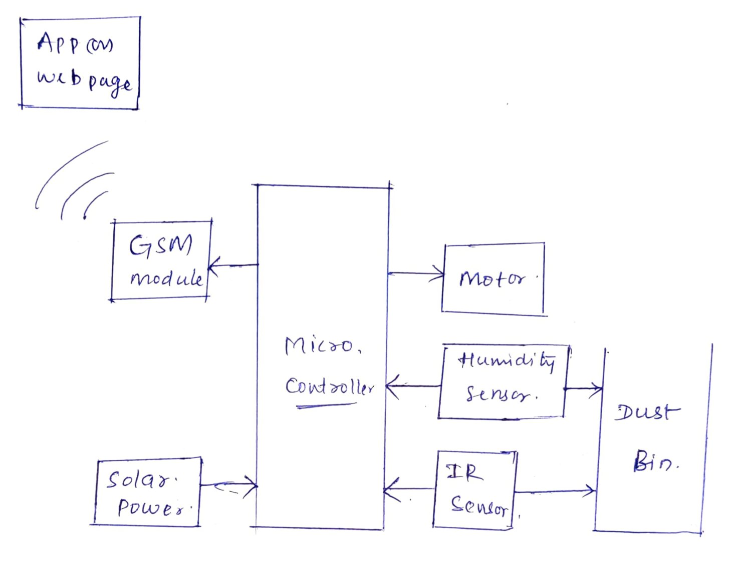

**Social Impact**

One of the outcomes of overflowing garbage is air pollution, which causes various respiratory diseases and other adverse health effects as contaminants are absorbed from lungs into other parts of the body. The toxic substances in air contaminated by waste include [carbon dioxide, nitrous oxide and methane](https://www3.epa.gov/climatechange/ghgemissions/gases.html). In everyday life we identify the polluted air especially through bad odors, which are usually caused by decomposing and liquid waste items.nowadays many problems caused by untidy environment round us .it even hammers our mood.

**Market Survey**

According to our survey we have seen that modified Dust bins are costlier in foreign countries .It can’t be accessed easily. But which we are planning to make are much affordable compare to other. So each and every person can take advantage of it.