**Team Name :** Vyoma

|  |  |  |  |  |
| --- | --- | --- | --- | --- |
|  | **Name** | **Branch and Semester** | **Contact Number** | **Email- ID** |
| **Team Leader** | Bhanana | Electronics and Communication Engineering  6th Sem | 9148647495 | [tiyyagurabhavana@gmail.c](mailto:tiyyagurabhavana@gmail.c)om |
| **Member 1** | Arun Louis | Electronics and Communication Engineering  6th Sem | 9972645173 | arunlouis.17@gmail.com |
| **Member 2** | Bharath N | Electronics and Communication Engineering  6th Sem | 8971877112 | bharath840999@gmail.com |
| **Transaction ID**  **(anju.marina.lobo@oksbi)** | bharath840999@oksbi | | | |

**Note:**

1. One can participate either as a part of a team or an individual basis. Switching teams is not allowed.
2. The uploaded ideas will be screened to go to the second round.
3. Judging : competition entries shall be judged, or winners selected based on the following criteria

* Is the problem worth solving
* How innovative or novel is the idea
* Scientific accuracy
* Social impact
* Scalability

1. Decisions of IIC JSSSTU in respect of all matters to do with the competition will be final and no correspondence will be entertained.
2. In second round, the selected teams will have to present their idea in front of the jury panel.
3. Payment of INR 50 should be made to the UPI ID [**anju.marina.lobo@oksbi**](mailto:anju.marina.lobo@oksbi)and submit the transaction ID above.
4. Idea should be submitted in **.pdf** format.

**Abstract**

Plastics are synthetic organic polymers that produce a lightweight, durable, and inexpensive material for the manufacturing of a very wide range of products. However, these are the exact characteristics causing plastics to be a growing hazard to the environment. Our project is to make a prototype(I) where the bot receives a location where the trash is and would go to that said location to clean up waste as well as picking up other trash along the way without harming any animals or plants.

A coordinate location of the trash is given to the bot which analyses it to get the path it should take to be effective. The bot will take the path to collect the trash without harming animals along the way. This would reduce manual labour efforts.

**Introduction**

Garbage generation is an issue of worldwide importance, requiring global attention. Improper management of waste and garbage is the root cause of several hindrances and issues that we face today such as health and hygiene, transport safety, wildlife endangerment and environmental aestheticism. At present, the method of cleaning up is mainly manual. With trends in industries shifting towards automation, it should also be efficiently applied towards waste management. While manual labor to clean up garbage is a good source of employment, there are several problems that are associated with cleaning up garbage manually. Thanks to an exponential rise in population, there is an increased production of waste, and also a significant amount of litter consisting of plastic, paper, and other such products carelessly thrown about and scattered in public. Using technology, it is convenient to clean up the trash we’ve left behind and ensure a clean habitat for the organisms and plants to thrive.

**Motivation**

Lakes and small water bodies are an important feature of the Earth’s landscape. They are extremely valuable ecosystems and a significant source of precious water as they provide habitat for many animals and plants. Pollution for the last two decades, there has been an explosive increase in the urban population without corresponding expansion of civic facilities such as adequate infrastructure for the disposal of waste. Hence, as more and more people are migrating to cities the urban civic services are becoming less adequate. As a result, almost all urban water bodies in India are suffering because of pollution and are used for disposing untreated local sewage and solid waste, and in many cases the water bodies have been ultimately turned into landfills.

**Methodology (block diagram, related figures etc)**

With this project we are aiming on improving the quality of the water bodies by continuously collecting the trash that is accumulated in them. This also helps in improving the quality of the aquatic life. Since the bot is autonomous, this reduces the man power required to keep the place clean. The bot selectively picks up only trash thus not harming any aquatic life. This project can be demonstrated in the Kukarahalli Lake, which is situated near the College.

**Proposed Block Diagram**

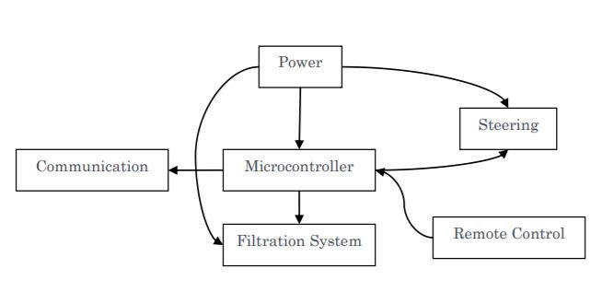

**Fig 3.1 block diagram**

**Social Impact**

Of all trash, plastic trash has the greatest potential to harm the environment, wildlife and human beings. It is often eaten by birds and aquatic life and hence, increasing the concentration of toxic chemicals in their tissue and causing them to starve. Our project will help, if implemented, in solving this problem.

**Market Survey**

These are some thoughts of people concerning the lakes in Mysore

<https://drive.google.com/drive/folders/10kbOfzrMGTIZBsYKtu1thc5Y6KK9CsQq>