**Team Name :** ____________Lakshya________________

|  |  |  |  |  |
| --- | --- | --- | --- | --- |
|  | **Name** | **Branch and Semester** | **Contact Number** | **Email- ID** |
| **Team Leader** | KARTIKEYA JOIS | EC 6th sem | 7760458093 | [kartijois@gmail.com](mailto:kartijois@gmail.com) |
| **Member 1** | PRANAV SHASHIDARA | EC 6th sem | 8431657063 | pranavmay22@gmail.com |
| **Member 2** | PRARTHANA GP | EC 6th sem | 8618987692 | [gpprarthana7@gmail.com](mailto:gpprarthana7@gmail.com) |
| **Transaction ID**  **(anju.marina.lobo@oksbi)** | 005621705125(gpprarthana7@okhdfcbank) | | | |

**Note:**

1. One can participate either as a part of a team or an individual basis. Switching teams is not allowed.
2. The uploaded ideas will be screened to go to the second round.
3. Judging : competition entries shall be judged, or winners selected based on the following criteria

* Is the problem worth solving
* How innovative or novel is the idea
* Scientific accuracy
* Social impact
* Scalability

1. Decisions of IIC JSSSTU in respect of all matters to do with the competition will be final and no correspondence will be entertained.
2. In second round, the selected teams will have to present their idea in front of the jury panel.
3. Payment of INR 50 should be made to the UPI ID [**anju.marina.lobo@oksbi**](mailto:anju.marina.lobo@oksbi)and submit the transaction ID above.
4. Idea should be submitted in **.pdf** format.

**Abstract: (not more than 150 words)**

Blind people face issues while reading documents such sale deeds, question papers, property documents, etc. Especially when there is a need to sign a document, a blind person faces difficulty in understanding what document he is signing, and exposes himself to being manipulated and duped. To solve this problem we are making a product which can capture the text from the document or paper and convert the text to audio signal so that the user can understand, thus making them more independent.

**Introduction ( not more than 200 words)**

An embedded system is a collection of computer software and hardware components, perhaps some mechanical components to perform a specific function. Our device makes the life of the visually impaired easier by effectively reading paper printed text as well as written documents. This can be especially useful to read documents, which can be a problem for the visually impaired when they can’t see what document they are signing or they want to verify an answer written by a scribe.

**Motivation (not more than 100 words)**

Many visually impaired students face a lot of challenges everyday which may seem to be insignificant to us, but are very significant for the blind. If a blind person has to understand what is written on a document, he or she should depend on another person who can read it for them. A blind person will always run the risk of being duped or fooled when reading a document, as he cannot verify the contents of the document himself. Our aim is to make their life easier by making a product which can read text form a document or paper and give the output as audio.

**Methodology (block diagram, related figures etc)**

Whatever documents a blind person has to read, he/she will place on our smart reader. The smart document reader consists of a clipboard with a camera protruding from the top end, placed at a fixed height which guarantees that the entire clipboard frame is captured clearly, which allows the camera to focus on the text to be read. A switch is used to turn the device. The same switch to capture the image when pressed for a longer duration. Once the document is placed, the text is extracted from the document. The text is then converted to voice signal. The voice signal can be given to the blind person either through means of a speaker or by earphones. By hearing the extracted text, the blind person will be able to find out what information is present in the document. Our product will have 2 modes; online mode and offline mode; online mode will be used whenever there is a handwritten document to be read. The offline mode will be used to read typed text documents. The online mode uses Google API to detect the text while the offline mode uses the Tesseract and converts the handwritten and typed text to speech respectively.

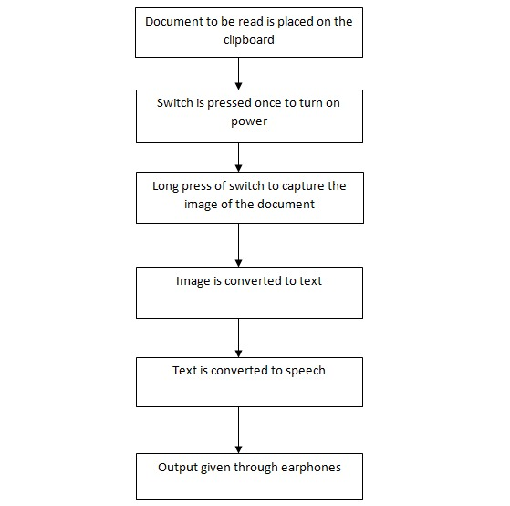

The given block diagram shows the hardware connections of the smart document reader. A switch is connected to camera and Raspberry pi which when pressed turns the device on and captures the picture of the document placed on the clipboard. Once the camera is turned on, it takes the picture and sends the same to the Raspberry pi for further processing. Two methods are used for the extraction of text from the document. In online mode, Google based API is used, while offline mode uses an open source processor called Tesseract to extract the text from the image taken by the camera. Once we are ready with the text to be read, it is converted to speech using the Raspberry pi and the audio output is heard using speaker or earphones.

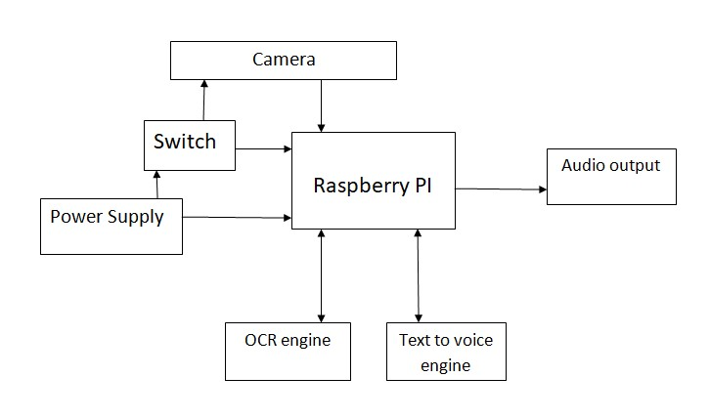

Block Diagram of Smart Document Reader

**Social Impact**

With this project, we will be able to improve the general life quality of the blind people. Using our product, blind will able to be more independent, and can easily read documents and paper which would normally not be accessible to them.

**Market Survey**

There is a huge demand for better and efficient products for the blind, as they prefer to be independent. Our product would help the blind person to be more independent and reduce their need to rely on others. Blind schools and colleges would be our potential customers and even the blind people who wish to be independent.

In our interaction, we saw that our customers were willing to pay anywhere between 30,000 and 100,000 for our product. The market survey conducted by us showed that we can have a huge market as shown in the following video link:

https://youtu.be/Hfir-GbsUhk