**Team Name:** V - 4\_\_

|  |  |  |  |  |
| --- | --- | --- | --- | --- |
|  | **Name** | **Branch and Semester** | **Contact Number** | **Email- ID** |
| **Team Leader** | Yassawini | ECE,4th sem | 8088172580 | yassawini2001@gmail.com |
| **Member 1** | Rishitha R Gowda | ECE,4th sem | 63665 83997 | rishitharamachandregowda@gmail.com |
| **Member 2** | Likhitha.S. | ECE,4th sem | 8431872134 | likhi2803@gmail.com |
| **Member 3** | Ananya G.R | ECE,4th sem | 8073153972 | Ananyaanju47@gmail.com |

**Note:**

1. One can participate either as a part of a team or an individual basis. Switching teams is not allowed.
2. The uploaded ideas will be screened to go to the second round.
3. Judging: competition entries shall be judged, or winners selected based on the following criteria

* Is the problem worth solving
* How innovative or novel is the idea
* Scientific accuracy
* Social impact
* Scalability

1. Decisions of IIC JSSSTU in respect of all matters to do with the competition will be final and no correspondence will be entertained.
2. In second round, the selected teams will have to present their idea in front of the jury panel.
3. Idea should be submitted in **.pdf** format.

**Abstract: (not more than 150 words)**

Electricity is the most general forms of energy used across the world. This paper focuses on designing a setup that leads to the generation of electrical energy which is going to waste when humans are walking. Footsteps are an untapped natural-resources. This generated energy is, however, costeffective and non-hazardous for human. Electrical energy can be produced by converting mechanical energy using footsteps. Generating the electric power through the fabrication of footstep arrangement by a prototype comprises of a pipe, nozzle, unidirectional valve, water reservoir, turbine, and DC motor. Whenever pressure is exerted on the reservoir, water flows through the nozzle into the turbine and generates electrical energy. This energy is stored in the battery. This project will reduce the global warming and load shedding in a much cleaner cost-effective way. Since this project is related directly to the human movement, the weight of the setup is a crucial factor

**Introduction ( not more than 200 words)**

The process of generation of electricity with help of different type of energy sources is called as electricity generation. We covert energy by converting many forms of primary sources. We usually generate energy by coal, fossils, gasoline etc, but the problems with them are they pollute the nature more than production of electricity. The extensive use of these non-renewable sources has made them to come to extinction. So, now the question is How to come out of this problem?. Yes, we have solution for everything. As we were using non renewable energy sources, the question arises is can’t we use renewable energy to generate the electricity? The answer is yes we can, but How? We might have observed while walking the kinetic energy generated by our footstep Is converted into heat energy and is completely wasted. There are many people who walk daily all the heat energy generated by their footsteps are wasted and is not utilized. In this project we have originated electricity through human power mechanism.

**Motivation (not more than 100 words)**

Walking is the most common activity in day-to-day life. When a person walks, he loses energy to the road surface in the form of impact, vibration, sound etc, due to the transfer of his weight on to the road surface, through foot falls on the ground during every step. This energy can be tapped and converted in the usable form such as in electrical form.

**Methodology (block diagram, related figures etc)**

WORKING
When ever force is applied on piezo electric crystals
that force is converted to Electrical energy is used to
driv...

  Whenever force is applied on piezo electric crystals that force is converted to Electrical energy is used to drive DC loads. And that minute voltage Which is stored in the Lead Acid battery. The battery is connected to the inverter. This inverter is used to convert the 12 Volt D.C to the 230 Volt A.C. This 230 Volt A.C voltage is used to activate the loads. We are using conventional battery charging unit also for giving supply to the circuitry.

**PIEZO SENSOR:**

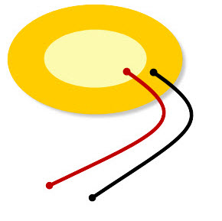A **piezoelectric sensor** is a device that uses the piezoelectric effect to measure changes in pressure, acceleration, temperature, strain, or force by converting them to an electrical charge. The prefix *piezo-* is Greek for 'press' or 'squeeze'.

Piezo sensor

A piezoelectric sensor is an electric device which is used to measure acceleration, pressure, or force to convert them to an electric signal. [These sensors](https://www.elprocus.com/types-of-sensors-with-circuits/" \t "_blank) are mainly used for process control, quality assurance, research and development in various industries. The applications of this sensor involve, aerospace, medical, nuclear instrumentation, and as a pressure sensor it is used in the touch pad of mobile phones. In the automotive industry, these sensors are used to monitor ignition when developing internal burning engines.

#### AC Ripple Neutralizer

It is used to remove the ripples from the [output of the rectifier](https://www.elprocus.com/full-wave-rectifier-circuit-working-theory/" \t "_blank) and smoothens the output of the D.C which is received from the filter, and it is constant until the load and mains voltage is kept constant. Though, if either of the two is varied, then the received D.C. voltage at this point changes. So a regulator is applied at the output stage.

#### Lead Acid Battery

Lead battery is most commonly used in PV systems due to low cost and easily available everywhere in the world. These batteries are available in both sealed and wet cell batteries. Lead acid batteries have high reliability due to their capability to withstand overcharge, over discharge & shock. The batteries have excellent charge acceptance, low self-discharge and large electrolyte volume. Lead acid batteries Are tested using Computer Aided Design.

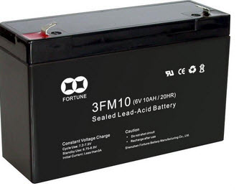

Lead acid battery

**Inverter**

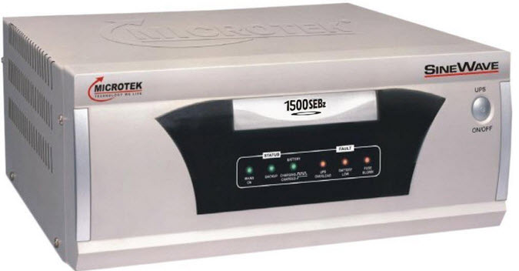An inverter is an electrical device that converts direct current to alternating current; the converted alternating current can be at any required voltage & frequency with the use of applicable control circuits, transformers and switching.

Inverter

Solid state inverters are used in a wide range of applications because they have no moving parts from small switching power supplies to large electric utility high-voltage direct footstep power generation using piezoelectric material that transport bulk power. Inverters are used to supply AC power from DC sources like batteries or solar panels. These are classified into two types. The modified sine wave inverter’s o/p is similar to a square wave o/p excluding that the o/p goes to 0 V for a time before switching +Vee or -Vee. It is very simple and low cost and is well-suited with various electronic devices, except for sensitive or specialized equipment like laser printers.

#### Unidirectional Current Controller

As term specifies this circuit lets only one direction current flowing. They are [diodes and Thyristors](https://www.elprocus.com/3-different-types-diodes/" \t "_blank). In this project diode (D=1N4007) is used as a unidirectional current controller. The main function of the diode is, it allows the flow of current in only one direction while blocking current in the reverse direction.

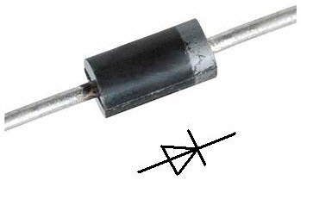Unidirectional current controller

**Social Impact:**

The waste energy of human during walking is used in this system. Footstep is an uninterrupted and renewable source of energy. The system repeatedly operates in a short duration of time and is not possible for the turbine to maintain a constant speed. As a result, voltage variation occurred which is controlled by a voltage regulator. The total system of the power generation using footsteps depend mainly on the angle of attack of the flowing medium. High voltage dynamo should be used to produce more electricity. Though many systems are available for power generation from footsteps, the proposed system is very economical and affordable. As Bangladesh is a developing country with a large population, we face difficulty day by day due to power shortage. Many people in our country cannot enjoy the facility used for generating electricity. Though power produced in this process is minimal, as a whole country, this will be a considerable source of electrical energy.

**Market Survey:**

PAVEGEN is a leading company which is using footsteps to generate electricity.It has been widely used in abroad countries to get the electricity. This idea is widely used where the blocks are placed to generate power. These are used in party halls,schools,parks,etc where there will be more population.A  leading semiconductor manufacturing company commissioned Pavegen to install a permanent array at the entrance to its new R&D facility in Bangalore, India. This installation marks Pavegen’s first permanent deployment in India.Still many researches has to be done in developing still advanced mechanism and can be suitable to install in India where lakh of people walk in the street.