**Team Name:** ______SMART GUARD______________________

|  |  |  |  |  |
| --- | --- | --- | --- | --- |
|  | **Name** | **Branch and Semester** | **Contact Number** | **Email- ID** |
| **Team Leader** |  |  |  |  |
| **Member 1** | VAISHNAVI M | ECE 6TH SEM | 6362499554 | Mvaishnavibhat21@gmail.com |
| **Member 2** | PRASANNA V BHAT | ECE 6TH SEM | 94815 94476 | prasannavbhat9@gmail.com |

**Note:**

1. One can participate either as a part of a team or an individual basis. Switching teams is not allowed.
2. The uploaded ideas will be screened to go to the second round.
3. Judging: competition entries shall be judged, or winners selected based on the following criteria

* Is the problem worth solving
* How innovative or novel is the idea
* Scientific accuracy
* Social impact
* Scalability

1. Decisionsof IIC JSSSTUin respect of all matters to do with the competition will be final and no correspondence will be entertained.
2. In second round, the selected teams will have to present their idea in front of the jury panel.
3. Idea should be submitted in **.pdf** format.

**Abstract: (not more than 150 words)**

In today world there has been a gradual increase in number of births of mentally retarded children due to lack of nutrition, lack of rest to the woman during her pregnancy, food, unusual hormone variations etc. So, it is necessary to protect and safeguard these kinds of people who are much innocent to understand the things happening in the society. My article is about the personal assistant and bodyguard of a mentally challenged person. For example, this personal assistant will assist the mentally challenged person may be in purchasing the vegetables or other stuffs or it may guide him/her in cooking etc. Also, it will work as a bodyguard while the person is in danger. As soon as the mentally challenged person’s blood pressure increases and he/she starts to scream program should be done to call nearby police or his/her parents who can save the person from the danger.

**Introduction (not more than 200 words)**

Technological advancement has greatly influenced human being which mostly controls his acts. So it is our duty to utilise these advancements in a likely and right way for the beneficiary of human beings. Hence let us make a part of it to be beneficial for mentally challenged people who are struggling to live in this society. Mental retardation is the developmental disability seen in children where the child’s brain will not be developed or matured according to their age. Though there is increase in their physical age, the mental age will be still unchanged and their thoughts will be of the same. There are mentally challenged children who are poor in studies, who fight with everyone if they feel irritated, they will be fewer patients, and they will not be able to control their emotions.

Nowadays it is a bit difficult for a mentally challenged girl to save herself from the men as we can see a number of rape cases on these girls. Also it will be an easy task for human trafficking of these people. So it is necessary to have a personal assistant or a bodyguard for mentally challenged children. These mentally challenged people will listen to only those whom they love a lot and whom they admire the most.

It is very difficult for a mentally challenged person to buy some goods from the market as they might not know calculation of money or the vendors may misuse their innocence and may ask more money from them. Sometime they may forget the way to home. So there is a necessity of a personal assistant to assist and safeguard them

**Motivation (not more than 100 words)**

The personal assistant and bodyguard is on extensive use of sensors and actuators. Various kinds of sensors are used to check the condition of the mentally challenged person and a number of actuators are required to actuate according to the sensor signals. It is required to have a microcontroller for the working or proper functioning of these sensors and actuators together when required. Especially these personal assistants and bodyguards providing to mentally challenged children will decrease the rate of harassments on these people and may safeguard them from inhuman and illegal activities in which they are too innocent to take part. Today as we can see the girls are becoming prey to most of illegal things like human trafficking, rapes etc, these mentally challenged girls can be used so easily. To avoid these things from happening it is very much necessary to save them from becoming prey to these things.

**Methodology (block diagram, related figures etc)**

In this project we are interfacing Raspberry pi microcontroller different sensors such as spy camera for face recognition, speech recognition sensor and digital blood pressure sensor.

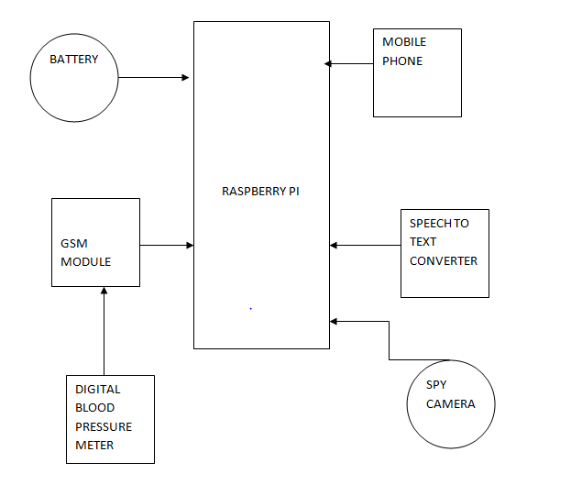

**Social Impact**

Positive :

It will make the life of a mentally challenged people and in extend of women . After learning how to use the device they can carry it and use it easily anywhere. It will be eco friendly and also

More importantly it will be cost-friendly. The device we are building is very efficient as it processes 3 features. Another important is that its very ease interface for monitoring people

Negative:

It could be difficult for mentally challenged to use until they learn how to use it. It could be difficult for them to carry as it requires more sensors and processors. The processing speed of the device should be good and the communication line between the monitoring people and the user should be fast and if they got failed or get slowed down the purpose of using the device get failed.

**Market Survey**

Our product mainly comes under the category of Security and medical. A particular device can be used from a single user and it is controlled by third party. For our convenience, now it can be used by mentally challenged. In future it can be used by women for security and safety purpose also