**Team Name:V-4**

|  |  |  |  |  |
| --- | --- | --- | --- | --- |
|  | **Name** | **Branch and Semester** | **Contact Number** | **Email- ID** |
| **Team Leader** | Rishitha R Gowda | ECE,4th sem | 63665 83997 | rishitharamachandregowda@gmail.com |
| **Member 1** | Ananya G.R | ECE,4th sem | 8073153972 | Ananyaanju47@gmail.com |
| **Member 2** | Likhitha.S. | ECE,4th sem | 8431872134 | likhi2803@gmail.com |
| **Member 3** | Yassawini | ECE,4th sem | 8088172580 | yassawini2001@gmail.com |

**Note:**

1. One can participate either as a part of a team or an individual basis. Switching teams is not allowed.
2. The uploaded ideas will be screened to go to the second round.
3. Judging: competition entries shall be judged, or winners selected based on the following criteria

* Is the problem worth solving
* How innovative or novel is the idea
* Scientific accuracy
* Social impact
* Scalability

1. Decisions of IIC JSSSTU in respect of all matters to do with the competition will be final and no correspondence will be entertained.
2. In second round, the selected teams will have to present their idea in front of the jury panel.
3. Idea should be submitted in **.pdf** format.

**Abstract: (not more than 150 words)**

Now a days, Home Security threat is the most challenging task in our life. To overcome this threat, our houses must be Smart. This paper gives a solution to overcome the Home security threat. Using Zigbee network enabled digital technology, we can make our home Smart and secure. The technology gives us the opportunity to increase the connectivity of various devices hence we can get an overall security solution. Moreover, as the area of Internet is widening, we can remotely control and monitor the network enabled devices. The device can also send signal to the remote person whom we want to notify about the threat. Common gateway is used by both the Zigbee security system and Wi-Fi network for integration purpose. The use of this system would be user-friendly, flexible and cost effective. This system will based on Zigbee network. Hence, the hardware required would be Zigbee Modules, Micro-Controller (ATMEGA168), Relays, Voltage Regulator and various sensor devices. In this method, The sensors will sense the threat and send signals to the micro-controller through Zigbee network and the micro-controller would take appropriate action and send signal to the remote location on the reception of threat signals. Zigbee technology is simple, flexible and very reliable to use. It is broadly used transceiver standard. It has low data rate and consume low power. It’s operational range is in between 10 meters to 20 meters but can be extended upto 150 meters by the use of direct sequence spread spectrum (which is quite well for the purpose of a home)

**Introduction ( not more than 200 words)**

Almost every day, we hear about the security issues in our surrounding. This issue might be of robbery, murder and all others by tempering the lock in a house. That means only a lock could not be the solution to check all these threats, our house will have some of the security features so that it could automatically detect the situation and work accordingly like a smart home. We could convert our houses into a Smart Home by using some of the sensors. These sensors will work as the eyes and ears of the house. Like as a human, there must also be a brain to look after the data received by the sensors, here this brain is ATMEGA168 Micro-Controller. This complex system will sense the data and will have the superior capability of decision making about the subject and its environment. This system will use the Zigbee technology. Zigbee is an IEEE 802.15.4 based specification of high level Communication protocol which is suited for creating Personal Area Network. This network will connect all the sensor devices and the micro-controller and relay devices. The advantage of using Zigbee is that it works on low power and have sufficient amount of network range. We can also monitor and control the system remotely from any distinct locations. This security system required for Empty Homes , Banks ,Industries, Many more Suppose, There is no one in the house or bank and someone came with bad intentions and try to temper the lock or try to break the door then this system will automatically came in action and lock the door permanently, cameras will start to take picture of the person standing outside the door and send these picture to the owner and will wait for the response of the owner and then work accordingly

**Motivation (not more than 100 words)**

In this fast growing world even the thieves have become modernized they have been using many techniques to rob banks,home,etc.Still a improved technology has to be done in order to avoid this robbery .By using these techniques we can be safe and it will even give security to the home.

**Methodology (block diagram, related figures etc)**

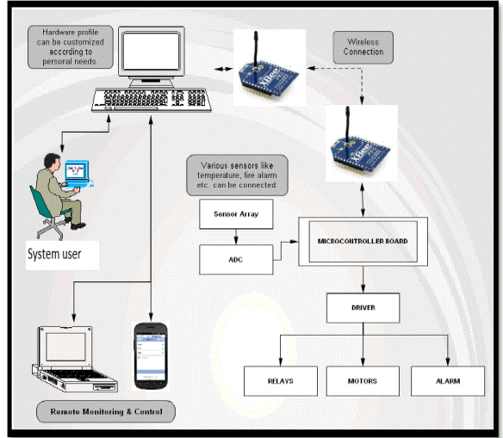

Figure 1

Fig. 1 shows the basic architecture of the security system.This is the proposed architecture for Zigbee based security system. Here, Sensors are used as an input devices. These inputs are cameras, infrared motion sensors and SIM 900A GSM module. These sensors will sense the presence of the person trying to enter into the house or banks, if he is a authorized person then there will be no problem but if the person is unauthorized then the system will barred the entrance by locking the doors. Here,In this system some drivers are used as an output devices. These outputs are relays, motors, SIM 900 GSM Module. The main purpose of the proposed design is to use of technology for enhancing the security for upcoming threats. Here, We have used Zigbee technology because it is reliable, low power consumption, low data rate, supports up to 65,000 nodes in a network, can automatically established its network and uses small packets compared with WiFi and Bluetooth. This system consist of two modules-

* Entrance Sensing Module 
* Control Module with Relay Controlling Circuits.

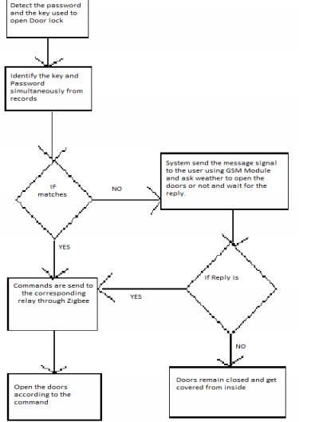

Figure 2

Fig. 2 shows the sequence of working of the system. As the device will ask for the password and the door key, if key and password is correct then door will get open and the person can get into the house otherwise, if, any of the two is incorrect then door will not open and send a message signal to the owner through GSM Module. After the reply of owner, the device will work accordingly.

**Social Impact**

Use of this device helps to increase the security of the home,bank etc.It helps in gradual reduction in the robbery as there will be a lot of facilities to reduce it. Even the thief can be identified by using these technologies.So it helps in increasing the security and reduction in crime cases.

**Market Survey :**

Many automated homes are using these home security to secure their homes by robbery.Even in many industries where security has become the biggest problem they are using this technique to over come this problem.Even in the banks they are using this security system to overcome many problems.Hence we can say that it has a high market impact.