Write algorithms and draw flow charts for the following problems.

1. **To find the area of a circle and print the result (Area = πr2).**

**ALGORITHM FLOWCHART**

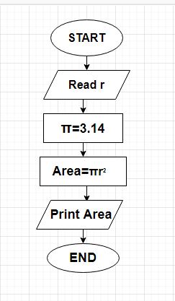

1. START
2. READ THE VALUE OF RADIUS OF A CIRCLE.
3. GIVE π=3.14
4. CALCULATE THE AREA OF THE CIRCLE = πr2
5. PRINT AREA.
6. END
7. **To print the sum of first ‘5’ whole numbers (0,1,2,3,4,5,6,7,…).**

**ALGORITHM FLOWCHART**

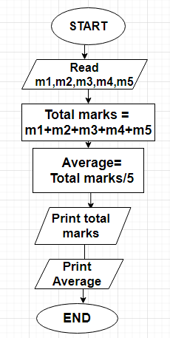

1. START
2. READ THE VALUES M1,M2,M3,M4,M5.
3. CALCULATE TOTAL MARKS = M1+M2+M3+M4+M5
4. AVERAGE = TOTAL MARKS/5
5. PRINT TOTAL MARKS
6. PRINT AVERAGE
7. END.
8. **To find the total marks and average of a student, who has 5  
   subjects.**

**ALGORITHM FLOWCHART**

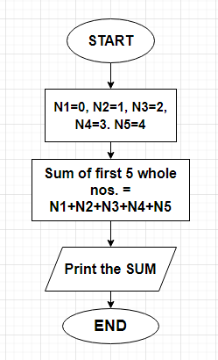

1. START
2. TAKE = N1=0, N2=1, N3=2, N4=3, N5=4.
3. CALCULATE SUM OF FIRST 5 WHOLE NOS. = N1+N2+N3+N4+N5.
4. PRINT SUM OF FIRST FIVE WHOLE NUMBERS.
5. END