1.17- Problem Sheet – Solving by Python

# 1. Write a python program to find the volume of a cone. Refer the problem definition given below.

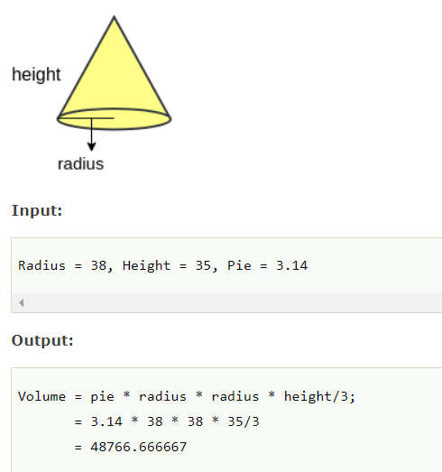

## Algorithm:

1. **Start**
2. **Read the value of radius & height of cylinder and pie from users**
3. **Calculate Volume of cone using vol=(pie*radius*radius*height/3)**
4. **Print Volume**
5. **End**

## Code:

print("Hey Programmers !!! Welcome to python programming.")

print("This python program is for calculating Volume of Cone.")

print("------------------------------------------------------")

r=float(input("Enter the value of radius: "))

h=float(input("Enter the value of height: "))

pie=float(input("Enter the value of pie: "))

Vol=pie*r*r*h/3

print("------------------------------------------------------")

print("The volume of cone= ", Vol)

## Output:

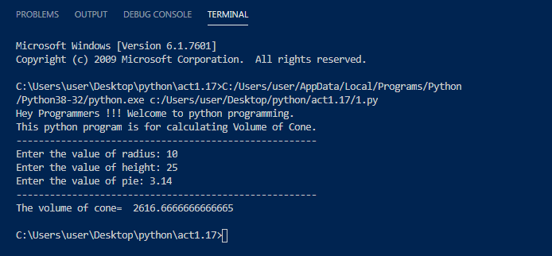

# 2. Write a python program to find the volume of a cylinder. Refer the problem definition given below.

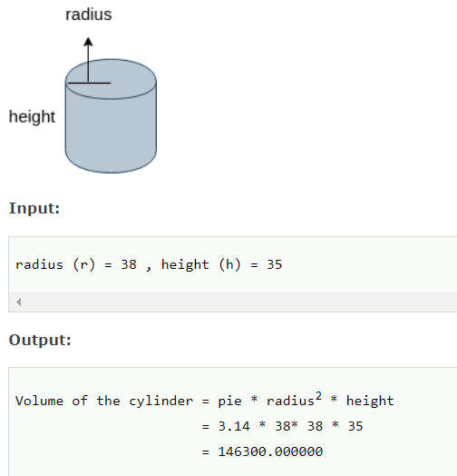

## Algorithm:

1. **Start**
2. **Read the values of radius & height of cylinder from user**
3. **Calculate the Volume using Vol = (pie*radius*radius*height)**
4. **Print the Volume**
5. **End**

## Code:

print("Hey Programmers !!! Welcome to python programming.")

print("This python program is for calculating Volume of Cylinder.")

print("------------------------------------------------------")

r=float(input("Enter the value of radius: "))

h=float(input("Enter the value of height: "))

pie=float(input("Enter the value of pie: "))

Vol=pie*r*r*h

print("------------------------------------------------------")

print("The volume of cylinder= ", Vol)

## Output:

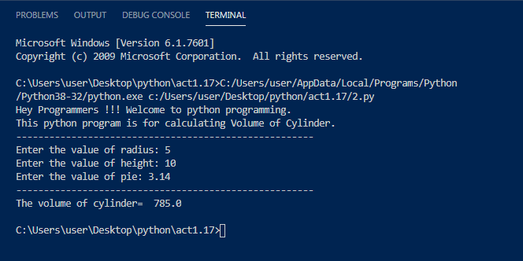

# 3. Write a python program to convert celsius into fahrenheit. Refer the problem definition given below.

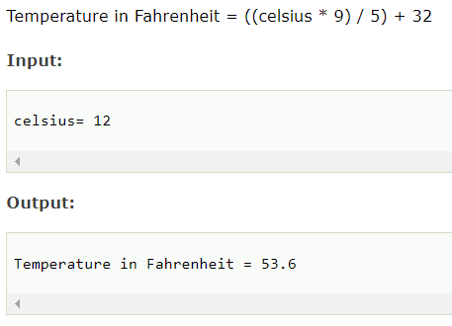

## Algorithm:

1. **Start**
2. **Read the value of celsius temperature from the user.**
3. **Convert this value into fahrenheit scale using formula Fahrenheit = ((celsius*)/5)=32 and store it**
4. **Print the value of Fahrenheit temperature**
5. **End**

## Code:

print("\n")

print("---------------------------------------------------------------")

print("Hey Programmers !!! Welcome to python programming.")

print("This python program is for converting celsius into fahrenheit.")

print("---------------------------------------------------------------")

cel=float(input("Enter the value of celsius temperature: "))

fah=((cel*9)/5)+32

print("The Temperature in Fahrenheit=",fah)

print("---------------------------------------------------------------")

## Output:

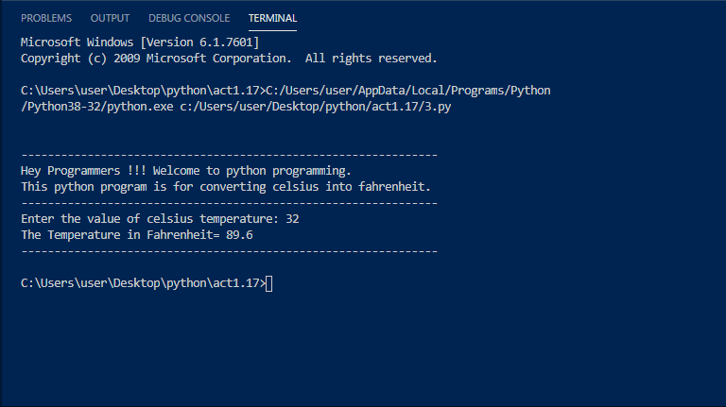

# 4. Program to find simple interest.

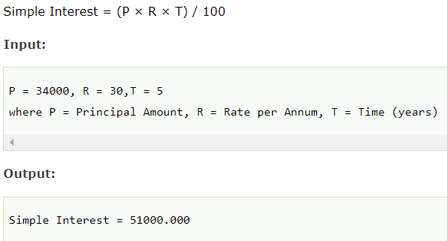

## Algorithm:

1. **Start**
2. **Read the vaues of Principal Amount, Rate, and Time from the users**
3. **Calculate the Simple Interest using formula (P*R*T)/100 and store it**
4. **Print simple interest**
5. **End**

## Code:

print("\n")

print("---------------------------------------------------------------")

print("Hey Programmers !!! Welcome to python programming.")

print("This python program is for calculating simple interest.")

print("---------------------------------------------------------------")

p=float(input("Enter the value of Principal Amount: "))

r=float(input("Enter the value of Rate per Annum: "))

t=float(input("Enter the value of time: "))

si=(p*r*t)/100

print("The Value of Simple Interest is ",si)

print("---------------------------------------------------------------")

## Output:

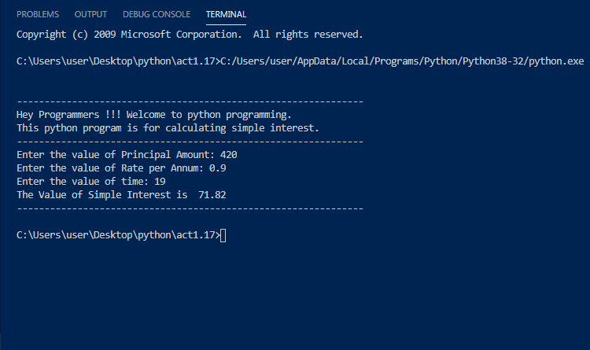

# 5. Program to check Disarium number.

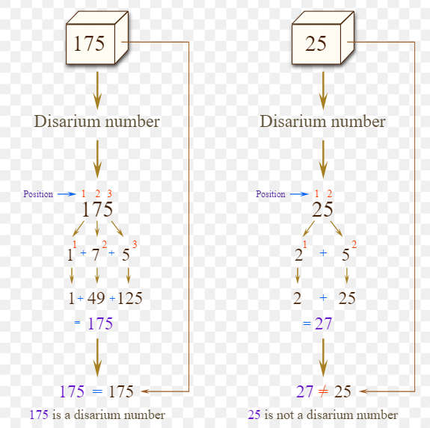

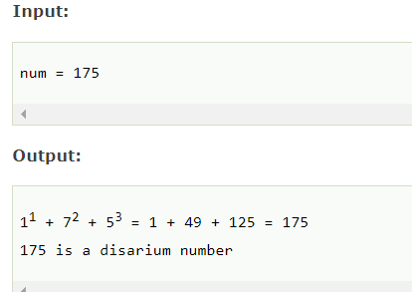

## Algorithm: