**• To use online C compiler to practice the following C programs and use online tool (www.draw.io) to draw the flow chart for the  
above C programs.**

**1. Adding 3 numbers**

**CODE;**

#include<stdio.h>

int main()

{

int num1, num2, num3, sum;

printf(“Enter 3 numbers to add\n”);

scanf(%d %d %d, &num1, &num2, &num3);

sum = num1+num2+num3;

printf(“Sum of 3 numbers= %d/n, sum”);

return 0;

}

**RESULT;**

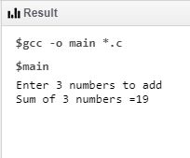

**FLOWCHART;**

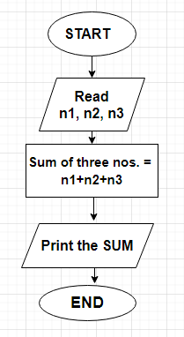

**2. Calculating the total and average marks of a student with six subjects.**

**CODE;**

#include<stdio.h>

void main()

{

int s1,s2,s3,s4,s5,t,avg;

printf(“\n Enter marks of 6 subjects ”);

printf(“\n\n Mathematics = 94”);

scanf(“%d”,&s1);

printf(“\n Science = 85”);

scanf(“%d”,&s2);

printf(“\n English = 83”);

scanf(“%d”,&s3);

printf(“\n History = 79”);

scanf(“%d”,&s4);

printf(“\n Geography= 90”);

scanf(“%d”,&s5);

printf(“\n Economics = 95”);

scanf(“%d”,&s6);

t=s1+s2+s3+s4+s5+s6;

printf(“\n\n Total marks = %d”,t);

avg=t/6;

printf(“\n\n Average = %d, avg”);

return 0;

}

**RESULT;**

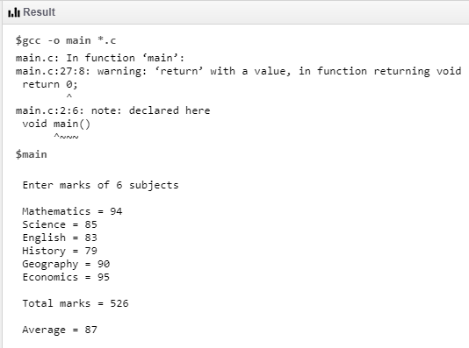

**FLOWCHART;**

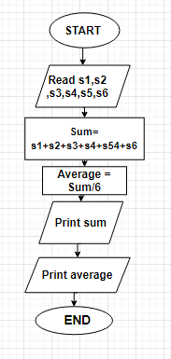

**3. To find the largest among three given numbers, which are different from each other.**

**CODE;**

#include<stdio.h>

{

Int A,B,C;

Printf(“Enter the numbers A,B,C: ”);

Scanf(“%d %d %d”, &A, &B, &C);

If (A >= B && A >= C)

Printf(“%d is the largest number.”,A);

If (B >= A && B >= C)

Printf(“%d is the largest number.”,B);

If (C >= A && C >= B)

Printf(“%d is the largest number.”,C);

Return 0;

}

**RESULT;**

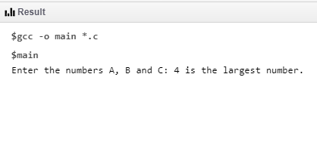

**FLOWCHART;**

