Using Anaconda distribution, execute the following programs.

1. **Write a python program to read 5 numbers from users and print the addition result.**

**CODE;**

#store input numbers

num1 = input('Enter first number: ')

num2 = input('Enter second number: ')

num3 = input('Enter third number: ')

num4 = input('Enter fourth number: ')

num5 = input('Enter fifth number: ')

#Add five numbers

sum = float(num1)+float(num2)+float(num3)+float(num4)+float(num5)

#Display the sum

print('The sum of {0}, {1}, {2}, {3}, and {4} is {5}'.format(num1, num2, num3, num4, num5, sum))

**RESULT;**

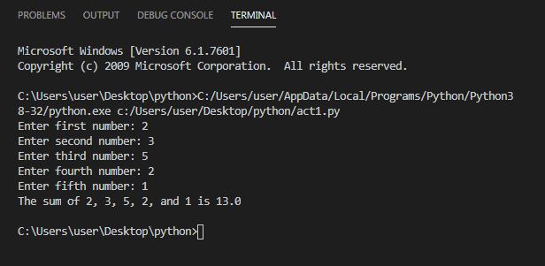

1. **Write a python code to read radius of a circle (say ‘r’) from user and calculate the circumference of the circle. Print the result.**

**CODE;**

#store radius

rad = input('Enter radius of Circle.')

radius = float(rad)

circumference = 2*3.14*radius

print("Circumference of Circle= ",circumference,"\n")

**RESULT;**

