**•** Execute the following commands in Anaconda Prompt and take the screen shots. Document it in PDF file.

**• CD**

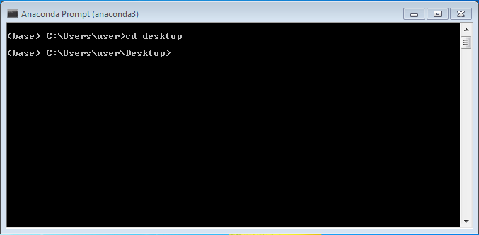

**•  CD/**

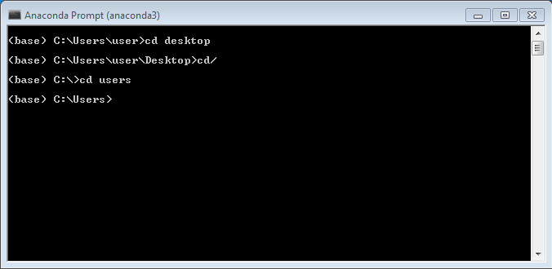

**•  DIR**

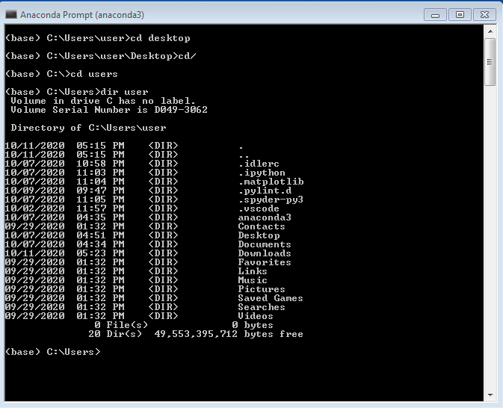

**•  MKDIR**

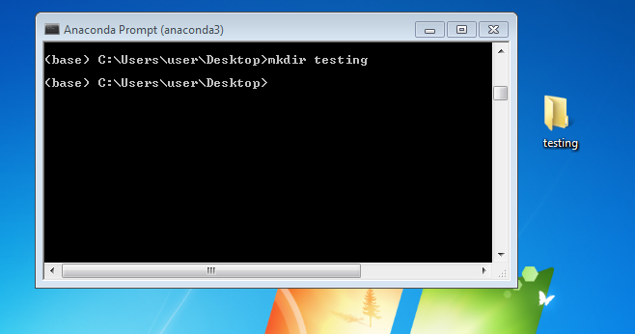

**•  MD**

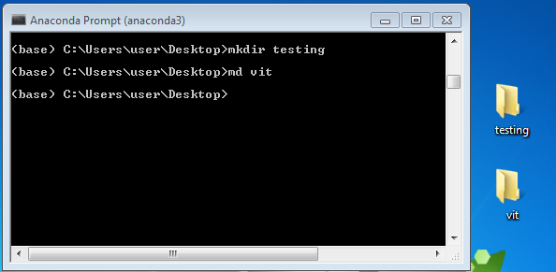

**•  CLS**

SCREENSHOT 1: BEFORE ENTERING CLS COMMAND

SCREENSHOT 2: AFTER RUNNING CLS COMMAND.

CLS IS USE TO CLEAR THE SCREEN.

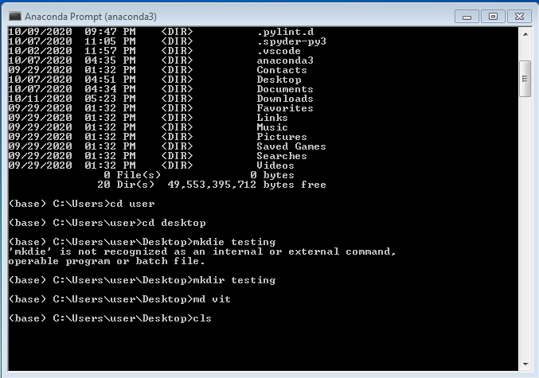

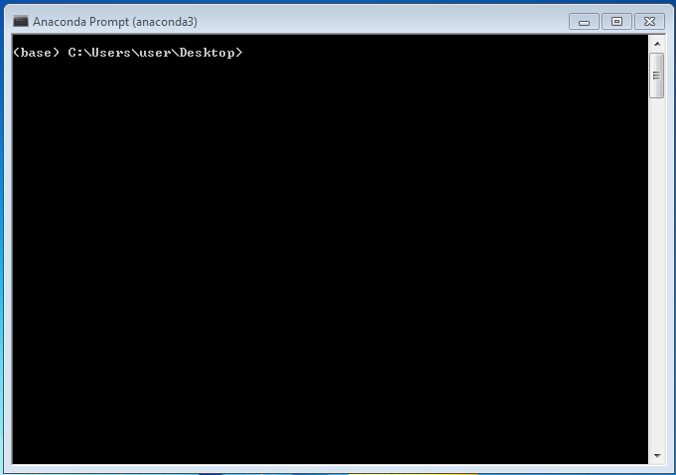

* What is the command for deleting files in Anaconda command prompt? Give sample scree shots.

The command for deleting files in anaconda command prompt is

**DEL**

