**Python Practice – SIMPLE PROGRAMS**

1) Write an algorithm, draw a flow chart and write a python program for the following requirements.a. Read choice from users.  
b. If user’s choice is ‘1’, then print 5 points about our India.  
c. If user’s choice is ‘2’, then print your details (5 points).  
d. If user’s choice is ‘3’, then print 5 points about the Sun.

**ALGORITHM :**

1. Start
2. Read choice from users.
3. According to the users choice print the desired result.
4. End

**FLOWCHART :**

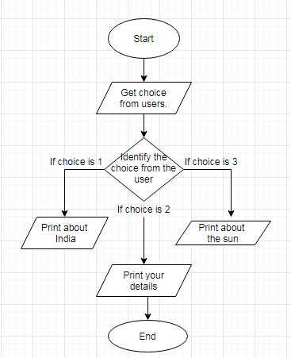

**CODE :**

choice=int(input("Enter your choice 1,2,3: "))

print(choice)

if choice == 1:

  print("India is a country in south asia.")

  print("India is the 2nd most populous country.")

  print("India is 7th largest country by land area.")

  print("India is most populous democracy in world.")

  print("India is in the vicinity of Sri Lanka.")

elif choice == 2:

  print("I am Akshat.")

  print("I am 18 years old.")

  print("I am from Vit University.")

  print("I am pursuing Software Engineering course.")

  print("My goal is to be a software developer.")

elif choice == 3:

  print("The Sun is the star at the center of the Solar System.")

  print("It is a nearly perfect sphere of hot plasma.")

  print("It radiates energy mainly as light.")

  print("Its diameter is 1.39 million km.")

  print("Its mass is about 330000 times that of Earth.")

else:

  print("Invalid choice.")

**OUTPUT :**

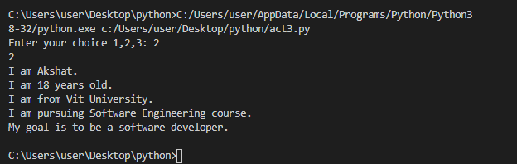

1. Write an algorithm, draw a flow chart and write a python program for the following requirements.a. Read Basic Pay (BP), House Rent Allowance (HRA), Dearness Allowance (DA), Medical Allowance  
   (MA) from users.  
   b. Calculate the total salary using the following formulas.  
   i. HRA = 15 % of BP  
   ii. DA = 25 % of BP  
   iii. MA = 15 % of BP  
   iv. Total_Salary = BP + HRA + DA + MA  
   c. Print BP, HRA, DA, MA and Total_Salary in output screen in legible format.

**ALGORITHM :**

1. Start
2. Read Basic Pay from users.
3. Calculate

HRA by BP*15%

DA by BP*25%

MA by BP*15%

Total salary by BP+DA+HRA+MA

1. Print

TOTAL SAL, HRA , DA, MA, BP

1. End

**FLOWCHART:**

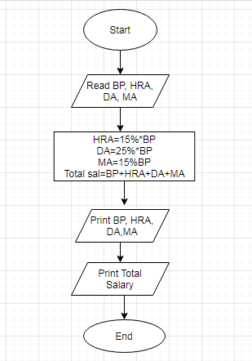

**CODE:**

#storing BP, HRA, DA, MA

bp=input("Enter Basic Pay.")

BasicPay=float(bp)

hra=0.15*float(bp)

da=0.25*float(bp)

ma=0.15*float(bp)

Totalsal=float(hra)+float(da)+float(ma)+float(bp)

print("Total salary is:",Totalsal,"\n")

print("BP is:",bp,"\n")

print("HRA is:",hra,"\n")

print("DA is:",da,"\n")

print("MA is:",ma,"\n")

**OUTPUT:**

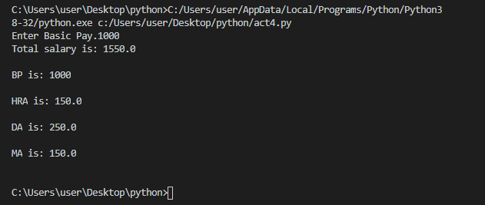

3) Write an algorithm, draw a flow chart and write a python program for the following requirements.a. Read the radius of a circle from user and calculate its area.  
b. Read the length and width of a rectangle from user and calculate its area.  
c. Compare the area of the circle and the rectangle.  
d. Print the one with largest area.

ALGORITHM:

1. Start
2. Read the radius of circle
3. Read the length and breadth of Rectangle
4. Calculate Area of circle by  πr2 .
5. Calculate Area of Rectangle by Length*Breadth.
6. Compare areas of circle and rectangle.
7. Print the largest one.

**FLOWCHART:**

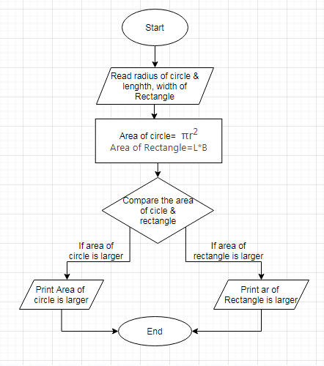

**CODE:**

cir_r = int(input("Enter the radius of circle : "))

rec_l = int(input("Enter the length of the rectangle : "))

rec_w = int(input("Enter the width of the rectangle : "))

area_cir = (cir_r*cir_r) * 22/7

area_rec = rec_l * rec_w

print("Area of the circle is = ",area_cir)

print("Area of the rectangle is = ",area_rec)

if area_cir > area_rec :

    print("Area of the circle is largest")

else :

    print("Area of the rectangle is largest")

**OUTPUT:**

