1.22 Python-Dictionary and its operations (Continuation)

Example:

**INPUT :**

student_dict={

    "Name": "Akshat",

    "Reg No":"20MIS0183",

    "Mathematics":100,

    "Science":95,

    "Computer":99,

    "Result": "PASS"

 }

print("\nInitial Dictionary")

print(student_dict)

student_dict.update({"Mathematics":24})

student_dict.update({"Result":"FAIL"})

print("\nDictionary after using update()")

print(student_dict)

print("\nRemoving the Computer from the list")

student_dict.pop("Computer")

print("Dictionary after using pop()")

print(student_dict)

print("\nDictionary after using popitem()")

student_dict.popitem()

print(student_dict)

print("\nDictionary after deleting name")

del student_dict["Name"]

print(student_dict)

print("\nDictionary after using clear()")

student_dict.clear()

print(student_dict)

student_dict={

    "Name": "Akshat",

    "Reg No":"20MIS0183",

    "Mathematics":100,

    "Science":95,

    "Computer":99,

    "Result": "PASS"

 }

print("\nRecreating the Dictionary")

print(student_dict)

print("\nCopying Student Dictionary using copy()")

student_dict1=student_dict.copy()

print("New Dictionary")

print(student_dict1)

print("\nCopying Student Dictionary using dict()")

student_dict2=dict(student_dict)

print("New Dictionary")

print(student_dict2)

OUTPUT :

[Running] python -u "c:\Users\user\Desktop\python\act1.22\pcc.py"

Initial Dictionary

{'Name': 'Akshat', 'Reg No': '20MIS0183', 'Mathematics': 100, 'Science': 95, 'Computer': 99, 'Result': 'PASS'}

Dictionary after using update()

{'Name': 'Akshat', 'Reg No': '20MIS0183', 'Mathematics': 24, 'Science': 95, 'Computer': 99, 'Result': 'FAIL'}

Removing the Computer from the list

Dictionary after using pop()

{'Name': 'Akshat', 'Reg No': '20MIS0183', 'Mathematics': 24, 'Science': 95, 'Result': 'FAIL'}

Dictionary after using popitem()

{'Name': 'Akshat', 'Reg No': '20MIS0183', 'Mathematics': 24, 'Science': 95}

Dictionary after deleting name

{'Reg No': '20MIS0183', 'Mathematics': 24, 'Science': 95}

Dictionary after using clear()

{}

Recreating the Dictionary

{'Name': 'Akshat', 'Reg No': '20MIS0183', 'Mathematics': 100, 'Science': 95, 'Computer': 99, 'Result': 'PASS'}

Copying Student Dictionary using copy()

New Dictionary

{'Name': 'Akshat', 'Reg No': '20MIS0183', 'Mathematics': 100, 'Science': 95, 'Computer': 99, 'Result': 'PASS'}

Copying Student Dictionary using dict()

New Dictionary

{'Name': 'Akshat', 'Reg No': '20MIS0183', 'Mathematics': 100, 'Science': 95, 'Computer': 99, 'Result': 'PASS'}

[Done] exited with code=0 in 0.741 seconds

# 1. Read any 10 numbers (values) from user and add them to a dictionary (keys are 1,2, …10). Let the dictionary name be number_dict. Sample output:

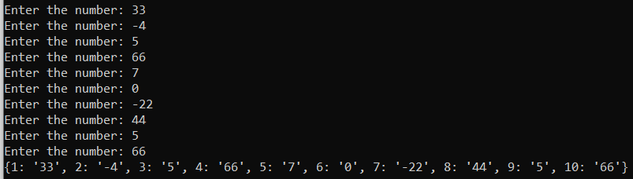

CODE:

num_dict={}

for x in range(1,11):

    n=int(input("Enter the number: "))

    num_dict[x]=n

print(num_dict)

C:\Users\user\Desktop\python>C:/Users/user/AppData/Local/Programs/Python/Python3

8-32/python.exe c:/Users/user/Desktop/python/act1.22/1.22.1.py

Enter the number: 90

Enter the number: 89

Enter the number: 87

Enter the number: 76

Enter the number: 65

Enter the number: 54

Enter the number: 43

Enter the number: 32

Enter the number: 21

Enter the number: 10

{1: 90, 2: 89, 3: 87, 4: 76, 5: 65, 6: 54, 7: 43, 8: 32, 9: 21, 10: 10}