Activity 1.31

**# algorithm for bubble sorting**

**1. Start**

**2. Read an unsorted list from the user.**

**3. It starts from the 1st index value of the list i.e; index 0**

**4. It compares the value of 1st index with the next adjacent block**

**5. If the number in 1st index value is greater than the number in the 2nd index value**

**then the both numbers are swapped**

**6. This same step is followed for each block till it reaches the last value in the list**

**7. This sorting ends when the block is arranged in increasing order**

**9. End**

**# flowchart for bubble sorting**

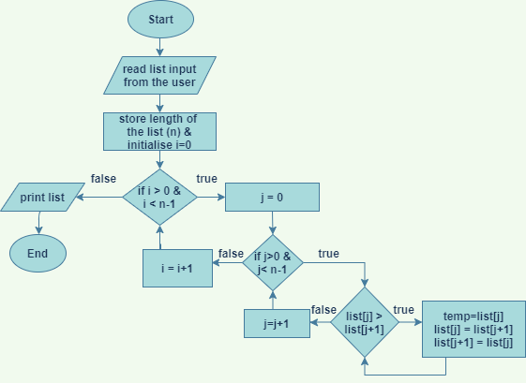

**# code**

list_numbers=[]

print("Enter 10 numbers")

i=1

*while* i <= 10:

    n=int(input("Number {} : ".format(i)))

*if* n not in list_numbers:

        list_numbers.append(n)

*else*:

        print("You have already entered this number, Try Another number")

*continue*

    i += 1

print('List created :', list_numbers, '\n')

*#-------------------------------------------------------------------------------------*

print('List is sorted in ascending order')

ln=len(list_numbers)

*for* x *in* range(ln):

*for* j *in* range(ln-1):

*if* list_numbers[j] > list_numbers[j+1]:

            temp=list_numbers[j]

            list_numbers[j]=list_numbers[j+1]

            list_numbers[j+1]=temp

print(list_numbers)

f=open('ascending_numbers.txt', 'a')

*for* b *in* list_numbers:

    f.write(str(b))

    f.write('\n')

print('Created a file ascending_numbers\n')

f.close()

*#-------------------------------------------------------------------------------------*

print('List is sorted in descending order')

ln=len(list_numbers)

*for* x *in* range(ln):

*for* j *in* range(ln-1):

*if* list_numbers[j] < list_numbers[j+1]:

            temp=list_numbers[j]

            list_numbers[j]=list_numbers[j+1]

            list_numbers[j+1]=temp

print(list_numbers)

f=open('descending_numbers.txt', 'a')

*for* b *in* list_numbers:

    f.write(str(b))

    f.write('\n')

print('Created a file descending_numbers\n')

f.close()

*#-------------------------------------------------------------------------------------*

f_e=open('even_numbers.txt', 'a')

f_o=open('odd_numbers.txt', 'a')

*for* c *in* list_numbers:

*if* c%2 == 0:

        f_e.write(str(c))

        f_e.write(str('\n'))

*else*:

        f_o.write(str(c))

        f_o.write(str('\n'))

print('Created a file even_numbers\n')

print('Created a file odd_numbers\n')

f_o.close()

f_e.close()

**# output**

**C:\Users\user\Desktop\python>C:/Users/user/AppData/Local/Programs/Python/Python3**

**8-32/python.exe c:/Users/user/Desktop/python/act1.31/1.py**

Enter 10 numbers

Number 1 : 10

Number 2 : -2222

Number 3 : 100

Number 4 : 0

Number 5 : 86

Number 6 : -576

Number 7 : -224

Number 8 : 90

Number 9 : 1

Number 10 : 327

List created : [10, -2222, 100, 0, 86, -576, -224, 90, 1, 327]

List is sorted in ascending order

[-2222, -576, -224, 0, 1, 10, 86, 90, 100, 327]

Created a file ascending_numbers

List is sorted in descending order

[327, 100, 90, 86, 10, 1, 0, -224, -576, -2222]

Created a file descending_numbers

Created a file even_numbers

Created a file odd_numbers