Activity 1.32

**# algorithm for selection sorting**

**1. Start**

**2. Read an unsorted list from the user and store its length.**

**3. The outer “for loop” takes each value from the list**

**4. The value of outer “for loop” is assigned as Mvi**

**5. Inner “for loop” runs from a value greater than the “outer for loop”**

**6. It is compared with the Mvi**

**if it is less than Mvi**

**the value of Mvi is swapped (the value of j is incremented upto its range)**

**7. If the Mvi is not equal to the “outer for loop”**

**Mvi is swapped with “outer for loop” value**

**8. This loop runs until it is terminated & the list is sorted.**

**9. End**

**# flowchart for selection sorting**

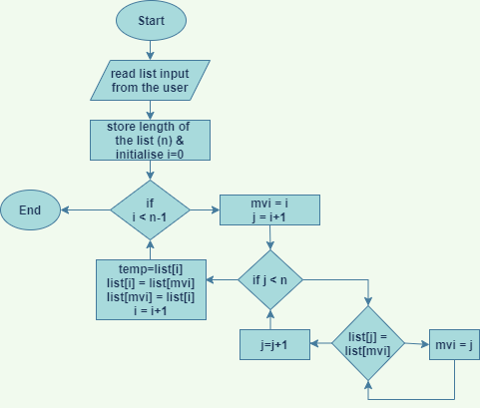

**# practice code**

def selectionSort(*itemsList* ):

    n=len(*itemsList*)

*for* i *in* range(n-1):

        minValueIndex=i

*for* j *in* range(i+1,n):

*if* *itemsList*[j] < *itemsList*[minValueIndex]:

                minValueIndex=j

*if* minValueIndex != i:

            temp=*itemsList*[i]

*itemsList*[i]=*itemsList*[minValueIndex]

*itemsList*[minValueIndex]=temp

*return* *itemsList*

list_numbers=[100,25,0,-1,21,88,16,99,133,23]

print("\nList before Sorting")

print(list_numbers)

print("\nList after applying Selection Sort Technique: ")

print(selectionSort(list_numbers))

**# output**

**C:\Users\user\Desktop\python>C:/Users/user/AppData/Local/Programs/Python/Python38-32/python.exe c:/Users/user/Desktop/python/act1.32/pcc.py**

List before Sorting

[100, 25, 0, -1, 21, 88, 16, 99, 133, 23]

List after applying Selection Sort Technique:

[-1, 0, 16, 21, 23, 25, 88, 99, 100, 133]

C:\Users\user\Desktop\python>

## 3) Write a python program for the following requirements. a) Read 6 numbers from users and insert them into a list (say list_numbers). Make sure that list_numbers contains negative, positive, odd, even numbers. b) Print the list_numbers. c) Using selection sorting technique, sort the numbers in list_numbers and print them in ascending order. Also store the numbers in ascending order into a file (say ‘ascending_numbers.txt’). d) Store the numbers in descending order into a file (say ‘descending_numbers.txt’). e) Take the even numbers from list_numbers and store them into a file (say ‘even_numbers.txt’). f) Take the odd numbers from list_numbers and store them into a file (say ‘odd_numbers.txt’). g) Trace the entire program manually (handwritten material) in neat format to show the status of all variables and condition checking during all iterations. Add the scanned soft copy into the answer sheet (PDF file).

def selection_sort(*given_list*):

    length = len(*given_list*)

*for* x *in* range(length-1):

        minimum_value_holder = x

*for* j *in* range(x + 1, length):

*if* *given_list*[j] < *given_list*[minimum_value_holder]:

                minimum_value_holder = j

*if* minimum_value_holder != x:

            temp = *given_list*[x]

*given_list*[x] = *given_list*[minimum_value_holder]

*given_list*[minimum_value_holder] = temp

def selection_sort_dec(*given_list*):

    length = len(*given_list*)

*for* x *in* range(length-1):

        minimum_value_holder = x

*for* j *in* range(x + 1, length):

*if* *given_list*[j] > *given_list*[minimum_value_holder]:

                minimum_value_holder = j

*if* minimum_value_holder != x:

            temp = *given_list*[x]

*given_list*[x] = *given_list*[minimum_value_holder]

*given_list*[minimum_value_holder] = temp

list_numbers = []

print("Enter 6 numbers")

i = 1

*while* i <= 6:

    number = int(input("Number {} :".format(i)))

*if* number not in list_numbers:

        list_numbers.append(number)

*else*:

        print("You have already entered this Number, Try another")

*continue*

    i += 1

print('List created :', list_numbers, '\n')

*# ----------------------------------------------------------------------------------------------*

print('List is sorted in ascending order')

selection_sort(list_numbers)

print(list_numbers)

file_handler = open('ascending_numbers.txt', 'a')

*for* t *in* list_numbers:

    file_handler.write(str(t))

    file_handler.write('\n')

print('Created a file ascending_numbers\n')

file_handler.close()

*# ------------------------------------------------------------------------------------------------*

print('List is sorted in descending order')

selection_sort_dec(list_numbers)

print(list_numbers)

file_handler = open('descending_numbers.txt', 'a')

*for* t *in* list_numbers:

    file_handler.write(str(t))

    file_handler.write('\n')

print('Created a file descending_numbers\n')

file_handler.close()

*# ------------------------------------------------------------------------------------------------*

file_handler_even = open('even_numbers.txt', 'a')

file_handler_odd = open('odd_numbers.txt', 'a')

*for* z *in* list_numbers:

*if* z % 2 == 0:

        file_handler_even.write(str(z))

        file_handler_even.write('\n')

*else*:

        file_handler_odd.write(str(z))

        file_handler_odd.write('\n')

print('Created a file even_numbers\n')

print('Created a file odd_numbers\n')

file_handler_odd.close()

file_handler_even.close()

## #output

**C:\Users\user\Desktop\python>C:/Users/user/AppData/Local/Programs/Python/Python38-32/python.exe c:/Users/user/Desktop/python/act1.32/1.py**

Enter 6 numbers

Number 1 :76

Number 2 :-2

Number 3 :233

Number 4 :-102

Number 5 :57

Number 6 :-11

List created : [76, -2, 233, -102, 57, -11]

List is sorted in ascending order

[-102, -11, -2, 57, 76, 233]

Created a file ascending_numbers

List is sorted in descending order

[233, 76, 57, -2, -11, -102]

Created a file descending_numbers

Created a file even_numbers

Created a file odd_numbers

