* I have created a customized image of Jenkins using centos and I have installed java-1.8.0 and Jenkins-2.222.3 in it initially and then cloned it. After writing the systemctl command for Jenkins “/etc/rc.d/init.c/Jenkins start”. It is starting the Jenkins in the container and listening on port 8080.
* Bt in the dockerfile when I write the systemctl command it automatically exits the container so I changed this command “CMD /usr/lib/Jenkins/Jenkins.war”

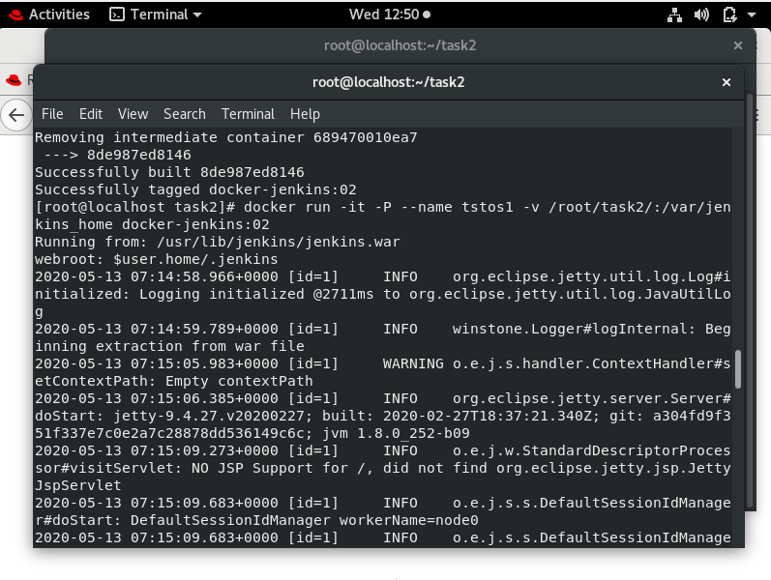

* After running the container from the docker-jenkins:02(customized docker image). The Jenkins will work remotely and also it will give you the pwd in the logs.

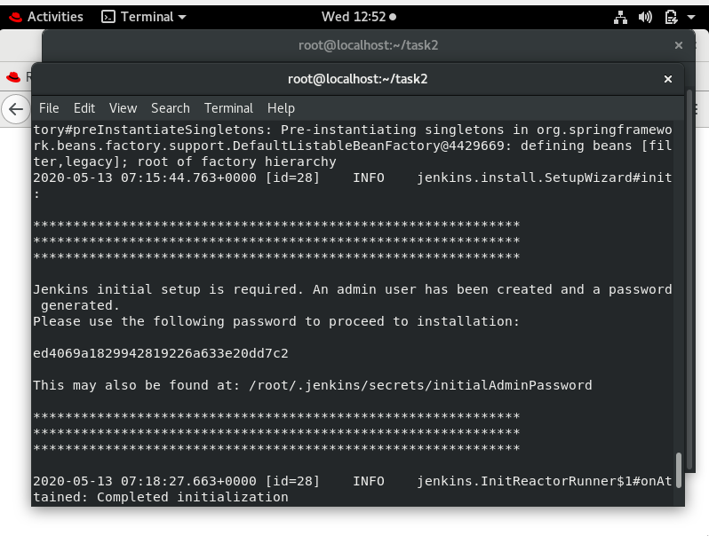

* After running the Jenkins in the browser. We need to install all the necessary plugins for the project.
* Now moving to the jobs I have modified them accordingly. As I don’t know about some concepts in the Jenkins and linux.
* The first job is to retrieve the repo files and codes. So I used poll scm to monitor the codes and retrieve them in a task2p folder.

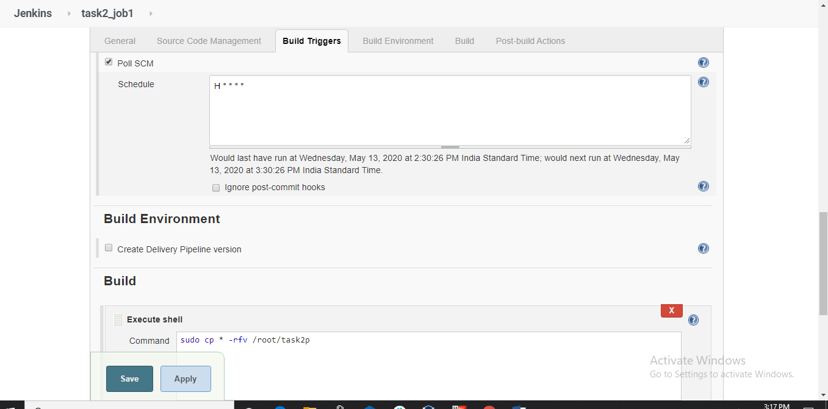

* The 2nd job is to check the code and to run the interpreter for the same to deploy code. In my case I have used python , php , html interpreter’s container. As I have the custom images which will run the interpreter for the same when I run the respective container

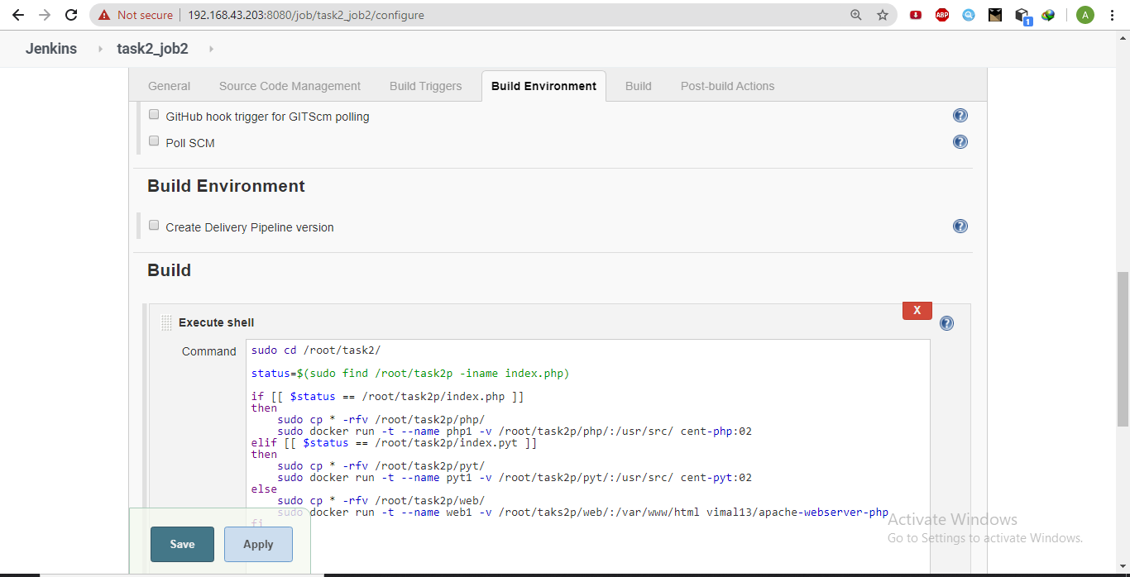

* Using this if else statement I am able to run multiple containers bt only the webserver container will successfully run and the other two os will keep on running in the job. If anyone reading this and knows anything about how to stop this job please tell me about it. Below snips will give you the idea

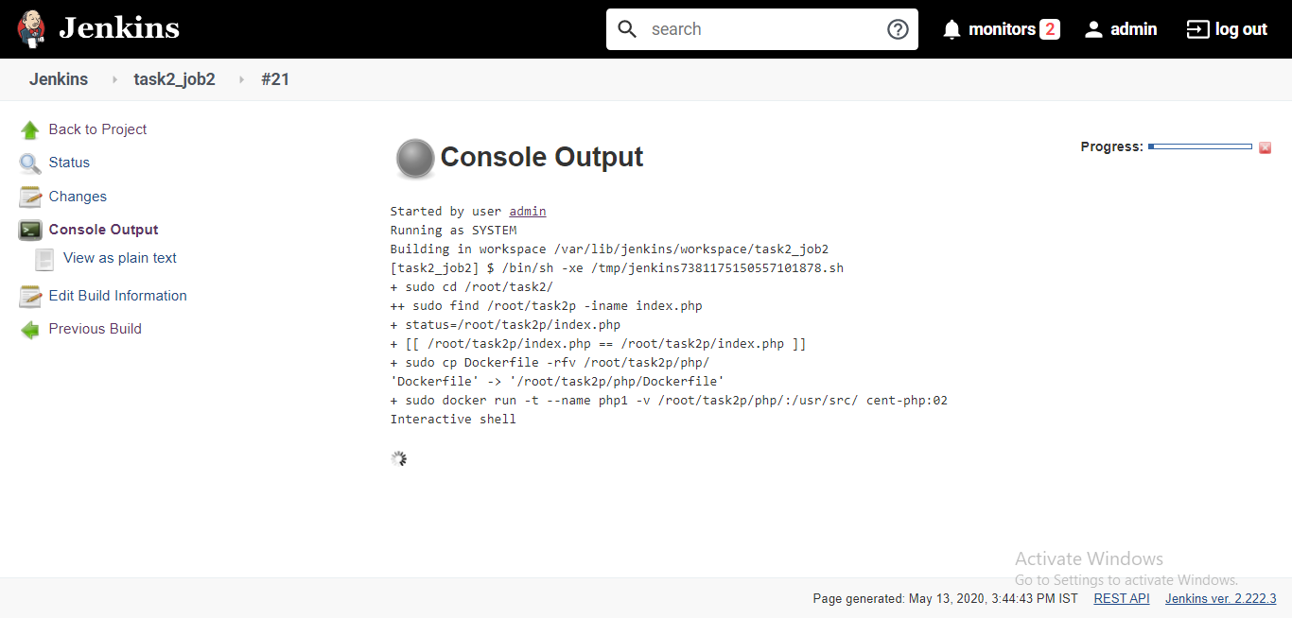

* And it will run the docker container having php an interactive shell in it

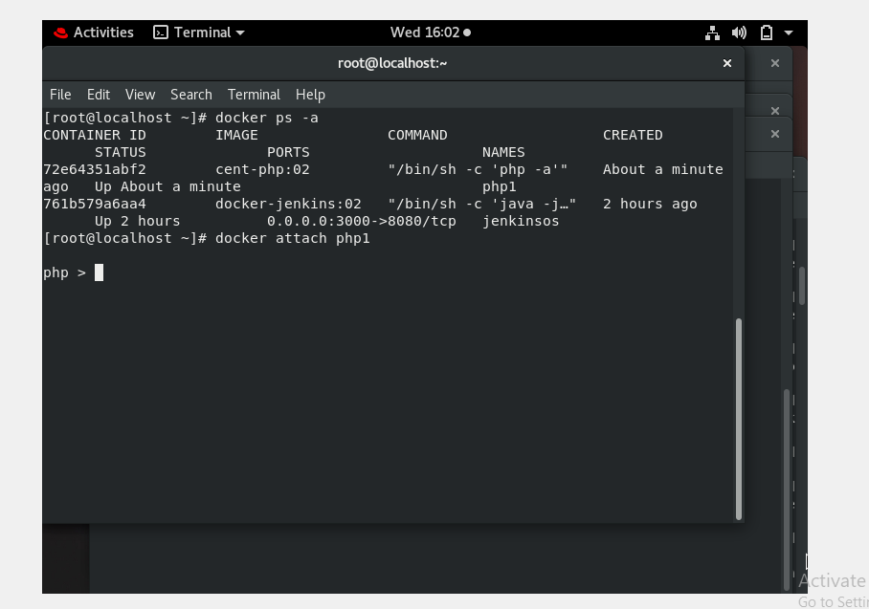

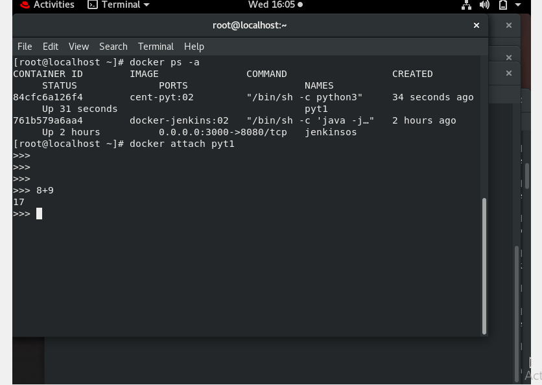



* My job 3 can only run the check when the webserver is deployed and not for the python or php container to run.
* And for the 4th job I have used the Jenkins credentials for doing the email. And it will trigger whenever the job3 fails.

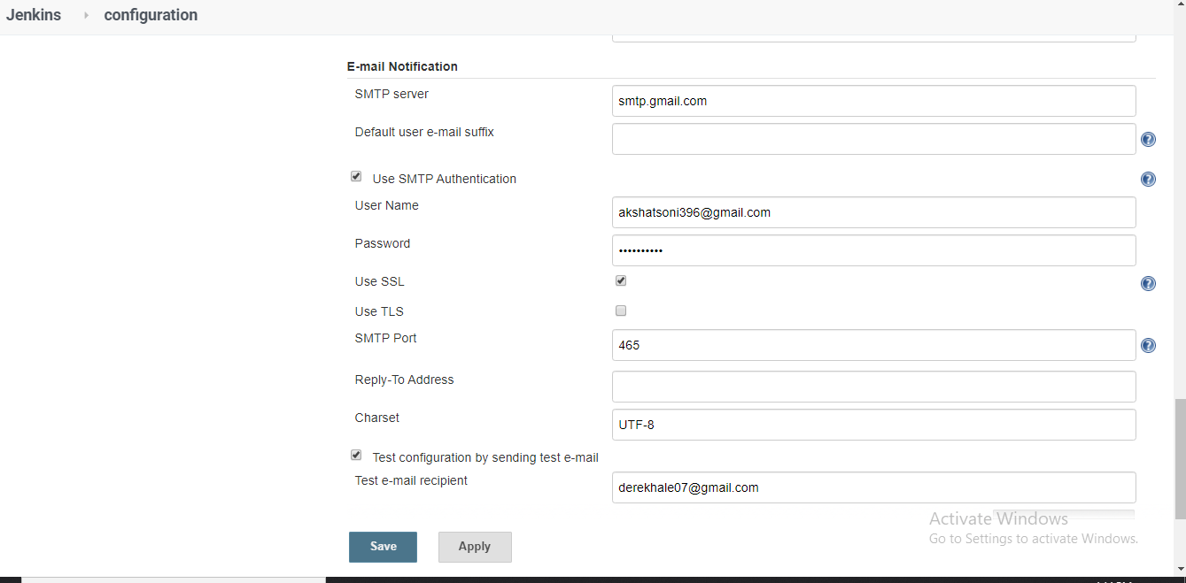

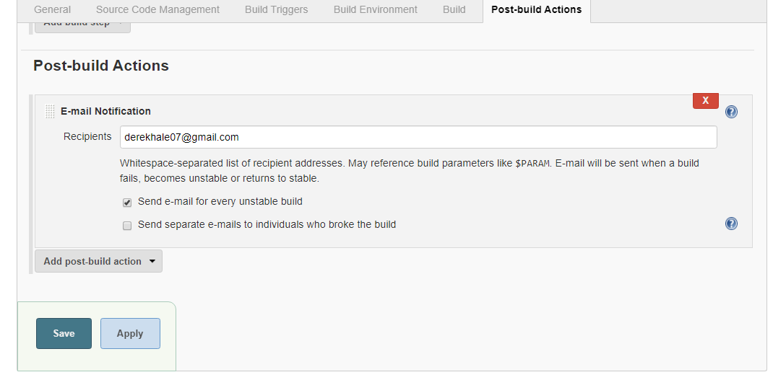

* Bt in this project I have certain limitations such as the developer must have the initial file as index.php or index.html or index.py
* And the second thing is that the whole folder must contain a particular files. We can resolve this using multiple branch and writing individual job for a particular part.