TASK3 (ML+DEVOPS)

* I started the project by creating a docker image which have jenkins and docker installed in it.

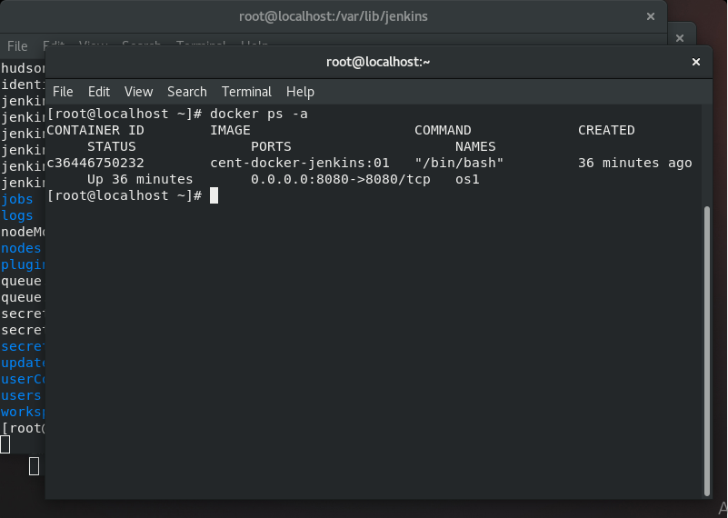

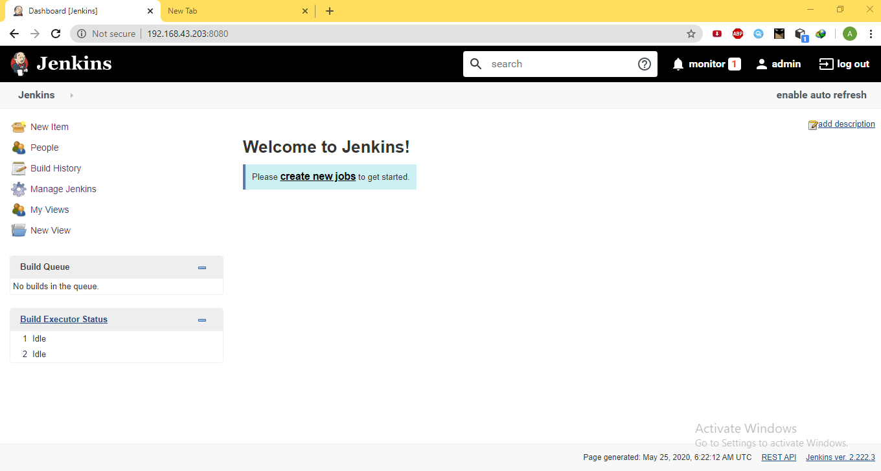

* This img will automatically start the jenkins sever as soon as the img runs. And to use the jenkins UI we need to run the the IP:8080
* Now the first job is to pull the code from the github account and to copy it in the jenkins container notebooks folder.

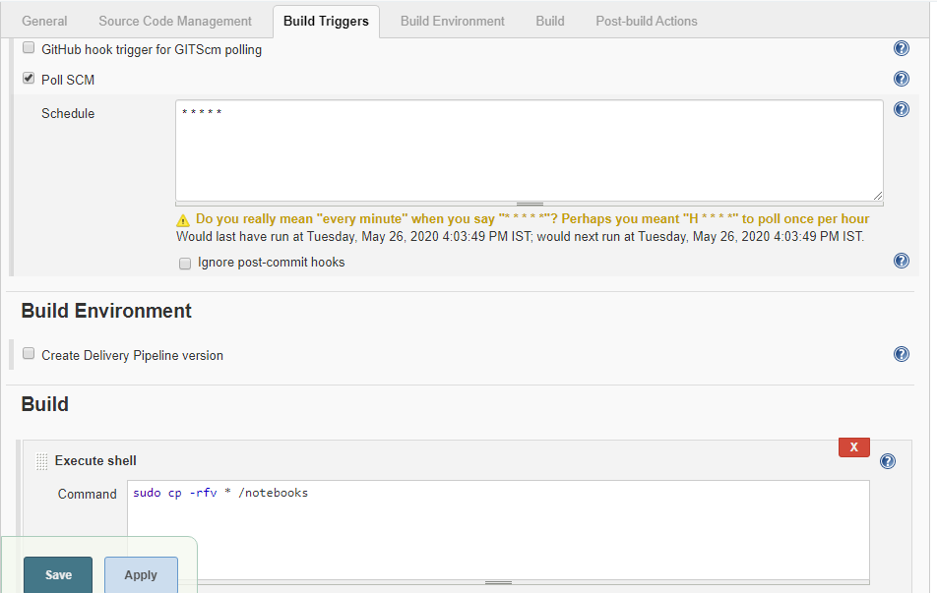

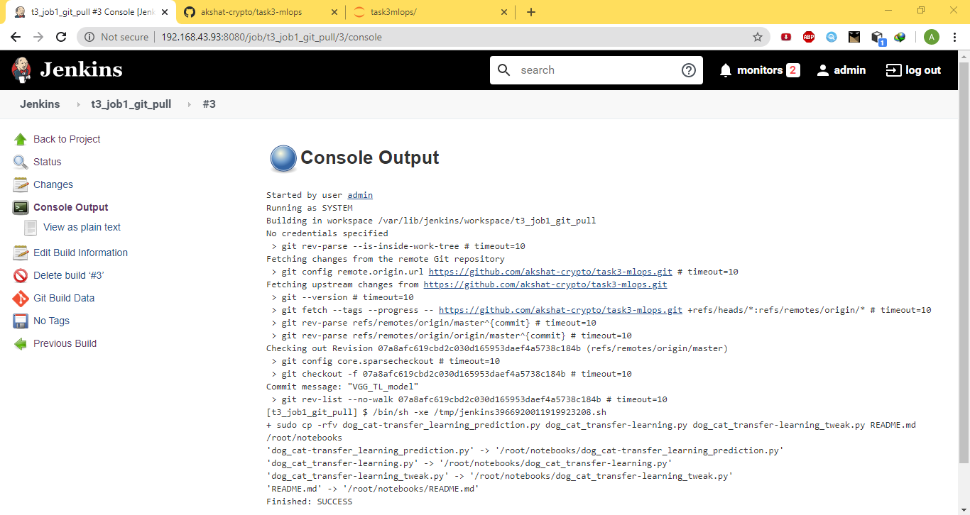

* After the codes is copied in the folder the 2nd job is to identify if it’s a cnn model or regr or any other model. And it will run the respective container in which the complete env is installed.

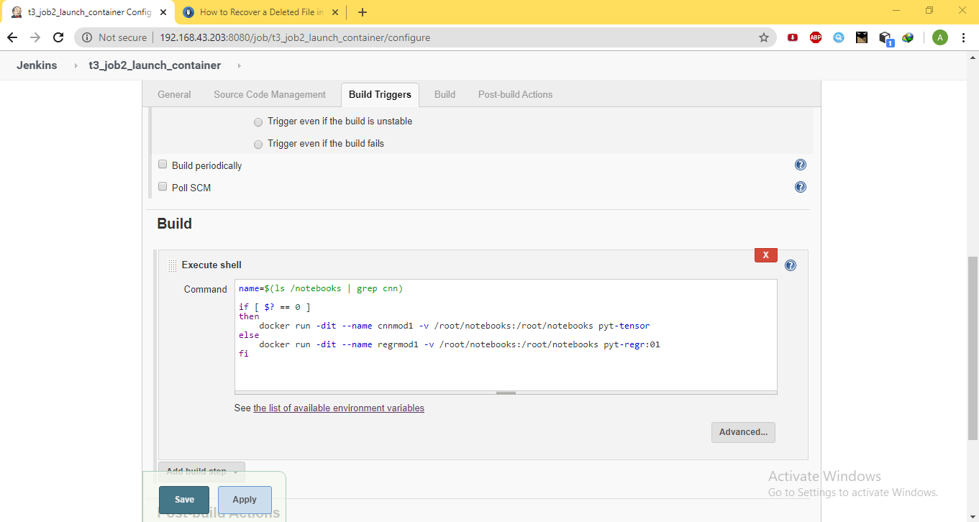

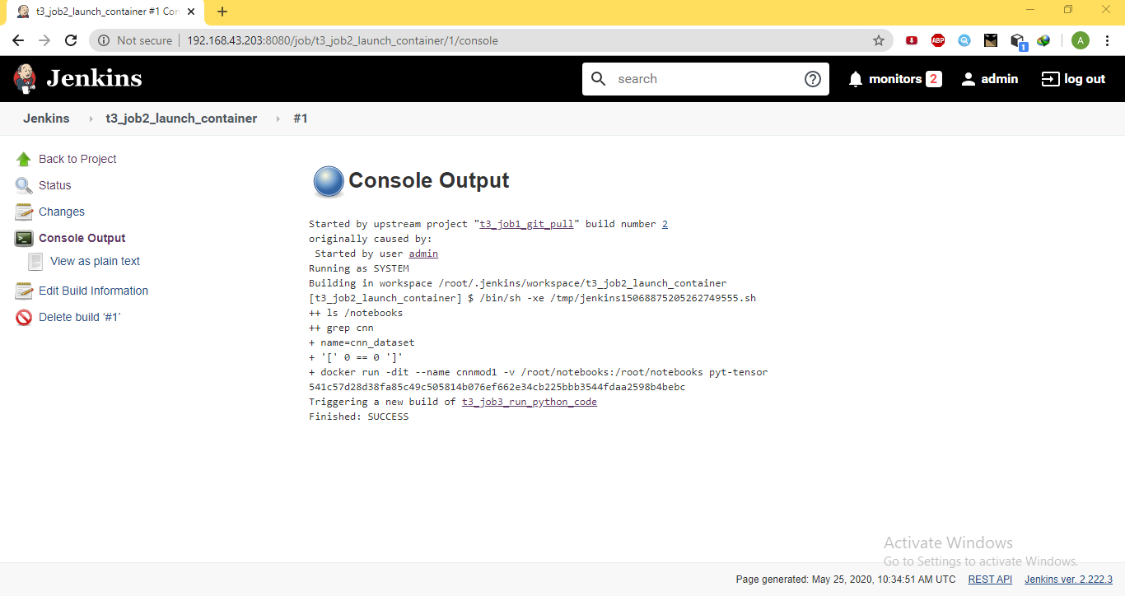

* Now for 3rd job is to train the model in that container. I have created a python code in which it will first train the model and will print the accuracy of the trained model as an exit code.

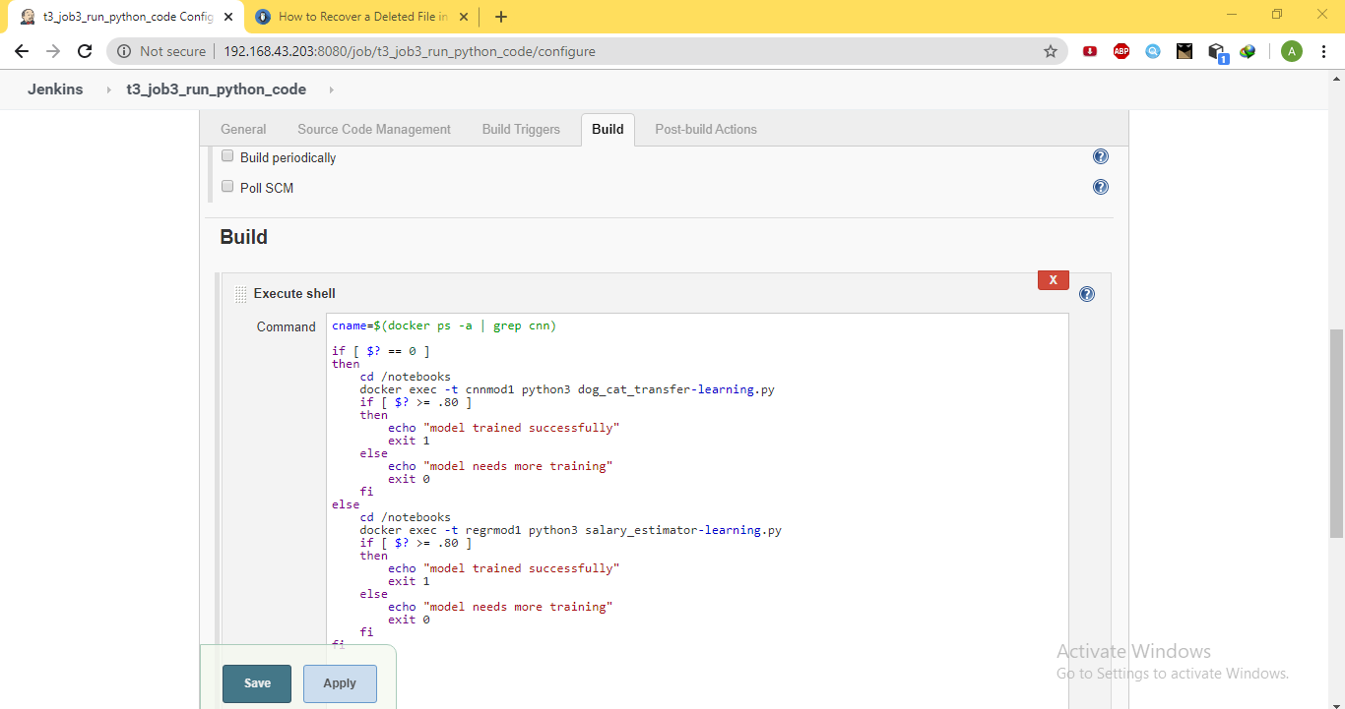

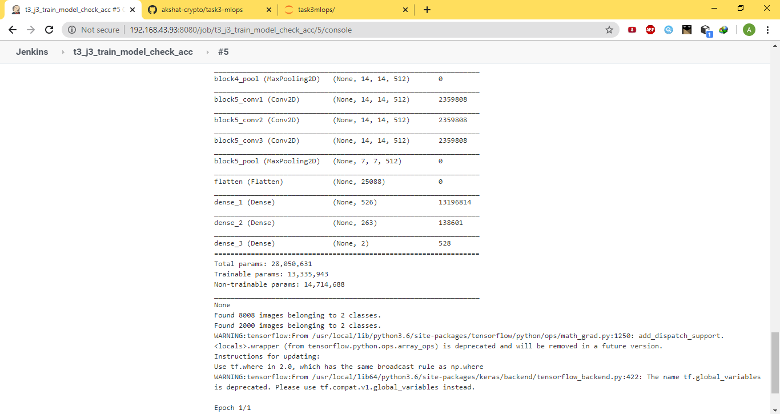

* Now if the exit code tells accuracy is more than 80% than while exiting it will not trigger the code for tweaking the python code in the container. Else it will trigger the 4th job is to run the tweaking model code in that container. Here exit 0 means the job will build successfully and not trigger the next job.

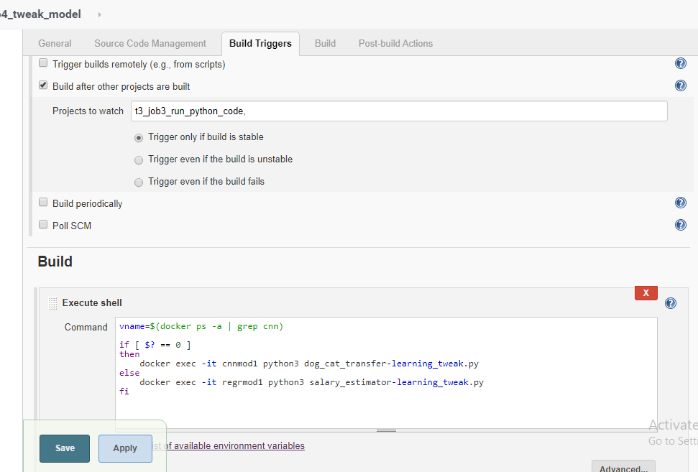

Now in this job the python code will modify the architecture of the model and train it again and again until the accuracy reaches upto 85%.()

* In the 5th job it will notify about the completion of the model training. Using the email and also prints the mssg on the screen

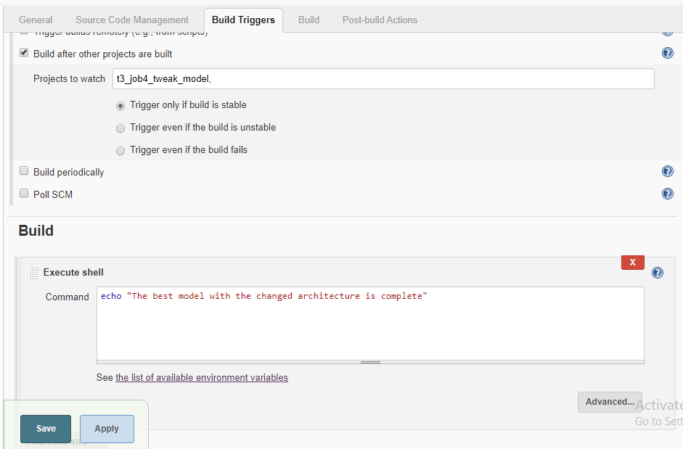

* The additional 6th job is to monitor the container in which the training is going and if in any case the container stops it will run a new container and run the same process.

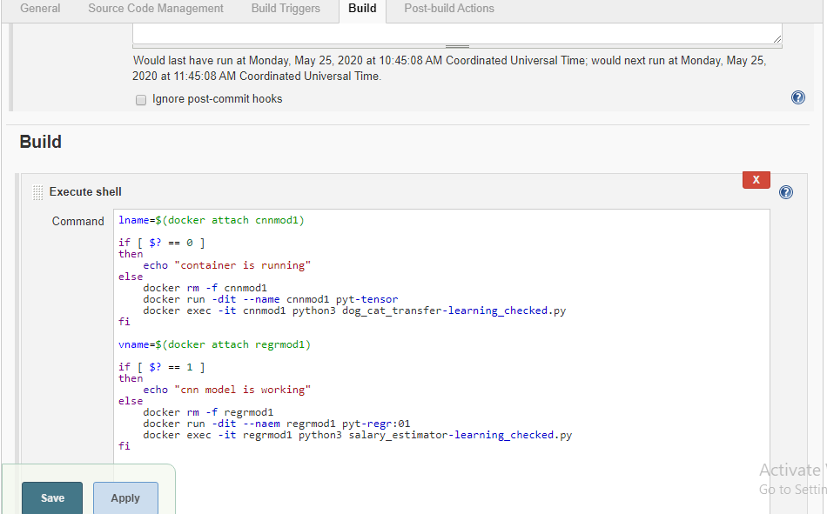

NOTE:-

This model have some constraints

1. The name of the model must contain cnn in case of a cnn model and regr in case of regression model.
2. At the time of training one model is trained at one time and the layer is added in a loop means we cant tweak the model more than 5 times. Check the python code for your refrence.
3. This model is created mainly on the concepts of regression and CNN model only.

Thank you so much PRIYANSH M , CYBER WIZARD , PRASHANT SAINI. Because of their help I am able to complete my complete project.