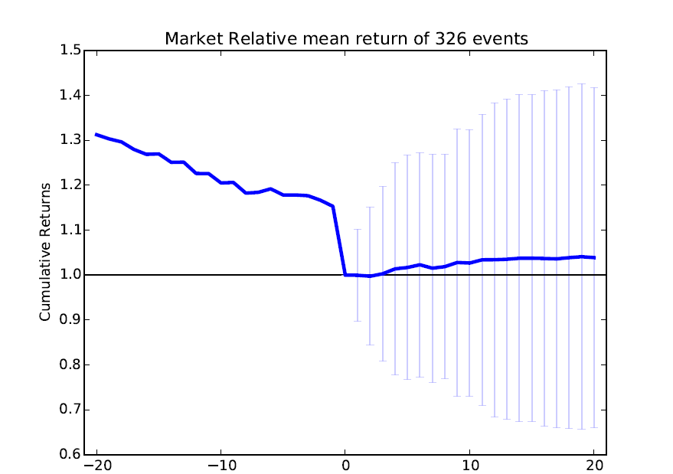
2008 S&P

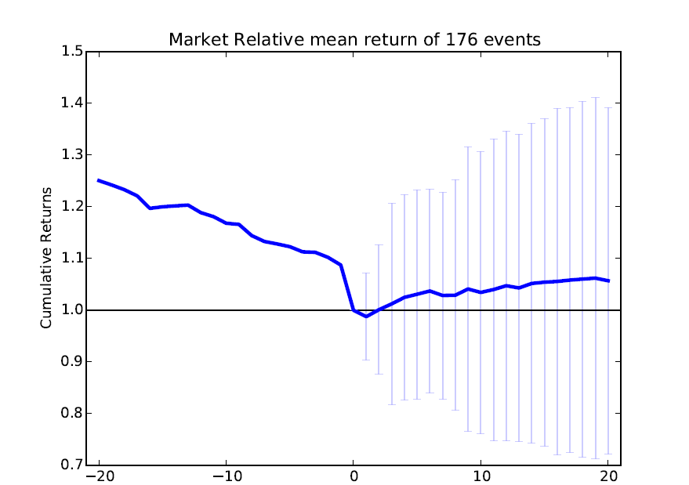
2012 S&P

Consider the similarities and differences between the two charts. In what ways are they different? To what do you believe we could attribute the differences?
The event charts are different in the return after 20 days as well as the drop observed.
For returns, it is larger in case of S&P 500 from 2012 as compared to 2008. the possible reasons could be that the economic recession around the year 2008 caused the companies from S&P 500 in 2008 to perform worse. When we look at companies in S&P in 2012, there could be the case that only the strong companies that performed comparatively well in 2008 survived. So there is a survivor bias in the data set of the companies on which we perform the analysis for the same time period, hence resulting in better performance. Similar reasons could be attributed to the fact that the drop for S&P 2012 stocks is lesser, in that these stocks were inherently stronger.

The similarity is that after the drop, both the stock price on average rise. This is also called dead cat bounce.

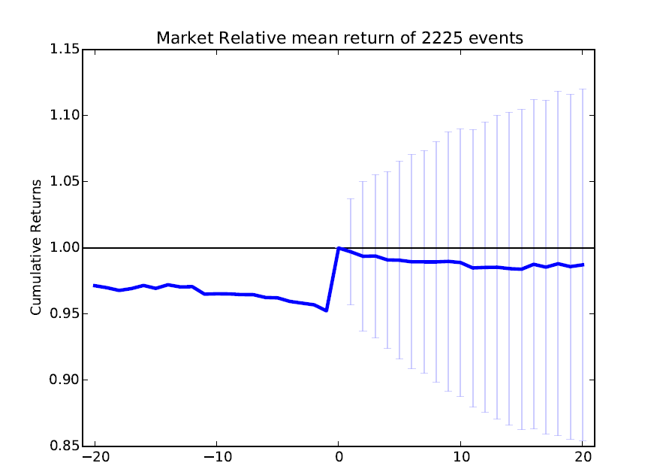
Even is rise by 5 $

Include a description and motivation for your event.
The event is that the stock price today is 5 $ greater than stock price a day earlier. The motivation is that such a sudden price rise is a market mistake and hence the market would adopt corrective measures, resulting in drop of price in subsequent days.
Is it possible to make money using your event?
Yes, by shorting the stocks.
If it is possible, what investing strategy would you use? Think about details of entry (buy) and exit (sell), how many days would you hold?
The possible strategy would involve shorting the stock when the event occurs. After the five dollar rise event, we observe that on average the stocks register a drop of around 98% of the the value at the time of event. We can short the stock for 20 days, thereby generating a profit.
Is this a risky strategy?
Based on the standard deviation(around .15 cents per dollar) observed for the event, this is a risky strategy if done in isolation for each event.
How much do you expect to make on each trade?
Each trade doesn't have a constant value for the event, as we see due to large (+-.15 cents) standard deviation in the chart. However on average if we buy at say 1$, we have to again buy the same number of stocks at 0.98 $ after 20 days, resulting in a profit of 2 cents per dollar we invest.
How many times do you expect to be able to act on this opportunity each year?
There are 2225 events per year, so we hope to have the opportunity that many times a year. In fact to ensure that this is a viable strategy, we have to invest for a large enough sample so as to ensure on average we register a profit.
Is there some way to reduce the risk?
The risk is reduced if we invest for each event and look at the average return. There is a large standard deviation observed, hence in isolation it is a risky strategy. Risk reduces if we invest in all the event occurrences. Another way to reduce the risk would be to conduct further analysis of this event by imposing further conditions.

NOTE:Unless otherwise specified, values are based on per dollar investment basis

