Akshat Harit
903090915

For orders.csv
TEXT OUTPUT
The final value of the portfolio using the sample file is -- 2011-12-20 16:00:00: 1133860.0
Details of the Performance of the portfolio :

Data Range : 2011-01-10 16:00:00 to 2011-12-20 16:00:00

Sharpe Ratio of Fund : 1.21540462111
Sharpe Ratio of $SPX : 0.0183391412227

Total Return of Fund : 1.13386
Total Return of $SPX : 0.97759401457

Standard Deviation of Fund : 0.00717514512699
Standard Deviation of $SPX : 0.0149090969828

Average Daily Return of Fund : 0.000549352749569
Average Daily Return of $SPX : 1.72238432443e-05

PLOT
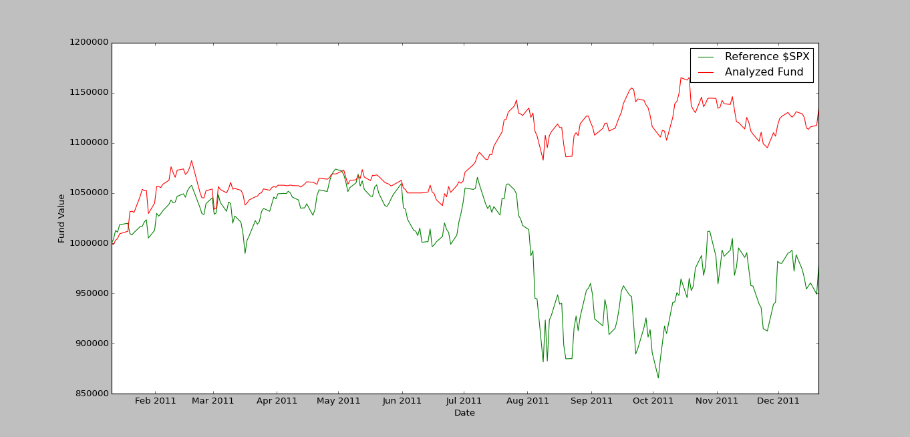

For orders2.csv
TEXT OUTPUT
The final value of the portfolio using the sample file is -- 2011-12-14 16:00:00: 1078752.6
Details of the Performance of the portfolio :

Data Range : 2011-01-14 16:00:00 to 2011-12-14 16:00:00

Sharpe Ratio of Fund : 0.788985460132
Sharpe Ratio of $SPX : -0.177204632551

Total Return of Fund : 1.0787526
Total Return of $SPX : 0.937041848381

Standard Deviation of Fund : 0.00708034136287
Standard Deviation of $SPX : 0.0149914504972

Average Daily Return of Fund : 0.000351902965125
Average Daily Return of $SPX : -0.000167347202139

PLOT
