Akshat Harit
903090915
Five Dollar Event
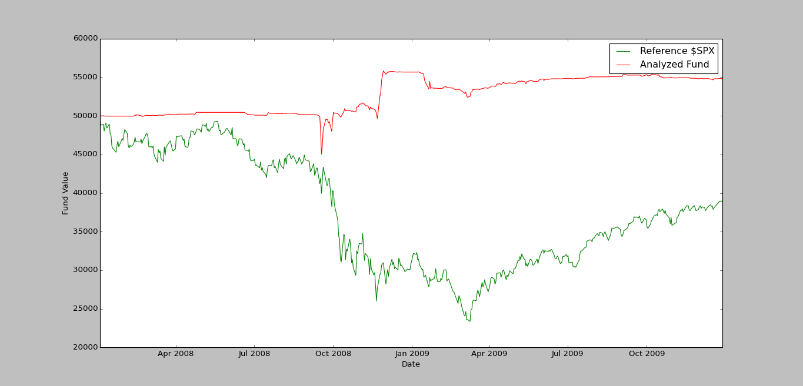
The final value of the portfolio using the sample file is -- 2009-12-28 16:00:00: 54824.0
Details of the Performance of the portfolio :

Data Range : 2008-01-03 16:00:00 to 2009-12-28 16:00:00

Sharpe Ratio of Fund : 0.527865227084
Sharpe Ratio of $SPX : -0.184202673931

Total Return of Fund : 1.09648
Total Return of $SPX : 0.779305674563

Standard Deviation of Fund : 0.0060854156452
Standard Deviation of $SPX : 0.022004631521

Average Daily Return of Fund : 0.000202354576186
Average Daily Return of $SPX : -0.000255334653467

My event
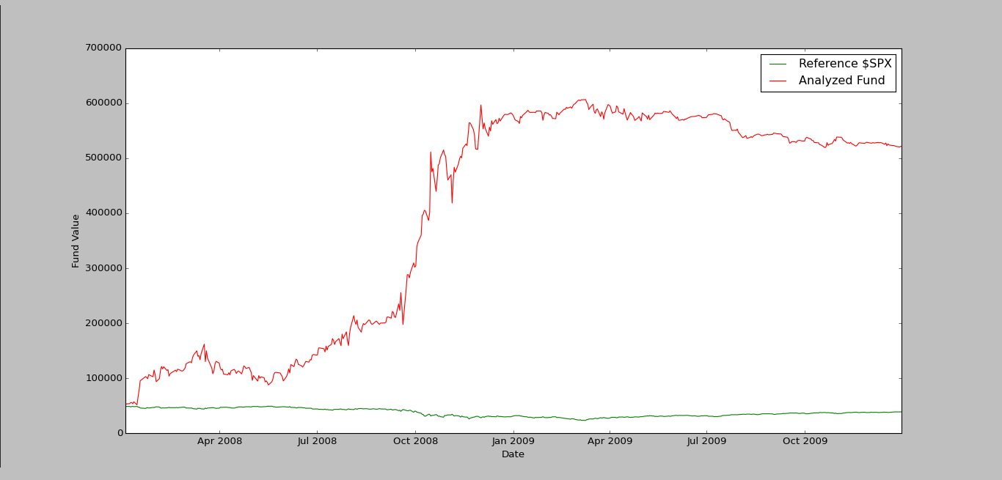

The final value of the portfolio using the sample file is -- 2009-12-30 16:00:00: 521183.0
Details of the Performance of the portfolio :

Data Range : 2008-01-03 16:00:00 to 2009-12-30 16:00:00

Sharpe Ratio of Fund : 1.93312786464
Sharpe Ratio of $SPX : -0.18556812555

Total Return of Fund : 10.42366
Total Return of $SPX : 0.778365902872

Standard Deviation of Fund : 0.0469971438961
Standard Deviation of $SPX : 0.0219609097257

Average Daily Return of Fund : 0.00572310582404
Average Daily Return of $SPX : -0.000256716295552

Description
The event is that the stock price today is 5 $ greater than stock price a day earlier. The motivation is that such a sudden price rise is a market mistake and hence the market would adopt corrective measures, resulting in drop of price in subsequent days.

