

**Basic Linux Commands Assignments**

Assignment-1

Connect and disconnect with login Access

* What happens when you login a non-existent users or username?
  + Provide Screenshot and What you understand, explain in short brief?

If we provide a non-existent user or username then it outputs that the user

doesn’t exists.

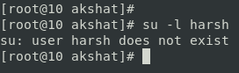

Assignment-2

Password changing

* Login into your account and then change password?
  + Change your password into **IneuR0n#42** and hit the **Enter** key
    - Explain what happen and give screenshot?

I used “passwd <username>” command to change the password of any user.

I typed the new password and retyped the new password as shown in the

screenshot. As a result password was changed successfully.

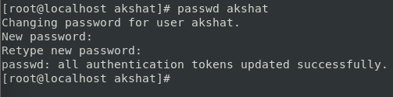

* + Try again to change password but use like password ***1234*** or ***abcd***
    - Explain what happen and give screenshot?

If we want to change a password that is less than 8 characters then it is prompted by centos as BAD PASSWORD as seen in the screenshot.

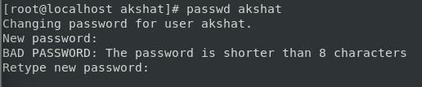

* + Try again to change password but now don’t use any password just hit **Enter** key
    - Explain what happen and give screenshot?

If we don’t type anything then it is prompted that “No password supplied”. So we need to supply password that is more than 8 characters long to change the password.

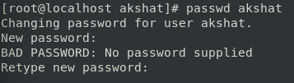

Assignment-3

Working with Directories

* Enter the command **cd /** and then **ls** and then hit **Enter** key
  + Take screenshot and explain what output we got?

“cd /” command takes us to the root directory. And when we do ls at root directory then we get to see all the files present in the system or root directory.

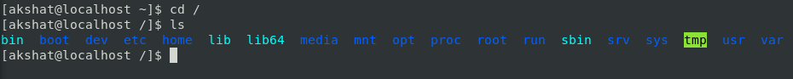

* Enter the command now **cd /home** and then hit **Enter** key
  + Do **ls,** provide screenshot and explain what is **/home** directory used for?

“cd /home” takes us to home directory which is present inside root directory. And when we do ls then we can see all the users in our system.

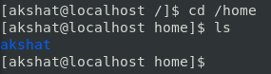

* Enter **cd ..** and hit **Enter** key [ *Note: here we have space after cd then use double dot*]
  + Check what happen and give screenshot?

“cd ..” takes us to the previous directory. We go from home to the root directory.

assignment3-img3

* Now enter **cd /var/www/html** and then type **cd** and hit **Enter** key
  + Explain what happen and give screenshot?

Since there is no folder named www present in var directory that is why it is   
 showing “No such file or directory”. We don’t have any web service installed  
 on the system.

assignment3-img4

* Now type **cd /root** and then hit **Enter** key
  + Do **ls,** check any output we have on screen if yes then take screenshot?

When we perform “cd /root” as a normal user then the permission is denied. But  
 when we perform this command as a root user then it takes us to the home folder   
 of root user.

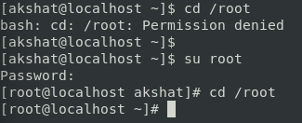

Assignment-4

Working with File Listing

* Go to **cd /etc** and type **ls**
  + Take screenshot and explain what files you have seeing?

This command shows all the files present inside the etc directory. We have seen passwd, os-release, yum, firefox, and many more.

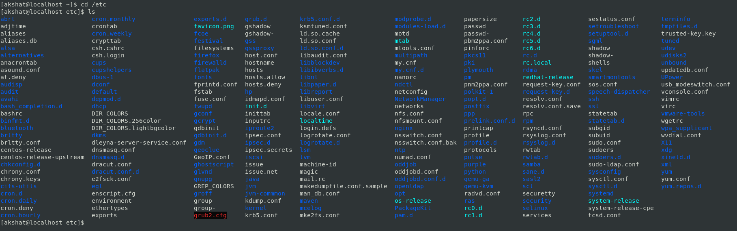

* + Take screenshot and explain what different output you found compare to previous command you used?

I think these files are the applications and settings that are present inside our

system as Linux treats all thing as files.



* Then type **ls -al** and hit **Enter** key
  + Take screenshot and explain what new file or directory you found?

By using “-al” as options parameter with ls we can see the permissions of all the files and directories present inside etc directory. We can see permissions for User, Group and Others.

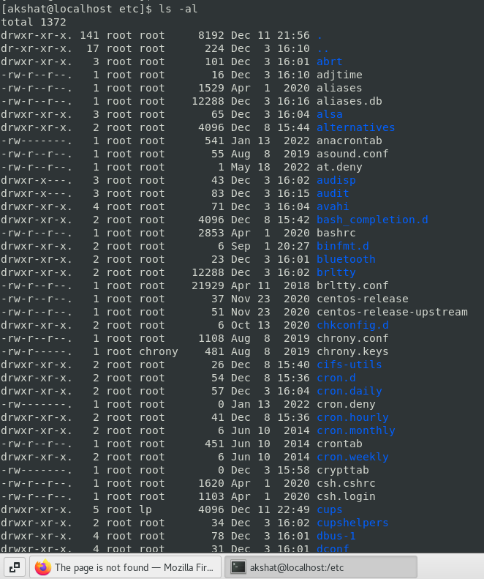

* Then use **ls -i** and hit **Enter** key
  + Now see what different output its shows and take screenshot?

By using “-i” as option we can see the size of all the directories and files.

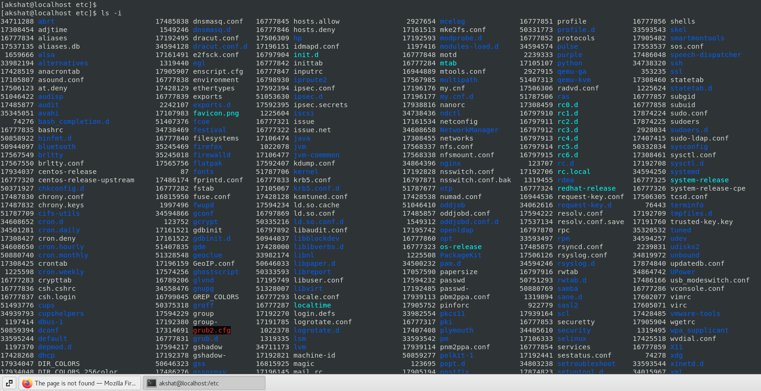

* Then use **ls –help** and see other options about **ls** command
  + Explore it and try with other attribute we can use with **ls** command

Assignment-5

Know where you are and where you working

*Here we use* ***pwd, cd and ls*** *as combine task to understand where you working on terminal and how you can switch from one directory to another one.*

* Open terminal after restart the linux
  + Check which location you working, type **pwd** and take screenshot

assignment5-img1

* Now use **cd /var** and hit **Enter** key
  + Do **ls,** and see what output comes, give screenshot?

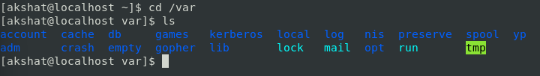

* Do explore other help options of each command to learn more other things we can do with these commands