Abstract - This project presents a smart and efficient Android-based Attendance Management System designed to streamline the attendance tracking process using facial recognition technology. The system utilizes real-time face detection through a mobile camera to mark attendance, minimizing manual intervention and reducing the risk of proxy entries.
The application offers a dual-mode attendance mechanism: automatic attendance using facial recognition and manual selection via student ID or roll number as a fallback. Upon successful face detection, the system logs the attendance, storing the data securely. If face detection fails or is not preferred, the user can manually select the corresponding roll number and mark attendance.
In today’s fast-paced digital world, traditional attendance systems often suffer from inefficiency, manual errors, and lack of real-time validation. To address these challenges, this project proposes an automated attendance system using face recognition technology powered by machine learning. By leveraging real-time image capture and advanced face detection algorithms, the system ensures accurate, secure, and contactless attendance marking. This approach reduces the administrative workload while enhancing the overall user experience for both students and staff.
The system architecture integrates multiple modules, including image capture, preprocessing, face detection, and recognition, all seamlessly connected to a backend attendance database. Using a trained deep learning model (such as FaceNet) combined with a robust error-handling mechanism, the system can handle unrecognized faces, low-light conditions.Attendance records are stored in a cloud database (like Firebase), ensuring scalability, security, and easy access for reporting or audits. The modular design allows flexibility for future enhancements, such as multi- face detection or integration with mobile devices.
This project demonstrates the successful implementation of an end-to-end intelligent attendance management system, tested under various conditions for reliability and accuracy. The outcomes highlight the potential of machine learning in automating routine administrative tasks, improving operational efficiency, and reducing human error. Beyond academic settings, the system can be adapted for workplaces, events, or secure facility access, showcasing its versatility and real-world application potential.
Keywords: Facial Recognition, Secure Data Storage, Accuracy, Android-based, Automatic Attendance

- Introduction
In modern educational institutions and organizations, efficient attendance management is crucial for maintaining accurate records and ensuring fair participation. Traditional attendance systems, whether manual sign-ins or basic digital registers, often fall short due to issues like human error, proxy attendance, and the significant time investment required. These shortcomings highlight the urgent need for a more advanced, automated solution that can enhance both efficiency and reliability.
This project introduces a smart Android-based Attendance Management System powered by facial recognition technology. By leveraging the capabilities of real-time face detection through a mobile device’s camera, the system eliminates the need for manual attendance marking and significantly reduces the chances of proxy entries. The core aim is to create a system that not only automates attendance tracking but also ensures security, scalability, and ease of use.
The application offers two modes for flexibility: automatic mode where facial recognition marks attendance seamlessly, and a manual fallback mode where users can input attendance using student IDs or roll numbers when needed. The system securely stores attendance data and provides instant visual feedback to users, confirming successful detection and submission.
The project integrates machine learning techniques with mobile app development to deliver a robust, intuitive solution. This system is particularly beneficial for educational settings, where managing large student groups can be challenging, but it is also adaptable for corporate or organizational use. By combining automation, security, and a user friendly interface, the proposed solution promises to transform traditional attendance practices into a modern experience.

- Literature Review
The efficiency and accuracy of attendance systems have been widely studied in academic and industrial research. Traditional attendance methods, including manual roll calls and RFID-based tracking, suffer from limitations such as human error, proxy attendance, and time inefficiencies. The literature reviewed below provides insight into the advancements in automated attendance solutions using biometric recognition and artificial intelligence.
Over the years, significant progress has been made in face recognition and attendance systems. Notable works like FaceNet (Schroff et al., 2015) and ResNet (He et al., 2016) introduced deep learning models that greatly improve recognition accuracy but come with high computational demands. MobileNetV2 (Sandler et al., 2018) and TensorFlow Lite (2017) focused on optimizing models for mobile devices, balancing performance with efficiency, although they face trade-offs in accuracy or limited support for complex tasks. Meanwhile, Kumar and Sharma (2017) proposed an automated attendance system using facial ID, emphasizing preprocessing to handle variations in lighting and facial features.
Further research explored cloud-based solutions (Singh Das, 2019), leveraging platforms like Firebase for real-time data handling, and IoT-based monitoring systems (Zhang Lee, 2018) that integrate biometrics for better tracking. Proxy detection using facial recognition (Patel Mehta, 2018) addressed classroom fraud, though limited to specific environments. Comparative studies (Kaur Verma, 2018) evaluated the performance of classic vs. deep learning methods, highlighting the need to adapt to environmental conditions. More recently, edge AI models (Reddy Krishnan, 2020) assessed the deployment efficiency on mobile devices, though resource limitations remain a challenge. Together, these studies lay a strong foundation for designing modern, efficient, and scalable attendance systems.

- System Architecture
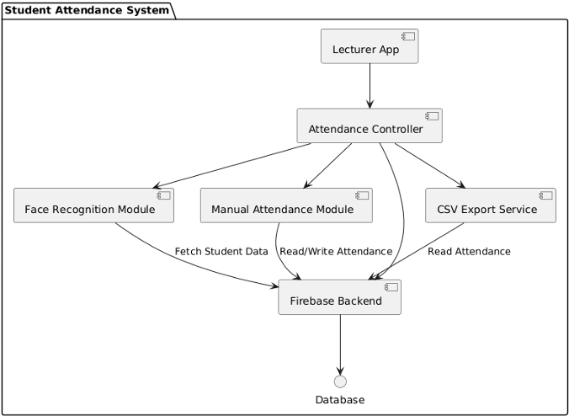
The Android-based Attendance Management System is designed following object-oriented principles to ensure modularity, scalability, and maintainability. The system is composed of several key components, each handling a distinct responsibility within the attendance process.

Teacher Module: This module allows teachers to log in securely, select specific lectures, mark student attendance, and export attendance reports for review or record-keeping. Core methods include login() for authentication, selectLecture() to choose the relevant session, markAttendance() to update student attendance, and exportAttendance() to generate attendance records.
Student Module: This module represents student profiles, including essential details such as studentID, name, rollNumber, course, and faceData used for facial recognition.
Lecture Module: This component manages lecture details such as the subject, date, and time. It provides methods like getLectureDetails() to retrieve relevant lecture information.
Attendance Module: Responsible for tracking each student’s attendance status within a lecture, this module includes methods like markAttendance() to update status and getAttendanceStatus() to retrieve the current attendance record for a student.
Face Recognition Module: This critical component handles the facial recognition tasks using pre-trained machine learning models. Important methods include trainModel() to prepare the facial recognition system and recognizeFace() to identify students during attendance marking.
Database Design: The system relies on a cloud-integrated relational database to store all data related to teachers, students, lectures, and attendance records. This integration ensures real-time data access, secure storage, and easy scalability as the institution’s needs grow.

- Methodology

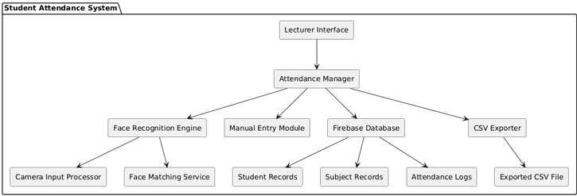
Login Page:The login page serves as the initial gateway to the application. It is intricately connected to a database that securely stores user information, including IDs and passwords. Based on the user’s type (whether regular user or admin), the features available within the application are dynamically defined. This ensures that users only have access to functionalities relevant to their roles.
Dashboard:The dashboard serves as the central hub presenting the application’s key features. Depending on the user type—regular user or admin—the dashboard customizes its display. For regular users, it showcases a streamlined set of essential features, ensuring a clean and focused interface. On the other hand, administrators are granted visibility to all features, allowing them to oversee and manage the application comprehensively.
camera: The camera section is a pivotal component that facilitates the connection and utilization of the USB camera attached to the microscope. This functionality allows users to view the microscope’s output directly on the screen. Users are empowered to capture high-quality images, providing a visual record of their observations. This feature enhances the documentation process, enabling users to capture and store images seamlessly

- Implementation
For the implementation of our Simple Desktop System, we opted for Python as the primary programming language due to its simplicity and versatility. Leveraging the Tkinter library, we designed a straightforward graphical user interface (GUI) featuring prominently displayed buttons for core functionalities. Upon launching the application, users are greeted with a clean main window housing buttons labeled ”File Manager,” ”Task Manager,” and ”Communicator.” These buttons serve as entry points to the respective modules of the desktop system. Clicking on the ”File Manager” button prompts the system to initiate the file management module, enabling users to navigate, organize, and manipulate their files and directories. Similarly, selecting the ”Task Manager” button activates the task management module, allowing users to create, prioritize, and monitor their tasks effectively. Lastly, clicking on the ”Communicator” button triggers the communication module, facilitating seamless interaction through messaging features.
