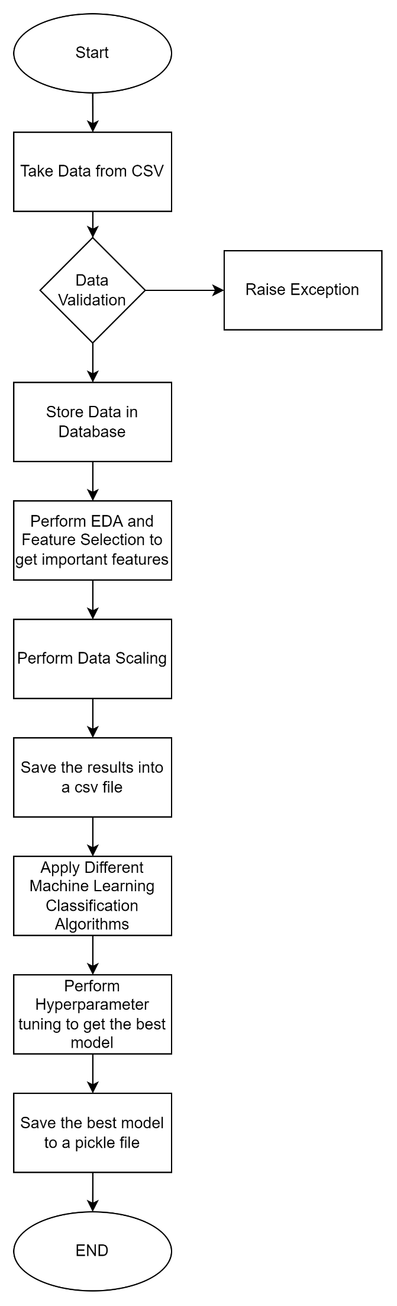

***System Architecture for Training the Model***

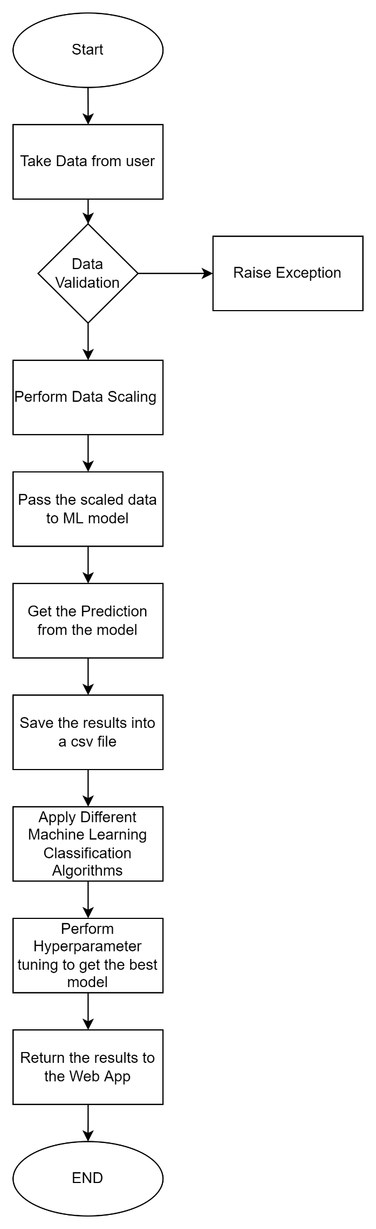

***System Architecture for Prediction***