**Introduction**

Waste management in high-traffic environments such as universities, railway stations, and airports presents significant challenges. Traditional systems rely on manual inspections to monitor trash levels, leading to inefficiencies, unsanitary conditions, and overflow issues. To address these problems, the problem statement aims at developing a Smart Disposal Machine (SDM), integrating advanced technologies for enhanced efficiency and hygiene.

**Objectives:**

The smart disposable machine aims to:

1. Monitor Fill Level Real-Time
2. Ensure Hygienic Operations
3. Extended Operational Time (External compartments or compaction mechanisms)
4. Additional Features:

* IoT based monitoring
* Waste Segregation

**1. Design:**

The design is done keeping in mind the dimension constraints of 30x30x30 to 50x50x50 cm3 . The SDM is minimalistic and simple which is a square box with expandable top which aids towards the expandable storage of the machine. The lid is equipped with HC-SR04 Ultrasonic sensors to provide fill level monitoring. The lid also holds the sealing mechanism for the trash bag which keeps the overall project hygienic to human use. Three indicating LEDs are also installed to indicate the fill level along side ESP-32 based IoT system which harnesses the onboard WiFi and Blynk app to display the current fill percentage of dustbin and alerts upon overfill. The app also includes a button which when pressed, activates the expansion mechanism of the SDM.

**1.1 CAD Model:**

To get a better understanding of the model of the machine, a CAD model was prepared. We used OnShape to make the CAD model. The parts in the model were also later exported to DWG file for laser cutting. The assembly of the CAD model is shown below:

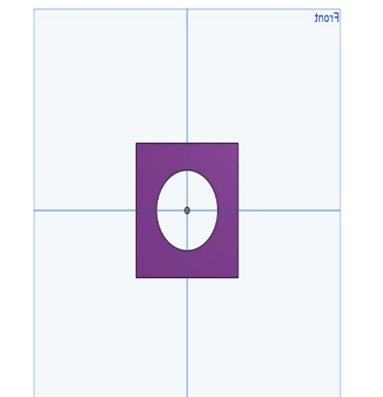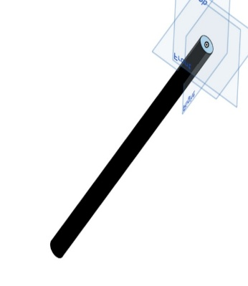

**1.2 Challenges Faced:**

Two major challenges faced while the designing the SDM were:

1. **Expandable System:** As per the PS, to extend the time between trash retrievals, some system was to be innovated. We came up with an expandable storage unit. It posed several problems such as which mechanism to use, which direction to expand, how to accommodate it in the model, etc.
2. **Sealing Mechanism:** To minimise human intervention, we thought of implementing a sealing mechanism which would seal the trash bag for easy emptying of the machine.

**1.3 Solution to Problems:**

1. To cater the expandable storage problem, we came up with the rack and pinion mechanism which would push the top part of the machine upwards, creating more room for the trash. The sealing and fill detection mechanisms were attached to the top part as well to ensure their continuous functionality
2. To seal the bags, we came up with a simple mechanism involving nichrome wire. Due to its high melting point, it acts as a good heat source. When current is passed through it, due to its resistance it generates heat which we utilise to melt the plastic trash bag and seal its end together. The mechanism is pushed from one end of the lid to other via a linear actuator involving plastic pipe, nut and a motor, which again was designed by us.

**2. Materials Used:**

The materials used in the SDM are chosen to keep the cost minimal alongside maintaining the complete functionality of the machine. Some of the materials used include:

1. **Body**: Acrylic sheet, nuts, plastic pipes, Hinges
2. **Electronics and IoT**: Wires, LEDs, HC-SR04 Ultrasonic sensor, Arduino UNO, ESP-32 wroom WiFi, DC Motors, L298N motor driver, Nichrome wire, 18650 Li-Ion batteries, Relay, and few other miscellaneous components.

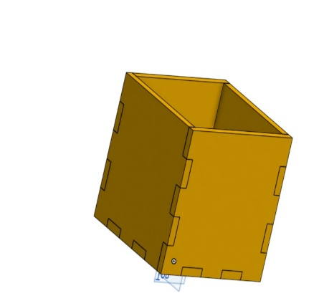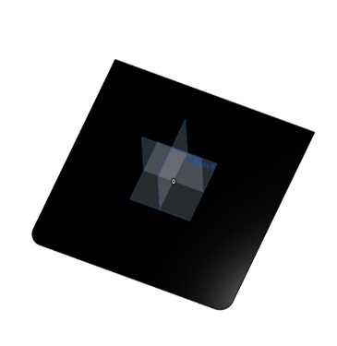

**3. Implementation:**

Although a tough plan was ready, its implementation was the greater challenge. The implementation was proceeded in several steps.

**3.1 Sensors:**

The major sensor used in this machine is the HC-SR04 ultrasonic sensor which is used mainly to calculate the percentage fill and then forward the data to Arduino and ESP-32 board. The working of HC-SR04 is simple, the transmitter emits ultrasonic waves at a certain interval (in micro seconds) which bounces back from the surface in front and is later detected by the receiver. The sensor then calculates the time difference between the two intervals. Given that we know the speed of sound, we can easily calculate the distance in front of the sensor. We have used a total of 4 sensors in this machine to tackle the problem of uneven surface. We calculate their average and thus get the appropriate fill percentage.

**3.2 Mechanism:**

Rack and pinion mechanism was used to make the expandable storage mechanism. The rack was attached to the top part while the pinion was attached to the bottom, with a gear motor for appropriate torque. The motor was driven by L298N motor driver. To move the Sealing mechanism, we used the mechanism of Linear Actuator. It is a simple mechanism in which a screw-like rod rotates using motor and the nut is fixed to the platform which is to be moved. As the rod only rotates and does not translate, the nut moves.

**3.3 Sealing:**

The sealing mechanism was initially planned to be a nichrome wire based mechanism which would melt the plastic bag using its heat and thus seal it together. However, given the time constraint and the complicacy of the mechanism, we decided to drop the mechanism and instead use a simpler one. We stitched the bag’s top with a thread and fixed one end to the bag itself and the other end to a motor. Motor rotates on command and wraps the thread around it, thereby sealing the bag.

**3.4 Structural Design:**

The structure of the machine is bult from acrylic sheet which was laser cut using the CAD model prepared initially. The CAD file was converted to DWG file for laser cutting. Afterwards, the parts were assembled together using adhesive.

**3.5 Electronics and IoT:**

The electronics and IoT are pretty straightforward. 4 HC-SR04 sensors are used which calculate the average fill percentage and feed the data to Arduino and ESP-32. Arduino controls the LEDs and the expandable storage while the ESP-32 handles the app connectivity for real time monitoring. Both the ESP-32 and Arduino are coded via Arduino IDE software.

**4. Testing and Results:**

A wide range of test runs were performed on the machine before the final submission. To test whether or not the machine could cater uneven fill surfaces, we filled the machine with different items of different heights. The machine was successfully able to provide the approximate height levels.

Further under the app testing, we could successfully retrieve data from the machine for fill levels and the machine also responded well when the expansion system was activated via the app. However, when we were assembling the linear actuator mechanism, we faced some problems in its initial testing one of them being it getting jammed. However, we managed to fix it soon.

**5. Hygienic operation and ease of maintenance:**

Hygiene being the key objective of this machine, it was specially kept in mind throughout the process. The lid closes every time after use and also the bag gets sealed on command. Also the design ensures ease of taking out the trash. As the lid remains closed, no foul smell is emitted. Also almost no maintenance is required except for charging the batteries and cleaning in certain amounts of time.