|  |
| --- |
| <<GUESS THE NUMBER>>      21CSS101J – PROGRAMMING FOR PROBLEM SOLVING    Mini Project Report      Submitted by    AKSHAT MITTAL [Reg. No.: RA2211003010790]  RITVIK RAJVANSHI [Reg. No.: RA2211003010792] B.Tech. CSE - <<CORE >>                SCHOOL OF COMPUTING  COLLEGE OF ENGINEERING AND TECHNOLOGY SRM INSTITUTE OF SCIENCE AND TECHNOLOGY  (Under Section 3 of UGC Act, 1956)  S.R.M. NAGAR, KATTANKULATHUR – 603 203  KANCHEEPURAM DISTRICT  December 2022 |

**TABLE OF**

**CONTENTS**

|  |  |  |
| --- | --- | --- |
| Chapter No. | Title | Page No. |
| 1 | Problem Statement | 3 |
| 2 | Methodology / Procedure | 4 |
| 3 | Coding (C or Python) | 5 |
| 4 | Results | 6 |
|  |  | 7 |
| 5 | Conclusion |  |

# Problem Statement

To write a program, take input from the user to guess the number.

# Methodology

Tasks to run:

1. Ask the user to enter their name.
2. Using random function, it will assign any number between 1 and 20, user have to guess that number.
3. Using while loop in python user gets 5 chances to guess the number.
4. In nested loop if the user guess wrong number, hint is given whether the number is greater or smaller then the input given by user, also number of chances left is printed.
5. If user guesses the number right then user will win and number of guesses took to guess the number will be printed.
6. The program will repeat 5 times.

**CODING**

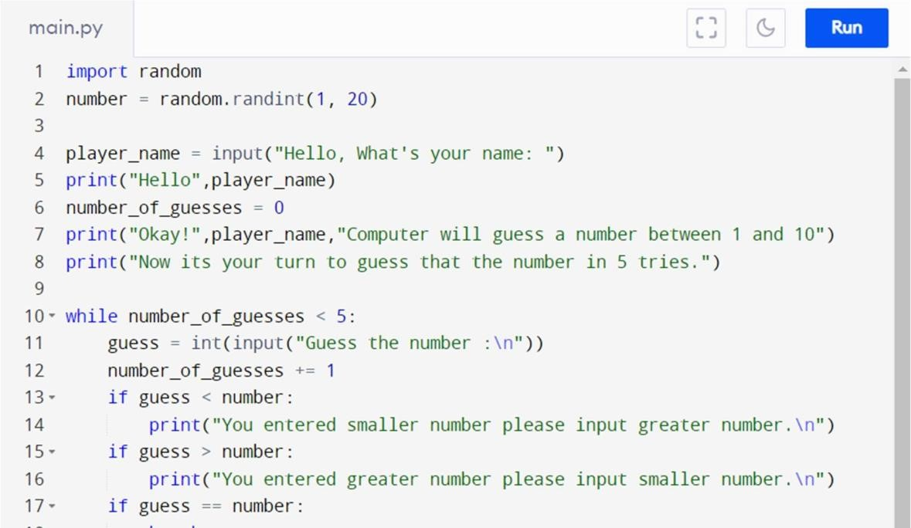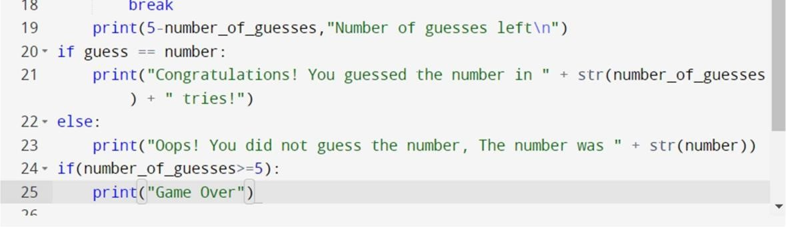

## RESULT

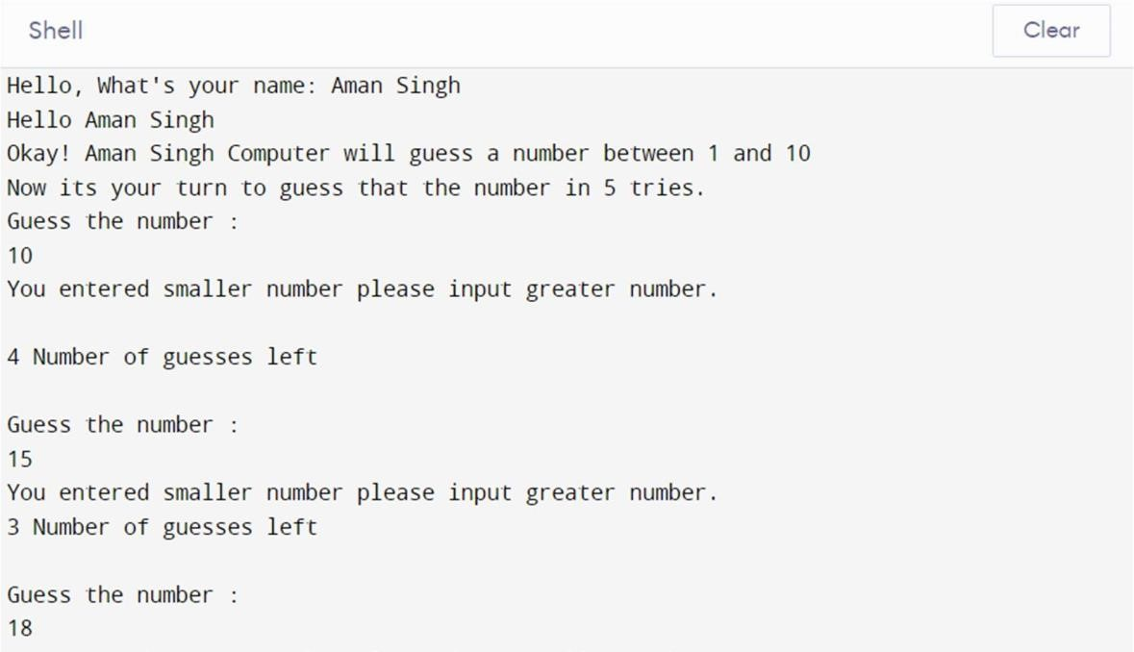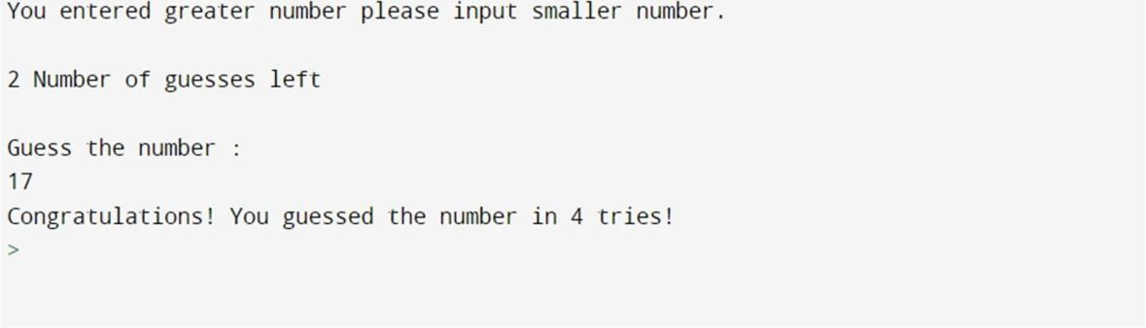

## CONCLUSION

We have built a game to guess the number using the Python programming language. It has been developed using the python programming language. Any purpose driven decision maker can have intelligence as a trait. An algorithm has been presented in the system and tested, and it has proven to be effective. Chiefly, the system is free of errors.

**THANK YOU**