PCAP MINI PROJECT
Parallelization of Image Processing using Geometric Transformations

Team Members:
Avikshit Dhar – 230905334
Akshat Singh – 230905250
Arnab Chakraborti – 230905231

School:
Manipal Institute of Technology

Guide:
Dr. Neelima B

Date of Submission:
15th April

Introduction
Image processing is used in a lot of real-world applications like medical imaging, computer vision, robotics, etc. Basically whenever we deal with images and want to modify or analyse them, image processing comes into play.
One important part of image processing is geometric transformations. These transformations change how an image looks by modifying pixel positions. For example, rotating an image, resizing it, shifting it, etc.
Now the problem is, when images are large (like HD or 4K), they contain millions of pixels. Processing each pixel one by one on a CPU takes a lot of time. This is where parallel computing comes in.
Instead of doing one pixel at a time, we can process multiple pixels simultaneously using GPU. GPUs have thousands of cores, so they are perfect for this kind of work.
In this project, we basically tried to implement geometric transformations using parallel computing and compare CPU vs GPU performance.

Literature Review
From the research we looked at, many people have already worked on speeding up image processing using GPUs.
Most papers show that CUDA-based implementations are much faster compared to CPU-based ones, especially when each pixel can be handled independently.
Some key points from existing work:
- GPU works really well for pixel-level operations
- Memory access patterns matter a lot
- Interpolation methods affect image quality
- Backward mapping is commonly used
But one issue we noticed is that:
- Many works only focus on one transformation
- Not all are optimized for real-time usage
So there was still scope to implement multiple transformations together and compare performance properly.
Sources like CUDA documentation and research papers were referred for this.

Problem Statement
Geometric transformations are useful but they come with some problems:
- High execution time when using CPU
- Not efficient for large images
- Not scalable for real-time applications
So the main problem is:
How to efficiently perform geometric transformations on large images using parallel computing while keeping execution time low and maintaining image quality.

Objectives
The main goals of our project were:
- To implement basic transformations like:
  - Translation
  - Rotation
  - Scaling
  - Affine transformation
- To use GPU parallelization (CUDA)
- To assign one thread per pixel
- To improve speed compared to CPU
- To compare performance between CPU and GPU
- To analyse how performance changes with image size

Methodology
First, we understood how geometric transformations work mathematically. Each pixel (x, y) is mapped to a new coordinate (x’, y’).
Then we implemented transformations like:
- Translation → shifting image
- Rotation → rotating image
- Scaling → resizing image
- Shearing → skewing image
We used parallel programming approach where:
- Each pixel is processed independently
- Threads are assigned per pixel
In CPU:
- Image is divided into chunks
- Each thread handles a part
In GPU:
- Thousands of threads run together
- Each pixel handled separately
This makes GPU much faster.
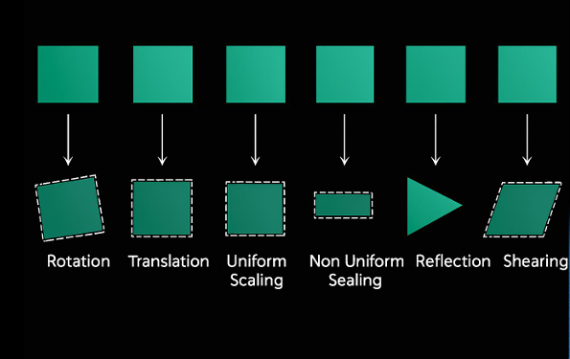
Experimental Setup
For our setup, we used:
- Programming Language: C/C++ with CUDA
- Platform: GPU-enabled system
- Libraries: CUDA toolkit
We tested:
- CPU implementation (normal execution)
- GPU implementation (parallel execution)
We used different image sizes to compare performance.

Results and Analysis

From our results, we observed:
- GPU was significantly faster than CPU
- As image size increased, CPU time increased a lot
- GPU handled large images easily
For small images:
- Difference was not that big
For large images:
- GPU was way faster (almost many times faster)
The graphs clearly show that:
- CPU time increases linearly
- GPU time stays relatively low

CODE BLOCKS :
// SCALING
__global__ void scaleKernel(unsigned char* input, unsigned char* output, int w, int h, int scale)
{
int x = blockIdx.x * blockDim.x + threadIdx.x;
int y = blockIdx.y * blockDim.y + threadIdx.y;

int newW = w * scale;
int newH = h * scale;

if (x < newW && y < newH)
{
int srcX = x / scale;
int srcY = y / scale;

output[y * newW + x] = input[srcY * w + srcX];
}
}

// TRANSLATION
__global__ void translateKernel(unsigned char* input, unsigned char* output, int w, int h, int tx, int ty)
{
int x = blockIdx.x * blockDim.x + threadIdx.x;
int y = blockIdx.y * blockDim.y + threadIdx.y;

if (x < w && y < h)
{
int newX = x + tx;
int newY = y + ty;

if (newX < w && newY < h)
output[newY * w + newX] = input[y * w + x];
}
}

// ROTATION
__global__ void rotateKernel(unsigned char* input, unsigned char* output, int w, int h, float angle)
{
int x = blockIdx.x * blockDim.x + threadIdx.x;
int y = blockIdx.y * blockDim.y + threadIdx.y;

if (x < w && y < h)
{
int cx = w / 2;
int cy = h / 2;

float rad = angle * 3.14159 / 180.0;

int srcX = (int)((x - cx) * cos(rad) + (y - cy) * sin(rad) + cx);
int srcY = (int)(-(x - cx) * sin(rad) + (y - cy) * cos(rad) + cy);

if (srcX >= 0 && srcX < w && srcY >= 0 && srcY < h)
output[y * w + x] = input[srcY * w + srcX];
else
output[y * w + x] = 0;
}
}

// AFFINE
__global__ void affineKernel(unsigned char* input, unsigned char* output, int w, int h,
float a, float b, float c, float d, float tx, float ty)
{
int x = blockIdx.x * blockDim.x + threadIdx.x;
int y = blockIdx.y * blockDim.y + threadIdx.y;

if (x < w && y < h)
{
int srcX = (int)(a * x + b * y + tx);
int srcY = (int)(c * x + d * y + ty);

if (srcX >= 0 && srcX < w && srcY >= 0 && srcY < h)
output[y * w + x] = input[srcY * w + srcX];
else
output[y * w + x] = 0;
}
}

SCALING (2x,2x):
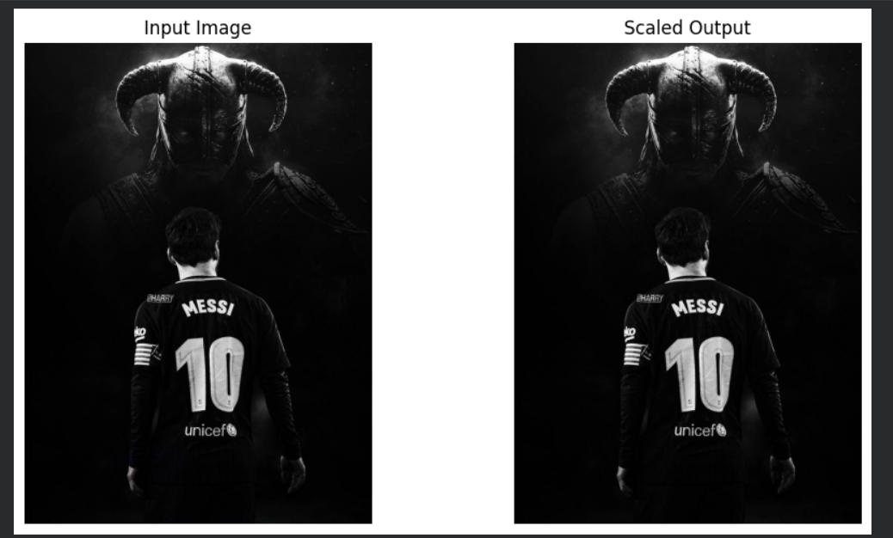

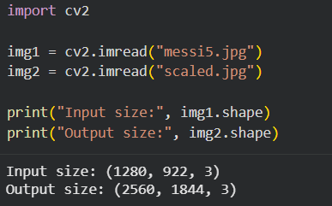

Translation:
100 pixels right 50 pixels down
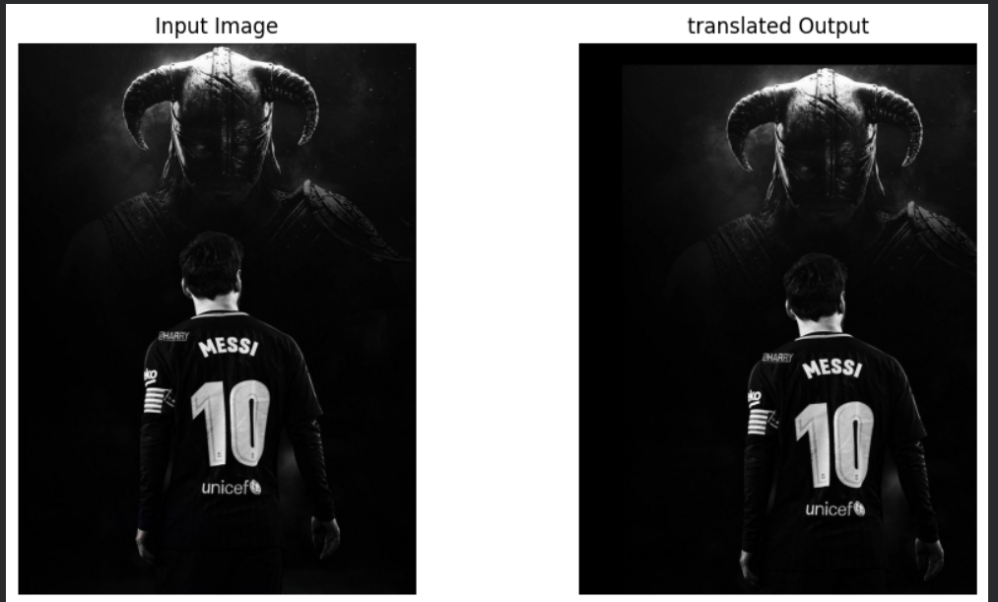

Rotation: (90 degrees)
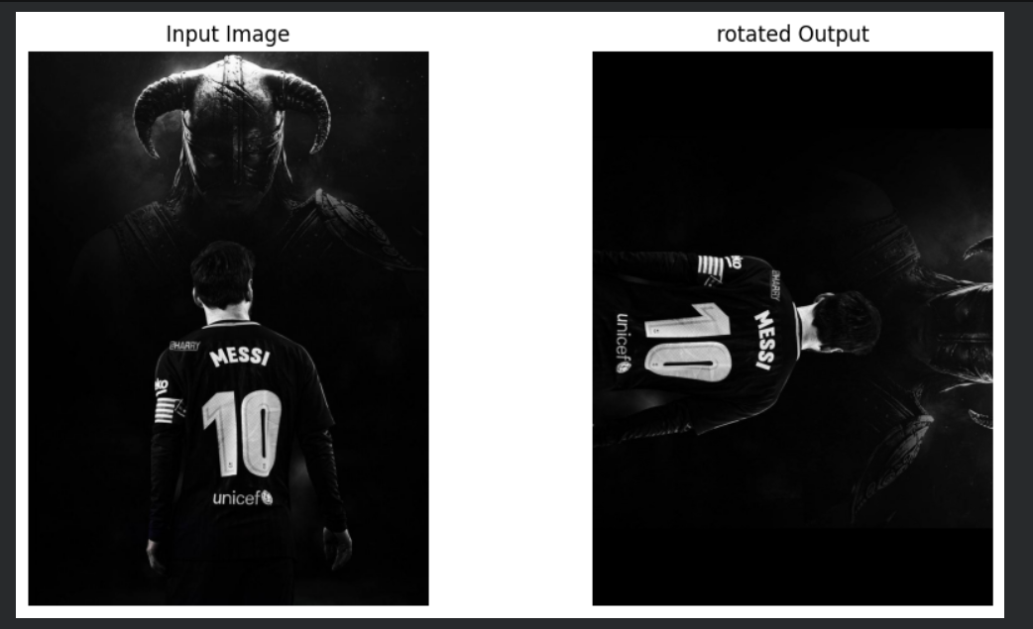

Affine transformation:
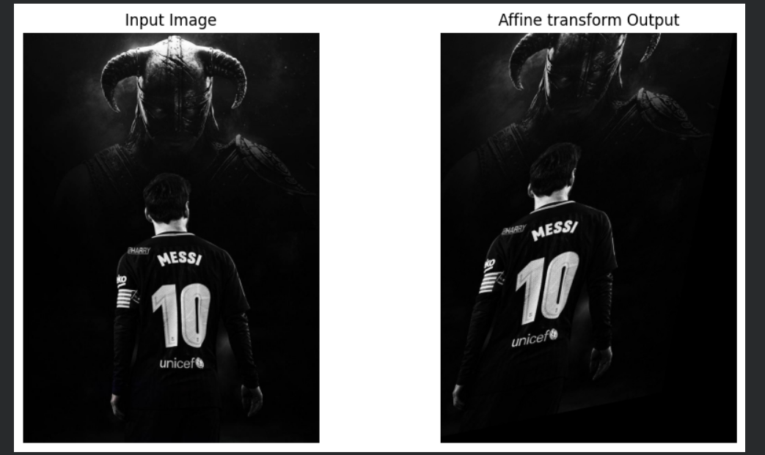

Conclusion and Future Work
In this project, we successfully implemented geometric transformations using parallel computing.
We clearly saw that GPU performs much better than CPU for image processing tasks.
Main takeaways:
- Parallel computing is very useful
- GPU is ideal for image processing
- Pixel-level operations are easy to parallelize
Future improvements can be:
- Add more transformations
- Improve interpolation methods
- Optimize memory usage
- Try real-time video processing
Also we can integrate this with ML models in future which would be interesting.

References
https://www.semanticscholar.org/paper/Parallel-Image-Processing-Based-on-CUDA-Yang-Zhu/
https://www.semanticscholar.org/paper/The-use-of-GPUs-in-image-processing-Frasheri-
https://www.geeksforgeeks.org/geometric-transformation-in-image-processing-1/
https://www.researchgate.net/publication/318320729_A_Comparative_Evaluation_of_the_GPU_vs_The_CPU_for_Parallelization_of_Evolutionary_Algorithms_Through_Multiple_Independent_Run
https://www.scaler.com/topics/geometric-transformation-in-computer-vision/
https://medium.com/@henriquevedoveli/geometric-transformations-in-image-processing-150b0de27c7a

