**CS210 : ARTIFICIAL INTELLIGENCE LAB**

**LAB ASSIGNMENT 4_5: AI & Python**

**Submitted By:**

**Name: AKSHAT SAHU**

**Roll No: U22CS034**

**Branch: CSE**

**Semester: 4th Sem**

**Division : A**

# Submitted To: Dr. Chandra Prakash

Department of Computer Science and Engineering



**SV NATIONAL INSTITUTE OF TECHNOLOGY**

**SURAT**

2024

Question no. 1

PART A : Introductory Problem [ 25 Marks] Maze Problem [15 Marks] 1. Consider a maze comprising of square blocks in which intelligent agent can move either vertically or horizontally. Diagonal movement is not allowed. Cost of each move is 1. Red block: initial position, Blue block: goal position and Grey block: obstacle Apply following Blind/Uninformed and Informed algorithms : (a) dfs: Depth first search (b) bfs: Breadth first search (c) dls: Depth limited search, use 3 as default depth (d) ucs: Uniform cost Search (e) gbfs: Greedy Best First Search (f) astar: A* Algorithm Inputs: Write a python program that takes input number of square blocks as input (i.e. 6 x 6) in first line. Second line contains the initial position of intelligent agent which is (1,1) and the goal square block which is (6,6) in above example. Third line contains the coordinates of the obstacles. Fourth line contains the search strategy. eg. input file: input.txt 6,6 1-1 1,1;6,6 2,1;2,5;3,2;3,3;3,5;4,5;4,6;5,2;5,3;6,3 dfs python TA_4_5_P2_maze_world.py “input2.txtȷıoutput2.txtȷ Outputs: Sequence of blocks that are explored (each on separate line) as per search algorithm so as to reach goal position. Last line should contain the total search cost.

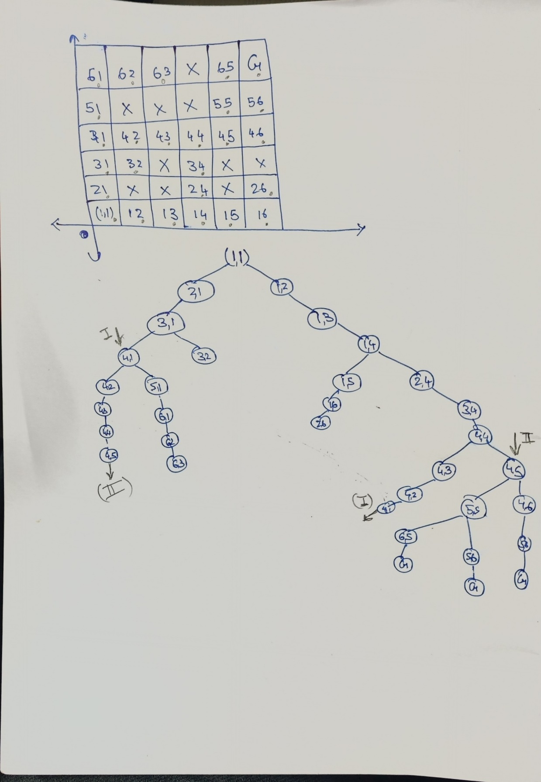

Pacman

. Search in Pac-Man This problem allow you to visualize the results of the techniques you implement. Pac-Man provides a challenging problem environment that demands creative solutions of a real-world AI problems. The Pacman agent needs to find paths through the maze world, both to reach a location and to collect food efficiently. In this Problem, you are expected to implement and experiment with different AI search techniques that was discussed in the class in a Pacman environment. This lab assignment is inspired by Project 1: Search, which is a part of a recent offering of CS188 at UC Berkeley[1]. We thank the authors at Berkeley for making their project available to the public.

