**PUNE INSTITUTE OF COMPUTER TECHNOLOGY, DHANKAWADI PUNE-43**

**MINI-PROJECT REPORT ON**

**BLOCKCHAIN-BASED APPLICATION ON HEALTH-RELATED MEDICAL RECORDS**

Submitted By

**Shreyash Shinkar (41373)**

**Sourav Kotkar (41378)**

**Shashank Udgirkar (41384)**

**Under the guidance of**

Prof. Satya Prakash Patel



**DEPARTMENT OF COMPUTER ENGINEERING**

**Academic Year 2022-23**

**PUNE INSTITUTE OF COMPUTER TECHNOLOGY, DHANKAWADI PUNE-43**

**CERTIFICATE**



This is to certify that **Shreyash Shinkar (41373), Sourav Kotkar (41378), Shashank Udgirkar (41384)** student of B.E. (Computer Engineering Department) Batch 2022-2023, have satisfactorily completed a report on “**Blockchain-Based Application on Health-Related Medical Records**” towards the partial fulfillment of the fourth year Computer Engineering Semester VII of SPPU.

Dr. G. V. Kale

**Head of Department,**

**Computer Engineering**

**Date:**

**Place: Pune**

**CONTENTS**

|  |  |  |
| --- | --- | --- |
| **Sr. No.** | **Title** | **Page No.** |
| **1.** | Problem Statement | **4** |
| **2.** | Abstract | **4** |
| **3.** | Introduction | **4** |
| **4.** | Objectives | **4** |
| **5.** | Motivation | **5** |
| **6.** | Theory | **5** |
| **7.** | Implementation | **7** |
| **8.** | Conclusion | **8** |
| **9.** | References | **8** |

**Problem Statement:**

Develop a Blockchain based application D-App (de-centralized app) for e- voting system.

**Abstract:**

Blockchain is a major breakthrough in the technological industry that provide immense secured platform. With the launch of Ethereum, a decentralized platform which runs decentralized applications (D-Apps) on it, a secured voting system now seems possible. Many organizations have now shifted their focus on voting through blockchain platforms. There’s a very high chance that a normal voting method won’t lead to a clear majority.

Here, we introduce the vote-trading concept where the votes can be redistributed to other candidates in case if there is no clear majority and also this ‘majority’ factor can be set by the organization according to their requirement. We discuss the design for the blockchain based preferential e-voting system using the Solidity programming language where instead of one vote per candidate, we provide the concept of giving preference to the candidates.

**Introduction:**

Blockchain is a decentralised and public digital ledger that records transactions on many computers so that no record involved can be altered retroactively without altering any blocks afterwards. Blockchain is verified and linked to the preceding ‘block,’ forming a long chain. After all, Blockchain is the name of the record. As any transaction is registered and checked publicly, Blockchain provides a good deal of accountability. When entered, no one can modify all the information written in the Blockchain. It serves to demonstrate that the data is actual and unchanged. In Blockchain, data are maintained on networks instead of a central database, improving stability and showing its proneness to be hacked. Blockchain offers a fantastic forum to develop and compete with traditional companies for modern and creative business models. Blockchain helps marketers to maintain an overview of the products used in medicine. Health and pharmaceuticals will get rid of counterfeit medications using Blockchain technologies, enabling tracing of all these medicines. It helps discover the cause of falsification. Blockchain can guarantee the confidentiality of patient records; when medical history is developed, Blockchain can also store it, and this record cannot be modified. This decentralised network is used with all commodity hardware in the hospital. Researchers allow computing estimates for therapies, medicines, and remedies of diverse illnesses and disorders using the resources saved by these devices.

**Objectives:**

1. To understand and explore the working of Blockchain technology and its applications.
2. To create a blockchain application for healthcare supply chain management.

**Motivation:**

Blockchain being the new and interesting emerging field has paved the path for many developers to create secure immutable applications in trustless environment. Hence as part of our curriculum we decided to create a D-App for e-voting system that could be free from manipulation and facilitate easy data storage.

**Theory:**

Blockchain is a distributed ledger network that adds and never deletes or modifies records without a common consensus. A Blockchain hash's value depends on a cryptographic hash that connects newly added information block records with each data block. The distributed Blockchain ledger architecture ensures that data is not processed in any centralised venue, making it accessible and accountable to all network users. This decentralised system avoids a single attack, strengthening and securing the system. It facilitates better control of health records and patient care by minimising twice the amount of medical practice and monitoring, saving both practitioners and patients time and resources. The patient will watch where their information goes and achieve it by keeping health records on a blockchain.

Scholars can use this technology to analyse a massive volume of unveiled knowledge about a particular group of individuals. It helps for the advancement of precision medicine to be provided appropriately for longitudinal research. We use Blockchain for healthcare in real-time with the help of the Internet of Things (IoT) and wearable's devices to store and update valuable patient data such as blood pressure and sugar level. It helps doctors track patients who are vulnerable to high risk and, if an emergency occurs, advise and alert their careers and families. Blockchain has a decentralised structure that allows it safely to hack and avoids compromising any single copy of the records.

**Need of blockchain in healthcare**

As far as healthcare is concerned, the urgency of development increases to more incredible speeds. Today the need is for quality health facilities supported by advanced and newer technologies. Here, Blockchain would play a critical role in transforming the healthcare sector. In addition, the landscape of the health system is moving towards a patient-centred approach focusing on two main aspects: accessible services and appropriate healthcare resources at all times. The Blockchain enhances healthcare organisations to provide adequate patient care and high-quality health facilities. Health Information Exchange is another time-consuming and repetitive process that leads to high health industry costs, quickly sorted out using this technology. Using Blockchain technology, citizens may take part in health study programs. In addition, better research and shared data on public wellbeing will enhance treatment for different communities. A centralised database is used to manage the entire healthcare system and organisations.

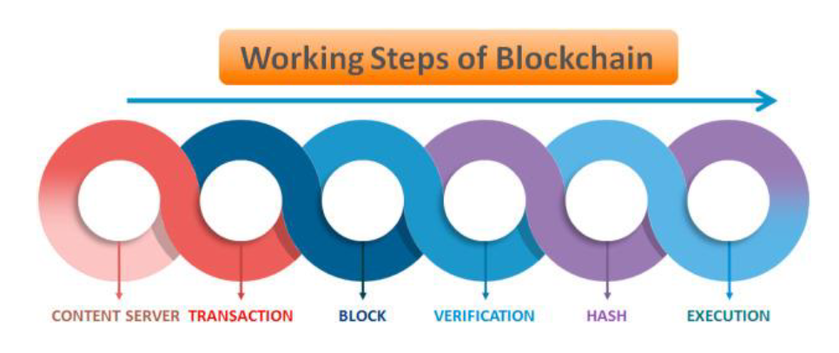

There are discrete pieces of health information that, if stored on-chain may have a huge impact on operational efficiency, availability and patient safety. Vaccination and allergy information are typical examples. vac-chain is a prototype of an on-chain storage of vaccination information on Ethereum blockchain using smart contracts in solidity using the truffle Drizzle box (React/Redux). This may be extended for similar use cases in medicine.

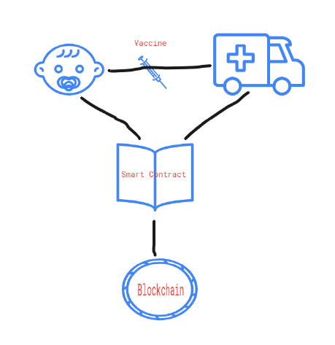

**Implementation:**

**Package.json**

{

"name": "drizzle-box",

"version": "1.0.0",

"description": "",

"main": "truffle-config.js",

"directories": {

"test": "test"

},

"scripts": {

"test": "echo \"Error: no test specified\" && exit 1",

"ganache": "ganache-cli -b 2 -h 0.0.0.0 -e 1000000"

},

"repository": {

"type": "git",

"url": "git+https://github.com/truffle-box/drizzle-box.git"

},

"keywords": [],

"author": "",

"license": "ISC",

"bugs": {

"url": "https://github.com/truffle-box/drizzle-box/issues"

},

"homepage": "https://github.com/truffle-box/drizzle-box#readme",

"dependencies": {

"ganache": "^7.0.3",

"ganache-cli": "^6.12.2",

"openzeppelin-solidity": "^2.3.0",

"truffle": "^5.5.7"

}

}

**Solidity Code**

pragma solidity >=0.4.25 <0.7.0;

contract Migrations {

address public owner;

uint public last_completed_migration;

modifier restricted() {

if (msg.sender == owner) _;

}

constructor() public {

owner = msg.sender;

}

function setCompleted(uint completed) public restricted {

last_completed_migration = completed;

}

}

**Conclusion:**

There are innovative applications of Blockchain in healthcare due to inherent encryption and decentralisation. It enhances the security of patients' electronic medical records, promotes the monetisation of health information, improves interoperability among healthcare organisations, and helps counterfeit combat medicines. Different healthcare fields can change with Blockchain technology; areas like healthcare, digital agreements allowed by intelligent contracts constitute one of Blockchain's most critical applications. By removing intermediaries from the payment chain, intelligent contracts will minimise costs. The Blockchain potential in healthcare depends significantly on the adoption of associated advanced technologies in the ecosystem. It includes system tracking, healthcare insurance, medicines tracing, and clinical trials. Hospitals can chart their services using a Blockchain framework, even over the entire life cycle, using device tracking. Blockchain technology can well be used to improve patient history management, especially tracking and the insurance mediation process, thereby accelerate clinical actions with optimised data maintenance. Overall, this technology would significantly enhance and eventually revolutionise how patients and physicians treat and use clinical records and improve healthcare services.

**References:**

1. <https://www.sciencedirect.com/science/article/pii/S266660302100021X>
2. https://builtin.com/blockchain/blockchain-healthcare-applications-companies