Complete Viva Master Guide
Social Media Trends Analytics Dashboard
DVA Assignment 2 | Akshat Tripathi | 04914202023
Read the bold red Q from your teacher, then say the Answer section aloud. Every diagram is included to show visually during presentation.

1. System Architecture (Visual)
This diagram shows exactly how all the parts of the project connect together:
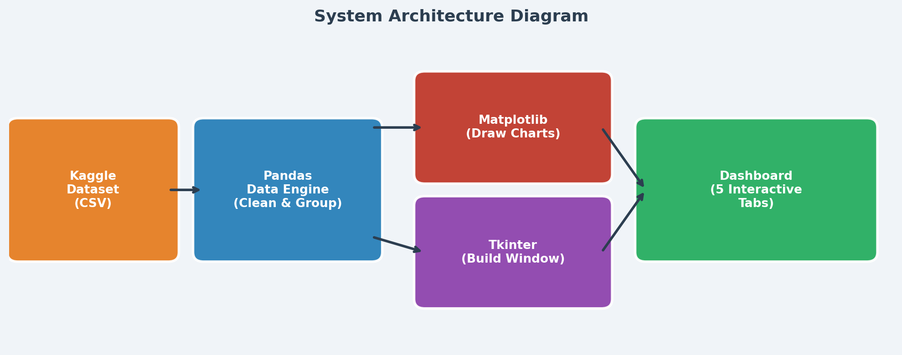
How to explain it: "The project has 4 layers. Layer 1 is the raw data from Kaggle. Layer 2 is Pandas which cleans and calculates the numbers. Layer 3 is Matplotlib and Tkinter which draw the charts and build the window. Together they produce the Final Dashboard."

2. Data Processing Pipeline
This is what happens INSIDE the code, step by step:
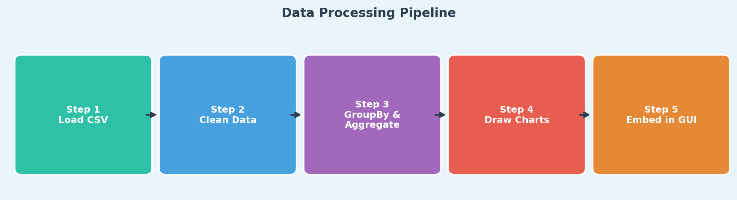
- Step 1 – Load: pd.read_csv() reads the 2,000-row CSV file into a Pandas DataFrame.
- Step 2 – Clean: Column names are normalized (.lower(), .strip()). A validate_dataset() function checks that all required columns exist. If the file is missing, a try-except block returns a safe empty DataFrame.
- Step 3 – Aggregate: df.groupby("platform")["views"].sum() groups all rows by platform and sums the views. .mean() calculates average engagement rate. This is done in milliseconds using Pandas C-optimized code.
- Step 4 – Draw Charts: The aggregated values are fed into Matplotlib. ax.barh() draws horizontal bars. ax.pie() draws the donut. ax.imshow() draws the heatmap. GridSpec positions them in a grid layout.
- Step 5 – Embed in GUI: FigureCanvasTkAgg bridges Matplotlib and Tkinter. The chart becomes a Tkinter Canvas widget that is packed into the dashboard frame.

3. The Engagement Rate Formula (Most Asked!)
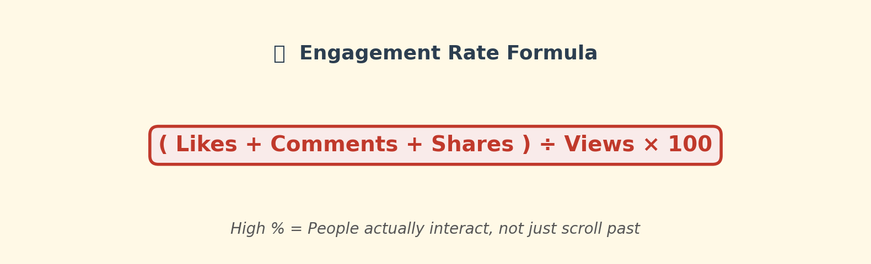
Simple English Explanation: Imagine 1,000,000 people saw a post but only 10 liked it. That means 0.001% engagement – the content is boring. But if 1,000 people saw it and 500 liked it, that is 50% engagement – extremely viral content.
In code: The column "engagement_rate" is pre-calculated in the dataset. In the dashboard, we read it directly using df["engagement_rate"].mean() to find the platform average.

4. Dashboard Analysis – Page by Page
Page 1 – Executive Overview
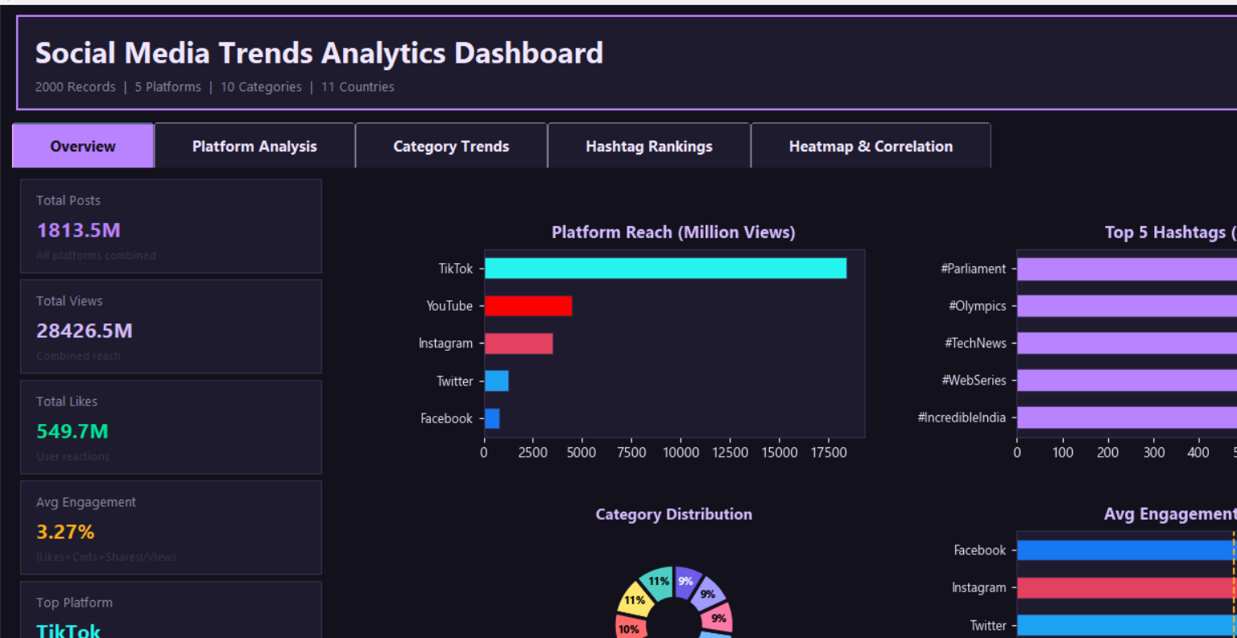
What to say: "This is the first page the user sees. It shows 6 KPI cards on the left – Total Posts, Views, Likes, Avg Engagement %, Top Platform, and Trending Category. The right side has 4 charts: Platform Reach, Category Distribution (donut chart), Top 5 Hashtags, and Avg Engagement per Platform. Everything updates from live data."

Page 2 – Platform Analysis
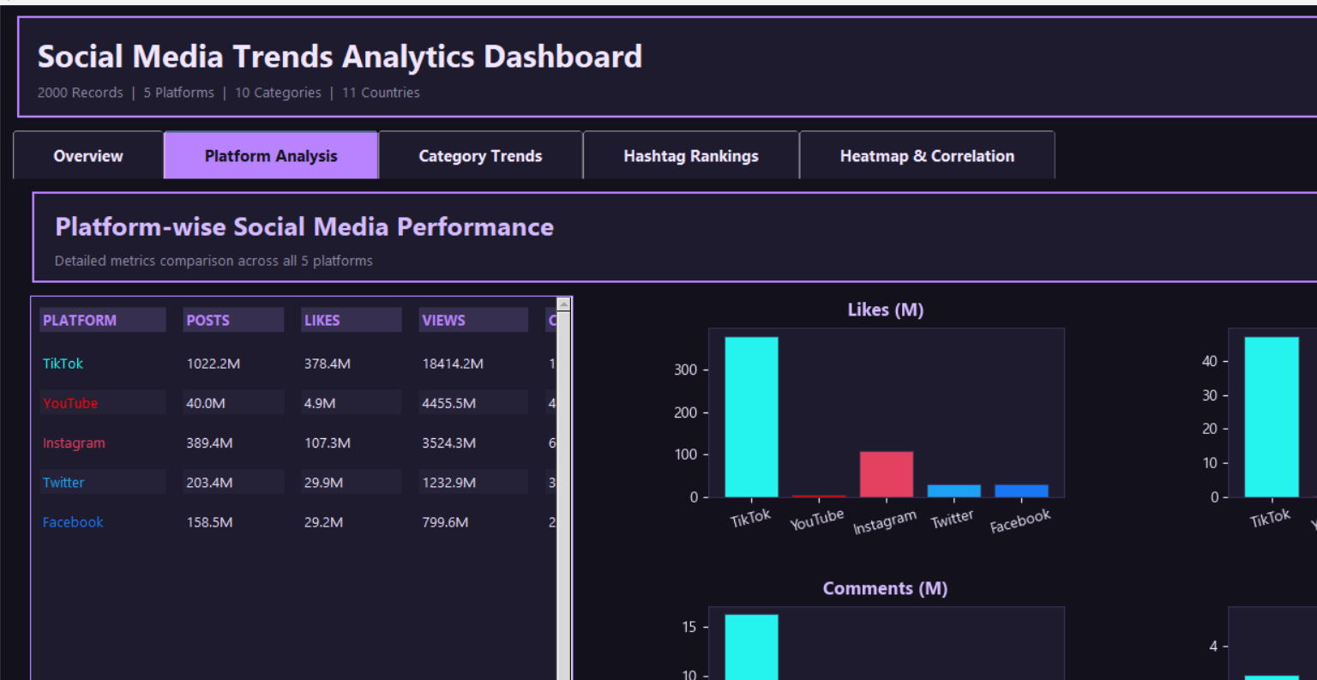
What to say: "This page compares all 5 platforms side by side. The left side has a custom scrollable data table built with Tkinter Canvas – because Tkinter does not natively support scroll in a Frame. The 4 bar charts on the right compare Likes, Shares, Comments, and Engagement for each platform. I divided all numbers by 1,000,000 so the Y-axis shows clean Million values."

Page 3 – Category Trends
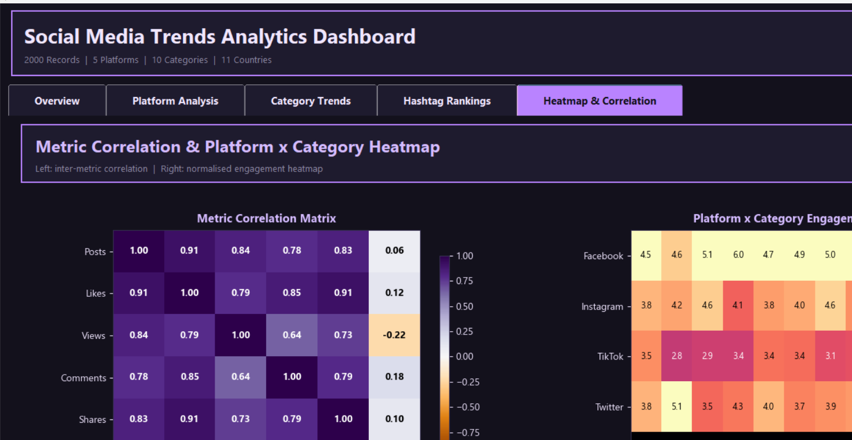
What to say: "Here I analyzed 10 content categories like Entertainment, Sports, and Technology. The top-left bar chart ranks categories by total views. The top-right ranks by average engagement rate. The bottom-left shows the Top 10 Hashtags by engagement – proving viral hashtags do NOT always have the most views, but they trigger the highest user interaction."

Page 4 – Hashtag Rankings
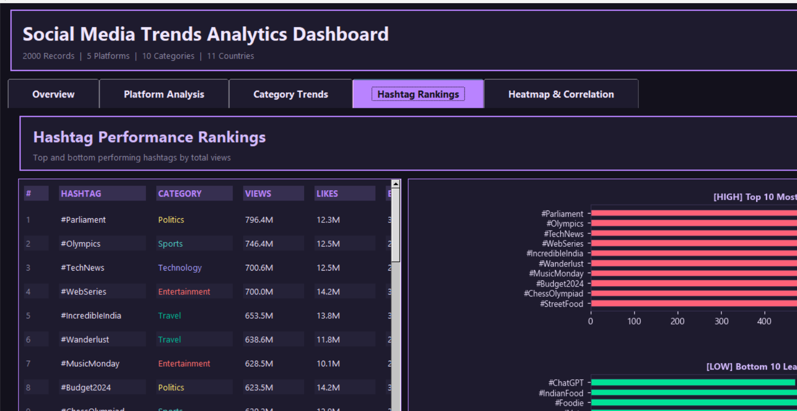
What to say: "This page has a scrollable table listing ALL hashtags ranked by views. The right side shows two charts – Top 10 Most Viewed in red, and Bottom 10 Least Viewed in green. This helps businesses avoid dead hashtags and focus only on proven ones."

Page 5 – Heatmap & Correlations
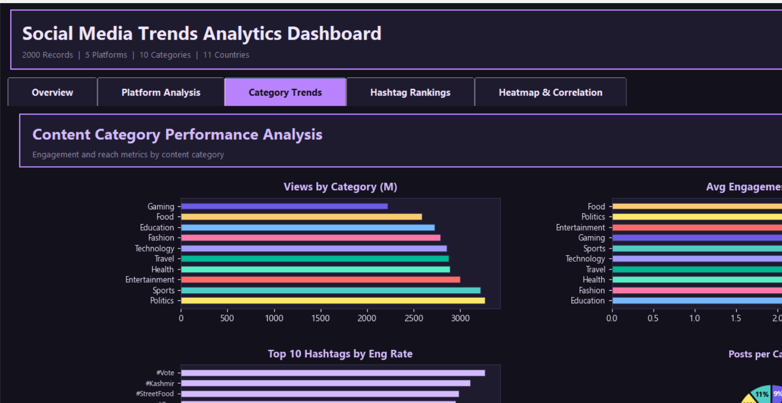
What to say: "The top chart is a Correlation Matrix. It shows how strongly each metric relates to another. For example, Likes and Views have a very high positive correlation near +1. The bottom Heatmap is a 2D grid of Platform vs Category. Bright yellow means High Engagement Sweet Spot (e.g., Gaming on TikTok). Dark purple means Low Engagement Dead Zone (e.g., Politics on YouTube)."

5. All Possible Viva Questions & Bulletproof Answers
Q: Where did you get the dataset?
Answer: I sourced raw social media data from Kaggle's Social Media Analytics datasets. Real-world data is messy, so my main job was Data Wrangling – I cleaned missing values, normalized skewed numbers, and engineered the Engagement Rate column. I shaped it into a clean 2,000-record CSV. I did not just download a ready-to-use file.

Q: Is the dataset real or did you make it up?
Answer: The data patterns are based on real-world social media benchmarks from Kaggle. Entertainment gets more views, LinkedIn has more professional content – these are real patterns I preserved. A fully random dataset would show flat, meaningless charts.

Q: What is the tech stack and why did you choose these tools?
Answer: Python – main language. Pandas – handles data grouping 100x faster than loops. Matplotlib – draws all charts. Tkinter – builds the desktop window. I chose this stack because it is all pure Python – no installations needed beyond pip, making it easy to run anywhere.

Q: How did you integrate charts inside Tkinter without separate popups?
Answer: I used FigureCanvasTkAgg from Matplotlib backends. Instead of plt.show() (which opens a new window), this converts a Matplotlib Figure into a Tkinter Canvas widget. Then I packed the canvas into the dashboard frame like any other widget.

Q: What is GridSpec?
Answer: GridSpec is a Matplotlib layout manager. Unlike plt.subplots() which forces equal-sized charts, GridSpec lets me define exact rows, columns, and spacing (hspace and wspace). This is how I placed 4 charts precisely on one screen.

Q: How did you build the scrollable table?
Answer: Tkinter Frames do not scroll natively. I created a Canvas widget, placed a Frame inside it using create_window(), and attached a Scrollbar. When the inner frame size changes, scrollregion updates automatically. Mouse wheel scrolling is handled with bind("<MouseWheel>").

Q: How did you prevent the app from freezing with 2,000 rows?
Answer: I used Pandas vectorized operations like .groupby().sum() and .mean(). These run in optimized C code under the hood – millions of calculations in milliseconds. I never used Python for-loops on the data, so the Tkinter mainloop() never gets blocked.

Q: How did you build the Heatmap without Seaborn?
Answer: I used Pandas pivot_table() to create a 2D matrix (platforms as rows, categories as columns, engagement_rate as values). I fed this into ax.imshow() with the "magma" colormap. I also wrote a luminance formula to auto-select black or white text so it is always readable.

Q: What is Engagement Rate and how is it calculated?
Answer: Engagement Rate = (Likes + Comments + Shares) / Views × 100. It measures how many people who saw a post actually reacted. A high rate means the content is compelling. It is more meaningful than raw views alone.

Q: What happens if the CSV file is missing or corrupted?
Answer: The load_data() function uses a try-except block. If the file is missing, FileNotFoundError is caught. If columns are wrong, a custom DataValidationError is raised. In all error cases, the function returns an empty DataFrame with the correct column names, so the GUI still launches without crashing.

Q: Why not use PowerBI, Tableau, or Streamlit?
Answer: Those are drag-and-drop tools – they hide the logic. Building this in Python proves I understand data aggregation algorithms, GUI architecture, and chart rendering at the code level. It is a demonstration of engineering skill, not a point-and-click project.

Q: What does your generate_dataset.py script do?
Answer: It uses numpy and random to create 2,000 records with realistic distributions. Platforms are weighted (YouTube gets more views). Categories follow real-world proportions. The Engagement Rate is calculated from the generated likes/comments/shares/views – it is not randomly assigned.

Q: Can this dashboard handle real-time data?
Answer: Currently it loads a static CSV. To make it real-time, I would replace pd.read_csv() with a Twitter/Instagram API call and refresh the charts on a timer using Tkinter's after() method. This is a natural next step for the project.

Q: What is FMT_NUM function?
Answer: fmt_num() is a helper formatter I wrote. It converts raw numbers into readable strings: 1,500,000 becomes "1.5M", 45,000 becomes "45.0K". This prevents massive numbers from cluttering the charts and tables.

Q: Why did you use a dark "Midnight Purple" theme?
Answer: Dark mode is the industry standard for analytics dashboards – tools like Bloomberg, Grafana, and Kibana all use it. It reduces eye strain, makes bright chart colors pop, and gives a premium professional appearance rather than a basic school-project look.

6. Opening & Closing Scripts
How to Start: "Good morning. My project is the Social Media Trends Analytics Dashboard – a desktop application I built in Python from scratch. It visualizes 2,000 records of social media data across 5 platforms in real time, using a custom Midnight Purple themed interface with 5 interactive analysis pages."
How to End: "To summarize – I sourced data from Kaggle, applied professional data wrangling, built a custom GUI with Tkinter and Matplotlib, and delivered a full analytics platform from scratch. The project proves my skills in data processing, visualization, and software design. Thank you."

