Define the Problem
Modern communication and social media platforms are fundamentally broken for deep, intentional relationships—especially when one partner is hyper-autonomous or anti-social media.
Currently, users are forced to choose between chaotic instant messengers (like WhatsApp) and attention-grabbing social networks. This setup introduces several critical friction points:
- The Attention Tax & Notification Trap: To stay in touch with a single person, users must keep notifications on and open apps that are engineered for endless scrolling. This constantly derails focus, exposing them to unsolicited updates and information overload.
- The Pressure of Instant Gratification: Instant messaging platforms create an implicit, high-anxiety expectation for immediate replies or reactions. There is no safe, sacred digital space to simply pour out one’s inner world without demanding a response.
- Poor Long-Form Writing UX: Existing platforms are designed for quick, fragmented text bursts. They are hostile to the slow, deliberate format of traditional, long-form letter writing.
- Zero Organization or Epistolary Archiving: Messages disappear into an endless chronological scroll. Unlike workspace tools, current social apps lack a structural system (folders, tabs, or tags like #written-letters or #future-reads) to categorize and archive meaningful correspondence.
- Platform Restrictions & Poor Engineering: Many intimate sharing apps require a mobile installation, lacking a web counterpart entirely, or they feature poorly optimized, non-responsive web versions that ruin the desktop experience.

What You Are Building: "The Social Media Room"
You are building a hyper-focused, private, dual-user web application that acts as a "Google Drive inside Slack" for your relationship. It strips away the noise, algorithms, and public performance of traditional social media, replacing them with an intentional, digital sanctuary featuring a native, permanent Dark Mode layout, a private, deliberate, asynchronous communication space designed for high-depth, low-distraction intimacy.
The app uses a Discord/Slack-style interface with a clean, vertical left sidebar for organized structural spaces and a dynamic right-hand panel that shifts layouts based on your selected category:
- The Postbox Category (Grid of Digital Envelopes): Selecting channels like #written-letters or #future-reads displays an organized, clean grid of styled Cards (Digital Envelopes). Clicking any card opens a distraction-free, full-page overlay to read that specific letter in absolute isolation.
- The Chat Category (Linear Messaging Stream): Selecting channels like #general-dm seamlessly transitions the right panel into a bottom-anchored, real-time scrolling chat stream for daily conversation.

Who Is It For?
This platform is custom-built for couples, close confidants, or family members where at least one partner is highly protective of their digital peace (an anti-social media minimalist or a Hyper-Autonomous Rationalist).
It is for people who value profound, unhurried emotional expression over real-time chatter. The ideal user wants to share their rich inner world with someone they care about deeply, but requires a strict boundary against notification fatigue, algorithmic manipulation, and the pressure of instant feedback loops.

Product Mechanics: How It Will Work
The platform functions as a highly responsive web application (and cross-platform space) that prioritizes structured delivery over instant notification.

1. The Interface (Slack/Discord Layout)
- The Left Sidebar: A clean, vertical navigation panel divided into organized, custom categories and spaces (e.g., "Getting Started," "Daily Logs," "Deep Musings").
- The Main Content Area: A spacious, distraction-free reading and writing canvas on the right side of the screen, supporting elegant markdown for long-form reading, media attachments, and subtle, interactive emojis.

2. The Organization (The Knowledge Base Layer)
- Instead of a single, chaotic chat stream, communication is treated like a beautifully cataloged library.
- Users can create distinct folders, tabs, and Slack-style tags (e.g., 1.#written-letters, 2.#future-reads) to organize essays, letters, and shared media under specific headers for seamless future retrieval.

3. The Communication Philosophy (Asynchronous & Safe)
- Zero Response Pressure: The UX is deliberately optimized to eliminate the "typing..." indicator or the implicit demand for an immediate reply. It acts as an open journal or a digital mailbox where you can post your thoughts with a peaceful, "Here is my inner world—read it when you are ready, react only if you want" philosophy.
- Siloed & Clean: It operates entirely independent of the broader internet ecosystem. There are no feeds, no discovery tabs, and no external distractions—ensuring that when you open the application, your focus remains entirely on your person.

🏗️ System Architecture Design
Project Concept: A private, asynchronous, "Google Drive inside Slack" digital sanctuary designed for deep, long-form communication with zero response pressure.

1. System Architecture Diagram
The system follows a Serverless Backend-as-a-Service (BaaS) topology. The client web application communicates directly with managed cloud services using secure rules, eliminating the need to maintain an intermediate API server.
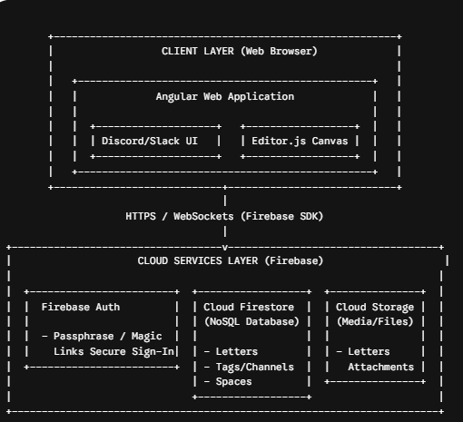

2. Technology Stack Selection
To achieve maximum responsive performance across desktop and mobile browsers, high developer velocity, and a hard $0 monthly operating cost, the following stack has been curated:
Component | Technology Selection | Core Purpose & Architectural Benefit
Frontend Framework | Angular (v18+) | Structured framework matching an enterprise workspace design. Built-in routing easily handles multi-panel sidebar synchronization, while strict lifecycle hooks keep real-time UI reactive yet stable.
Styling & Layout | Tailwind CSS | Low-overhead utility framework. Crucial for building a viewport-locked, fluid desktop dashboard that seamlessly collapses into a clean bottom-nav/off-canvas drawer on mobile devices.
Rich Text Editor | Editor.js | A block-style, distraction-free canvas (similar to Notion). It outputs data as a clean JSON structure rather than raw HTML strings, which maps perfectly to a NoSQL database document layer.
Core Database | Cloud Firestore | A serverless, flexible NoSQL document store. Native SDK listeners handle background syncs cleanly, updating the app instantly without chat-style popups or aggressive typing notifications.
Media Storage | Firebase Cloud Storage | Handles letter attachments, rich media embedding, and file uploads.
Authentication | Firebase Auth | Provides secure user session handling directly on the client side with minimal integration overhead.
Hosting Deployment | Firebase Hosting | Free global CDN hosting supporting single-command automated deployment and custom SSL certificate provisioning.

3. Data Schema Model (NoSQL Document Design)
Firestore organizes data into collections of flexible documents. To power the Slack-style navigation panels, custom tags, and folder groupings, the database will structure documents using three main relational collections:

spaces Collection
Defines the high-level grouping headers in the left sidebar (e.g., "Getting Started", "Deep Musings").
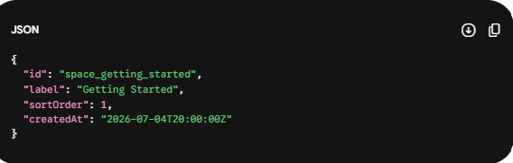

tags Collection
Defines individual channels/folders that live inside a space, managing how letters are cataloged.
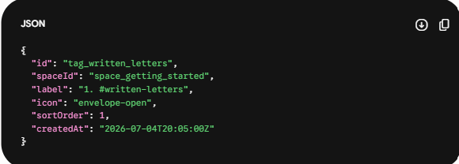

letters Collection
The core content engine. Stores the full structure of your long-form letters, including multi-tag assignments and a state flag to track unread letters without triggering intrusive popup badges.
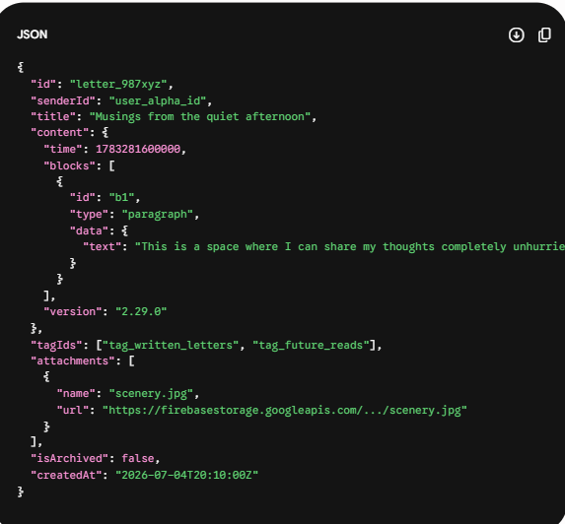

4. Key Architectural Mechanisms
- Asynchronous UX Isolation: The Angular state service will listen to Firestore real-time snapshots quietly in the background. When a new letter arrives, it updates the document count in the sidebar invisibly rather than triggering alert sound bars, chat banners, or intrusive interruptions—respecting the focus of both users.
- Decoupled Rich-Text Storage: By storing text blocks as clean JSON structures from Editor.js rather than pre-rendered HTML strings, the platform remains highly adaptable. If you later choose to pivot your UI design, change themes, or build a specialized application view, the underlying text data can be reformatted easily on the fly without database cleanup.
- Granular Security Policies: Firebase Security Rules act as a decentralized firewall. Since there is no custom middle backend, database security rules will strictly validate that only verified user accounts belonging to your specific personal link can read or write documents.

Epic 1: Root Sandbox & Interface Frame

Story 1: Dual-User Global Dark Frame
- User Story: As an authorized partner, I want to open the web app on any desktop or mobile device and see an instant, permanent dark-mode Slack/Discord-style split viewport layout so that my eyes can rest in a distraction-free environment.
- Tiniest End-to-End Slice:
  - Frontend: Create an Angular shell component utilizing a viewport-locked Tailwind CSS layout (h-screen overflow-hidden) with a rigid 260px left sidebar panel and a fluid right-side content panel.
  - Database Layer: Mock a hardcoded session parameter for two users to verify layout visibility.
  - Acceptance Criteria: Shrinking the web browser viewport dynamically collapses the left sidebar into an off-canvas slide drawer or bottom-navigation tray on mobile screens without breaking content layouts.

Story 2: Sidebar Spaces & Tags Render
- User Story: As a user, I want the left sidebar to display structured, high-level header spaces grouping specific channels so that I can see the exact layout of our digital library.
- Tiniest End-to-End Slice:
  - Frontend: Build an Angular structural component that binds to local observable arrays for spaces and tags.
  - Database Layer: Manually seed documents into your Firestore spaces and tags collections matching your configuration (e.g., Space: Getting Started, Tags: 1.#written-letters, 2.#future-reads).
  - Acceptance Criteria: The UI successfully reads from Firestore and renders the list with explicit ordering (sortOrder) and custom icons in the sidebar frame.

Epic 2: The Postbox View (#written-letters, #future-reads)

Story 3: Postbox Envelope Grid View
- User Story: As a partner clicking an archive tag like #written-letters, I want the right-side panel to load a clean grid of styled cards representing digital envelopes so that I can browse long-form correspondence neatly.
- Tiniest End-to-End Slice:
  - Frontend: Configure an Angular route matching the selected tagId that dynamically updates the right panel into a grid layout.
  - Database Layer: Query the Firestore letters collection where tagIds contains the active tagId string.
  - Acceptance Criteria: Selecting #written-letters displays all matching letter document cards showing only titles and timestamps, while clicking #future-reads filters the grid cleanly.

Story 4: Isolated Overlay Reader
- User Story: As a reader clicking on a digital envelope card, I want a full-page, distraction-free overlay to take over the viewport so that I can read that specific letter in complete isolation.
- Tiniest End-to-End Slice:
  - Frontend: Create an absolute overlay canvas component that triggers on card selection, disabling background scroll.
  - Database Layer: Pass the matching Firestore letter document ID directly to the overlay wrapper to fetch and render the block-content fields.
  - Acceptance Criteria: Clicking an envelope card displays the full text with a close button that restores the underlying postbox grid view safely without forcing a full page refresh.

Story 5: Asynchronous Unread Badge
- User Story: As a user, I want the sidebar tags to quietly update an unread item count next to their name without playing popups or banners when my partner saves a new letter so that my real-time focus is never disrupted.
- Tiniest End-to-End Slice:
  - Frontend: Use an Angular state service linked to an active Firestore data snapshot stream to watch for changes silently in the background.
  - Database Layer: Calculate the delta count of letters where status == 'unread' for the recipient user.
  - Acceptance Criteria: When a letter document is added to Firestore, the count integer in the sidebar increments silently—generating zero sound effects, alerts, or active notification loops.

Epic 3: The Long-Form Canvas Engine

Story 6: Block-Style Editor Canvas
- User Story: As an author pouring out my inner world, I want a spacious, clean block text editing environment so that I can write structured, long-form essays comfortably without character limits or real-time typing pressure indicators.
- Tiniest End-to-End Slice:
  - Frontend: Embed an Editor.js structural instance inside an isolated view layer, locking out typing indicators or user presence states.
  - Database Layer: Configure a save button that exports the raw block text arrays as a clean JSON block directly to a new record inside the Firestore letters collection.
  - Acceptance Criteria: Saving a long letter successfully records the multi-block JSON data inside Firestore exactly as defined in your content architecture without generating "User is typing..." alerts.

Story 7: Letter Tag Assignment
- User Story: Before archiving a long letter, I want to select one or more sidebar tags (like #written-letters) from a toggle check row so that it routes to the correct folders in our repository.
- Tiniest End-to-End Slice:
  - Frontend: Create a multi-select form element above the saving canvas that dynamically maps all active IDs from the sidebar tags collection.
  - Database Layer: Append the chosen array strings directly into the target letter document's tagIds array field.
  - Acceptance Criteria: A letter saved with tags ["tag_written_letters", "tag_future_reads"] shows up instantly across both postbox folders when browsed.

Story 8: Cloud Attachment Upload
- User Story: As an author, I want to drop an image or media file directly onto my letter draft so that I can share visual entries securely within our archive.
- Tiniest End-to-End Slice:
  - Frontend: Bind a file selection interceptor inside the editor panel.
  - Database Layer: Stream the binary payload directly into Firebase Cloud Storage, then append the absolute URL string to the letter document's attachments block.
  - Acceptance Criteria: An uploaded file displays cleanly as an inline interactive media frame inside the Isolated Overlay Reader view.

Epic 4: The Chat View (#general-dm)

Story 9: Linear Chat Layout Switch
- User Story: As a user switching to #general-dm, I want the right-hand panel layout to change into a bottom-anchored, linear scrolling message list so that I can review casual text streams seamlessly.
- Tiniest End-to-End Slice:
  - Frontend: Apply an Angular layout filter that detects if the active sidebar channel belongs to a Chat category vs. a Postbox category.
  - Database Layer: Set up a separate collection or specific tag route for continuous linear messages.
  - Acceptance Criteria: Clicking #general-dm shifts the right panel from a grid layout into a classic bottom-anchored messaging column.

Story 10: Asynchronous Chat Send
- User Story: As a user typing a message in the linear chat, I want to hit submit without displaying a typing state indicator or explicit delivery status notifications so that I can message my partner without pressure.
- Tiniest End-to-End Slice:
  - Frontend: Implement a standard text box field with zero active focus listeners or message status markers.
  - Database Layer: Instantly commit the message string to Firestore along with a creation timestamp.
  - Acceptance Criteria: Submitting a message updates the scroll list instantly without triggering active delivery checkpoints, seen receipts, or real-time indicators.

Epic 5: Vault Access & Guardrails

Story 11: Passphrase/Magic Link Dual Access Gate
- User Story: As a partner accessing our sanctuary, I want to sign in securely using a simple magic link or shared passphrase so that our private entries are locked away from the public.
- Tiniest End-to-End Slice:
  - Frontend: Construct a minimal Angular sign-in page that calls the Firebase Auth SDK directly.
  - Database Layer: Restrict database interaction using client rules until a valid token is established.
  - Acceptance Criteria: Entering an unauthorized user account returns a secure routing denial, preventing access to the workspace sidebar layout.

Story 12: Granular Vault Security Rules
- User Story: As a user, I want the system's database configuration to strictly reject any external modifications so that our letters remain isolated from third-party networks.
- Tiniest End-to-End Slice:
  - Database Layer: Write and deploy Firestore Security Rules directly matching your architecture specifications:
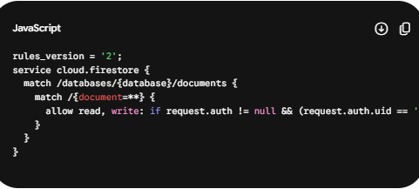
Acceptance Criteria: Any read or write request attempted outside of your authenticated user IDs is instantly terminated at the cloud server level.

Folder structure
