FOR TASK 3

Google for response sheet :

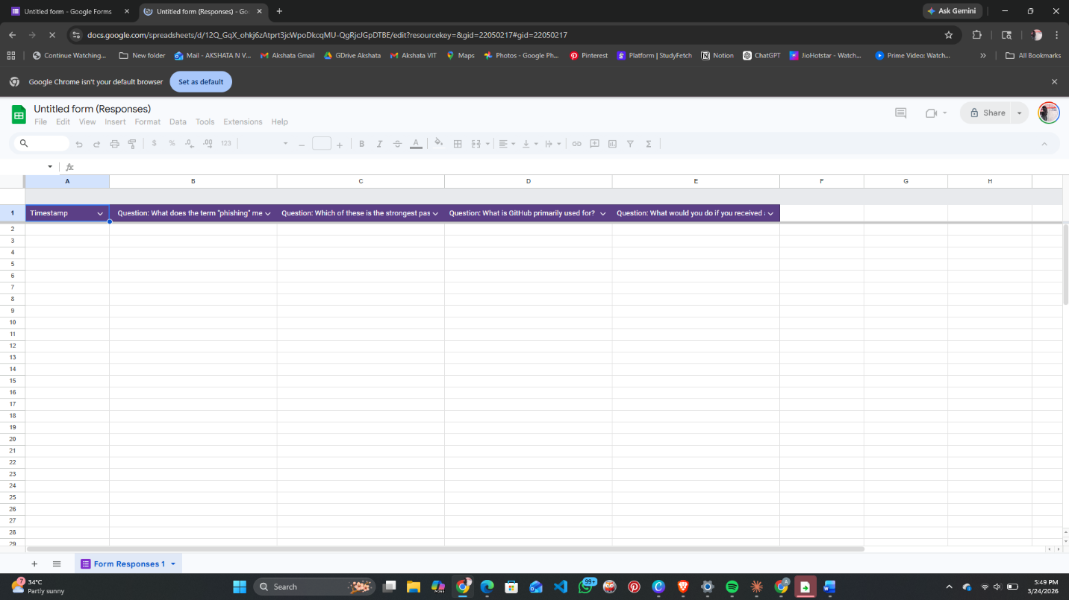

FOR THE CODING COLLABORATOR
