**Industrial Internship Report on**

**” Cloud-Based Bus Pass System”**

**Prepared by**

**Akshata Jayant Jitaitkhane**

|  |
| --- |
| *Executive Summary* |
| This report provides details of the Industrial Internship provided by upskill Campus and The IoT Academy in collaboration with Industrial Partner UniConverge Technologies Pvt Ltd (UCT). This internship focused on a cloud-based bus pass system project provided by UCT. We completed the project, including the report, in six weeks. This internship gave me an excellent opportunity to gain exposure to industrial problems and design and implement solutions. It was an overall great experience. |

**TABLE OF CONTENTS**

1 Preface 3

2 Introduction 4

2.1 About UniConverge Technologies Pvt Ltd 4

2.2 About upskill Campus 8

2.3 Objective 9

2.4 Reference 9

2.5 Glossary 10

3 Problem Statement 11

4 Existing and Proposed solution 12

5 Proposed Design/ Model 13

6 My learnings 15

7 Future work scope 16

# Preface

This section summarizes the work completed during the six-week internship. It discusses the necessity of relevant career development internships and briefly overview the project/problem statement. USC and UCT planned the program, and my learnings and overall experience are shared here. Acknowledgments are given to all who helped me, and I share a message to my juniors and peers.

.

# Introduction

## About UniConverge Technologies Pvt Ltd

A company established in 2013 and working in Digital Transformation domain and providing Industrial solutions with prime focus on sustainability and RoI.

For developing its products and solutions it is leveraging various**Cutting Edge Technologies e.g. Internet of Things (IoT), Cyber Security, Cloud computing (AWS, Azure), Machine Learning, Communication Technologies (4G/5G/LoRaWAN), Java Full Stack, Python, Front end**etc.

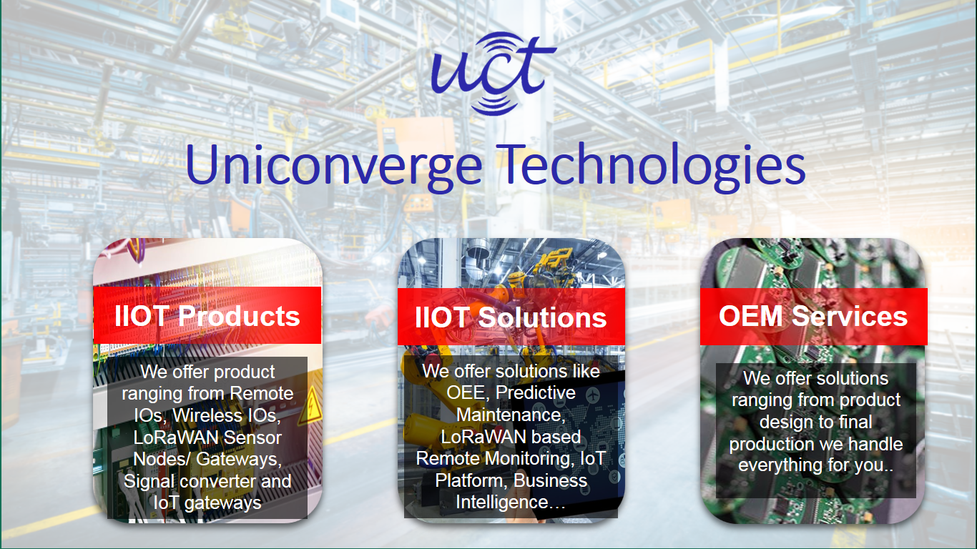

1. UCT IoT Platform **(****)**

**UCT Insight** is an IOT platform designed for quick deployment of IOT applications on the same time providing valuable “insight” for your process/business. It has been built in Java for backend and ReactJS for Front end. It has support for MySQL and various NoSql Databases.

* It enables device connectivity via industry standard IoT protocols - MQTT, CoAP, HTTP, Modbus TCP, OPC UA
* It supports both cloud and on-premises deployments.

It has features to  
• Build Your own dashboard  
• Analytics and Reporting  
• Alert and Notification  
• Integration with third party application(Power BI, SAP, ERP)  
• Rule Engine

 

1. **Smart Factory Platform (****)**

Factory watch is a platform for smart factory needs.

It provides Users/ Factory

* with a scalable solution for their Production and asset monitoring
* OEE and predictive maintenance solution scaling up to digital twin for your assets.
* to unleased the true potential of the data that their machines are generating and helps to identify the KPIs and also improve them.
* A modular architecture that allows users to choose the service that they what to start and then can scale to more complex solutions as per their demands.

Its unique SaaS model helps users to save time, cost and money.

 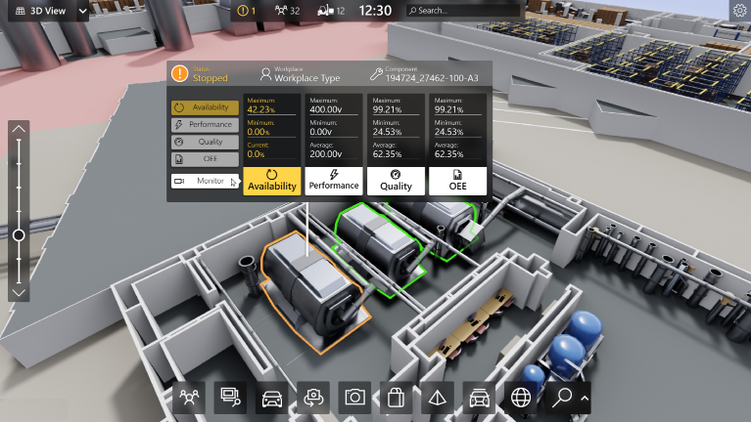

1. 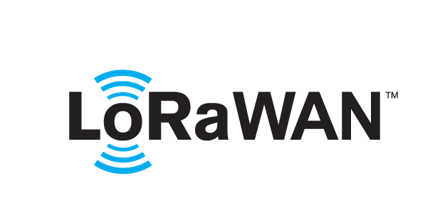 based Solution

UCT is one of the early adopters of LoRAWAN teschnology and providing solution in Agritech, Smart cities, Industrial Monitoring, Smart Street Light, Smart Water/ Gas/ Electricity metering solutions etc.

1. Predictive Maintenance

UCT is providing Industrial Machine health monitoring and Predictive maintenance solution leveraging Embedded system, Industrial IoT and Machine Learning Technologies by finding Remaining useful life time of various Machines used in production process.



## About upskill Campus (USC)

upskill Campus along with The IoT Academy and in association with Uniconverge technologies has facilitated the smooth execution of the complete internship process.

USC is a career development platform that delivers **personalized executive coaching** in a more affordable, scalable and measurable way.



Seeing need of upskilling in self paced manner along-with additional support services e.g. Internship, projects, interaction with Industry experts, Career growth Services

<https://www.upskillcampus.com/>

upSkill Campus aiming to upskill 1 million learners in next 5 year

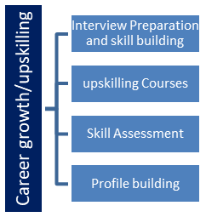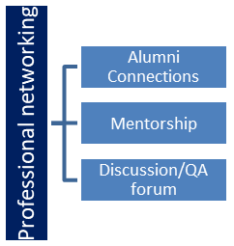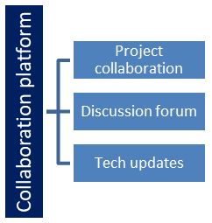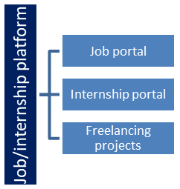

## The IoT Academy

The IoT academy is EdTech Division of UCT that is running long executive certification programs in collaboration with EICT Academy, IITK, IITR and IITG in multiple domains.

## Objectives of this Internship program

The objective for this internship program was to

 ☛ get practical experience of working in the industry.

 ☛ to solve real world problems.

 ☛ to have improved job prospects.

 ☛ to have Improved understanding of our field and its applications.

 ☛ to have Personal growth like better communication and problem solving.

## Reference

**1. "A Cloud-Based Bus Pass System Using RFID"** by S. Sridevi, B. Sravani, M. Prathyusha, and A. Laxmi. This paper discusses the implementation of a cloud-based bus pass system using RFID technology to enhance the efficiency and convenience of public transportation systems.

* Link: [IEEE Xplore](https://ieeexplore.ieee.org/document/8955801)

**2. "Smart Bus Pass System using Cloud-Based Technology"** by S. S. Arjun, P. A. Bhupathi, and D. B. Vinay. This research paper explores the development of a smart bus pass system that leverages cloud technology to manage and streamline the issuance and verification of bus passes.

* Link: [ResearchGate](https://www.researchgate.net/publication/334676759_Smart_Bus_Pass_System_using_Cloud-Based_Technology)

**3. "A Cloud-Based Automated Public Transportation System"** by S. M. Kavi, A. H. Shubhangi, and R. V. Deepali. This article describes a cloud-based automated system for public transportation, focusing on bus pass management and real-time tracking.

* Link: Journal of Network Communications and Emerging Technologies

## Glossary

|  |  |
| --- | --- |
| Terms | Acronym |
| Radio Frequency Identification | RFID |
| Internet of Things | IoT |
| Application Programming Interface | API |

# Problem Statement

The problem statement assigned was to design and implement a cloud-based bus pass system. This system needed to manage bus pass issuance, renewal, and validation, ensuring user-friendliness, scalability, and data security.

The project aims to design and implement a cloud-based bus pass system that replaces traditional manual methods with a digital solution. This system will manage the entire lifecycle of bus passes, including issuance, renewal, and validation, ensuring a seamless and efficient experience for both users and administrators. Users can apply for new bus passes, renew existing ones, and validate their passes through a user-friendly online interface. The system will be scalable to handle a growing number of users and transactions, and will prioritize data security to protect user information and payment details. By leveraging cloud technology, the system will provide reliable access and real-time updates, enhancing the overall efficiency and convenience of public transportation management.

# Existing and Proposed solution

Existing solutions are typically manual or semi-automated, lacking integration and scalability. They often face issues like data inconsistency, security vulnerabilities, and inefficiencies in pass management.

Our proposed solution is a fully automated cloud-based system that provides a unified platform for bus pass management, addressing these limitations by offering real-time data processing, secure transactions, and user-friendly interfaces.

## Code submission (Github link)

https://github.com/akshata5670/Bus-ticket-system.git

## Report submission (Github link) :

# Proposed Design/ Model

[The **Real-Time Cloud-Based Bus Pass System** serves as a convenient solution for commuters facing difficulties with the current manual bus pass system1](https://www.ijraset.com/research-paper/cloud-based-bus-pass-system). Here’s an overview of the proposed design model:

1. **Registration Module**: Passengers register online by submitting personal details, including their photo and address proof. The system reviews the information and approves or rejects the bus pass application accordingly.
2. **Authentication Module**: The system assigns a unique number to each passenger, preventing duplication. Passengers can travel easily with a mobile ticket QR code, which they can display if they lose their ticket during inspections.
3. **Online Payment**: Passengers can pay for their bus pass using various methods, including credit or debit cards. This eliminates the need for cash payments.
4. **Generation of Bus Pass**: Once registered and authenticated, passengers receive a mobile ticket QR code that they can use for travel. Train Ticket Examiners (TTEs) and system administrators verify the QR code’s authenticity.
5. **Bus Pass Renewal**: Passengers can renew their bus pass online, extending its validity period. Timely alerts are sent via SMS or email before the pass expires.

# My learnings

During the internship, I gained valuable hands-on experience in designing and implementing a cloud-based bus pass system, which enhanced my technical skills in cloud computing, system design, and software development. I learned to manage the entire lifecycle of a project, from initial requirements gathering and system architecture to coding, testing, and deployment. The focus on user-friendliness, scalability, and data security provided me with practical insights into creating efficient, secure, and scalable applications. This experience is highly relevant to my career growth as it equipped me with industry-standard skills, improved my problem-solving abilities, and provided a deeper understanding of how to leverage technology to address real-world challenges. The collaborative environment and exposure to current technologies have prepared me to take on more complex projects and advance in the field of software engineering.

# Future work scope

The future scope for the cloud-based bus pass system includes integrating advanced payment and validation methods, such as NFC-enabled smart cards and mobile payment systems like Apple Pay and Google Wallet, to enhance user convenience and reduce validation times. Additionally, incorporating real-time bus tracking and schedule notifications using GPS technology can provide users with up-to-date information on bus arrivals and delays. Expanding the system to support multiple languages and accessibility features will make it more inclusive. Implementing advanced data analytics can offer insights into usage patterns, helping to optimize bus routes and schedules. Furthermore, integrating with other transportation services, like ride-sharing and bike rentals, can create a comprehensive transportation ecosystem. Enhancing security features with biometric authentication and continuous monitoring will ensure robust protection of user data. These improvements, though not implemented due to time constraints, would significantly enhance the functionality, user experience, and overall efficiency of the bus pass system.