

**BASAVESHWAR ENGINEERING COLLEGE, BAGALKOT**

**DEPARTMENT OF MASTER OF COMPUTER APPLICATIONS (MCA)**

**2024­25**

***Assignment report on***

**“Website Development”**

***Submitted by***

# Miss.AKSHATA JAVALAGI

## CSN:2024070026

***Submitted to***

# Prof. KARUNA B. KURBET

## Dept.of MCA

## Code:-

## <!DOCTYPE html>

## <html lang="en">

## <head>

## <meta charset="UTF-8">

## <meta name="viewport" content="width=device-width, initial-scale=1.0">

## <title>Editable Content</title>

## <style>

## body {

## font-family: Arial, sans-serif;

## padding: 0;

## margin: 0;

## background-color: pink;

## }

## .main {

## display: grid;

## grid-template-columns: 1fr 3fr;

## gap: 20px;

## padding: 20px;

## }

## .items {

## background-color:#333;

## padding: 20px;

## border: 1px solid #ccc;

## box-shadow: 0 0 10px rgba(0, 0, 0, 0.1);

## border-radius: 20px;

## }

## .item {

## cursor: pointer;

## margin: 10px 0;

## padding: 10px;

## border: 1px solid palegoldenrod;

## border-radius: 5px;

## background-color: #fafafa;

## text-decoration: none;

## display: block;

## }

## .item:hover {

## background-color: palevioletred;

## transition: 0.3s ease;

## }

## .details {

## background-color: #555;

## padding: 20px;

## border: 1px solid #ccc;

## border-radius: 8px;

## box-shadow: 0 0 10px rgba(0, 0, 0, 0.1);

## }

## .details h2 {

## margin-top: 0;

## }

## .section {

## display: none;

## }

## .section:target {

## display: block;

## }

## .section h3 {

## color: #333;

## font-size: 1.5em;

## }

## .section p {

## color: #555;

## font-size: 1.1em;

## line-height: 1.6;

## }

## </style>

## </head>

## <body>

## <h1 style="text-align: center; margin-top: 20px;">MASTER OF COMPUTER APPLICATION 1ST SEM</h1>

## <div class="main">

## <div class="items">

## <a href="#tags" class="item">Formatting tags</a>

## <a href="#links" class="item">Links</a>

## <a href="#lists" class="item">Lists</a>

## <a href="#table" class="item">Table</a>

## <a href="#forms" class="item">Forms</a>

## <a href="#html5" class="item">HTML5</a>

## </div>

## <div id="tags" class="section">

## <h3>Formatting tags</h3>

## <ul type="square">

## <li><p>Formatting tags are HTML tags used to apply styles and formatting to the text content. These tags help in adjusting the presentation and look of the content on the page. Some commonly used formatting tags include:</p></li>

## </ul>

## <ul>

## <li><b>&lt;b&gt;</b> - Defines bold text. <br>

## <strong>Example:</strong> <code>&lt;b&gt;This is bold text&lt;/b&gt;</code><br>

## <strong>Output:</strong> <pre><b>This is bold text</b></pre>

## </li>

## <li><b>&lt;i&gt;</b> - Defines italic text. <br>

## <strong>Example:</strong> <code>&lt;i&gt;This is italic text&lt;/i&gt;</code><br>

## <strong>Output:</strong> <pre><i>This is italic text</i></pre>

## </li>

## <li><b>&lt;u&gt;</b> - Defines underlined text. <br>

## <strong>Example:</strong> <code>&lt;u&gt;This is underlined text&lt;/u&gt;</code><br>

## <strong>Output:</strong> <pre><u>This is underlined text</u></pre>

## </li>

## <li><b>&lt;strong&gt;</b> - Defines important text (strong emphasis). <br>

## <strong>Example:</strong> <code>&lt;strong&gt;This is strong text&lt;/strong&gt;</code><br>

## <strong>Output:</strong> <pre><strong>This is strong text</strong></pre>

## </li>

## <li><b>&lt;em&gt;</b> - Defines emphasized text (italic). <br>

## <strong>Example:</strong> <code>&lt;em&gt;This is emphasized text&lt;/em&gt;</code><br>

## <strong>Output:</strong> <pre><em>This is emphasized text</em></pre>

## </li>

## <li><b>&lt;mark&gt;</b> - Defines highlighted text. <br>

## <strong>Example:</strong> <code>&lt;mark&gt;This is

## highlighted text&lt;/mark&gt;</code><br>

## <strong>Output:</strong> <pre><mark>This is highlighted text</mark></pre>

## </li>

## <li><b>&lt;small&gt;</b> - Defines smaller text. <br>

## <strong>Example:</strong> <code>&lt;small&gt;This is smaller text&lt;/small&gt;</code><br>

## <strong>Output:</strong> <pre><small>This is smaller text</small></pre>

## </li>

## <li><b>&lt;del&gt;</b> - Defines deleted text (strikethrough). <br>

## <strong>Example:</strong> <code>&lt;del&gt;This is deleted text&lt;/del&gt;</code><br>

## <strong>Output:</strong> <pre><del>This is deleted text</del></pre>

## </li>

## <li><b>&lt;ins&gt;</b> - Defines inserted text (underline). <br>

## <strong>Example:</strong> <code>&lt;ins&gt;This is inserted text&lt;/ins&gt;</code><br>

## <strong>Output:</strong> <pre><ins>This is inserted text</ins></pre>

## </li>

## </ul>

## <ul type="square">

## <li><p>These tags are essential for styling and providing visual emphasis in your content, but they do not affect the document structure or layout.</p></li>

## </ul>

## </div>

## <div id="links" class="section">

## <h3>Links</h3>

## <ul>

## <li><p>Links in HTML are defined using the &lt;a&gt; (anchor) tag. This tag allows you to create hyperlinks that connect to different pages, sections within the same page, or external websites.</p></li>

## <li>Links, also known as hyperlinks, are clickable elements that allow users to navigate to other web pages or resources. They are created using the tag in HTML.</li>

## <li>To create HTML links:</li>

## <ul>

## <li>Use the &lt;a&gt; tag.</li>

## <li>Add the URL of the destination resource to the <b>href</b> attribute.</li>

## <li>Specify the link text between the opening and closing &lt;a&gt; tags.</li>

## </ul>

## </ul>

## <ul>

## <li><b>&lt;a href="URL"&gt;link text&lt;/a&gt;</b> - The most basic form of a link. For example:</li>

## <pre>&lt;a href="https://www.geeksforgeeks.org/"&gt;Visit Example&lt;/a&gt;</pre>

## <p>This creates a clickable text that links to the specified URL (e.g., "https://www.geeksforgeeks.org/").</p>

## <p>Visit <a href="https://www.geeksforgeeks.org/" target="_blank">Geeks for Geeks</a> for more information.</p>

## <li><b>Linking to an internal page:</b></li>

## <pre>&lt;a href="about.html"&gt;About Us&lt;/a&gt;</pre>

## <p>This creates a link to another page within the same website (about.html).</p>

## <li><b>Linking to a specific part of a page:</b></li>

## <pre>&lt;a href="#section1"&gt;Go to Section 1&lt;/a&gt;</pre>

## <p>In this case, clicking the link will take the user to a specific section on the same page (e.g., an element with the ID "section1").</p>

## </ul>

## </div>

## <div id="lists" class="section">

## <h3>Lists</h3>

## <p>Lists are used to group related items together in a structured manner. HTML supports three types of lists:</p>

## <h4>Unordered List (Bulleted)&lt;ul&gt;</h4>

## <p>An unordered list displays items with bullet points:</p>

## <ul>

## <li>Apple</li>

## <li>Banana</li>

## <li>Cherry</li>

## </ul>

## <pre>&lt;ul&gt;

## &lt;li&gt;Apple&lt;/li&gt;

## &lt;li&gt;Banana&lt;/li&gt;

## &lt;li&gt;Cherry&lt;/li&gt;

## &lt;/ul&gt;</pre>

## <p>Output:</p>

## <ul>

## <li>Apple</li>

## <li>Banana</li>

## <li>Cherry</li>

## </ul>

## <h4>Ordered List (Numbered)&lt;ol&gt;</h4>

## <p>An ordered list displays items with numbers:</p>

## <ol>

## <li>First Item</li>

## <li>Second Item</li>

## <li>Third Item</li>

## </ol>

## <pre>&lt;ol&gt;

## &lt;li&gt;First Item&lt;/li&gt;

## &lt;li&gt;Second Item&lt;/li&gt;

## &lt;li&gt;Third Item&lt;/li&gt;

## &lt;/ol&gt;</pre>

## <p>Output:</p>

## <ol>

## <li>First Item</li>

## <li>Second Item</li>

## <li>Third Item</li>

## </ol>

## <h4>Definition List &lt;dl&gt;</h4>

## <p>A definition list is used to display terms and their definitions:</p>

## <dl>

## <dt>HTML</dt>

## <dd>HyperText Markup Language, the standard for creating web pages.</dd>

## <dt>CSS</dt>

## <dd>Cascading Style Sheets, used to style HTML elements.</dd>

## <dt>JavaScript</dt>

## <dd>A programming language used to create interactive web pages.</dd>

## </dl>

## <pre>&lt;dl&gt;

## &lt;dt&gt;HTML&lt;/dt&gt;

## &lt;dd&gt;HyperText Markup Language, the standard for creating web pages.&lt;/dd&gt;

## &lt;dt&gt;CSS&lt;/dt&gt;

## &lt;dd&gt;Cascading Style Sheets, used to style HTML elements.&lt;/dd&gt;

## &lt;dt&gt;JavaScript&lt;/dt&gt;

## &lt;dd&gt;A programming language used to create interactive web pages.&lt;/dd&gt;

## &lt;/dl&gt;</pre>

## <p>Output:</p>

## <dl>

## <dt>HTML</dt>

## <dd>HyperText Markup Language, the standard for creating web pages.</dd>

## <dt>CSS</dt>

## <dd>Cascading Style Sheets, used to style HTML elements.</dd>

## <dt>JavaScript</dt>

## <dd>A programming language used to create interactive web pages.</dd>

## </dl>

## </div>

## <div id="table" class="section">

## <h3>Table with Rowspan and Colspan</h3>

## <p>The rowspan attribute allows a cell to span multiple rows, and the colspan attribute allows a cell to span multiple columns.</p>

## <h4>Example Table:</h4>

## <table border="1" style="border-collapse: collapse; width: 100%; text-align: center;">

## <thead>

## <tr>

## <th>Day</th>

## <th>Session 1</th>

## <th>Session 2</th>

## <th>Session 3</th>

## </tr>

## </thead>

## <tbody>

## <tr>

## <td rowspan="2">Monday</td>

## <td>Math</td>

## <td colspan="2">Science</td>

## </tr>

## <tr>

## <td>English</td>

## <td>History</td>

## <td>Geography</td>

## </tr>

## <tr>

## <td>Tuesday</td>

## <td rowspan="2" colspan="2">Sports</td>

## <td>Music</td>

## </tr>

## <tr>

## <td>Wednesday</td>

## <td>Art</td>

## </tr>

## </tbody>

## </table>

## <h4>Code Explanation:</h4>

## <ul>

## <li><b>Rowspan:</b> The rowspan attribute is used to merge a cell across multiple rows. For example, the "Monday" cell spans two rows.</li>

## <li><b>Colspan:</b> The colspan attribute is used to merge a cell across multiple columns. For example, the "Science" cell spans two columns.</li>

## <li>Combining both attributes helps to create complex table layouts.</li>

## </ul>

## <h4>Code:</h4>

## <pre>

## &lt;table border="1"&gt;

## &lt;thead&gt;

## &lt;tr&gt;

## &lt;th&gt;Day&lt;/th&gt;

## &lt;th&gt;Session 1&lt;/th&gt;

## &lt;th&gt;Session 2&lt;/th&gt;

## &lt;th&gt;Session 3&lt;/th&gt;

## &lt;/tr&gt;

## &lt;/thead&gt;

## &lt;tbody&gt;

## &lt;tr&gt;

## &lt;td rowspan="2"&gt;Monday&lt;/td&gt;

## &lt;td&gt;Math&lt;/td&gt;

## &lt;td colspan="2"&gt;Science&lt;/td&gt;

## &lt;/tr&gt;

## &lt;tr&gt;

## &lt;td&gt;English&lt;/td&gt;

## &lt;td&gt;History&lt;/td&gt;

## &lt;td&gt;Geography&lt;/td&gt;

## &lt;/tr&gt;

## &lt;tr&gt;

## &lt;td&gt;Tuesday&lt;/td&gt;

## &lt;td rowspan="2" colspan="2"&gt;Sports&lt;/td&gt;

## &lt;td&gt;Music&lt;/td&gt;

## &lt;/tr&gt;

## &lt;tr&gt;

## &lt;td&gt;Wednesday&lt;/td&gt;

## &lt;td&gt;Art&lt;/td&gt;

## &lt;/tr&gt;

## &lt;/tbody&gt;

## &lt;/table&gt;

## </pre>

## </div>

## <div id="forms" class="section">

## <h3>Forms</h3>

## <p>Forms in HTML are used to collect user input and send it to a server for processing. A form is created using the &lt;form&gt; tag, and it contains input fields, buttons, and other interactive elements.</p>

## <h4>Basic Form Example</h4>

## <div class="form-box">

## <form action="/submit_form" method="POST">

## <label for="name">Name:</label><br>

## <input type="text" id="name" name="name" placeholder="Enter your name" required><br><br>

## <label for="email">Email:</label><br>

## <input type="email" id="email" name="email" placeholder="Enter your email" required><br><br>

## <label for="password">Password:</label><br>

## <input type="password" id="password" name="password" placeholder="Enter your password" required><br><br>

## <label for="gender">Gender:</label><br>

## <input type="radio" id="male" name="gender" value="male">

## <label for="male">Male</label><br>

## <input type="radio" id="female" name="gender" value="female">

## <label for="female">Female</label><br><br>

## <label for="hobbies">Hobbies:</label><br>

## <input type="checkbox" id="reading" name="hobbies" value="reading">

## <label for="reading">Reading</label><br>

## <input type="checkbox" id="sports" name="hobbies" value="sports">

## <label for="sports">Sports</label><br><br>

## <label for="country">Country:</label><br>

## <select id="country" name="country">

## <option value="india">India</option>

## <option value="uk">UK</option>

## </select><br><br>

## <input type="submit" value="Submit">

## <input type="reset" value="Reset">

## </form>

## </div>

## <h4>Form Explanation</h4>

## <p>The form above contains various input types and attributes:</p>

## <ul>

## <li><b>action</b>: Specifies the URL to which the form data is sent.</li>

## <li><b>method</b>: Defines the HTTP method (e.g., GET or

## POST) used to send the form data.</li>

## <li><b>input</b>: Used for text, email, password, radio buttons, checkboxes, and buttons.</li>

## <li><b>textarea</b>: Allows multi-line text input.</li>

## <li><b>select</b>: Creates a dropdown menu.</li>

## <li><b>submit</b>: A button to submit the form.</li>

## <li><b>reset</b>: A button to reset the form inputs.</li>

## </ul>

## <pre>

## &lt;form action="/submit_form" method="POST"&gt;

## &lt;label for="name"&gt;Name:&lt;/label&gt;

## &lt;input type="text" id="name" name="name" required&gt;

## ...

## &lt;input type="submit" value="Submit"&gt;

## &lt;input type="reset" value="Reset"&gt;

## &lt;/form&gt;

## </pre>

## </div>

## <style>

## .form-box {

## border: 1px solid #ccc;

## padding: 20px;

## border-radius: 10px;

## max-width: 400px;

## margin: 20px auto;

## box-shadow: 0 4px 8px rgba(0, 0, 0, 0.1);

## background-color: #f9f9f9;

## }

## .form-box input[type="text"],

## .form-box input[type="email"],

## .form-box input[type="password"],

## .form-box select {

## width: 100%;

## padding: 8px;

## margin: 8px 0;

## border: 1px solid #ccc;

## border-radius: 5px;

## box-sizing: border-box;

## }

## .form-box input[type="submit"],

## .form-box input[type="reset"] {

## background-color: #4CAF50;

## color: white;

## padding: 10px 15px;

## border: none;

## border-radius: 5px;

## cursor: pointer;

## }

## .form-box input[type="reset"] {

## background-color: #f44336;

## }

## .form-box input[type="submit"]:hover,

## .form-box input[type="reset"]:hover {

## opacity: 0.9;

## }

## </style>

## <!DOCTYPE html>

## <html lang="en">

## <head>

## <meta charset="UTF-8">

## <meta name="viewport" content="width=device-width, initial-scale=1.0">

## <title>HTML5 Tags and Examples</title>

## <style>

## body {

## font-family: Arial, sans-serif;

## line-height: 1.6;

## margin: 0;

## padding: 0;

## }

## .section {

## padding: 20px;

## margin: 20px auto;

## max-width: 800px;

## background-color: #f9f9f9;

## border: 1px solid #ddd;

## border-radius: 8px;

## }

## video, audio {

## display: block;

## margin: 10px 0;

## }

## code {

## background-color: #eee;

## padding: 2px 5px;

## border-radius: 4px;

## }

## </style>

## </head>

## <body>

## <div id="html5" class="section">

## <h3>HTML5</h3>

## <p>HTML5 introduced several new semantic tags that enhance the structure and accessibility of web pages. These tags provide meaningful context for different sections of a page.</p>

## <h4>HTML5 Video Example</h4>

## <video width="400" controls>

## <source src="a.mp4" type="video/mp4">

## <source src="sample-video.ogg" type="video/ogg">

## Your browser does not support the video tag.

## </video>

## <h4>HTML5 Audio Example</h4>

## <audio controls>

## <source src="horse.ogg" type="audio/ogg">

## <source src="a.mp3" type="audio/mpeg">

## Your browser does not support the audio tag.

## </audio>

## <h4>Additional HTML5 Semantic Tags</h4>

## <h5>1. &lt;article&gt; Tag</h5>

## <p>The <code>&lt;article&gt;</code> tag represents a self-contained piece of content that could stand alone or be distributed independently.</p>

## <article>

## <h2>Benefits of HTML5</h2>

## <p>HTML5 simplifies web development and enhances user experience with rich media elements.</p>

## </article>

## <h5>2. &lt;aside&gt; Tag</h5>

## <p>The <code>&lt;aside&gt;</code> tag is used for content that is tangentially related to the main content, like sidebars or pull quotes.</p>

## <aside>

## <p>Did you know? HTML5 was officially released in October 2014!</p>

## </aside>

## <h5>3. &lt;section&gt; Tag</h5>

## <p>The <code>&lt;section&gt;</code> tag is used to define sections within a document, such as chapters or grouped content.</p>

## <section>

## <h2>HTML5 Features</h2>

## <ul>

## <li>Improved semantic elements</li>

## <li>Multimedia support</li>

## <li>Canvas for graphics</li>

## <li>Offline storage capabilities</li>

## </ul>

## </section>

## <h5>4. &lt;nav&gt; Tag</h5>

## <p>The <code>&lt;nav&gt;</code> tag is used to define a block of navigation links.</p>

## <nav>

## <ul>

## <li><a href="#html5">Home</a></li>

## <li><a href="#video">Videos</a></li>

## <li><a href="#audio">Audio</a></li>

## <li><a href="#examples">Examples</a></li>

## </ul>

## </nav>

## <h5>5. &lt;footer&gt; Tag</h5>

## <p>The <code>&lt;footer&gt;</code> tag is used to define footer content, such as copyright or contact information.</p>

## <footer>

## <p>&copy; 2025 WebDev Tutorials. All rights reserved.</p>

## </footer>

## </div>

## <!DOCTYPE html>

## <html lang="en">

## <head>

## <meta charset="UTF-8">

## <meta name="viewport" content="width=device-width, initial-scale=1.0">

## <title>HTML5 Tags and Examples</title>

## <style>

## body {

## font-family: Arial, sans-serif;

## line-height: 1.6;

## margin: 0;

## padding: 0;

## }

## .section {

## padding: 20px;

## margin: 20px auto;

## max-width: 800px;

## background-color:lightblue;

## border: 1px solid #ddd;

## border-radius: 8px;

## }

## video, audio {

## display: block;

## margin: 10px 0;

## }

## code {

## background-color: #eee;

## padding: 2px 5px;

## border-radius: 4px;

## }

## </style>

## </head>

## <body>

## <div id="html5" class="section">

## <h3>HTML5</h3>

## <p>HTML5 introduced several new semantic tags that enhance the structure and accessibility of web pages. These tags provide meaningful context for different sections of a page.</p>

## <h4>HTML5 Video Example</h4>

## <video width="400" controls>

## <source src="a.mp4" type="video/mp4">

## <source src="sample-video.ogg" type="video/ogg">

## Your browser does not support the video tag.

## </video>

## <h4>HTML5 Audio Example</h4>

## <audio controls>

## <source src="horse.ogg" type="audio/ogg">

## <source src="a.mp3" type="audio/mpeg">

## Your browser does not support the audio tag.

## </audio>

## <h4>Additional HTML5 Semantic Tags</h4>

## <h5>1. &lt;article&gt; Tag</h5>

## <p>The <code>&lt;article&gt;</code> tag represents a self-contained piece of content that could stand alone or be distributed independently.</p>

## <article>

## <h2>Benefits of HTML5</h2>

## <p>HTML5 simplifies web development and enhances user experience with rich media elements.</p>

## </article>

## <h5>2. &lt;aside&gt; Tag</h5>

## <p>The <code>&lt;aside&gt;</code> tag is used for content that is tangentially related to the main content, like sidebars or pull quotes.</p>

## <aside>

## <p>Did you know? HTML5 was officially released in October 2014!</p>

## </aside>

## <h5>3. &lt;section&gt; Tag</h5>

## <p>The <code>&lt;section&gt;</code> tag is used to define sections within a document, such as chapters or grouped content.</p>

## <section>

## <h2>HTML5 Features</h2>

## <ul>

## <li>Improved semantic elements</li>

## <li>Multimedia support</li>

## <li>Canvas for graphics</li>

## <li>Offline storage capabilities</li>

## </ul>

## </section>

## <h5>4. &lt;nav&gt; Tag</h5>

## <p>The <code>&lt;nav&gt;</code> tag is used to define a block of navigation links.</p>

## <nav>

## <ul>

## <li><a href="#html5">Home</a></li>

## <li><a href="#video">Videos</a></li>

## <li><a href="#audio">Audio</a></li>

## <li><a href="#examples">Examples</a></li>

## </ul>

## </nav>

## <h5>5. &lt;footer&gt; Tag</h5>

## <p>The <code>&lt;footer&gt;</code> tag is used to define footer content, such as copyright or contact information.</p>

## <footer>

## <p>&copy; 2025 WebDev Tutorials. All rights reserved.</p>

## </footer>

## </div>

## </body>

## </html>

**OUPUT:-**

**1. Formatting tags**

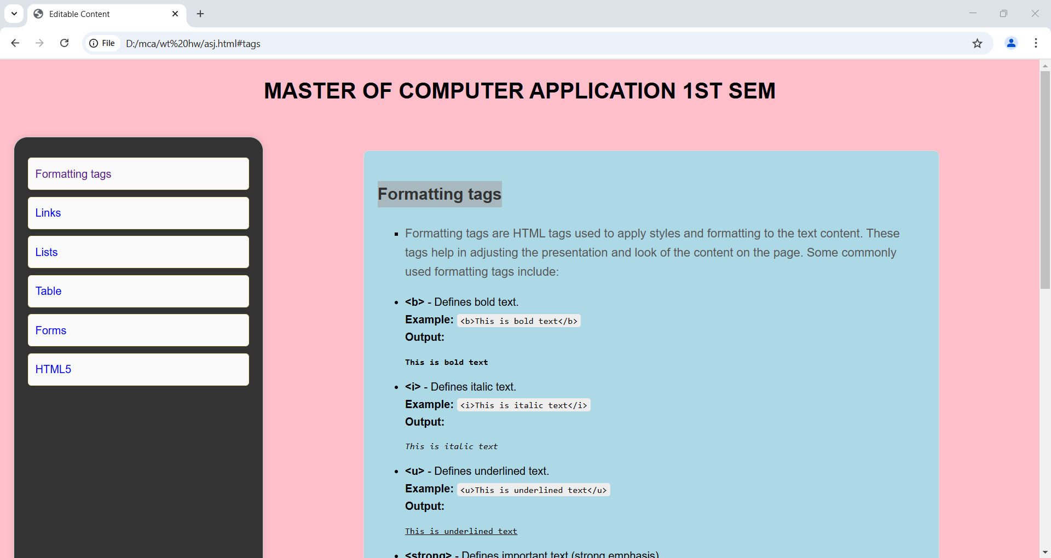

**2. Links Tag**

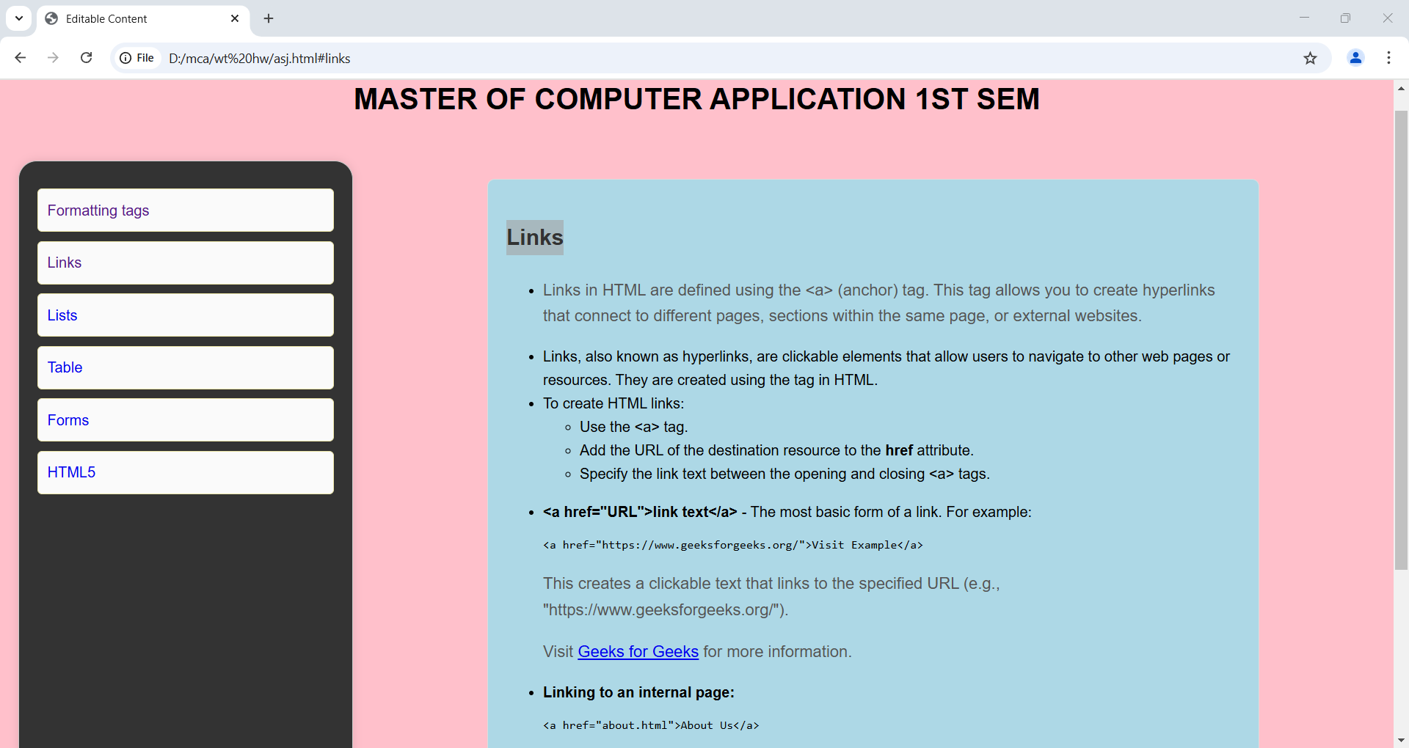

**3. Lists Tags**

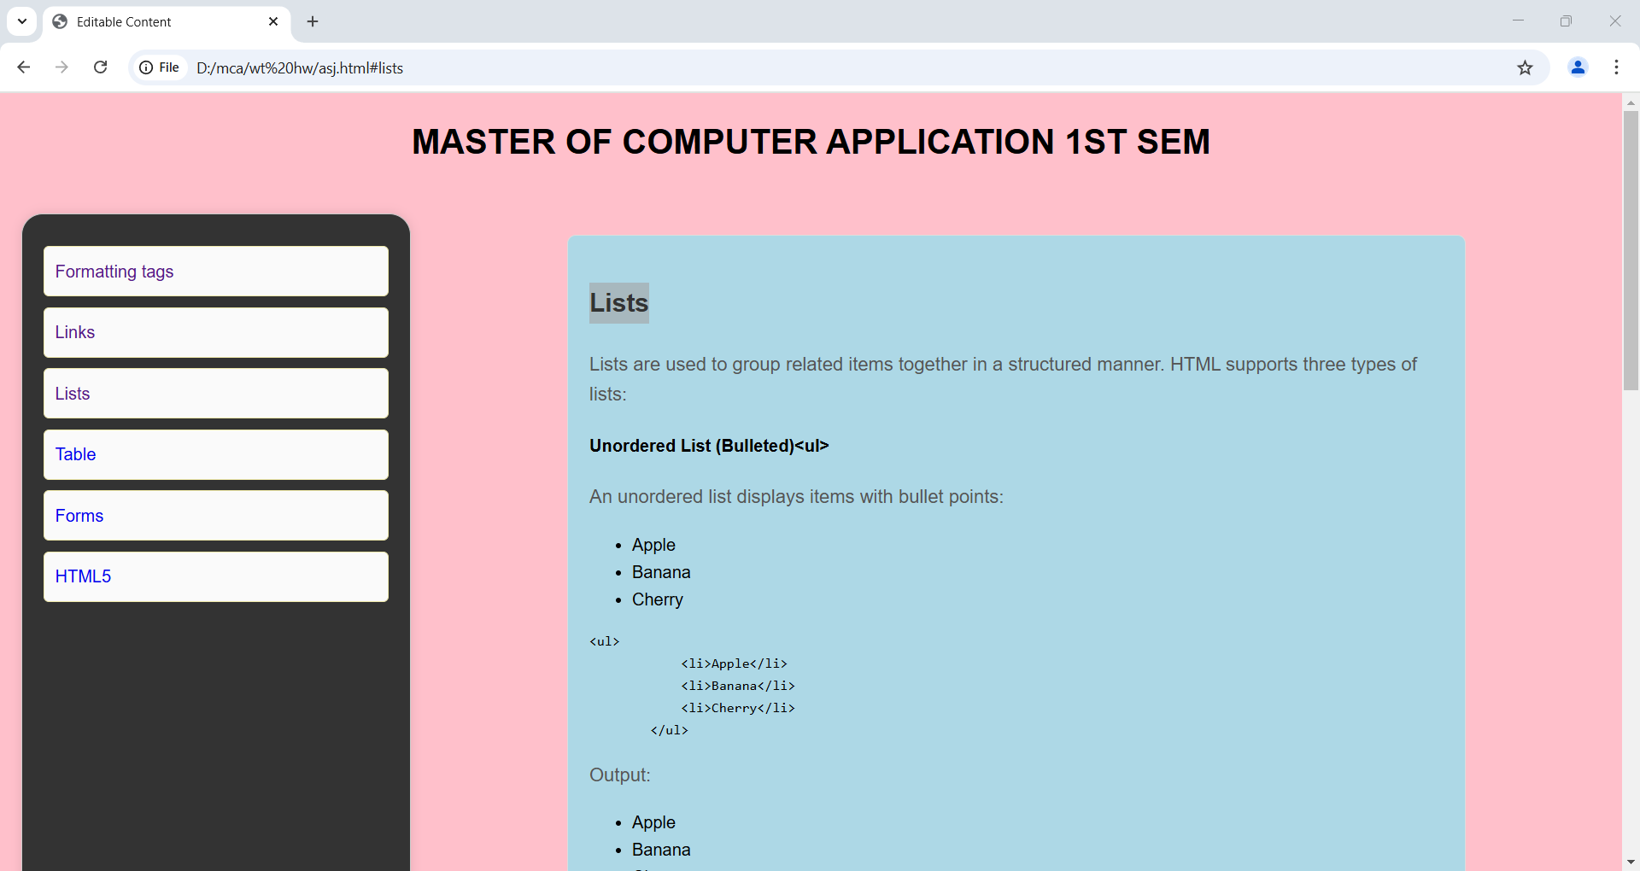

**4. Table with Rowspan and Colspan Tags**

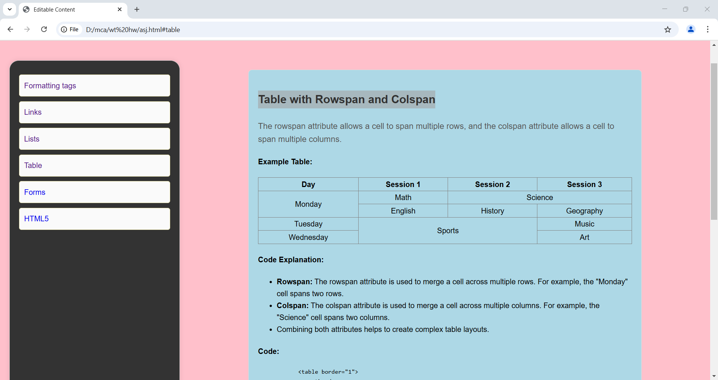

**5. Forms Tags**

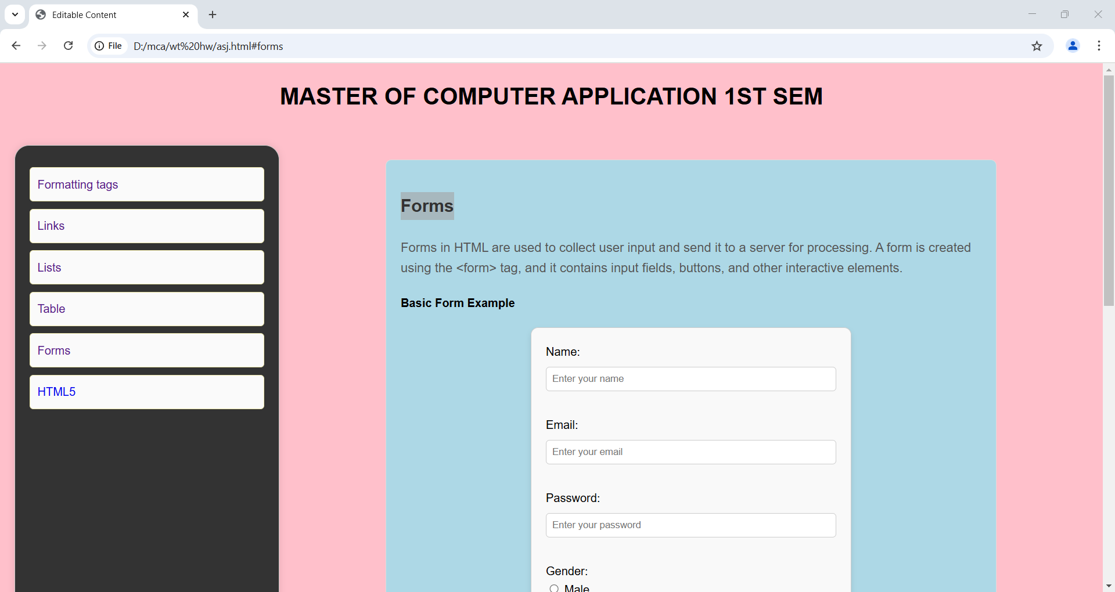

**6. HTML5 Tags**

