A
Project Report On

“Smart Door Lock”

SUBMITTED TO THE PAH SOLAPUR UNIVERSITY, SOLAPUR IN PARTIAL FULFILMENT OF THE REQUIREMENTS FOR THE AWARD OF
B.TECH IN
ELECTRONICS & TELECOMMUNICATIONAND ENGINEERING
SUBMITTED BY

Sunny Sajagane | 202301007073043
Ronit Permale | 202301007072908
Atharv karyakarte | 202301007072916
UNDER THE GUIDANCE OF

Prof. Amol Velapure


DEPARTMENT OF COMPUTER SCIENCE AND ENGINEERING MIT COLLEGE OF RAILWAY ENGINEERING & RESEARCH, BARSHI – 413 401
2025-2026
AFFILIATED TO

PAH SOLAPUR UNIVERSITY, SOLAPUR



CERTIFICATE
This is to certify that Project report entitled

“Smart Door Lock”

Submitted by

Sunny Sajagane | 202301007073043
Ronit Permale | 202301007072908
Atharv karyakarte | 202301007072916
is bonafide work carried out under the supervision of Prof.Amol Velapure by above student and it is submitted towards the fulfilment of the requirement of PAH Solapur University, Solapur for the award of the degree of Bachelor of Technology (Electronics & Telecommunication and Engineering) during academic year 2025-26.

Project Guide H.O.D. Principal
Prof. A.S.Velapure Prof. Deepali Mali Dr. Madhukar Lengare

External Viva:

Name of Examiners:- Signature with date
1)
2)

Place: Barshi
Date: / /

DECLARATION

I undersigned hereby declare that the Report for B.Tech. ENTC Dissertation entitled “Smart Door Lock” is done under the guidance of Prof. Amol Velapure. I am declaring that this dissertation work is carried out by me and it is original. I have not copied any material, which is useful to work or other reports that are submitted to the PAH Solapur University, Solapur.

Yours faithfully,
Sunny Sajagane | 202301007073043
Ronit Permale | 202301007072908
Atharv karyakarte | 202301007072916

Place: Barshi Date: / /

ACKNOWLEDGEMENT
I feel profound happiness in forwarding this dissertation report as an image of sincere efforts. The successful dissertation reflects my work effort of my guide in giving me good information.
My sincere thanks to my guide Prof. Amol Velapure. I give my special thanks to respected Prof. S.V Raut Project Coordinator for giving me his valuable support and cooperation to enable me to complete my project successfully.
Prof. Deepali.G.Mali H.O.D ENTC Department who has been a constant source of information and guiding star in achieving my goal & for giving valuable guidelines for completing this dissertation.
I express my deep sense of gratitude to Dr.Madhukar J. Lengare, our Principal, for his constant interest and encouragement throughout the completion of my project.
Goal makes us do work. Vision is more important than a goal which makes us do work in the best way to make work equally the best. I thank all ENTC department staff members for their support and guidance.
I am also thankful to my parents and friends for their extended support and valuable guidance.

Group Members

Sunny Sajagane | 202301007073043
Ronit Permale | 202301007072908
Atharv karyakarte | 202301007072916

ABSTRACT

Security is one of the most important concerns in homes, offices, laboratories, and restricted areas. Conventional locks can be duplicated or broken easily. To improve security, an advanced smart door locking system is developed using MFRC522 RFID Reader Module, OTP verification, ESP32 DevKit, GSM communication through SIM800L GSM/GPRS Module, and cloud notification using Blynk IoT.
The system uses dual authentication:
- RFID card authentication
- OTP verification through keypad
When an authorized RFID card is scanned, a random OTP is generated and sent to the user through:
- Blynk mobile app
- SMS via GSM module
The user enters the OTP using a keypad. If the OTP is correct, the SG90 Micro Servo Motor unlocks the door. If the card or OTP is invalid, the system activates a buzzer and sends an alert notification.
The system provides higher security than traditional locks and can be used in secure environments.

Contents
- INTRODUCTION 7
- LITERATURE REVIEW 8
- COMPONENTS USED 10
- BLOCK DIAGRAM 11
- WORKING PRINCIPLE 12
- CIRCUIT CONNECTIONS 39
- SOFTWARE USED 41
- FLOWCHART 42

- APPLICATIONS……………………………………………………………………43
- FUTURE SCOPE 44
- RESULT 45
- CONCLUSION…………………………………………………………………..46
- REFERENCES………………. . 47

CHAPTER 1 : INTRODUCTION

INTRODUCTION

In today’s fast-paced and technology-driven world, security has become a primary concern for individuals, organizations, and institutions. With increasing cases of theft, unauthorized access, and security breaches, there is a growing need for more advanced and reliable security solutions. Modern security systems are expected to provide not only strong protection but also features such as reliability, remote monitoring, and multi-layer authentication to ensure complete safety.

Traditional locking mechanisms, although widely used, have several limitations. Physical keys can be easily lost or stolen, locks can be broken using force, and duplicate keys can be made without the owner’s knowledge. These drawbacks make conventional locks less secure and less efficient in today’s environment, where smarter and more adaptive solutions are required.

To overcome these challenges, a Smart Door Lock System has been developed by integrating advanced technologies. This system uses RFID (Radio Frequency Identification) for quick and contactless user identification, ensuring that only authorized users can access the door. In addition, OTP (One-Time Password) verification adds an extra layer of security by requiring dynamic authentication, making unauthorized entry significantly more difficult.

Furthermore, the system incorporates GSM (Global System for Mobile Communication) as a backup communication method, ensuring continuous operation even in case of internet failure. IoT (Internet of Things) integration enables real-time notifications and remote monitoring, allowing users to track access activities and control the system from anywhere.

Overall, this smart door lock system enhances security by combining multiple authentication methods and communication technologies. It not only addresses the limitations of traditional locks but also provides a modern, efficient, and user-friendly solution for improved safety and monitoring

CHAPTER 2 : LITERATURE REVIEW

2.1 Literature Review On Smart Door Lock.

Recent advancements in smart security systems have focused on integrating IoT technologies with multiple authentication mechanisms to enhance reliability and user safety. Several researchers have explored different approaches to improve traditional locking systems by incorporating RFID, OTP, and remote monitoring features.

A study conducted by Firdaus (2025) presented an automatic sliding gate control system using RFID technology integrated with the Blynk application and an ESP32 microcontroller. The system enabled users to control and monitor gate operations remotely. Experimental results indicated that the system achieved successful gate operation with an average response time of approximately 4.12 seconds in small-scale implementations. This research highlighted the effectiveness of combining RFID with IoT platforms for real-time monitoring and control.

Similarly, Muhammad (2025) developed an IoT-based security system for sliding doors that utilized RFID as the primary authentication method along with Blynk for real-time notifications and OTP-based verification. The system demonstrated high reliability, achieving 100% accuracy in differentiating between authorized and unauthorized RFID cards within a reading range of 0 to 1 cm. This work emphasized the importance of combining identification and verification techniques to strengthen access control systems.

In another relevant project, the Wireless-Lock system by Ohm-ic (2024) implemented an OTP-based door locking mechanism using the ESP32 microcontroller. The system generated and delivered OTPs via email, which were then entered through a keypad for authentication. The results confirmed the feasibility and effectiveness of OTP-based access control, particularly in preventing unauthorized entry through dynamic password verification.

Overall, these studies demonstrate that integrating RFID technology with IoT platforms and OTP-based authentication significantly improves the security, efficiency, and usability of modern access control systems. However, many existing systems rely on a single communication method, which may reduce reliability during network failures. This limitation highlights the need for multi-layered systems incorporating backup communication methods such as GSM, along with IoT-based notifications, to ensure continuous operation and enhanced security.

2.2 Theoretical Framework.

The proposed smart door lock system is based on the concept of Dual-Factor Authentication (2FA), which enhances security by combining two different types of credentials. In this system, authentication is achieved through:
- Something you have → RFID card (physical identification)
- Something you know → OTP (One-Time Password)

This dual-layer approach ensures that even if one authentication factor is compromised, unauthorized access can still be prevented.

IoT Communication Protocols Used

To enable seamless communication and system functionality, the following protocols are utilized:
- Wi-Fi(IEEE802.11b/g/n):
Used for communication between the ESP32 microcontroller and the Blynk cloud platform, enabling real-time monitoring and control through mobile applications.
- GSM(2G/3GviaSIM800L):
Provides backup communication by sending OTPs and alerts through SMS, ensuring system reliability even when internet connectivity is unavailable.
- I2C(Inter-IntegratedCircuit)Protocol:
Used for efficient communication between the microcontroller and LCD display, minimizing wiring complexity and improving system performance

CHAPTER 3 : COMPONENTS USED

Hardware Components

Component | Quantity
ESP32 DevKit | 1
MFRC522 RFID Reader Module | 1
16x2 I2C LCD Display Module | 1
4x4 Keypad | 1
SG90 Micro Servo Motor | 1
Buzzer | 1
SIM800L GSM/GPRS Module | 1
LM2596 DC-DC Buck Converter Module | 1
RFID Card/Tag | 1
Power Supply | 1

CHAPTER 4: BLOCK DIAGRAM

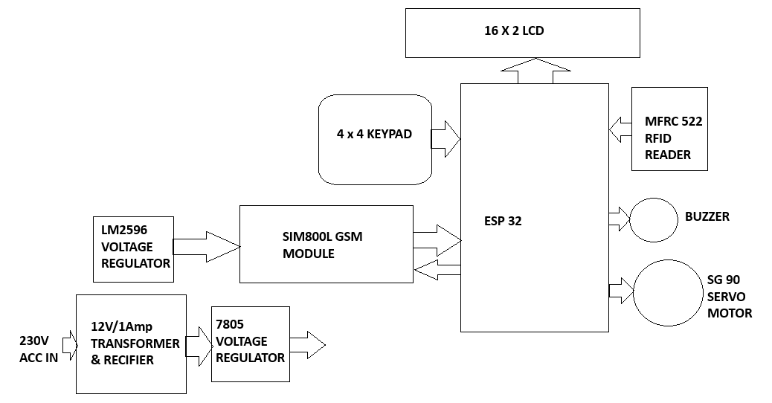

CHAPTER 5 : WORKING PRINCIPLE

Step 1 – Card Detection
The RFID reader detects the RFID card.
Step 2 – UID Verification
ESP32 compares scanned UID with stored UID.
Step 3 – OTP Generation
If card is valid:
- Random 4-digit OTP generated
Example:
4821
Step 4 – OTP Delivery
OTP sent through:
- Blynk notification
- GSM SMS
Step 5 – OTP Entry
User enters OTP using keypad.
Step 6 – Verification
ESP32 compares entered OTP with generated OTP.
Step 7 – Door Control
If correct:
- Servo rotates
- Door unlocks
Else:
- buzzer sounds
- alert sent

ESP32

First, to get started, what is an ESP32? The ESP32 is a series of chip microcontrollers developed by Espressif.
Why are they so popular? Mainly because of the following features:
- Low-cost: you can get an ESP32 starting at $6, which makes it easily accessible to the general public;
- Low-power: the ESP32 consumes very little power compared with other microcontrollers, and it supports low-power mode states like deep sleep to save power;
- Wi-Fi capabilities: the ESP32 can easily connect to a Wi-Fi network to connect to the internet (station mode), or create its own Wi-Fi wireless network (access point mode) so other devices can connect to it—this is essential for IoT and Home Automation projects—you can have multiple devices communicating with each other using their Wi-Fi capabilities;
- Bluetooth: the ESP32 supports Bluetooth classic and Bluetooth Low Energy (BLE)—which is useful for a wide variety of IoT applications;
- Dual-core: most ESP32 are dual-core— they come with 2 Xtensa 32-bit LX6 microprocessors: core 0 and core 1.
- Rich peripheral input/output interface—the ESP32 supports a wide variety of input (read data from the outside world) and output (to send commands/signals to the outside world) peripherals like capacitive touch, ADCs, DACs, UART, SPI, I2C, PWM, and much more.
- Compatible with the Arduino “programming language”: those that are already familiar with programming the Arduino board, you’ll be happy to know that they can program the ESP32 in the Arduino style.
- Compatible with MicroPython: you can program the ESP32 with MicroPython firmware, which is a re-implementation of Python 3 targeted for microcontrollers and embedded systems.

ESP32 Specifications
If you want to get a bit more technical and specific, you can take a look at the following detailed specifications of the ESP32 (source: http://esp32.net/)—for more details, check the datasheet):

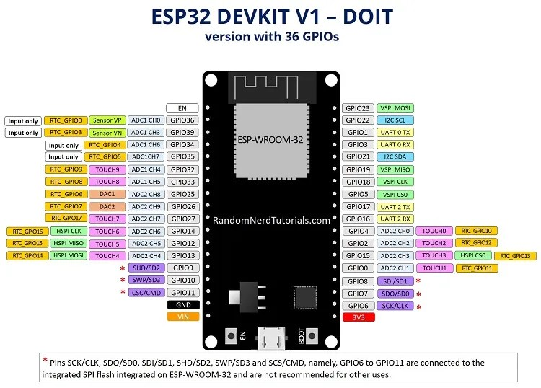

ESP32 module: ESP-WROOM-32
Power Pins
Usually, all boards come with power pins: 3V3, GND, and VIN. You can use these pins to power the board (if you’re not providing power through the USB port), or to get power for other peripherals (if you’re powering the board using the USB port).
General Purpose Input Output Pins (GPIOS)
Almost all GPIOs have a number assigned and that’s how you should refer to them—by their number.
With the ESP32 you can decide which pins are UART, I2C, or SPI – you just need to set that on the code. This is possible due to the ESP32 chip’s multiplexing feature that allows to assign multiple functions to the same pin.
- Wireless connectivityWiFi: 150.0 Mbps data rate with HT40
  - Bluetooth: BLE (Bluetooth Low Energy) and Bluetooth Classic
  - Processor: Tensilica Xtensa Dual-Core 32-bit LX6 microprocessor, running at 160 or 240 MHz
- Memory:
  - ROM: 448 KB (for booting and core functions)
  - SRAM: 520 KB (for data and instructions)
  - RTC fast SRAM: 8 KB (for data storage and main CPU during RTC Boot from the deep-sleep mode)
  - RTC slow SRAM: 8KB (for co-processor accessing during deep-sleep mode)
  - eFuse: 1 Kbit (of which 256 bits are used for the system (MAC address and chip configuration) and the remaining 768 bits are reserved for customer applications, including Flash-Encryption and Chip-ID)
  - Embedded flash: flash connected internally via IO16, IO17, SD_CMD, SD_CLK, SD_DATA_0 and SD_DATA_1 on ESP32-D2WD and ESP32-PICO-D4.
    - 0 MiB (ESP32-D0WDQ6, ESP32-D0WD, and ESP32-S0WD chips)
    - 2 MiB (ESP32-D2WD chip)
    - 4 MiB (ESP32-PICO-D4 SiP module)
- Low Power: ensures that you can still use ADC conversions, for example, during deep sleep.
- Peripheral Input/Output:
  - peripheral interface with DMA that includes capacitive touch
  - ADCs (Analog-to-Digital Converter)
  - DACs (Digital-to-Analog Converter)
  - I²C (Inter-Integrated Circuit)
  - UART (Universal Asynchronous Receiver/Transmitter)
  - SPI (Serial Peripheral Interface)
  - I²S (Integrated Interchip Sound)
  - RMII (Reduced Media-Independent Interface)
  - PWM (Pulse-Width Modulation)
- Security: hardware accelerators for AES and SSL/TLS

I2C LCD MODULE

I2C LCD Adapter
At the heart of the adapter is an 8-bit I/O expander chip – PCF8574. This chip converts the I2C data from an Arduino into the parallel data required for an LCD display.
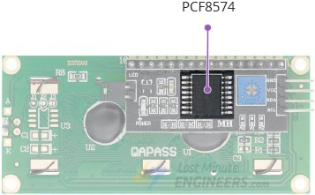

The board also includes a tiny trimpot for making precise adjustments to the display’s contrast.

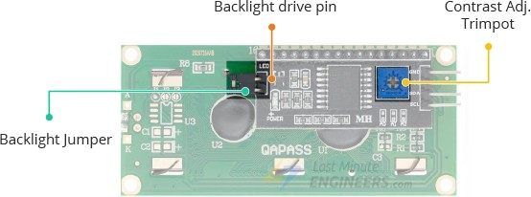

There is a jumper on the board that provides power to the backlight. To control the intensity of the backlight, you can remove the jumper and apply external voltage to the header pin labeled ‘LED’.

I2C Address of LCD
If you have multiple devices on the same I2C bus, you may need to set a different I2C address for the LCD adapter to avoid conflicting with another I2C device.
For this purpose, the adapter comes with three solder jumpers/pads (A0, A1, and A2). The address is set when a jumper is shorted with a blob of solder.
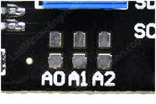
An important point to note here is that several companies, including Texas Instruments and NXP Semiconductors, manufacture the same PCF8574 chip. And the I2C address of your LCD depends on the chip manufacturer.

If your LCD has Texas Instruments’ PCF8574 chip:
According to the Texas Instruments’ datasheet, the three address selection bits (A0, A1, and A2) are located at the end of the 7-bit I2C address register.
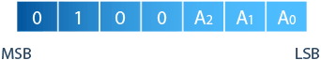

Because there are three address inputs that can take on two states, either HIGH or LOW, eight (2^3) different combinations (addresses) are possible.
All three address inputs are pulled HIGH using onboard pullups. This gives the PCF8574 a default I2C address of 0x27.
When you short a solder jumper, you pull that address input LOW. If you were to short all three jumpers, the address would be 0x20. So the range of all possible addresses spans from 0x20 to 0x27.
You can set a different I2C address, according to the table below.
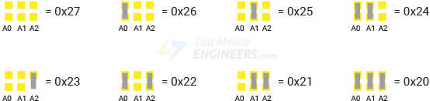

If your LCD has NXP’s PCF8574 chip:
According to the NXP Semiconductors’ datasheet, the three address selection bits (A0, A1, and A2) are located at the end of the 7-bit I2C address register. However, the remaining bits in the address register are different.
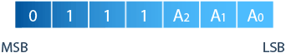
Because there are three address inputs that can take on two states, either HIGH or LOW, eight (2^3) different combinations (addresses) are possible.
All three address inputs are pulled HIGH using onboard pullups. This gives the PCF8574 a default I2C address of 0x3F.
When you short a solder jumper, you pull that address input LOW. If you were to short all three jumpers, the address would be 0x38. So the range of all possible addresses spans from 0x38 to 0x3F.
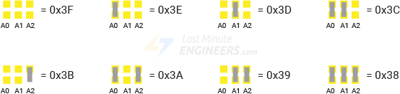
You can set a different I2C address, according to the table below.

So the I2C address of your LCD is most likely 0x27 or 0x3F. If you’re not sure what your LCD’s I2C address is, there’s an easy way to figure it out. You’ll learn about that later in this tutorial.

I2C LCD Display Pinout
The I2C LCD Display has only four pins. The following is the pinout:

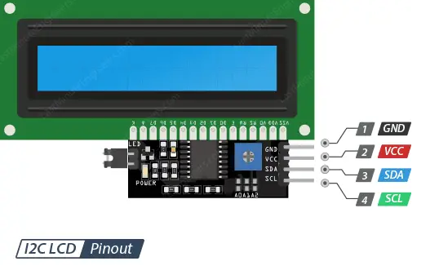
GND is a ground pin.
VCC is the power supply pin. Connect it to the 5V output of the Arduino or an external 5V power supply.
SDA is the I2C data pin.
SCL is the I2C clock pin.

RFID MFRC522 MODULE
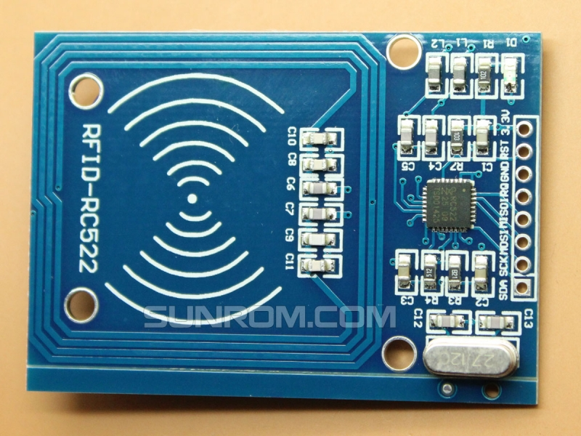
Mifare RC522 is the high integrated RFID card reader which works on non-contact 13.56mhz communication, is designed by NXP as a low power consumption, low cost and compact size read and write chip, is the best choice in the development of smart meters and portable hand-held devices.
MF RC522 use the advanced modulation system, fully integrated at 13.56MHz with all kinds of postive non-contact communication protocols. Support 14443A compatible answer signal. DSP deal with ISO14443A frames and error correction. Futhermore, it also supports rapid CRYPTO1 encryption to validate Mifare series products. MFRC522 support Mifare series higher speed non-contact communication, duplex communication speed up to 424 kb/s. As a new family member in 13.56MHz RFID family, MF RC522 has many similarities to MF RC5200 and MF RC530, and also has more new features.
This module can fit directly in hand held devices for mass production. Module use 3.3V power supply, and can communicate directly with any CPU board by connecting through SPI protocol, which ensure reliable work, good reading distance.

Specifications
- Voltage: DC 3.3V (Do not use 5V supply)
- Operating Current :13-26mA
- Idle Current :10-13mA
- Sleep current: <80uA
- Peak current: <30mA
- Operating Frequency: 13.56MHz
- Supported card types: mifare1 S50, mifare1 S70, mifare UltraLight, mifare Pro, mifare Desfire
- Dimensions: 40mm × 60mm
- Module Interface SPI Data Transfer Rate: Max. 10Mbit/s
- Card reading distance ：0～30mm （Mifare1 card）
- Integrated MF RC522
- 13.56MHz contactless communication card chip.
- The low-voltage, low-cost, small size of the non-contact card chip to read and write.
- Suitable for Smart meters and portable handheld devices.
- Advanced modulation and demodulation concept completely integrated into all types of 13.56MHz passive contactless communication methods and protocols.
- 14443A compatible transponder signals.
- ISO14443A frames and error detection.
- Supports rapid CRYPTO1 encryption algorithm, terminology validation MIFARE products.
- MFRC522 support MIFARE series of high-speed non-contact communication, two-way data transmission rate up to 424kbit/s.
- Low cost, and ideal for user equipment development.
- The reader and RF card terminal design meet advanced applications development and production needs.
- Can be directly loaded into the various reader molds, very convenient.

BUZZER

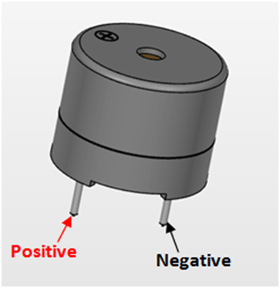
Buzzer Pin Configuration
Pin Number | Pin Name | Description
1 | Positive | Identified by (+) symbol or longer terminal lead. Can be powered by 6V DC
2 | Negative | Identified by short terminal lead. Typically connected to the ground of the circuit

Buzzer Features and Specifications
- Rated Voltage: 6V DC
- Operating Voltage: 4-8V DC
- Rated current: <30mA
- Sound Type: Continuous Beep
- Resonant Frequency: ~2300 Hz
- Small and neat sealed package
- Breadboard and Perf board friendly

What is a Servo Motor?
A servo motor is a type of motor that can rotate with great precision. Normally this type of motor consists of a control circuit that provides feedback on the current position of the motor shaft, this feedback allows the servo motors to rotate with great precision. If you want to rotate an object at some specific angles or distance, then you use a servo motor. It is just made up of a simple motor which runs through a servo mechanism. If motor is powered by a DC power supply then it is called DC servo motor, and if it is AC-powered motor then it is called AC servo motor. For this tutorial, we will be discussing only about the DC servo motor working. Apart from these major classifications, there are many other types of servo motors based on the type of gear arrangement and operating characteristics. A servo motor usually comes with a gear arrangement that allows us to get a very high torque servo motor in small and lightweight packages. Due to these features, they are being used in many applications like toy car, RC helicopters and planes, Robotics, etc.
Servo motors are rated in kg/cm (kilogram per centimeter) most hobby servo motors are rated at 3kg/cm or 6kg/cm or 12kg/cm. This kg/cm tells you how much weight your servo motor can lift at a particular distance. For example: A 6kg/cm Servo motor should be able to lift 6kg if the load is suspended 1cm away from the motors shaft, the greater the distance the lesser the weight carrying capacity. The position of a servo motor is decided by electrical pulse and its circuitry is placed beside the motor.

Servo Motor Working Mechanism
It consists of three parts:
- Controlled device
- Output sensor
- Feedback system
It is a closed-loop system where it uses a positive feedback system to control motion and the final position of the shaft. Here the device is controlled by a feedback signal generated by comparing output signal and reference input signal.
Here reference input signal is compared to the reference output signal and the third signal is produced by the feedback system. And this third signal acts as an input signal to the control the device. This signal is present as long as the feedback signal is generated or there is a difference between the reference input signal and reference output signal. So the main task of servomechanism is to maintain the output of a system at the desired value at presence of noises.

Servo Motor Working Principle
A servo consists of a Motor (DC or AC), a potentiometer, gear assembly, and a controlling circuit. First of all, we use gear assembly to reduce RPM and to increase torque of the motor. Say at initial position of servo motor shaft, the position of the potentiometer knob is such that there is no electrical signal generated at the output port of the potentiometer. Now an electrical signal is given to another input terminal of the error detector amplifier. Now the difference between these two signals, one comes from the potentiometer and another comes from other sources, will be processed in a feedback mechanism and output will be provided in terms of error signal. This error signal acts as the input for motor and motor starts rotating. Now motor shaft is connected with the potentiometer and as the motor rotates so the potentiometer and it will generate a signal. So as the potentiometer’s angular position changes, its output feedback signal changes.

4X4 KEYPAD
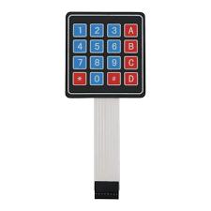
The 4×4 keypad module is an input device, used to provide input value within a project. This module includes a total of 16 keys which provide 16 input values. These matrix keypad modules are made with flexible membranes & thin material. The 16 keys in this module are arranged in a matrix of columns & rows. All these are linked to each other through a conductive trace. Generally, there is no link in this keypad between rows & columns. Once we push any key in the matrix keypad, then a row & a column in this keypad will make contact, or else; there is no link in the matrix keypad between rows & columns.
Specifications:
The specifications of the 4×4 keypad module include the following.
- The type of product is a 4 X 4 keypad module.
- The rating of voltage Max is 24V DC.
- The rating of the current Max is 30 mA.
- The operating range of temperature is 0 to 50 °Centigrade or 32 to 122 °F.
- It includes 8 pins.
- The dimension of the keypad is 6.9 cm X 7.9 cm.
- The dimension of the cable is 2.0 cm X 8.8 cm.
- This matrix keypad design is Ultra-thin.
- The key layout is 4 rows x 4 columns.
- The type of key is the membrane.

When a button is pressed in the matrix keypad, the microcontroller reads these lines like the following.
- The microcontroller first sets all the row & column lines in the keypad to input.
- After that, this microcontroller will set a row to LOW.
- It verifies the one-column line at a time.
- If the connection of the column is HIGH, then the row button has not been pushed.
- If this connection goes LOW, then the microcontroller identifies which row on the matrix is set to LOW & which column line was noticed to LOW once verified.
- Lastly, it recognizes which button on the keypad was pushed and that corresponds to the detected column & row.

GSM/GPRS Modem

GSM/GPRS Modem
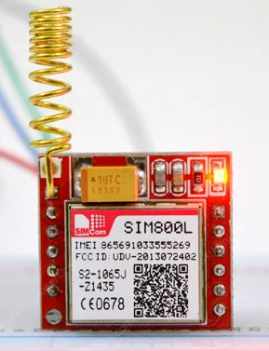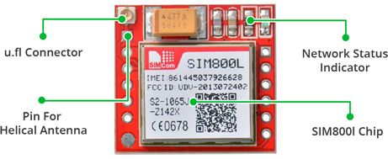

This GSM modem is a highly flexible plug and play quad band GSM modem for direct and easy
integration to RS232. Supports features like Voice, Data/Fax, SMS,GPRS and integrated TCP/IP
stack. The SIM800L GSM/GPRS module is a miniature GSM modem that can be used in a variety of IoT projects. You can use this module to do almost anything a normal cell phone can do, such as sending SMS messages, making phone calls, connecting to the Internet via GPRS, and much more.
Features
• Quad Band GSM/GPRS
850/900/1800/1900 Mhz
• GPRS multi-slot class 10/8
• GPRS Mobile station class B
• Compliant to GSM Phase 2/2+
o Class 4 (2W@850/900Mhz)
o Class 1(1W@1800/1900Mhz)
• Control via AT commands(GSM 07.07,
07.05 and enhanced AT commands)
• Operation Temperature(-20 deg C to
+55 deg C)
Specifications for Voice
• Tricodec
o Half rate(HR)
o Full rate(FR)
o Enchanced Full rate(EFR)
• Hands-free operation(Echo suppression)
Specifications for Fax
• Group 3, class 1
Specifications for data
• GPRS class 10: max 85.6 kbps(downlink)
• PBCCH support
• Coding schemes CS 1,2,3,4
• CSD upto 14.4 kbps
• USSD
• Non transparent mode
• PPP-Stack

Specifications for SMS
• Point-to-point MO and MT
• SMS cell broadcast
• Text and PDU mode
Power Supply
• Use AC – DC Power Adaptor with following ratings
• DC Voltage : 12V
• DC Current : 1A
• Polarity : Centre +ve & Outside –ve
• Current Consumption in normal operation 250mA, can rise up to 1Amp while transmission.
Interfaces
• RS-232 through D-TYPE 9 pin connector, Serial port baud rate adjustable 1200 to115200
bps (9600 default)
• Stereo connector for MIC & SPK
• Power supply through DC socket
• SMA antenna connector
• Push switch type SIM holder
• LED status of GSM / GPRS module
Getting Started
• Insert SIM card: Press the yellow pin to remove the tray from the SIM cardholder. After
properly fixing the SIM card in the tray, insert the tray in the slot provided.
• Connect Antenna: Screw the RF antenna on the RF cable output provided.
• If voice call is needed, connect the mic and speaker to stereo sockets.
• Connect RS232 Cable: (Cable provided for RS232 communication) Default baud rate is
9600 with 8-N-1, no hardware handshaking. Cable provided has pins 7 and 8 shorted that will
set to no hardware handshaking. In you need hardware handshaking the pins 7-8 can be
taken for signaling.
o Pin 2 is RS232 level TX out
o Pin 3 is RS232 level RX in
o Pin 5 is Ground
o Pin 7 RTS in (shorted to pin 8 in cable for no hardware handshaking)
o Pin 8 CTS out (shorted to pin 7 in cable for no hardware handshaking)
• Connect the power Supply (9-12V) to the power jack. Polarity should be Center +ve and
outer –ve DC jack.
• Network Led indicating various status of GSM module eg. Power on, network registration &
GPRS connectivity.
• After the Modem registers the network, led will blink in step of 3 seconds. At this stage you
can start using Modem for your application.
• AT commands set section is covered in following document
Examples for send and receive SMS
For sending SMS in text Mode:
AT+CMGF=1 press enter
AT+CMGS=”mobile number” press enter
Once The AT commands is given’ >’ prompt will be displayed on the screen.
Type the message to sent via SMS. After this, press ctrl+Z to send the SMS.
If the SMS sending is successful, “ok” will be displayed along with the message number.
For reading SMS in the text mode:
AT+CMGF=1 Press enter
AT+CMGR= no.
Number (no.) is the message index number stored in the sim card. For new SMS, URC will be received
on the screen as +CMTI: SM ‘no’. Use this number in the AT+CMGR number to read the message.

TRANSFORMER

Transformer is a major class of coils having two or more windings usually wrapped around a common core made from laminated iron sheets. It has two cols named primary and secondary. If the current flowing through primary is fluctuating, then a current will be inducted into the secondary winding. A steady current will not be transferred from one coil to other coil.
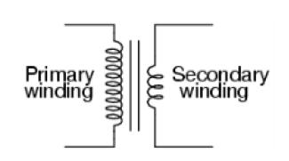
Transformers are of two types:
1.Step up transformer
2.Step down transformer
In the power supply we use step down transformer. We apply 220V AC on the primary of step down transformer. This transformer step down this voltages to 6V AC. We Give 6V AC to rectifier circuit, which convert it to 5V DC.
DIODE:
The diode is a p-n junction device. Diode is the component used to control the flow of the current in any one direction. The diode widely works in forward bias.
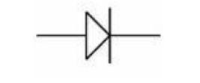
Diode When the current flows from the P to N direction. Then it is in forward bias. The Zener diode is used in reverse bias function i.e. N to P direction. Visually the identification of the diode`s terminal can be done by identifying he silver/black line. The silver/black line is the negative terminal (cathode) and the other terminal is the positive terminal (cathode).
APPLICATION
•Diodes: Rectification, free-wheeling, etc
•Zener diode: Voltage control, regulator etc.
•Tunnel diode: Control the current flow, snobbier circuit, etc

RESISTORS
The flow of charge through any material encounters an opposing force similar in many respects to mechanical friction .this opposing force is called resistance of the material .in some electric circuit resistance is deliberately introduced in form of resistor. Resistor used fall in three categories , only two of which are color coded which are metal film and carbon film resistor .the third category is the wire wound type ,where value are generally printed on the vitreous paint finish of the component. Resistors are in ohms and are represented in Greek letter omega, looks as an upturned horseshoe. Most electronic circuit require resistors to make them work properly and it is obliviously important to find out something about the different types of resistors available. Resistance is measured in ohms, the symbol for ohm is an omega ohm. 1 ohm is quite small for electronics so resistances are often given in kohm and Mohm. Resistors used in electronics can have resistances as low as 0.1 ohm or as high as 10 Mohm.
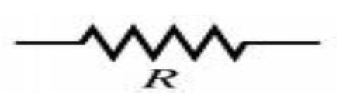
FUNCTION
Resistor restrict the flow of electric current, for example a resistor is placed in series with a light-emitting diode(LED) to limit the current passing through the LED.
TYPES OF RESISTORS
FIXED VALUE RESISTORS
It includes two types of resistors as carbon film and metal film .These two types are explained under
1. CARBON FILM RESISTORS
During manufacture, at in film of carbon is deposited onto a small ceramic rod. The resistive coating is spiraled away in an automatic machine until the resistance between there two ends of the rods is as close as possible to the correct value. Metal leads and end caps are added, the resistors is covered with an insulating coating and finally painted with colored bands to indicate the resistor value
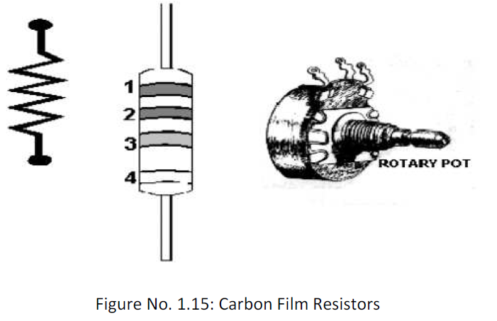

Another example for a Carbon 22000 Ohms or 22 Kilo-Ohms also known as 22K at 5% tolerance: Band 1 = Red, 1st digit Band 2 = Red, 2nd digit Band 3 = Orange, 3rd digit, multiply with zeros, in this case 3 zero's Band 4 = Gold, Tolerance, 5%
METAL FILM RESISTORS
Metal film and metal oxides resistors are made in a similar way, but can be made more accurately to within ±2% or ±1% of their nominal vale there are some difference in performance between these resistor types, but none which affects their use in simple circuit.
WIRE WOUND RESISTOR
A wire wound resistor is made of metal resistance wire, and because of this, they can be manufactured to precise values. Also, high wattage resistors can be made by using a thick wire material. Wire wound resistors cannot be used for high frequency circuits. Coils are used in high frequency circuit. Wire wound resistors in a ceramic case, strengthened with special cement. They have very high power rating, from 1 or 2 watts to dozens of watts. These resistors can become extremely hot when used for high power application, and this must be taken into account when designing the circuit.
TESTING
Resistors are checked with an ohm meter/millimeter. For a defective resistor the ohm-meter shows infinite high reading.

CAPACITORS
In a way, a capacitor is a little like a battery. Although they work in completely different ways, capacitors and batteries both store electrical energy. If you have read How Batteries Work , then you know that a battery has two terminals. Inside the battery, chemical reactions produce electrons on one terminal and absorb electrons at the other terminal.
BASIC
Like a battery, a capacitor has two terminals. Inside the capacitor, the terminals connect to two metal plates separated by a dielectric. The dielectric can be air, paper, plastic or anything else that does not conduct electricity and keeps the plates from touching each other. You can easily make a capacitor from two pieces of aluminum foil and a piece of paper. It won't be a particularly good capacitor in terms of its storage capacity, but it will work. In an electronic circuit, a capacitor is shown like this:
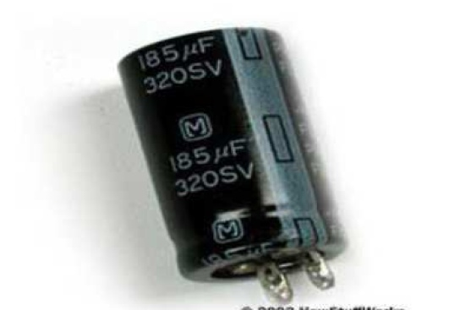

Figure No. 1.17: Symbol of Capacitor
When you connect a capacitor to a battery, here’s what happens:
•The plate on the capacitor that attaches to the negative terminal of the battery accepts electrons that the battery is producing.
•The plate on the capacitor that attaches to the positive terminal of the battery loses electrons to the battery.
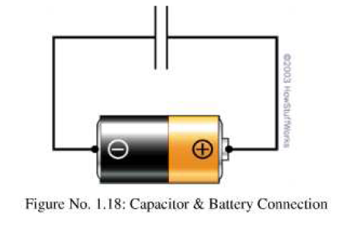
TESTING
To test the capacitors, either analog meters or specia l digital meters with the specified function are used. The non-electrolyte capacitor can be tested by using the digital meter. Multi – meter mode : Continuity Positive probe : One end Negative probe : Second end Display : `0`(beep sound occur) `OL` Result : Faulty OK

LED
LED falls within the family of P-N junction devices. The light emitting diode (LED) is a diode that will give off visible light when it is energized. In any forward biased P-N junction there is, with in the structure and primarily close to the junction, a recombination of hole and electrons. This recombination requires that the energy possessed by the unbound free electron be transferred to another state. The process of giving off light by applying an electrical source is called electroluminescence.
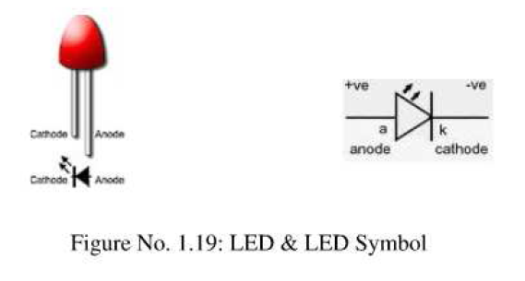
LED is a component used for indication. All the functions being carried out are displayed by led .The LED is diode which glows when the current is being flown through it in forward bias condition. The LEDs are available in the round shell and also in the flat shells. The positive leg is longer than negative leg.
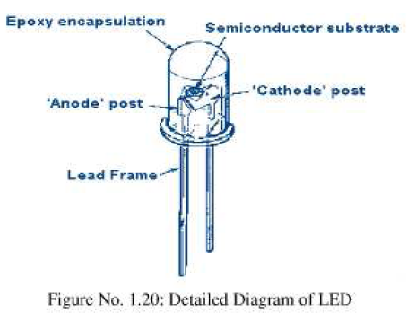

BLYNK APP
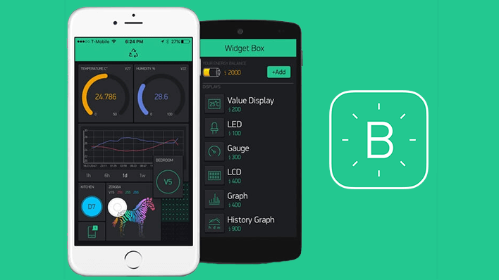

What is Blynk? A quick review.

With Blynk, you can create smartphone applications that allow you to easily interact with microcontrollers or even full computers such as the Raspberry Pi.

Read this article to learn about the components that make up the Blynk platform.

With Blynk, you can create smartphone applications that allow you to easily interact with microcontrollers or even full computers such as the Raspberry Pi.
The main focus of the Blynk platform is to make it super-easy to develop the mobile phone application. As you will see in this course, developing a mobile app that can talk to your Arduino is as easy as dragging a widget and configuring a pin.
With Blynk, you can control an LED or a motor from your mobile phone with literally zero programming. This is actually the first experiment that I will demonstrate in this course.
But don’t let this simplicity make you think that Blynk is only useful for trivial applications. Blynk is a robust and scalable tool that is used by hobbyists and the industry alike.
You can use it to monitor the soil humidity of your vegetable garden and turn on the water, or open up your garage door, with your phone.
You can also use it to control smart furniture that can learn from your routines, or embed IoT and AI to traditional industrial products such as a boiler, or for improving the integrity and safety of oilfields.
Blynk is free to use for personal use and prototyping. Their business model generates profits by selling subscriptions to businesses that want to publish Blynk-powered apps for their hardware products or services.
The Blynk app is is really an app editor.
It allows you to create one or more projects.
Each project can contain graphical widgets, like virtual LEDs, buttons, value displays and even a text terminal, and can interact with one or more devices. With the help of the Blynk library, it is possible to control Arduino or ESP32 pins directly from your phone, without having to write any code at all.
It is also possible to share a project with friends and even customers so that they can access the connected devices but not be able to modify the project. Imagine a scenario where you build a smartphone application where you can control lights, window blinds and room temperature from your phone. You can share the project with other family members so that they can also access the functionality.
Unlike IoT platform such as IFTTT, Twillio, and even Adafruit IO, you can host a private instance of the full Blynk server and connect your smartphone Blynk app to it.
The Blynk Cloud server is an excellent choice for most projects, as it is always there, ready to use. We will use the Cloud server in the first few experiments in this course to help you get started with minimal effort.
However, as you will see, the Cloud Blynk server has imposed limitations. Some limitations are due to the topology of the server: depending on your geographical location, the server may be in a different continent, which makes communications between the app, the devices and the server slow due to the amount of time it takes packets to travel across the Internet.
Another imposed limitation is that in the Cloud server, you can only use a small number of widgets. Blynk is using the concept of “energy” to implement a pricing system for its widgets. In the Cloud server you may start a new project with 1000 energy units. An LED widget may cost you 200 units, leaving 800 units for other widgets.
On a private server, you can set your own energy limits. You can configure your server to allocate 100,000 energy units to new users. It’s totally up to you.
Of course, you can purchase additional energy units to spent on the Cloud Blynk server, and this is a legitimate consideration especially if the users of your Blynk project are distributed around the world (therefore latency is not a big issue).
However, a private Blynk server gives you additional benefits:
- Essentially unlimited energy units, so that you can build any Blynk application you can think of.
- Minimal latency, which is useful when your application is used in a limited geographic area and responsiveness is important.
- Total control of your data. You can keep your own backups of your Private server, migrate your server to a new host, implement whichever security mechanisms you wish, and finely control your users.

CHAPTER 6 – CIRCUIT CONNECTIONS
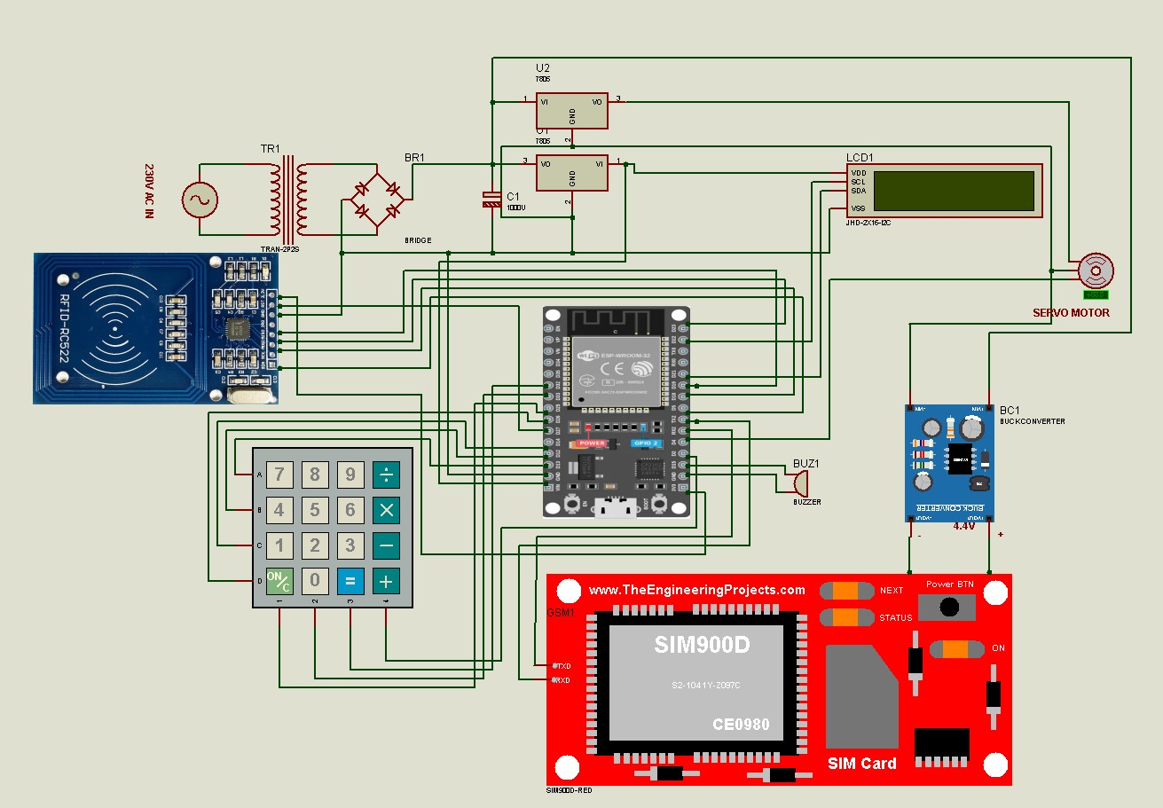

RFID Connections
RFID | ESP32
SDA | GPIO 5
SCK | GPIO 18
MOSI | GPIO 23
MISO | GPIO 19
RST | GPIO 27

LCD Connections
LCD | ESP32
SDA | GPIO 21
SCL | GPIO 22

Keypad Connections
Keypad | ESP32
R1 | GPIO 13
R2 | GPIO 12
R3 | GPIO 14
R4 | GPIO 26
C1 | GPIO 25
C2 | GPIO 32
C3 | GPIO 33
C4 | GPIO 2

Servo
Servo | ESP32
Signal | GPIO 4

Buzzer
Buzzer | ESP32
+ | GPIO 15

GSM
SIM800L | ESP32
TX | GPIO 16
RX | GPIO 17

CHAPTER 7 – SOFTWARE USED
Software used:
Software | Purpose
Arduino IDE | Programming
Blynk IoT | Notification
Serial Monitor | Debugging

CHAPTER 8 – FLOWCHART

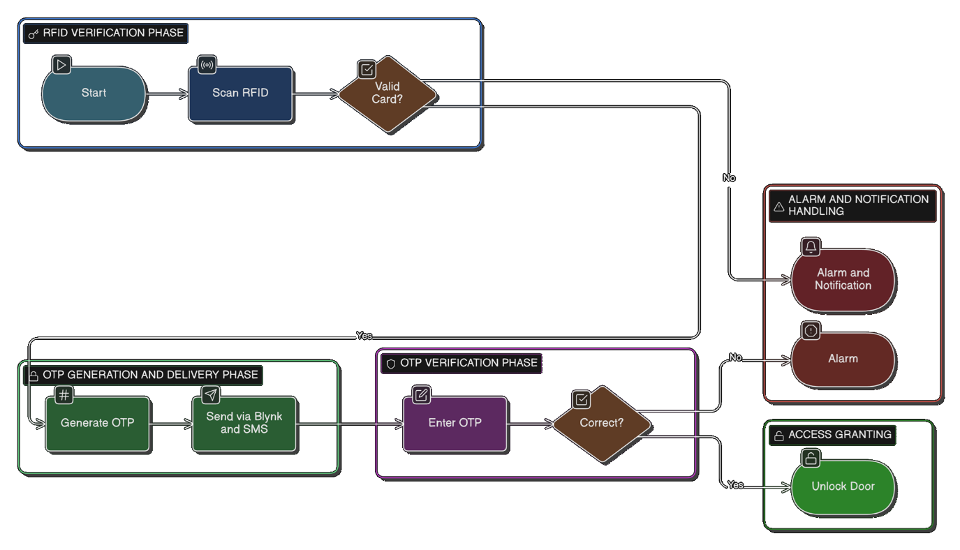

CHAPTER 9 – APPLICATIONS
Applications:
- Home security
- Office access
- Laboratory security
- Server rooms
- Bank lockers
- Smart buildings
FUTURE ENHANCEMENTS
10.1 Proposed Improvements
- Biometric Integration: Add fingerprint sensor for third authentication factor
- Cloud Logging: Implement Firebase or AWS IoT Core for permanent access logs
- Multiple Servo Control: Expand to control multiple doors/zones
- Mobile App Development: Create dedicated Flutter app replacing Blynk
- Facial Recognition: Integrate ESP32-CAM module for visual verification
- Battery Backup: Add 12V rechargeable battery and charging circuit
10.2 Scalability Options
- Database Support: External MySQL database via PHP API for unlimited card storage
- Network Expansion: Add Ethernet module for fixed installations
- Time-based Scheduling: Restrict access to specific time windows

CHAPTER 10 – FUTURE SCOPE
Future improvements:
- Face recognition
- Fingerprint sensor
- Camera image capture
- Cloud data logging
- Mobile app unlock
- Voice control

CHAPTER 11 – RESULT
The developed system successfully:
- reads RFID
- generates OTP
- sends OTP
- verifies keypad input
- opens door
- sends alerts
The system improves security significantly.

CHAPTER 12 – CONCLUSION
The project successfully demonstrates a secure IoT-based door locking system using RFID and OTP authentication. By combining:
- RFID
- GSM
- Blynk
- keypad
- servo
the system provides reliable and intelligent security for modern access control.

REFERENCES
- Espressif Systems ESP32 datasheet
- NXP Semiconductors MFRC522 datasheet
- Blynk Blynk documentation
- SIMCom SIM800L datasheet
- Firdaus, T. F. (2025). Prototipe Sistem Kontrol dan Notifikasi pada Gerbang Geser Menggunakan RFID dan Aplikasi Blynk Berbasis Mikrokontroler ESP32. Skripsi thesis, Universitas Pembangunan Nasional Veteran Jakarta.
- Ohm-ic. (2024). Wireless-Lock: OTP Based Door locking system with ESP32. GitHub Repository.
- GRBL Official Documentation. (2024). Power Supply Guidelines for ESP32 Control Boards.
- Abrar7789. (2025). Cold Storage Monitoring System using ESP32 and Blynk. GitHub Repository.
- Muhammad, F. I. (2025). Perancangan dan Implementasi Sistem Keamanan pada Pintu Geser Menggunakan RFID dan Aplikasi Blynk. Skripsi thesis, Universitas Sumatera Utara.
- CSDN Blog. (2025). AI智能棋盘应用LM2596完成电源降压设计.
- Prezi Presentation. (n.d.). Smart Digital Code Lock System using ESP32.

