
MAHARASHTRA STATE BOARD OF TECHNICAL EDUCATION, MUMBAI
A Project Report
On
”Singly Link List”
DIPLOMA
In
Computer Engineering
Submitted by

MR. SHRIDHAR RAGHUNATH DAVARE
` MR.TUSHAR RAVINDRA KURANE
MS.RUTUJA ANIL PATIL
MS. SAMIKSHA VISHNU PATIL
MR.ASHITOSH NAGOJI WANGANEKAR


UNDER GUIDANCE OF
MS.K.G.KURALE
DEPARTMENT OF COMPUTER
SANT GAJANAN MAHARAJ RURAL POLTECHNIC,
MAHAGAON
ACADEMIC YEAR 2021-2022



SANT GAJANAN MAHARAJ RURAL HOSPITAL &RESEARCH CENTER, MAHAGAON
“SANT GAJANAN MAHARAJ RURAL POLYTECHNIC”
A/P –MAHAGAON, SITE –CHINCHEWADI, TAL-GADHINGLAJ, DIST-KOLHAPUR
CERTIFICATE
This is to that the following students of third Semester of Diploma in Computer of Institute SANT GAJANAN MAHARAJ RURAL POLYTECHNIC, MAHAGAON-416503.(CODE-0965) has completed Micro project "Singly link list” in subject “data structure”subject code:-22317 of during the academic year 2021to 2022.
Roll No. | Student name | Enrollment no | Seat No
63 | MR. SHRIDHAR RAGHUNATH DAVARE | 2109650016 | 269248
43 | MS.RUTUJA ANIL PATIL | 2009650043 | 141222
58 | MR.TUSHAR RAVINDRA KURANE | 2009650058 | 141237
65 | MS. SAMIKSHA VISHNU PATIL | 2109650017 | 269249
68 | MR.ASHITOSH NAGOJI WANGANEKAR | 2109650015 | 269247

DATE:
PLACE: Mahagaon

MS.K.G.KURALE MRS.R.S.PATIL Dr.SANJAY DABHOLE

(Project Guide) (Head of Department) (Principal)

INDEX

SR.no | Contents | Page.no
1. | Introduction
2. | Search for a node in singly link list
3. | Add a node to singly link list
4. | Remove a node from singly link list
5. | Deletion of node from singly link list
6. | example
7. | Advantages and disavdvantages of singly link
8. | Program of singly link list
9. | conclusion

Introduction:

Singly linked list is a type of linked list that is unidirectional, that is, it can be traversed in only one direction from head to the last node (tail). Each element in a linked list is called a node. A single node contains data and a pointer to the next node which helps in maintaining the structure of the list.

The first node is called the head; it points to the first node of the list and helps us access every other element in the list. The last node, also sometimes called the tail, points to NULL which helps us in determining when the list ends.

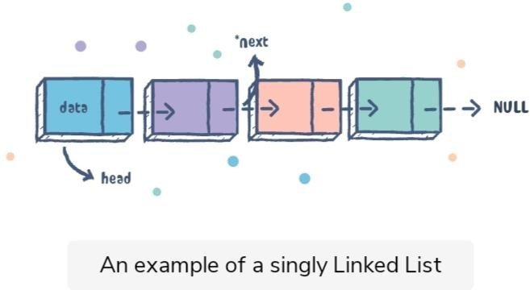
Example:-
Search for a node in the singly link list:-

You can determine and retrieve a specific node either from the front, the end, or anywhere in the list.

The worst case Time Complexity for retrieving a node from anywhere in the list is O(n).

Example:-

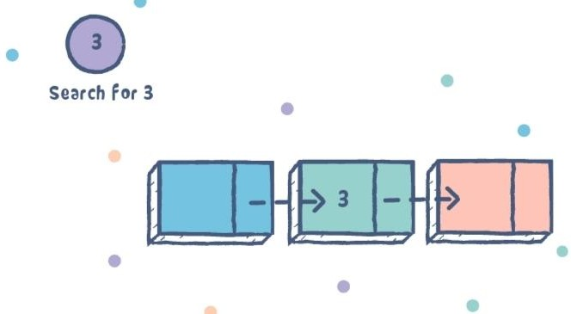

Add a node to singly link list:-

You can add a node at the front, the end or anywhere in the linked list.

The worst case Time Complexity for performing these operations is as follows:

Add item to the front of the list: O(1)
Add item to the end of the list: O(n)
Add item to anywhere in the list: O(n)

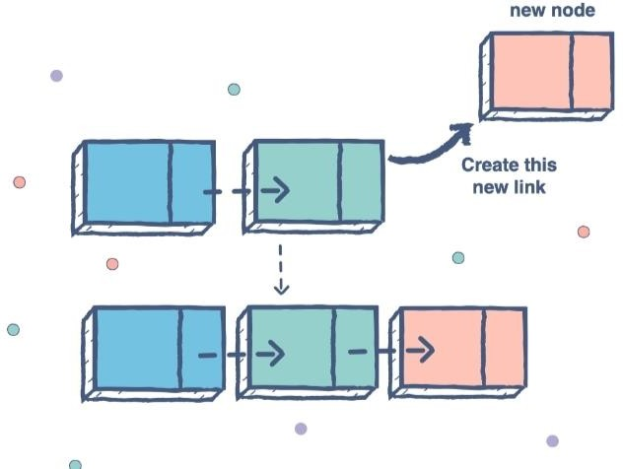

Remove a node from a singly link list:-

You can remove a node either from the front, the end or from anywhere in the list.

The worst case Time Complexity for performing this operation is as follows:

Remove item from the front of the list: O(1)
Remove item from the end of the list: O(n)
Remove item from anywhere in the list: O(n)

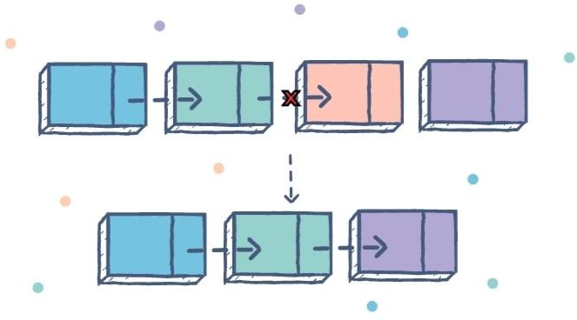

The Deletion of a node from a singly linked list can be performed at different positions. Based on the position of the node being deleted, the operation is categorized into the following categories.

S.N | Operation | Description
1 | Deletion at beginning | It involves deletion of a node from the beginning of the list. This is the simplest operation among all. It just need a few adjustments in the node pointers.
2 | Deletion at the end of the end of the list | It involves deleting the last node of the list. The list can either be empty or full. Different logic is implemented for the different scenarios.
3 | Deletion after specified node | It involves deleting the node after the specified node in the list. We need to skip the desired number of nodes to reach the node after which the node will be deleted. This requires traversing through the list.
4 | Traversing | In traversing we simply visit each node of the list at least ones in order to perform some specific operation on it. For example, Printing data part of each node present in the list.
5 | Searching | In searching. We match each element of the list with the given element is found on any of the location then location of that element is returned otherwise null is

A singly linked list defined as all nodes are linked together in a few sequential manners, hence, it also knows as a linear linked list.
Therefore, clearly it has the beginning and the end. the main problem which comes with this list is that we cannot access the predecessor of the node from the current node.

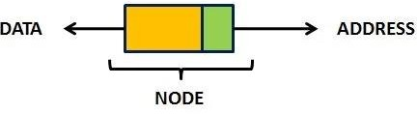
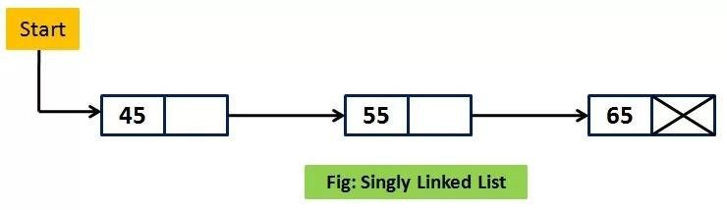
therefore, we can say that a singly linked list is a dynamic data structure because it may shrink or grow. hence, The shrinking and growing depending on the operation made.
let’s start a singly list by first creating it. I hope you know very well, the linked list is created for using structures, pointers and dynamic memory allocation function malloc().
furthermore, it considers the head as an external pointer. this will help us for creating and accessing other nodes in the linked list.
let’s see the following structures definition and head creation.
struct node
{
int num;
struct node*ptr;
typedef struct node NODE; NODE*start;
start=(node *)malloc(size of(NODE)); WHEN THE STATEMENT
start=(node*)malloc(size of(NODE));
Hence, as you have seen above, it is executed a block of memory sufficient for the store the node is allocated.
Therefore its assigns head as the starting address of the node. hence, these all activities can be pictorially shown as given figures.

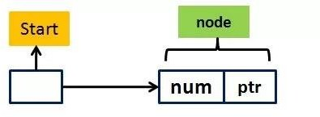

Example-1
Suppose that if you want to insert 35 after 30 in the given list as figure 1.1
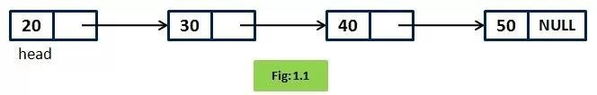

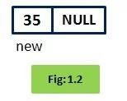
First of all, create a node 35

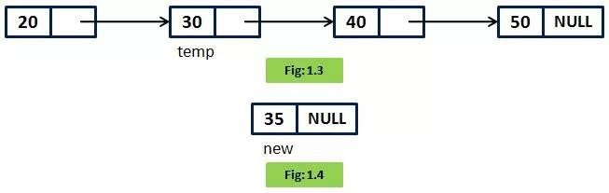
Therefore, after that Search for the node 30Then, 35 will be insert in the list

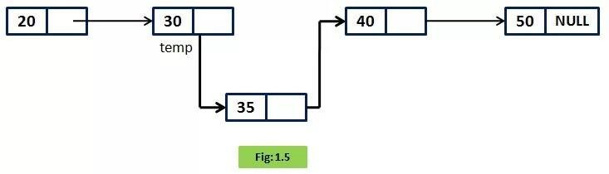
Hence, this process can be done through the following steps:

New -> next = temp-> next temp-> next=new
therefore, thus finally the desired node gets in

Advantages of Singly Linked List: -

there are some advantages of singly Linked List
it is very easier for the accessibility of a node in the forward direction.
the insertion and deletion of a node are very easy.
the Requirement will less memory when compared to doubly, circular or doubly circular linked list.
the Singly linked list is the very easy data structure to implement.
During the execution, we can allocate or deallocate memory easily.
Insertion and deletion of elements don’t ned the movement of all the elements when compared to an array.

Disadvantages of Singly Linked List: -

The disadvantages of singly Linked List are following-

Therefore, Accessing the preceding node of a current node is not possible as there is no backward traversal.
The Accessing of a node is very time-consuming.
Program of singly linked list: -

#include<stdio.h>
#include<stdlib.h>
struct node
{
int data;
struct node *next;
};
struct node *head;

void beginsert (); void lastinsert (); void randominsert(); void begin_delete(); void last_delete();
void random_delete(); void display();
void search(); int main ()
{
int choice =0;
while(choice != 9)
{
printf("\n\n*********Main Menu*********\n"); printf("\nChoose one option from the following list ...\n");
printf("\n===============================================\n");
printf("\n1.Insert in begining\n2.Insert at last\n3.Insert at any random location\n4.Delete from Beginning\n5.Delete from last\n6.Delete node after specified location\n7.Search for an element\n8.Show\n9.Exit\n");
printf("\nEnter your choice?\n"); scanf("\n%d",&choice); switch(choice)

case 1:

beginsert();
break;
case 2:
lastinsert();

break;
case 3: randominsert(); break;
case 4: begin_delete(); break;
case 5:
last_delete(); break;
case 6: random_delete(); break;
case 7:
search(); break; case 8:
display(); break; case 9:
exit(0); break; default:
printf("Please enter valid choice..");

}

}

}
void beginsert()
{
struct node *ptr; int item;
ptr = (struct node *) malloc(sizeof(struct node *)); if(ptr == NULL)
{
printf("\nOVERFLOW");
}
else
{
printf("\nEnter value\n"); scanf("%d",&item);
ptr->data = item; ptr->next = head; head = ptr;
printf("\nNode inserted");
}

}
void lastinsert()
{
struct node *ptr,*temp; int item;
ptr = (struct node*)malloc(sizeof(struct node)); if(ptr == NULL)
{
printf("\nOVERFLOW");
}
else

{

printf("\nEnter value?\n"); scanf("%d",&item);
ptr->data = item; if(head == NULL)
{
ptr -> next = NULL; head = ptr;
printf("\nNode inserted");
}
else
{
temp = head;
while (temp -> next != NULL)
{
temp = temp -> next;
}
temp->next = ptr; ptr->next = NULL;
printf("\nNode inserted");

}

}

}
void randominsert()
{
int i,loc,item;
struct node *ptr, *temp;
ptr = (struct node *) malloc (sizeof(struct node)); if(ptr == NULL)
{

printf("\nOVERFLOW");

}
else
{
printf("\nEnter element value"); scanf("%d",&item);
ptr->data = item;
printf("\nEnter the location after which you want to insert "); scanf("\n%d",&loc);
temp=head; for(i=0;i<loc;i++)
{
temp = temp->next; if(temp == NULL)
{
printf("\ncan't insert\n"); return;
}

}
ptr ->next = temp ->next; temp ->next = ptr; printf("\nNode inserted");
}

}
void begin_delete()
{
struct node *ptr; if(head == NULL)
{
printf("\nList is empty\n");

}
else
{
ptr = head;
head = ptr->next; free(ptr);
printf("\nNode deleted from the begining ...\n");
}

}
void last_delete()
{
struct node *ptr,*ptr1; if(head == NULL)
{
printf("\nlist is empty");
}
else if(head -> next == NULL)
{
head = NULL; free(head);
printf("\nOnly node of the list deleted ...\n");
}

else
{
ptr = head;
while(ptr->next != NULL)
{
ptr1 = ptr;
ptr = ptr ->next;
}

ptr1->next = NULL; free(ptr);
printf("\nDeleted Node from the last ...\n");

}

}
void random_delete()
{
struct node *ptr,*ptr1; int loc,i;
printf("\n Enter the location of the node after which you want to perform deletion \n"); scanf("%d",&loc);
ptr=head; for(i=0;i<loc;i++)
{
ptr1 = ptr;
ptr = ptr->next;

if(ptr == NULL)
{
printf("\nCan't delete"); return;
}
}
ptr1 ->next = ptr ->next; free(ptr);
printf("\nDeleted node %d ",loc+1);
}
void search()
{
struct node *ptr; int item,i=0,flag;

ptr = head; if(ptr == NULL)
{
printf("\nEmpty List\n");
}
else
{
printf("\nEnter item which you want to search?\n"); scanf("%d",&item);
while (ptr!=NULL)
{
if(ptr->data == item)
{
printf("item found at location %d ",i+1); flag=0;
}
else
{
flag=1;
} i++;
ptr = ptr -> next;
}
if(flag==1)
{
printf("Item not found\n");
}
}

}

void display()
{
struct node *ptr; ptr = head;
if(ptr == NULL)
{
printf("Nothing to print");
}
else
{
printf("\nprinting values \n");
while (ptr!=NULL)
{
printf("\n%d",ptr->data); ptr = ptr -> next;
}
}
}

Conclusion:-

Singly linked list is probably the most easiest data structure to implement. Insertion and deletion of element can be done easily. Insertion and deletion of elements doesn't requires movement of all elements when compared to an array.

References:-

https://www.javatpoint.com
https://www.educative.io

https://quesol.com

