MOVIE BOOKING – SEAT BOOKING SYSTEM
Project Documentation | Feature Set II
Requirements, Algorithm, Flowchart, ER Diagram & Sample Screens

1. Project Overview
The Movie Booking – Seat Booking System is a simple application designed to help customers view movie, theatre, and show information, check available seats, select a seat, and confirm a booking. The system covers five main areas: Movie Details, Theatre Details, Show Details, Seat Availability, and Booking. It validates seat availability and prevents duplicate booking of the same seat for the same show.

2. Functional Requirements
# | Requirement
1 | The system shall display a list of currently running movies with title, genre, language, and duration.
2 | The system shall display theatre details such as theatre name and location for each movie.
3 | The system shall display show details such as show date and show time for a selected movie and theatre.
4 | The system shall display the seat layout of the selected show and clearly mark seats as available or booked.
5 | The system shall allow the customer to select any one available seat from the seat layout.
6 | The system shall validate the selected seat and reject the selection if the seat is already booked.
7 | The system shall ask the customer to confirm the booking before finalising it.
8 | The system shall prevent duplicate booking of the same seat for the same show.
9 | The system shall update the seat status to 'Booked' immediately after a successful booking.
10 | The system shall generate and display a booking confirmation screen with booking ID, movie, theatre, show, seat number and customer details.

3. Non-Functional Requirements
# | Requirement
1 | Usability: The system shall provide a simple and user-friendly interface suitable for first-time users.
2 | Performance: Seat availability shall be checked and displayed within a few seconds of the request.
3 | Reliability: The system shall not allow two customers to book the same seat for the same show.
4 | Availability: The booking system shall be available whenever a customer wants to check shows or make a booking.
5 | Maintainability: The system shall be designed in a modular way so that new movies, theatres, or shows can be added easily.
6 | Security: Customer details shall be stored safely and shall not be shown to other customers.
7 | Scalability: The system shall be able to handle additional movies, theatres, shows, and seats as the business grows.

4. Hardware Requirements
# | Requirement
1 | Processor: Intel i3 or above (or equivalent)
2 | RAM: 4 GB minimum (8 GB recommended)
3 | Hard Disk: 250 GB or above with at least 2 GB free space
4 | Monitor: Standard colour monitor with minimum 1024 x 768 resolution
5 | Keyboard and Mouse for user input
6 | Internet connection (if the system is web-based / online booking is required)

5. Software Requirements
# | Requirement
1 | Operating System: Windows 10 / 11, Linux, or macOS
2 | Frontend: HTML, CSS, JavaScript (or any suitable UI technology)
3 | Backend Language: Python / Java / PHP (as per project scope)
4 | Database: MySQL / SQLite (to store Movie, Theatre, Show, Seat, Customer, and Booking data)
5 | IDE / Code Editor: VS Code, Eclipse, or similar
6 | Browser: Google Chrome, Mozilla Firefox, or any modern web browser (for web-based systems)

6. Algorithm
The following is a simple step-by-step algorithm for the complete movie seat booking process:
- Start the Movie Booking – Seat Booking System.
- Display the list of available movies with their details (title, genre, language, duration).
- Customer selects a movie. Display the theatre details available for that movie.
- Customer selects a theatre. Display the show details (date and time) for that theatre.
- Customer selects a show. Check and display the seat availability for the selected show.
- If no seats are available, display a message and go back to Step 5 to let the customer pick another show.
- If seats are available, allow the customer to select an available seat.
- Validate the selected seat: check whether it is already booked for that show.
- If the seat is already booked, display a message and return to Step 7 for the customer to choose another seat.
- If the seat is available, ask the customer to confirm the booking.
- If the customer does not confirm, return to Step 7 to allow seat re-selection.
- If the customer confirms, process and confirm the booking.
- Update the seat status to 'Booked' so the same seat cannot be booked again for that show.
- Generate a unique Booking ID and display the booking confirmation screen with movie, theatre, show, seat number, and customer details.
- End the process.

7. Flowchart
The flowchart below shows the complete flow of the booking process, including the loop for seat unavailability and booking non-confirmation.
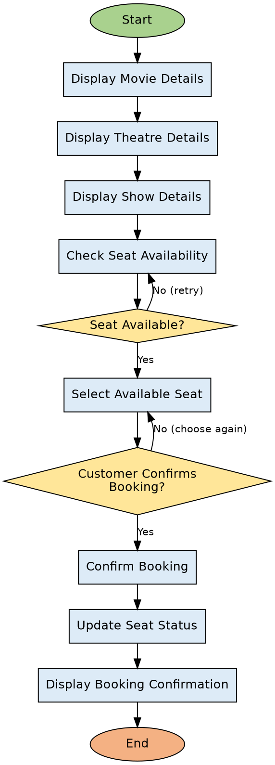
Fig 1: Flowchart of the Movie Booking – Seat Booking System

8. Entity Relationship (ER) Diagram
The ER diagram below shows the Movie, Theatre, Show, Seat, Customer, and Booking entities with their attributes, keys, and relationships. A movie can have many shows, a theatre can host many shows, a show contains many seats, and a customer can make many bookings.
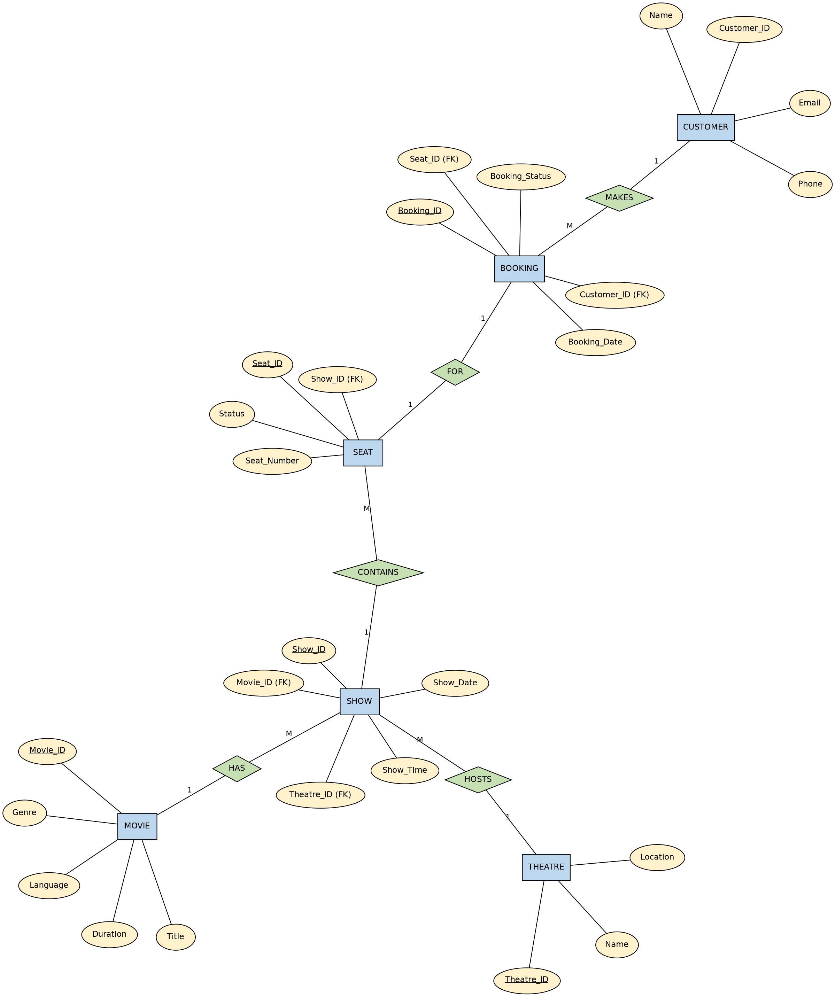
Fig 2: ER Diagram of the Movie Booking – Seat Booking System

9. Sample Screens

9.1 Seat Availability Screen
This screen allows the customer to view the movie, theatre, and show details, and select an available seat. Green seats are available, grey seats are already booked, and the blue seat is the one currently selected.
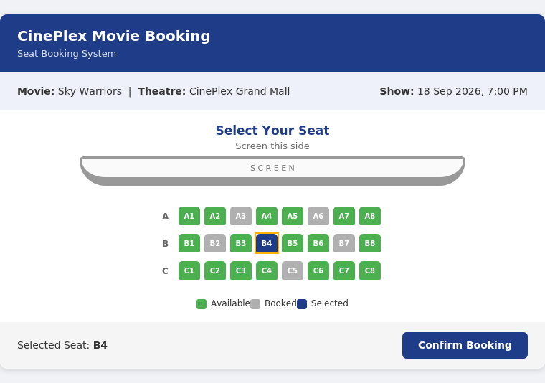
Fig 3: Sample Seat Availability Screen

9.2 Booking Confirmation Screen
This screen is displayed after the customer confirms the booking. It shows the booking status along with the movie, theatre, show, seat number, customer name, and a unique Booking ID.
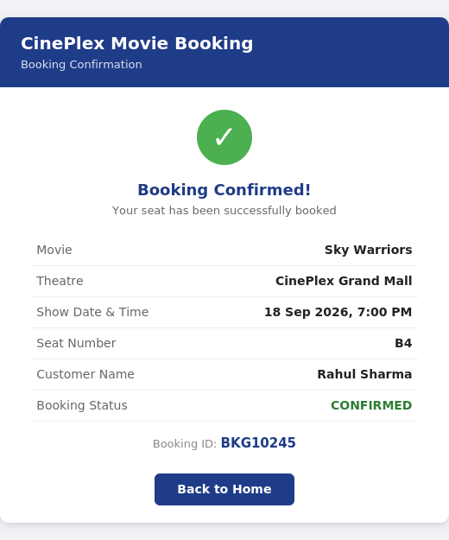
Fig 4: Sample Booking Confirmation Screen

